Ex2
1. Aim
The aim of this experiment is to evaluate the effect of visual chunking (grouping elements) on a user's short-term memory recall. It specifically tests whether users can recall more items when they are presented in organized groups compared to a random or continuous sequence.
Procedure
The experiment was conducted using a four-frame Figma prototype:
- Instruction Phase: The user is presented with a "Home Screen" explaining that they will have 5 seconds to view items before being asked to recall them.
- Chunking (Stimulus) Phase: * The user views a set of visual elements (icons) for exactly 5 seconds.
  - Independent Variable: The icons are either presented as a single list or organized into "chunks" of 3-5 items using visual borders or spacing.
- Recall Phase: The stimulus disappears, and the user is prompted to type the names of the items they remember into text input fields.
- Result Phase: The user clicks "Submit" to view a feedback screen showing their performance (e.g., "You recalled 3 out of 5 items").

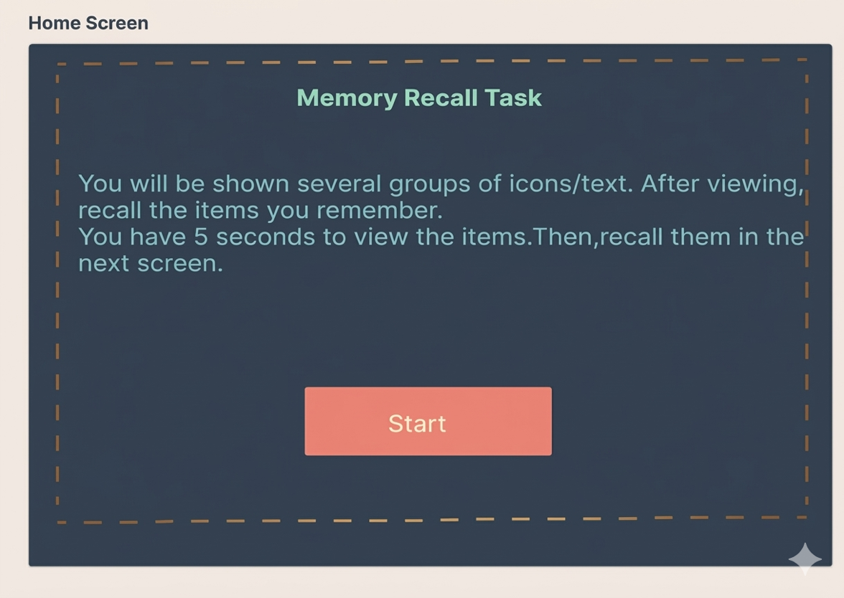
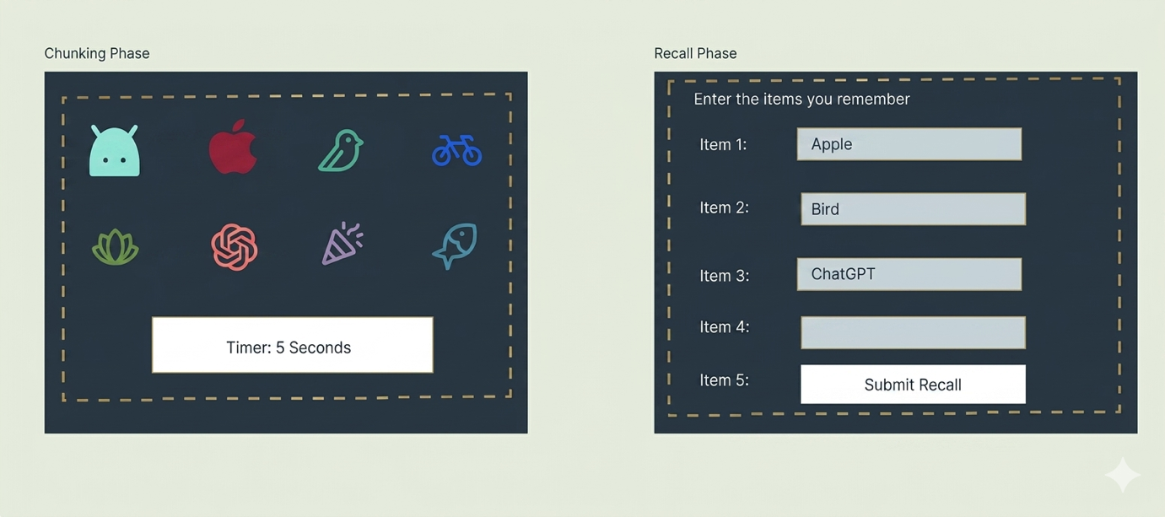

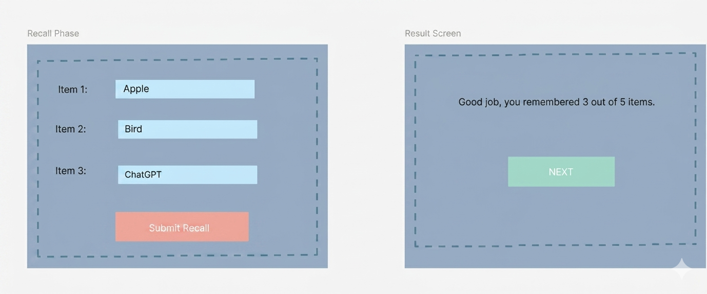

Results:
Organizing information into small, manageable groups (chunks) significantly improves the accuracy of short-term memory recall.

