Beach bar's website

*Vito Strahinjić*

**Assignment Description**

**Create User Personas**

Create a set of user personas (3) relevant to a specific project. Do not forget to include AI generated photo for your personas.

**Information Architecture**

Develop an information architecture for your project based on the card sorting method.

**Create a Sitemap**

Based on the combined categories from card sorting, design a detailed sitemap for your web application. Clearly display the structure and hierarchy of the information on your site.

*To streamline this potentially lengthy process do make use of ChatGPT.*

Source: <https://hci.mario-cagalj.from.hr/projektni-zadaci/2>

# Create user personas

In this section, we introduce the user personas generated with the assistance of ChatGPT. These personas represent the actual users of our website and aim to help developers understand for whom they are building the platform.

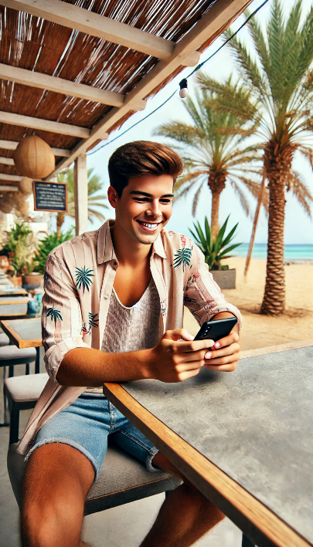**Persona 1: Alex - The Social Student**

* **Age:** 22
* **Occupation:** College Student
* **Tech Savvy Level:** High
* **Interests:** Socializing, digital games, discounts/coupons, exploring local scenes

**Bio:**  
Alex is a college student on vacation with friends, looking for fun spots to hang out. He’s very comfortable with technology and loves finding interactive elements on websites, especially if they offer incentives or discounts. He’s drawn to any activities that add value to his experience, like games that offer rewards or exclusive deals.

**Goals:**

* Quickly find menu items, especially drinks and shareable appetizers.
* Earn rewards or discounts through games for more affordable purchases.
* Have a fun and engaging experience on the site.

**Pain Points:**

* Losing interest if the site is too basic or lacks interactive features.
* Frustration with cluttered interfaces or unclear game rules.

**Motivations for Using the App:**

* Engage with fun browser games to get discounts and rewards.
* Discover the latest drink specials and recommended items.
* Share bar deals and experiences with friends through social media or quick messaging options.

**Persona 2: Mia - The Curious Weekender**



* **Age:** 43
* **Occupation:** Marketing Manager
* **Tech Savvy Level:** Medium
* **Interests:** Weekend getaways, discovering new places, relaxation, trying out local cuisines

**Bio:**  
Mia is on a weekend beach retreat, looking to unwind and explore the local offerings. She’s moderately comfortable with technology and curious about new places, especially unique, local bars and cafes. She enjoys spending her downtime playing simple games on her phone and is intrigued by local offers and discounts.

**Goals:**

* Access information about the bar’s signature items, food, and drinks.
* Find details about the bar's ambiance, specialties, and upcoming events.
* Try out games or activities if they’re straightforward and rewarding.

**Pain Points:**

* Becoming frustrated if navigation is confusing or if information is difficult to find.
* Losing interest if games are too complex or if rewards don’t seem worthwhile.

**Motivations for Using the App:**

* Discover unique drinks and menu items that are local or seasonal.
* Play an easy game that could earn a discount or a special offer.
* Get practical bar information, like hours, special events, and nearby attractions.

**Persona 3: Robert - The Relaxed Senior**

* **Age:** 68
* **Occupation:** Retired Teacher
* **Tech Savvy Level:** Low
* **Interests:** Relaxing atmospheres, simplicity in technology, enjoying food and drink at a slow pace

**Bio:**  
Robert is a retiree who enjoys traveling to calm beachside locations. He’s not very tech-savvy and prefers websites that are straightforward and easy to navigate. He likes trying new foods and appreciates clear, readable information. While he may not be interested in games, he values any helpful tips or specials.

**Goals:**

* Navigate to the menu quickly and find clear information on food and drink.
* Access any promotions or specials without needing to play games.
* Understand bar amenities, seating options, and additional services.

**Pain Points:**

* Difficulty reading small text or navigating cluttered layouts.
* Annoyance with overly interactive elements that are not intuitive.

**Motivations for Using the App:**

* Find easily accessible information on the menu, prices, and bar options.
* Discover promotions or coupons without engaging in games.
* Understand the bar’s accessibility and amenities, like seating and shade options.

ChatGPT query that got us previously described personas:

Can you help me create user personas for my website application. Websites primary function will be to host drinks menu of a beach bar. Bars guests will scan the QR code on the table and it will lead them to this website. As well as showing the menu, website will have additional functionalities like playable browser games which in reward give coupons, additional bar info and so on... Help me create personas who will use this website. Bars usual guests are people of various types. I need 3 personas to represent 3 main demographics: students and young people who will be the main target, curious middle aged people on a weekend getaway, elderly people who need to have easy time navigating the app.

# Information architecture

1. **Home**
   * Acts as the landing page when users scan the QR code, with options to quickly navigate to any main section.
2. **Menu**
   * Directly accessible from the Home page to allow users to view the full menu with minimal clicks, making it easy for all personas.
3. **Games**
   * Prominent section to engage users with interactive games. This section might display game options, rules, and potential rewards.
4. **Recommended Items**
   * Displays popular food and drink options. For quick access, users can directly see the top recommendations without having to scroll through the full menu.
5. **More Info**
   * Contains additional sections related to the bar and its unique offerings:
     + **Bar Story**: Background about the bar, enhancing user connection.
     + **Photo Gallery**: Visual content showing the bar, food, and ambiance.
     + **FAQs**: Essential info to answer common questions.
     + **Event Calendar**: A calendar of upcoming events for those interested.
     + **Language Selection**: Allows for language preferences, located in a spot where users can easily find it without overwhelming the main navigation.

# Create a Sitemap

