CISCO PACKET TRACER PROJECT REPORT
Design and Configure a Secure Office Network Using VLANs & Router-on-a-Stick
Course / Subject: | Computer Networking
Software Tool: | Cisco Packet Tracer
Author / Student Name: | Jai
Submission File: | Jai_VLAN_Routing_Project.pkt

1. Project Overview & Scenario
A small company currently operates a single flat broadcast domain network where all employees from HR, IT, and Finance communicate on the same physical and logical network. This unsegmented architecture presents serious security risks, allows unauthorized inter-departmental access to sensitive records, and degrades network performance due to excessive broadcast traffic.
To solve these operational issues, this project implements network segmentation using Virtual Local Area Networks (VLANs) across two Cisco 2960 switches, connected to a Cisco Router configured for Router-on-a-Stick (802.1Q trunking and subinterfaces). This creates three logically isolated broadcast domains while enabling secure inter-VLAN routing.
2. IP Addressing & VLAN Design Plan
Device Name | VLAN ID & Dept | IP Address | Subnet Mask | Default Gateway
HR-PC1 | VLAN 10 (HR) | 192.168.10.11 | 255.255.255.0 | 192.168.10.1
HR-PC2 | VLAN 10 (HR) | 192.168.10.12 | 255.255.255.0 | 192.168.10.1
IT-PC1 | VLAN 20 (IT) | 192.168.20.11 | 255.255.255.0 | 192.168.20.1
IT-PC2 | VLAN 20 (IT) | 192.168.20.12 | 255.255.255.0 | 192.168.20.1
FIN-PC1 | VLAN 30 (Finance) | 192.168.30.11 | 255.255.255.0 | 192.168.30.1
FIN-PC2 | VLAN 30 (Finance) | 192.168.30.12 | 255.255.255.0 | 192.168.30.1

2.2 TOPOLOGY
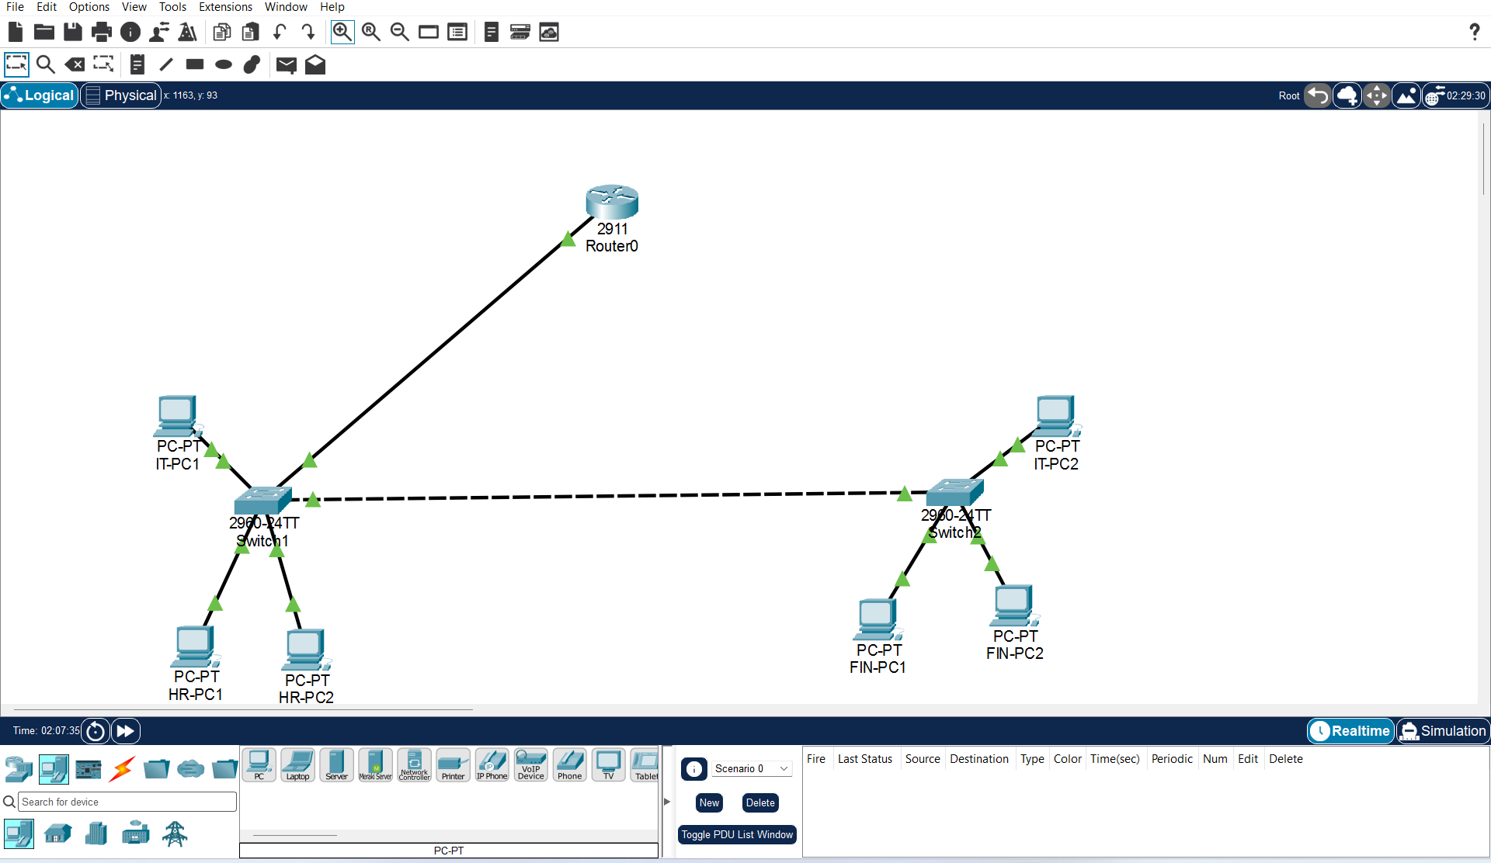
3. Step-by-Step Configuration Script
3.1 Switch Configuration (Both Switch 1 and Switch 2)
Switch> enable
Switch# configure terminal
Switch(config)# vlan 10
Switch(config-vlan)# name HR
Switch(config-vlan)# vlan 20
Switch(config-vlan)# name IT
Switch(config-vlan)# vlan 30
Switch(config-vlan)# name FINANCE
Switch(config-vlan)# exit
Switch(config)# interface FastEthernet0/2
Switch(config-if)# switchport mode access
Switch(config-if)# switchport access vlan 10
Switch(config-if)# exit
Switch(config)# interface FastEthernet0/1
Switch(config-if)# switchport mode trunk
Switch(config-if)# interface FastEthernet0/24
Switch(config-if)# switchport mode trunk
Switch(config-if)# end
Switch# write memory
3.2 Router Configuration (Router-on-a-Stick)
Router> enable
Router# configure terminal
Router(config)# interface GigabitEthernet0/0
Router(config-if)# no shutdown
Router(config-if)# exit
Router(config)# interface GigabitEthernet0/0.10
Router(config-subif)# encapsulation dot1Q 10
Router(config-subif)# ip address 192.168.10.1 255.255.255.0
Router(config-subif)# exit
Router(config)# interface GigabitEthernet0/0.20
Router(config-subif)# encapsulation dot1Q 20
Router(config-subif)# ip address 192.168.20.1 255.255.255.0
Router(config-subif)# exit
Router(config)# interface GigabitEthernet0/0.30
Router(config-subif)# encapsulation dot1Q 30
Router(config-subif)# ip address 192.168.30.1 255.255.255.0
Router(config-subif)# end
Router# write memory
CONFIGURATION SCREENSHOT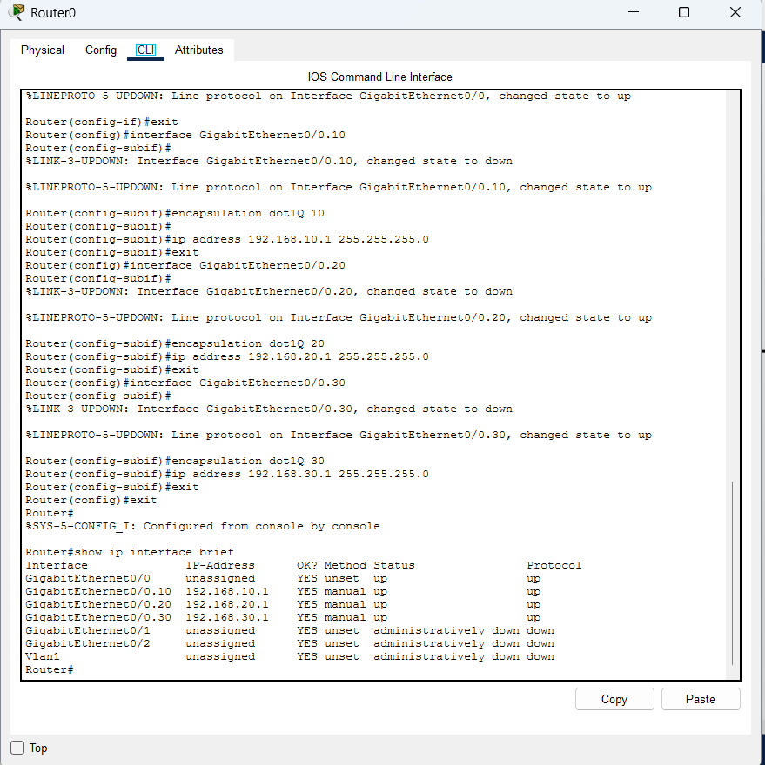
4. Testing and Verification Results
The network connectivity and isolation were verified through four structured test phases:
Test Phase | Source & Destination | Expected Result | Observed Outcome
Test A: Same-VLAN Ping | HR-PC1 -> HR-PC2  IT-PC1 -> IT-PC2 | 100% Success  (Layer 2 switching) | PASSED  (Replies received, <1ms)
Test B: Inter-VLAN Ping | HR-PC1 -> IT-PC1  HR-PC1 -> FIN-PC1 | 100% Success  (Router-on-a-Stick) | PASSED  (First packet ARP timeout, then 100%)
Test C: Isolation Test | HR-PC1 -> IT-PC1  (Router interface Shutdown) | 100% Ping Failure  (Inter-VLAN isolated) | PASSED  (Request timed out as expected)
Test C: Intra-VLAN Test | HR-PC1 -> HR-PC2  (Router interface Shutdown) | 100% Success  (Local switch forwarding) | PASSED  (Communicates without router)

TEST RESULT OUTPUT SCREENSHOTS

SAME VLAN
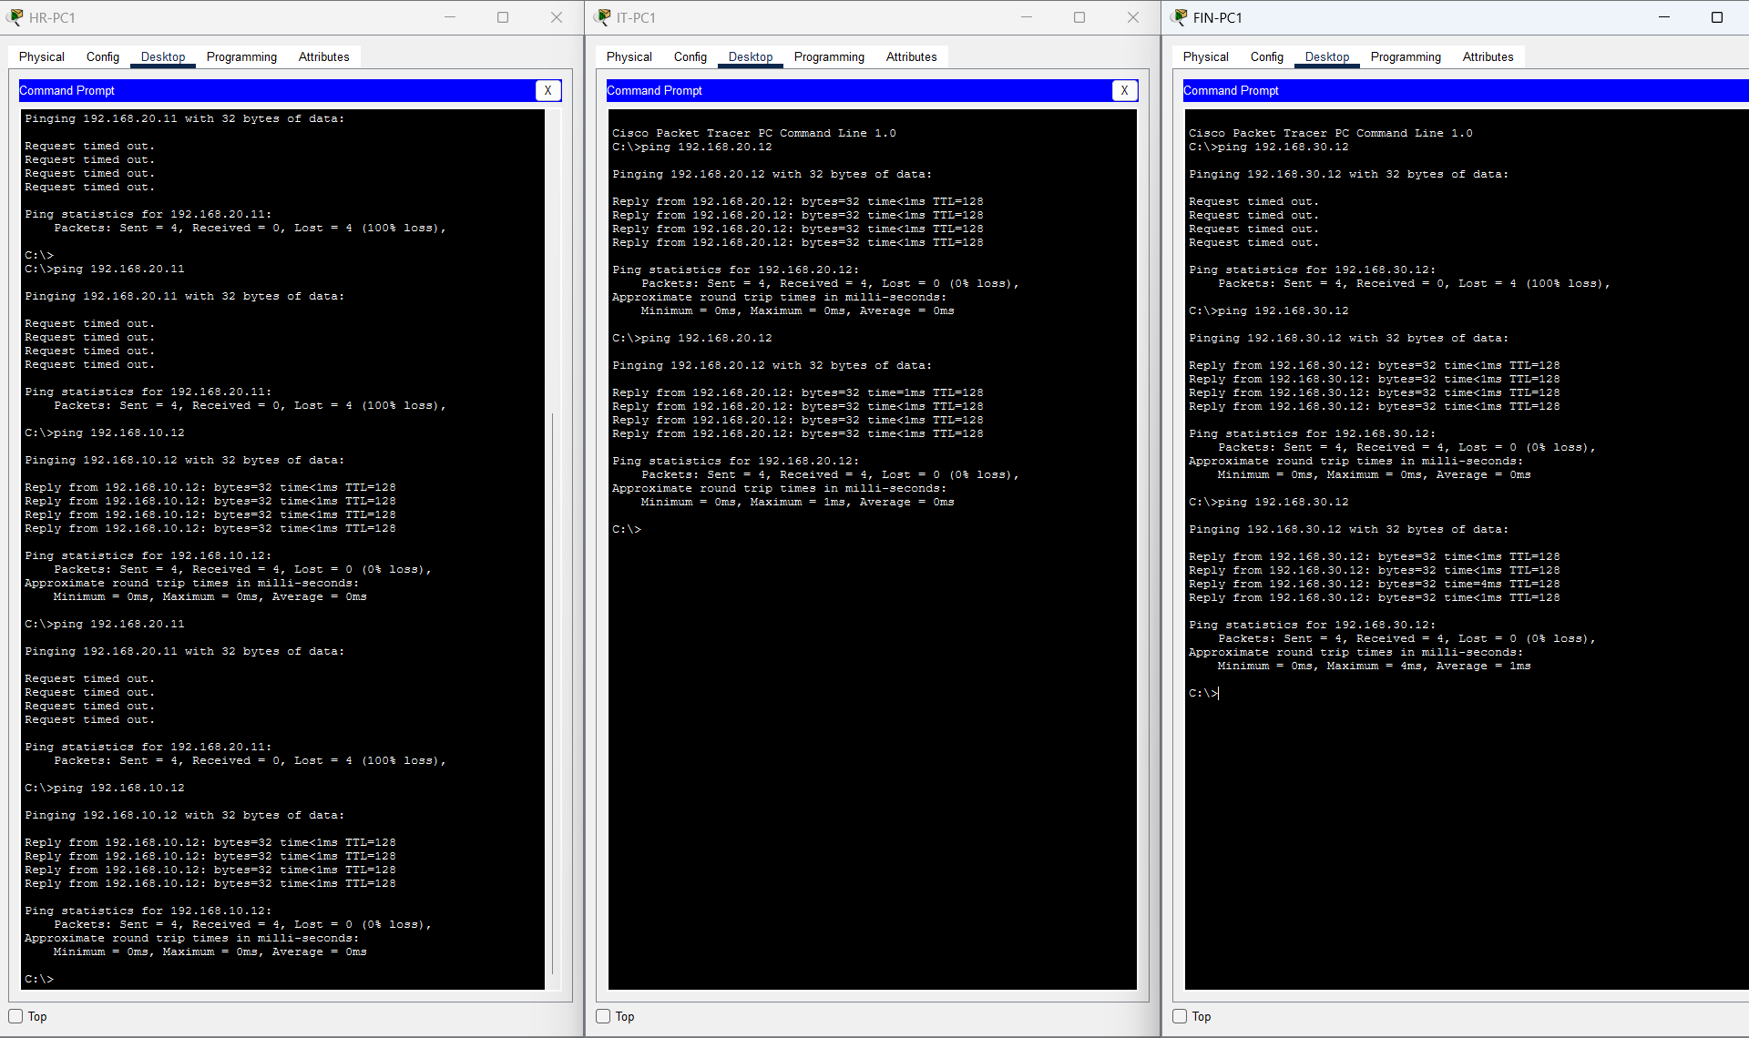

INTER VLAN
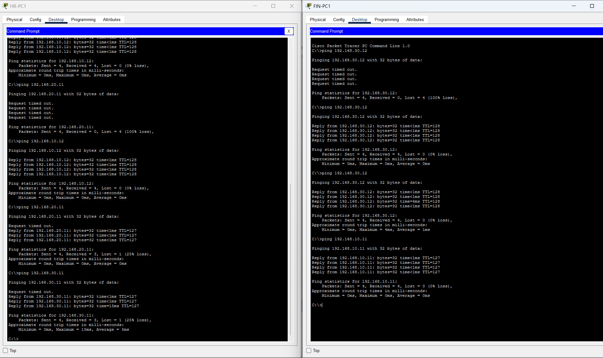
5. Simulation Mode & Packet Analysis Answers
1. How the source PC identifies its default gateway's MAC address:
The PC inspects its internal ARP table for the gateway IP address (192.168.10.1). If no entry exists, the PC sends a Layer 2 ARP Request broadcast (Destination MAC: FF:FF:FF:FF:FF:FF). The router subinterface receives the broadcast and replies with an ARP Reply containing its physical MAC address.
2. How the Ethernet frame travels from the access switch to the router:
When the access switch receives the untagged frame on HR-PC1's access port (VLAN 10), it inserts an IEEE 802.1Q header containing VLAN Tag 10. The frame travels across the trunk interface to the router with this tag intact.
3. How the router identifies the correct outgoing interface:
The router strips the 802.1Q header, reads the destination IP address (e.g., 192.168.30.11), and checks its Layer 3 Routing Table (show ip route). It finds a directly connected route for network 192.168.30.0/24 on logical subinterface GigabitEthernet0/0.30.
4. What happens to MAC addresses when the router forwards the packet:
At each Layer 3 hop, Ethernet headers are rewritten. The router sets the Source MAC address to its own outgoing subinterface MAC and the Destination MAC address to FIN-PC1's MAC address (resolved via ARP).
5. Do source and destination IP addresses change during ordinary routing?
No. In standard IP routing without Network Address Translation (NAT), original Source IP (192.168.10.11) and Destination IP (192.168.30.11) remain unchanged throughout the entire transmission path.
6. IOS Commands Reference
6.1 Required Verification Commands Summary(switches)
- show vlan brief: Displays all configured VLANs, status, and associated access ports.
- show interfaces trunk: Displays active trunk links, encapsulation type (802.1Q), and allowed VLANs.
- Show interfaces status: Displays the table of physical status and configuration of all the ports
- Show mac address-table: Displays the table of Dynamic mac address containing information about mac, type, port e.t.c.
- Show running-config: Displays interface configuration, ip address, vlan settings e.t.c.

6.1.1 SCREENSHOTS
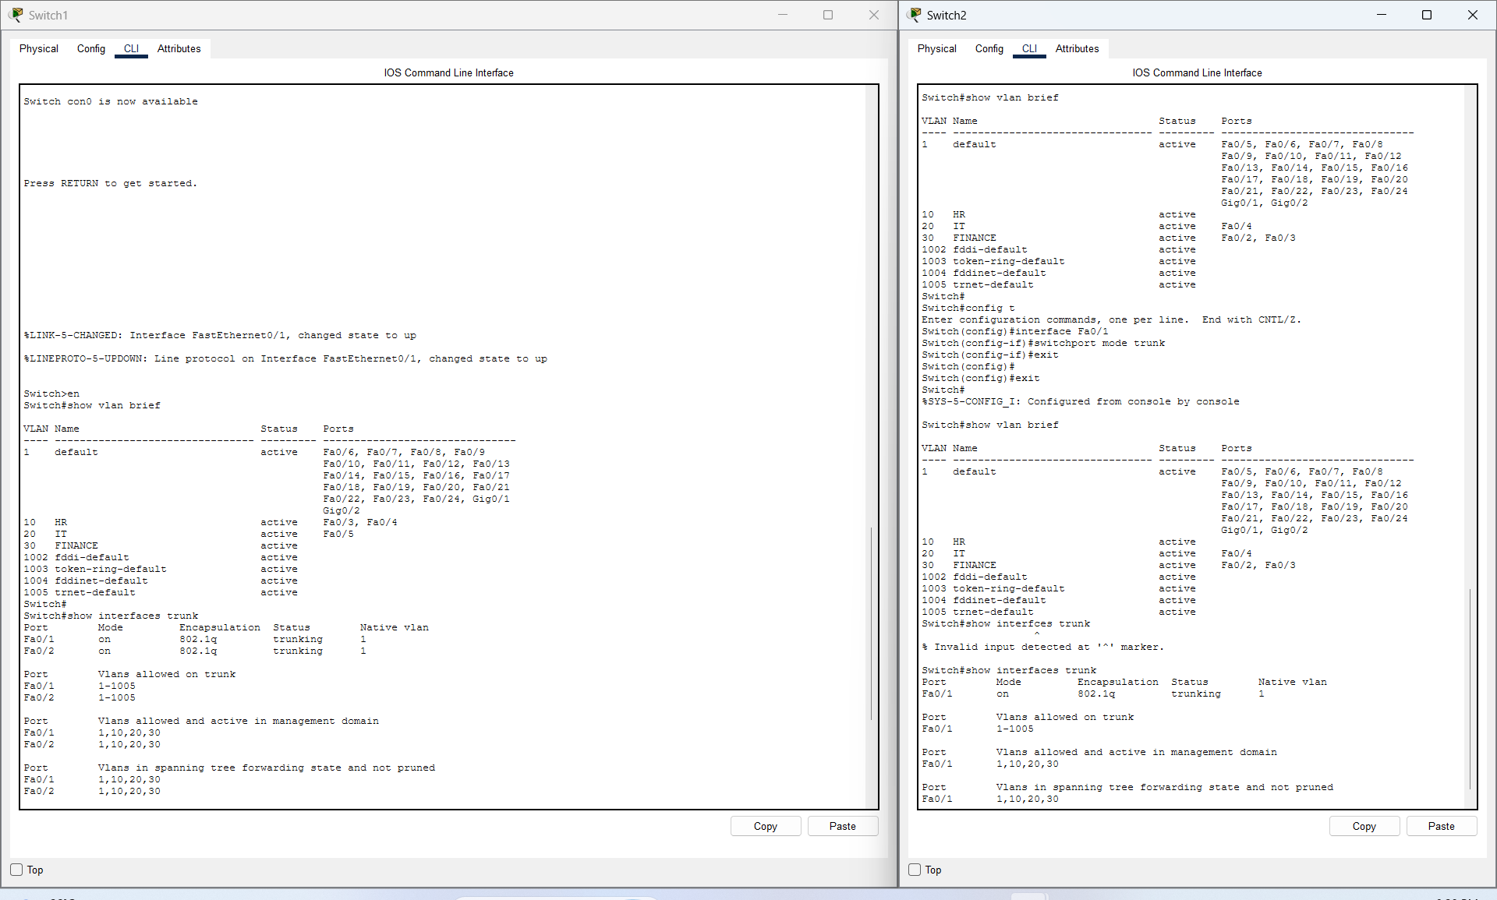
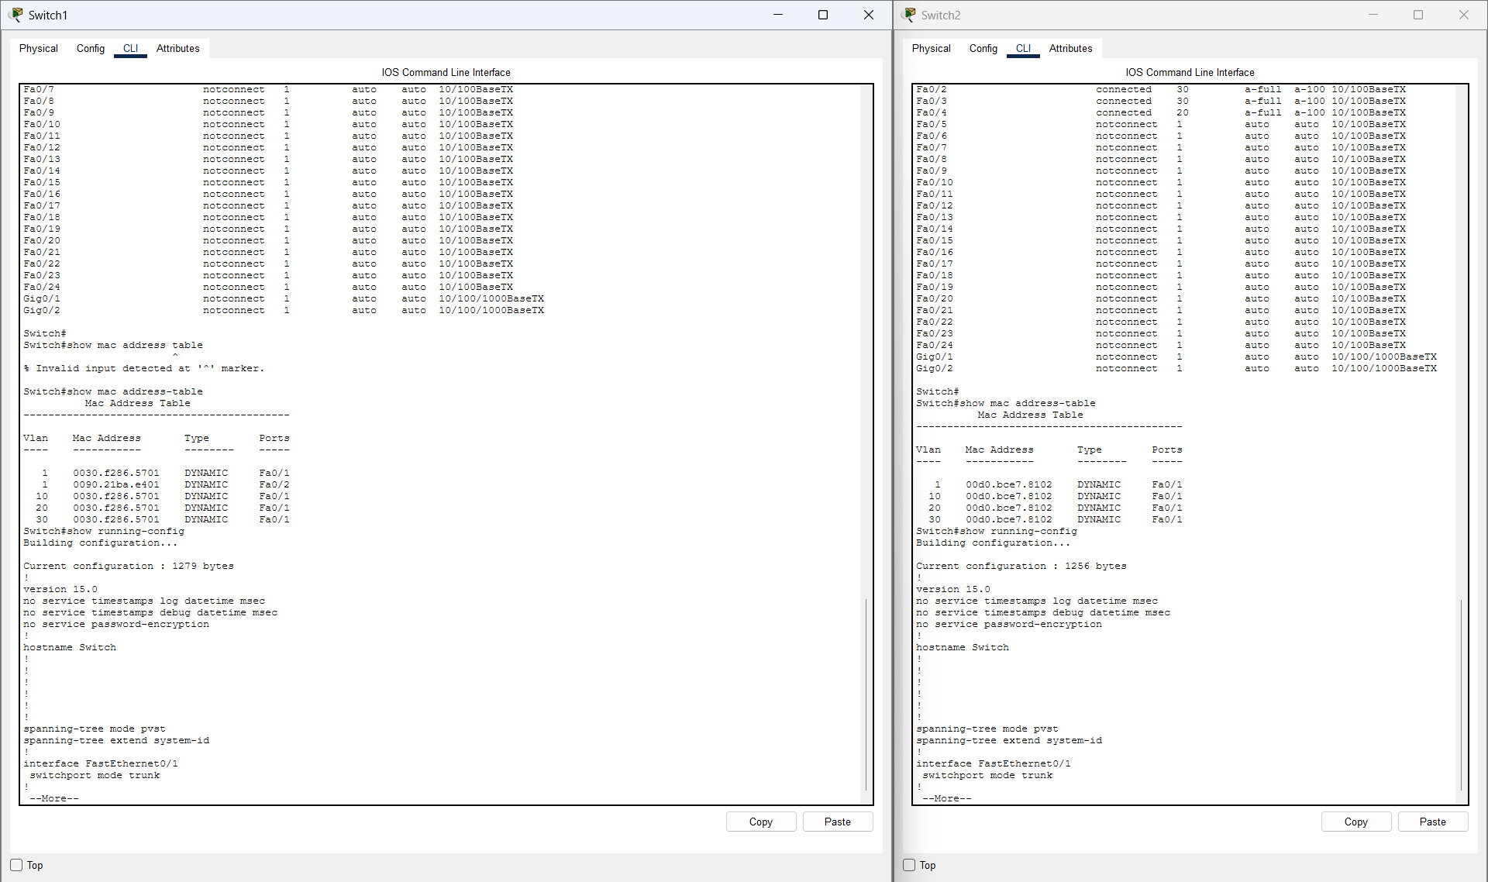

6.2 Required Verification Commands Summary(router)
- show ip interface brief: Displays summary of physical and subinterface operational status (up/up) and assigned IP addresses.
- show ip route: Shows the router's active routing table, highlighting directly connected subnets.
- Show running-config: Displays interface configuration, ip address, vlan settings e.t.c.
- Show interfaces: provides detailed, low-level technical statistics and configuration parameters for all physical interfaces and logical subinterfaces.
6.2.2 SCREENSHOTS
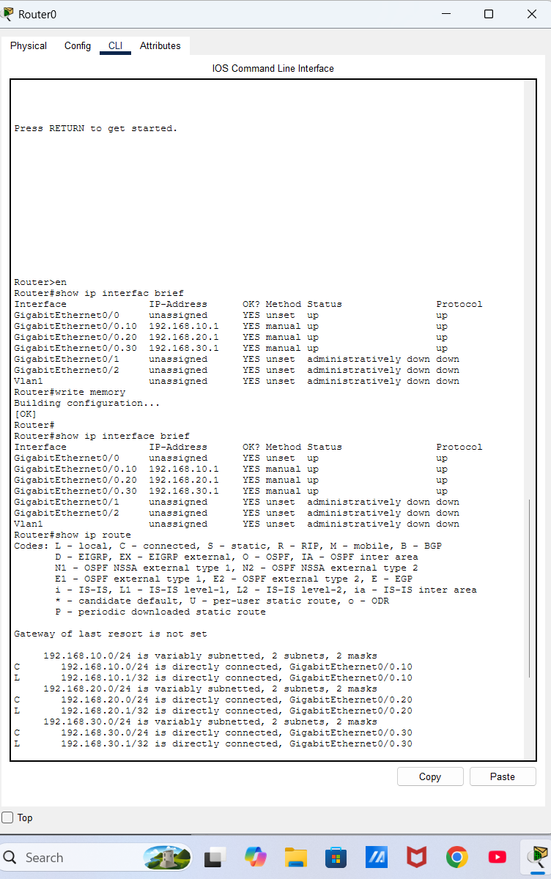
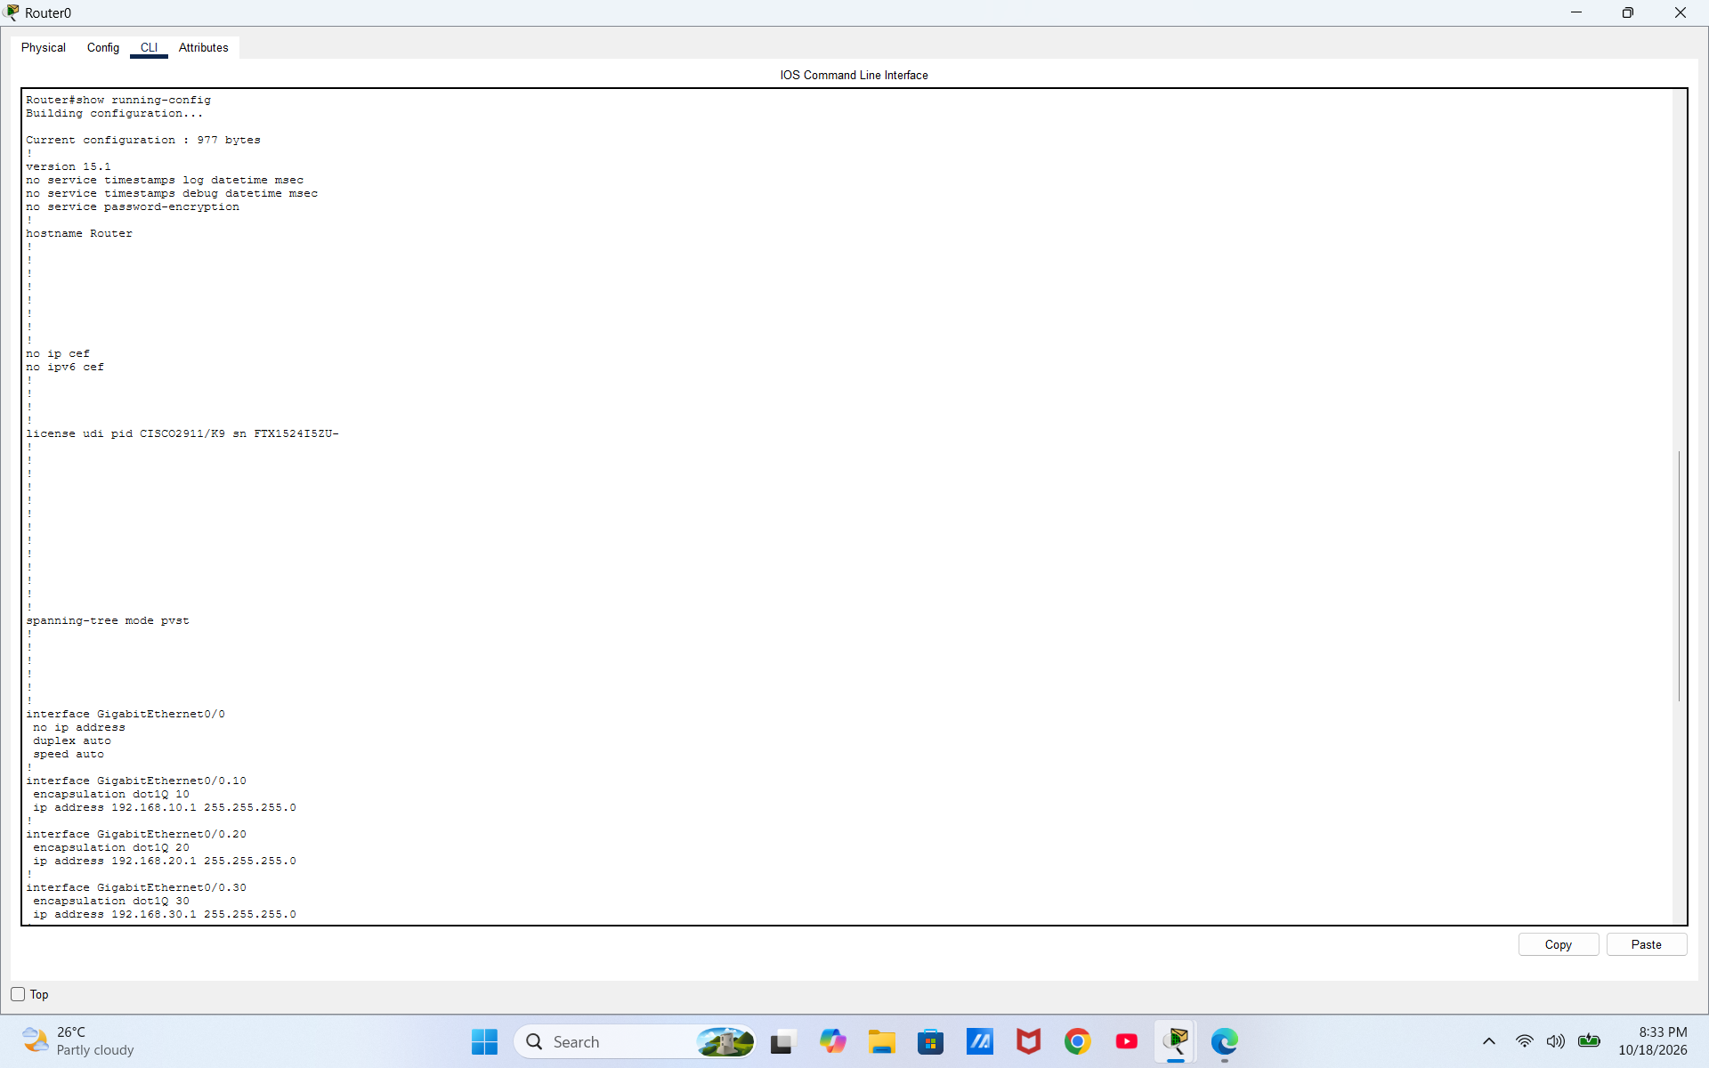
7. Conclusion
Implementing VLANs and Router-on-a-Stick inter-VLAN routing effectively transforms a flat physical topology into a highly organized, secure, and scalable enterprise network architecture. By segmenting HR, IT, and Finance into independent logical networks, broadcast domains are constrained, reducing unnecessary network overhead. Furthermore, inter-departmental communication is strictly controlled through Layer 3 subinterface routing, providing a solid foundation for administrative security policies and firewall access controls.

