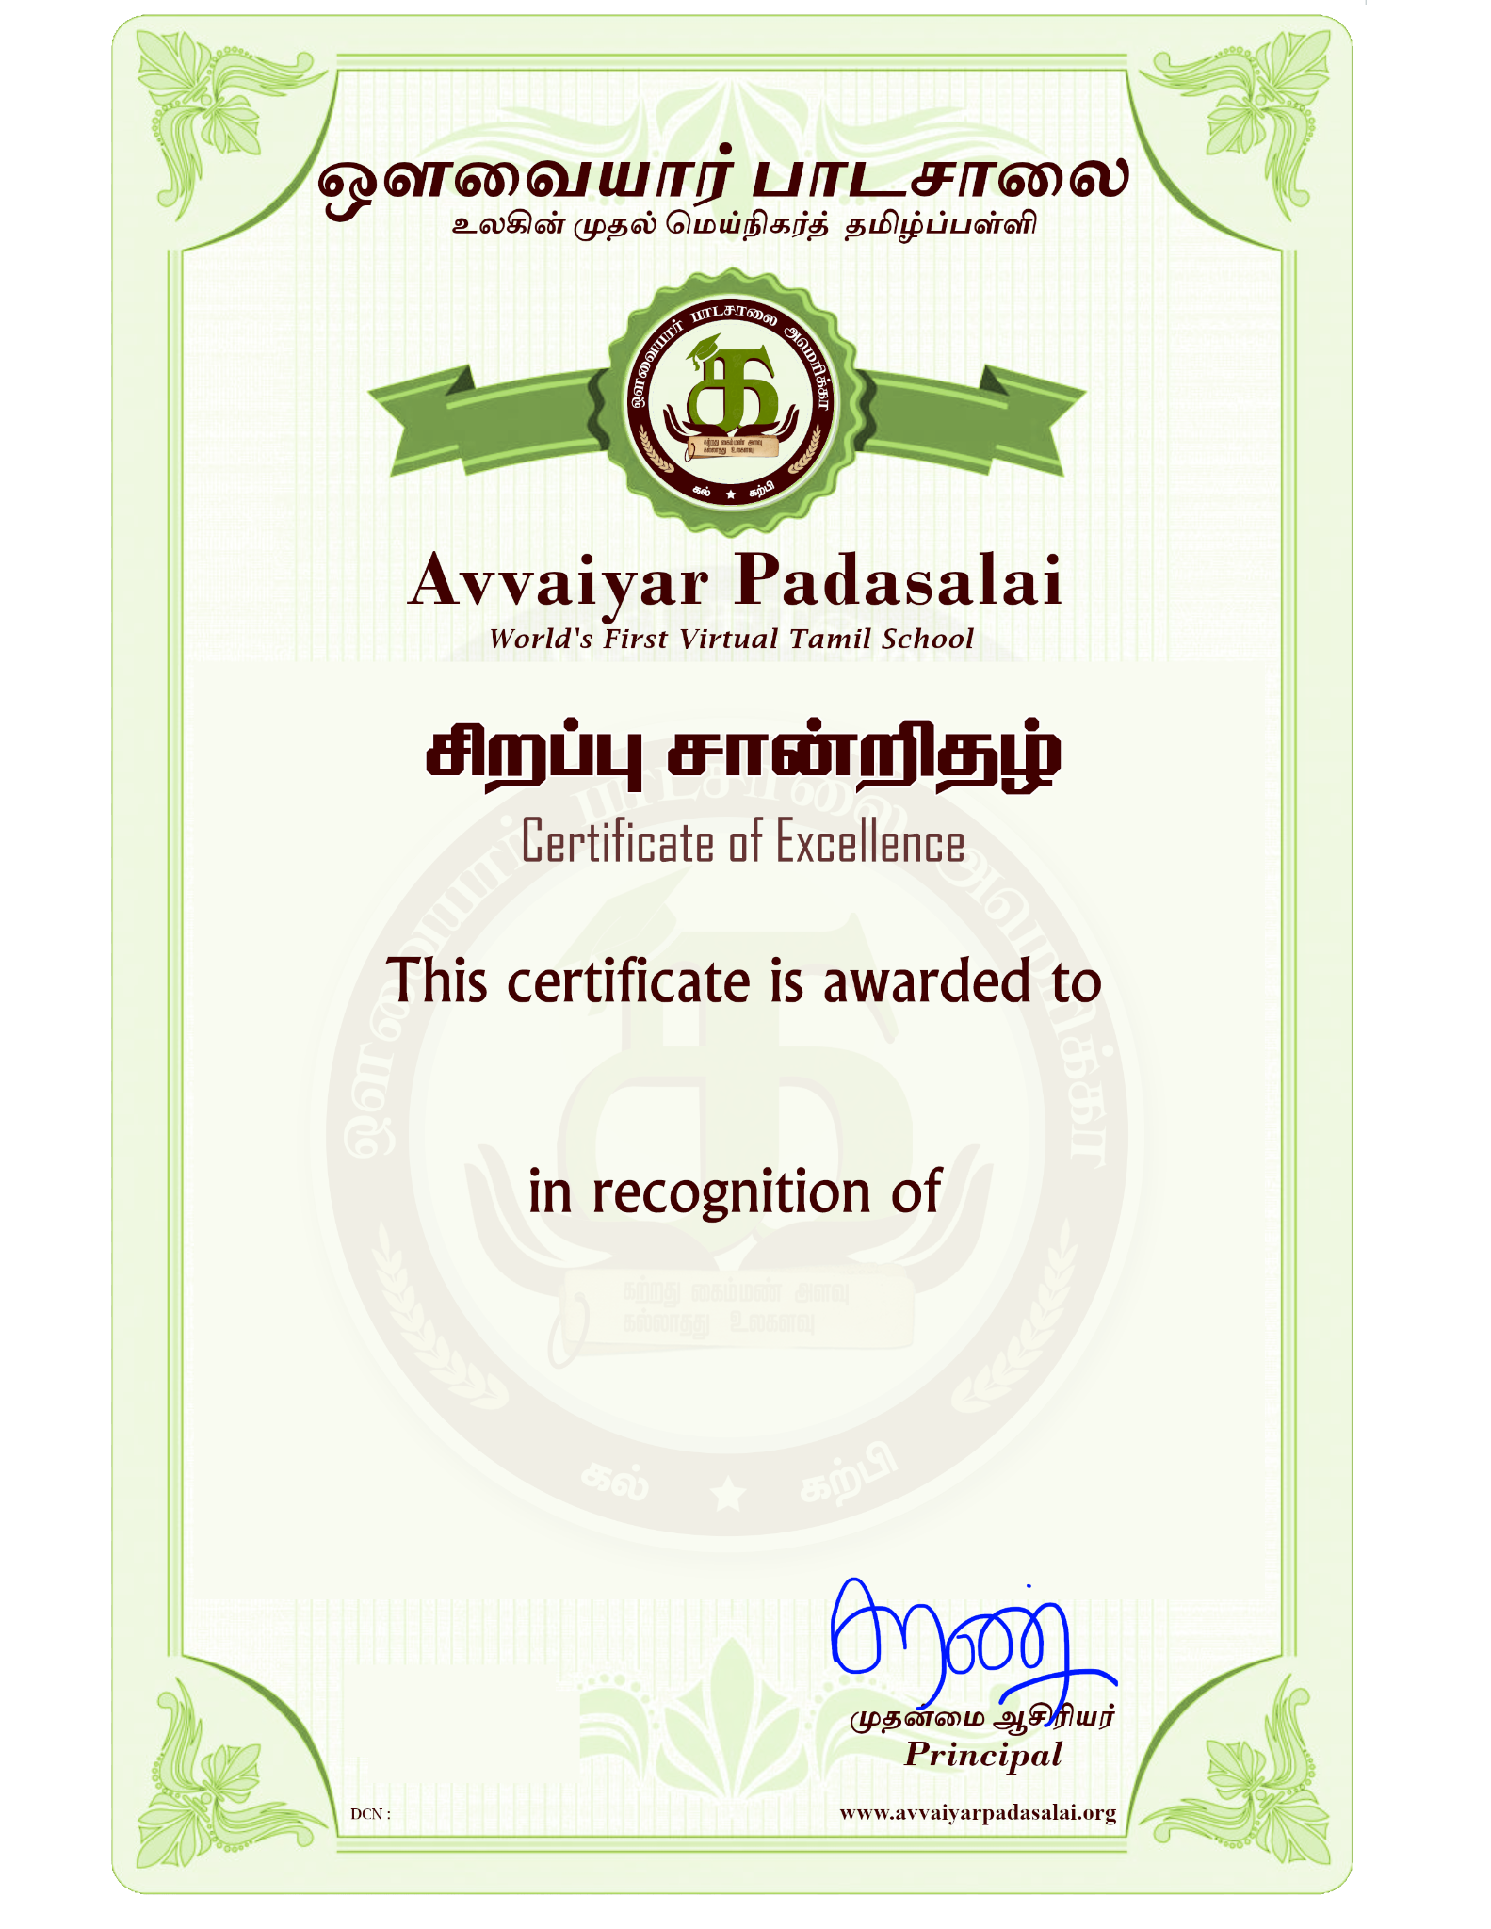
José <Raj> & María
Outstanding effort, kindness & "teamwork" — $5 star!
10-06-2026

