The instruction of running Eye Tracker Software:

1. Download and install Tobii software from the following link: <http://developer.tobii.com/eyex-setup/>

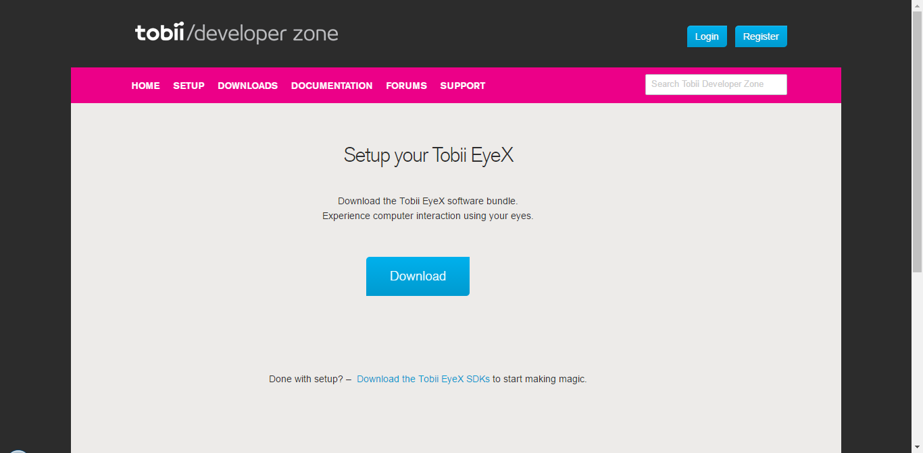

1. Download and install the visual studio software from the following link: [https://www.visualstudio.com/post-download-vs/?sku=ent&clcid=0x409&telem=ga#](https://www.visualstudio.com/post-download-vs/?sku=ent&clcid=0x409&telem=ga)

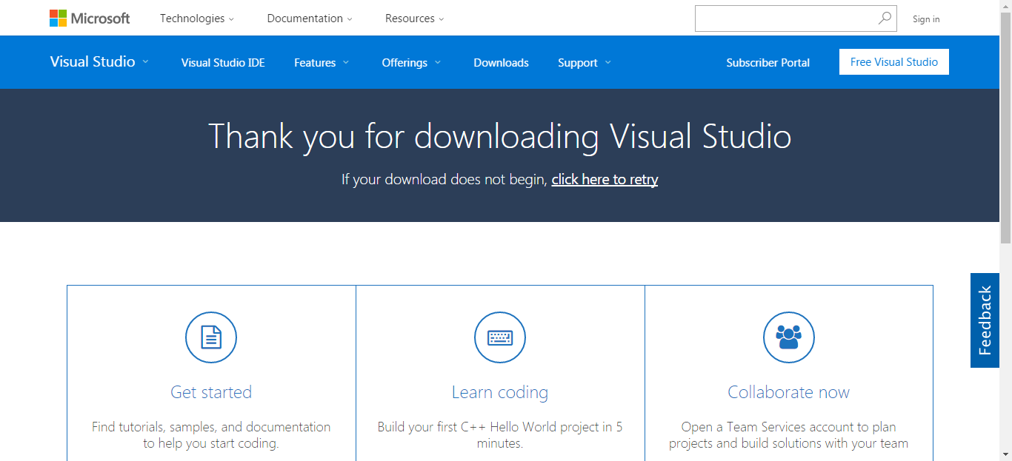

1. Connect Tobii eye tracker to USB 3.0 of your computer

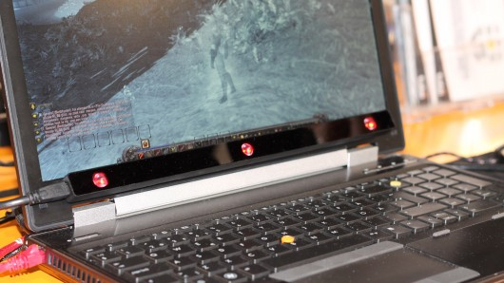

1. Open visual studio solution (..\FinalSubmission\ReadingWithYourEyes\source)

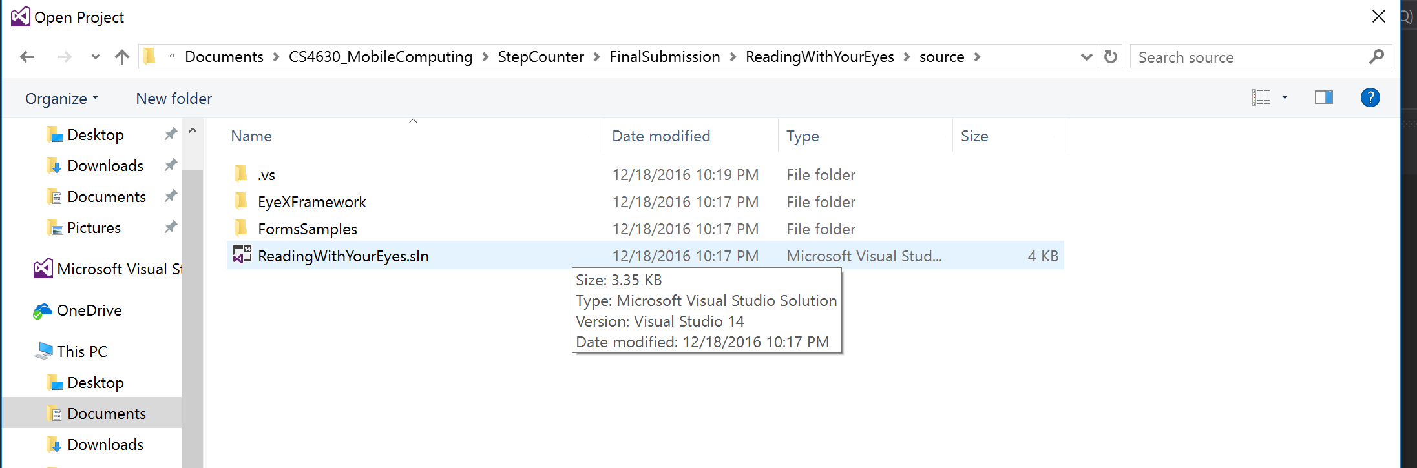

1. Calibrate your eyes using Tobii software.
2. Update the location of the audio files for each story page:

var audioURL = "..\\ReadingWithYourEyes\\AudioFiles\\";

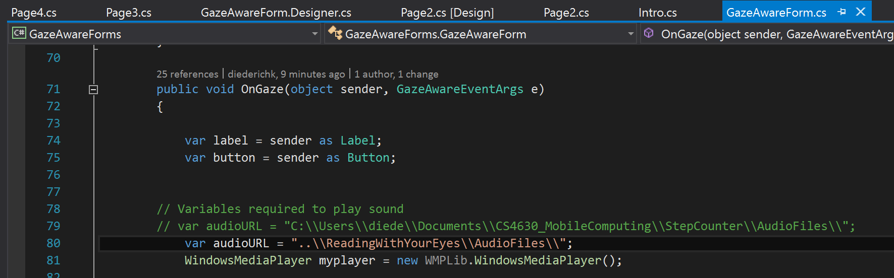

(I apologize, but I could not seem to find the correct method to get the relative path to work.)

1. In the visual studio software click on start button

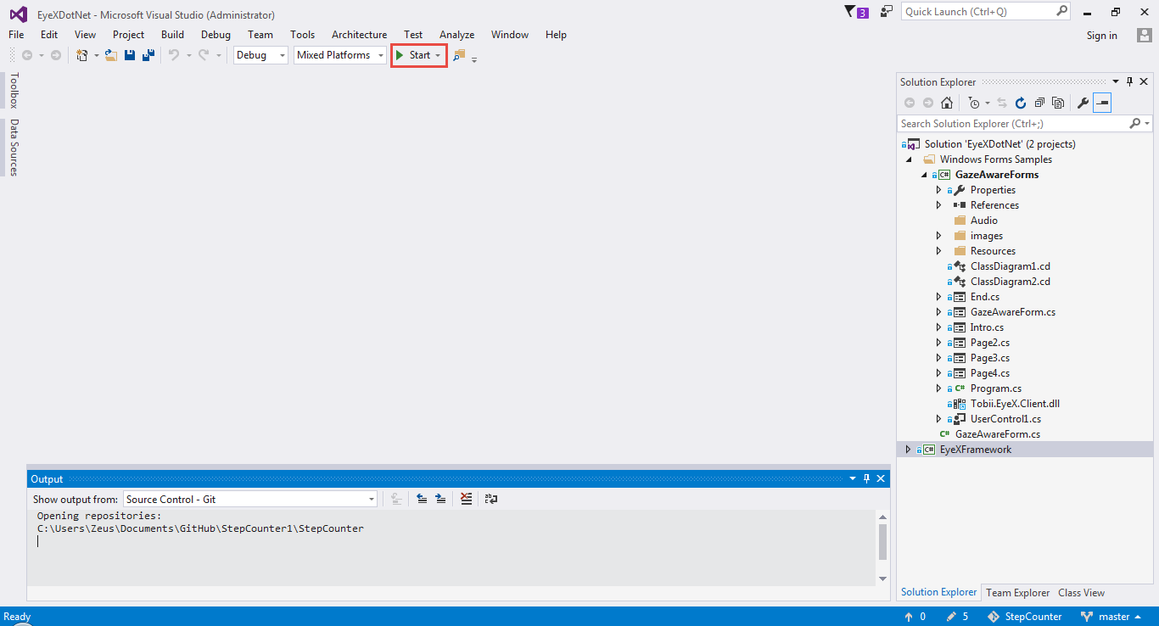

Click

1. Enjoy the demo