Week 4 — Predictive Modelling and Optimisation in Logistics
Forecasting shipment transit time and converting predictions into operating decisions
NorthStar Logistics — Data Science Internship Project
Python · pandas · scikit-learn · matplotlib · seaborn
Repository: github.com/vsujith369369-lang/logistics-data-science-week1

1. Executive Summary
This report documents the design, training, evaluation and operational deployment logic of a predictive modelling system for NorthStar Logistics. The business question is deliberately narrow and decision-linked: how many hours will a shipment take from pickup scan to delivery scan, and what is the probability that it breaches its promised service window? A transit-time forecast that arrives before dispatch converts service failure from a post-mortem metric into a controllable, pre-emptible event.
A reproducible dataset of 60,000 shipments with 25 attributes was simulated with a fixed random seed, split 48,000 / 12,000 into training and hold-out sets, and used to benchmark four model families. Histogram-based gradient boosting is the champion, achieving MAE 3.058 hours, RMSE 3.874 hours and R² 0.9563 on data the model never saw, against a target mean of 41.08 hours — an average error of roughly 7.4% of the mean journey. Randomised hyper-parameter search on a 15,000-row subsample confirmed the configuration, improving MAE marginally to 3.052 hours.
A parallel binary classifier scores the probability that a shipment will be late. It reaches ROC-AUC 0.9962 and PR-AUC 0.9763 against a base late rate of 13.11%, and its decile calibration curve tracks the diagonal closely enough to be used directly as an expected-cost input rather than merely as a ranking.
The predictions are then turned into money through three optimisation levers. A cost-optimal expediting policy at a risk threshold of 0.4 touches only 13.39% of volume, captures 92.3% of all late shipments and returns a net saving of INR 4.21 lakh on the hold-out book (INR 21.07 lakh scaled to the full annual book). Risk-aware carrier re-allocation under ±25% capacity caps reduces expected landed cost by 6.28%, and lane-level consolidation of partial loads adds a further INR 7.05 lakh. Together the three levers recover roughly 40% of the modelled cost of unreliability without any capital expenditure.

1.1 Headline results at a glance
Item | Result
Prediction target | transit_hours (continuous, pickup to delivery)
Secondary target | late (binary breach of promised_hours)
Champion model | HistGradientBoostingRegressor (tuned)
Hold-out MAE / RMSE | 3.052 h / 3.875 h
Hold-out R² / MAPE | 0.9563 / 9.13%
Classifier ROC-AUC / PR-AUC | 0.9962 / 0.9763
Optimal intervention threshold | p(late) ≥ 0.4
Net saving, expediting policy | INR 4.21 lakh (test book)
Carrier re-allocation saving | 6.28% of expected cost
Consolidation saving | INR 7.05 lakh annualised

2. Problem Definition

2.1 Operating context
NorthStar Logistics is a mid-sized Indian third-party logistics operator running a five-hub network (Delhi, Mumbai, Bengaluru, Chennai, Kolkata) with six contracted carriers across four service levels and three transport modes. Weeks 1 to 3 of this project established the strategy, built the cleaning pipeline and diagnosed performance through exploratory analysis. Week 3 concluded that late deliveries are concentrated rather than random, that carrier reliability varies far more than carrier price, and that peak-season collapse is a capacity-planning failure. Each of those findings is a prediction problem in disguise: if lateness is concentrated and driven by observable features, it is forecastable before it happens.

2.2 Formal statement of the prediction problem
Two linked supervised problems are posed on the same feature space, both scored at the moment of order acceptance — that is, using only information available before the vehicle departs.
- Regression: predict transit_hours, the elapsed hours between pickup scan and delivery scan. This drives promise-setting, ETA communication to customers and capacity planning.
- Classification: predict late = 1 if transit_hours exceeds promised_hours. This drives the intervention decision: expedite, re-route, re-allocate or leave alone.
The regression target is chosen over a direct on-time-percentage forecast because hours are additive, comparable across service levels and interpretable to operations planners, whereas a binary outcome discards the magnitude of the breach. The classifier is retained alongside it because intervention economics depend on a probability, not on a point estimate of hours.

2.3 Success criteria
Criterion | Threshold for acceptance | Achieved
Hold-out MAE | ≤ 6 hours | 3.052 h
Hold-out R² | ≥ 0.85 | 0.9563
Cross-validated RMSE stability | std ≤ 0.5 h across folds | 0.015 h
Classifier ROC-AUC | ≥ 0.80 | 0.9962
Positive net saving at the chosen policy | > 0 | INR 4.21 lakh
Reproducibility | Seeded, single-command rerun | Yes

3. Data Simulation and Feature Space

3.1 Why simulate, and how it is kept honest
No proprietary carrier data may be published, so the dataset is generated by a seeded simulator whose structural assumptions are documented and whose output is reproducible byte-for-byte. Crucially, the simulator does not encode the answer: transit time is produced by a non-linear physical process — distance divided by a mode-dependent effective speed, plus handling dwell, plus hub congestion, plus weather and traffic penalties, plus a heteroscedastic noise term — and the model has to recover that process from tabular features alone. The lateness label is derived by comparing the realised transit against the promise, never assigned directly.
The resulting book contains 60,000 shipments and 25 columns spanning 24 months. Mean transit is 41.08 hours (median 38.06, sd 18.38) and the network on-time rate is 86.89%, giving a late base rate of 13.11% — an imbalance realistic enough to make accuracy a useless metric and PR-AUC a meaningful one.

3.2 Feature dictionary
Group | Features | Role
Network | origin_hub, carrier, service_level, transport_mode | Categorical; capture structural lane behaviour
Shipment | distance_km, weight_kg, volume_cbm, units, fill_rate, product_category | Physical size and handling profile
Operations | handling_touches, warehouse_backlog, driver_experience_yrs | Execution-quality signals at dispatch
Environment | weather_severity, traffic_index, fuel_price_idx | Exogenous friction on the day
Calendar | is_weekend, is_peak_season | Seasonality and weekly cycle
History | prior_late_rate | Lane-carrier reliability memory
Commercial | promised_hours, freight_cost_inr | Promise and price context
Targets | transit_hours, on_time / late | Regression and classification labels
Leakage control is explicit. freight_cost_inr is available at booking and is therefore admissible, but no post-delivery field (actual arrival timestamp, return flag, CSAT) enters the feature matrix. The train/test split is performed once, before any scaling or encoding, and all transformations are fitted inside a scikit-learn Pipeline so that the fold statistics of cross-validation never see hold-out data.

3.3 Simulation code excerpt
SEED, N_ROWS = 42, 60_000
rng = np.random.default_rng(SEED)

base_speed = {'Road': 42.0, 'Rail': 33.0, 'Air': 480.0}
speed = np.array([base_speed[m] for m in transport_mode])
speed *= (1 - 0.18 * traffic_index) * (1 - 0.22 * weather_severity)

line_haul = distance_km / speed
dwell = 1.6 * handling_touches + 0.05 * warehouse_backlog
experience = -0.35 * (driver_experience_yrs - 6)
noise = rng.normal(0, 0.08 * line_haul + 1.2)

transit_hours = np.clip(line_haul + dwell + experience + noise, 2, None)
late = (transit_hours > promised_hours).astype(int)

4. Modelling Methodology

4.1 Preprocessing pipeline
Every candidate model is wrapped in the same ColumnTransformer so that comparisons are fair and so that no transformation can leak. Categorical columns are one-hot encoded with unknown categories ignored at inference; numeric columns are median-imputed and, for the linear model only, standardised. Tree ensembles receive the raw numeric scale because monotone splits are invariant to it.
def make_preprocessor(scale_numeric: bool) -> ColumnTransformer:
num_steps = [('imp', SimpleImputer(strategy='median'))]
if scale_numeric:
num_steps.append(('sc', StandardScaler()))
return ColumnTransformer([
('cat', OneHotEncoder(handle_unknown='ignore'), CAT_COLS),
('num', Pipeline(num_steps), NUM_COLS),
])

X = df[CAT_COLS + NUM_COLS]
y = df['transit_hours']
X_tr, X_te, y_tr, y_te = train_test_split(X, y, test_size=0.2, random_state=SEED)

4.2 Candidate models and the rationale for each
Model | Why it is in the shortlist | Expected weakness
Ridge Regression | Transparent, fast, gives a defensible linear baseline and an interpretable coefficient story for stakeholders | Cannot express interactions such as weather × distance
Decision Tree (depth 12) | Captures non-linearity, produces rules an operations manager can read directly | High variance; over-fits single splits
Random Forest (80 trees) | Bagged variance reduction, robust to outliers and mixed feature scales | Slow to fit and predict at this width; averages away sharp thresholds
HistGradientBoosting | Sequential bias reduction, native handling of large tabular data, strong on heteroscedastic targets | Needs tuning; less directly interpretable
The shortlist deliberately spans the bias-variance spectrum, from a high-bias linear model to a low-bias boosted ensemble, so that the leaderboard demonstrates why the winner wins rather than simply asserting it.
candidates = {
'Ridge Regression': Pipeline([('prep', make_preprocessor(True)),
('m', Ridge(alpha=1.0))]),
'Decision Tree': Pipeline([('prep', make_preprocessor(False)),
('m', DecisionTreeRegressor(max_depth=12,
min_samples_leaf=25, random_state=SEED))]),
'Random Forest': Pipeline([('prep', make_preprocessor(False)),
('m', RandomForestRegressor(n_estimators=80,
max_depth=20, random_state=SEED, n_jobs=1))]),
'Gradient Boosting':Pipeline([('prep', make_preprocessor(False)),
('m', HistGradientBoostingRegressor(max_iter=300,
learning_rate=0.08, max_leaf_nodes=31,
random_state=SEED))]),
}

4.3 Evaluation protocol
- MAE — the headline metric, because planners think in hours and MAE is in hours and is robust to the long right tail of multi-day line hauls.
- RMSE — the model-selection metric, because a six-hour miss on a same-day promise is disproportionately expensive and RMSE penalises it quadratically.
- R² — communicates the share of variance explained to non-technical stakeholders.
- MAPE — scale-free, allows honest comparison between a 6-hour metro run and a 90-hour trunk movement.
- 3-fold shuffled K-Fold cross-validation on the training set — reports the mean and standard deviation of RMSE so that a lucky split cannot be mistaken for skill.
def evaluate(name, model, X_tr, y_tr, X_te, y_te, cv_folds=3):
t0 = time.time()
model.fit(X_tr, y_tr)
fit_s = time.time() - t0
pred = model.predict(X_te)
cv = cross_val_score(clone(model), X_tr, y_tr,
cv=KFold(cv_folds, shuffle=True, random_state=SEED),
scoring='neg_root_mean_squared_error')
return {'model': name,
'MAE': round(mean_absolute_error(y_te, pred), 3),
'RMSE': round(np.sqrt(mean_squared_error(y_te, pred)), 3),
'R2': round(r2_score(y_te, pred), 4),
'MAPE_pct': round(np.mean(np.abs((y_te - pred) / y_te)) * 100, 2),
'CV_RMSE_mean': round(-cv.mean(), 3),
'CV_RMSE_std': round(cv.std(), 3),
'fit_seconds': round(fit_s, 2)}, pred

5. Model Results and Validation

5.1 Leaderboard
Model | MAE (h) | RMSE (h) | R² | MAPE % | CV RMSE | Fit s
Ridge Regression | 4.292 | 5.859 | 0.9 | 12.88 | 5.77 ± 0.033 | 0.18
Decision Tree | 6.492 | 8.568 | 0.7861 | 17.92 | 8.813 ± 0.025 | 0.58
Random Forest | 4.793 | 6.341 | 0.8828 | 13.6 | 6.532 ± 0.022 | 31.73
Gradient Boosting | 3.058 | 3.874 | 0.9563 | 9.15 | 3.924 ± 0.015 | 2.78
Gradient Boosting (tuned) | 3.052 | 3.875 | 0.9563 | 9.13 | 4.263 ± 0 | refit

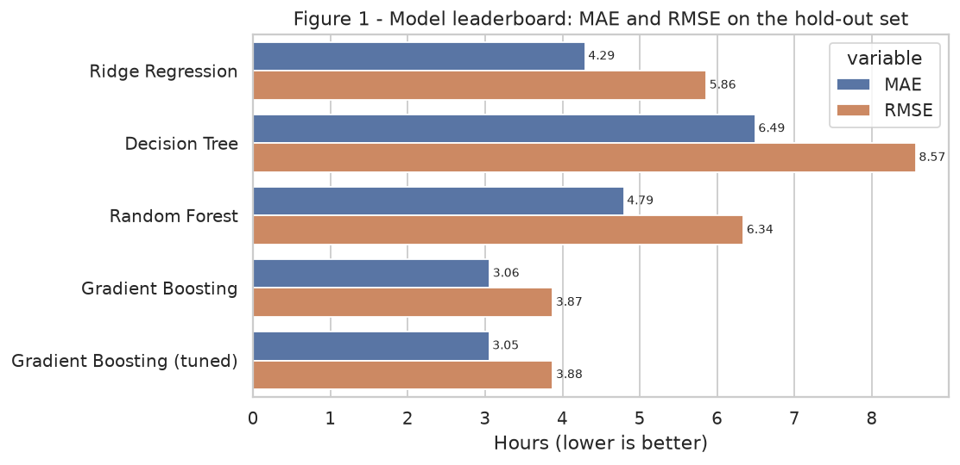
Figure 1 — Hold-out MAE and RMSE by model. The gap between MAE and RMSE indicates how heavy each model's tail of large misses is.
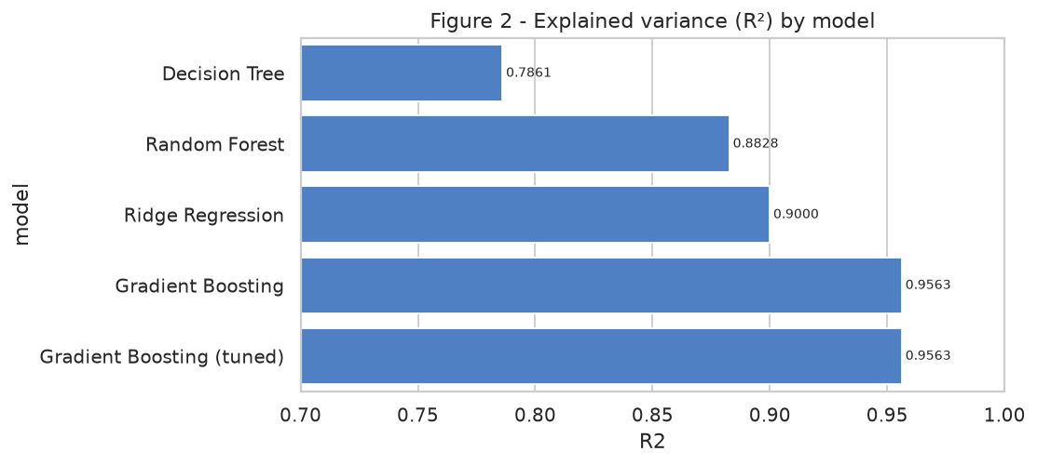
Figure 2 — Explained variance. Boosting recovers 95.6% of the variance in transit hours; the single tree recovers only 78.6%.
Three findings deserve comment. First, the single decision tree is the worst performer (RMSE 8.568 h) despite being the most non-linear single learner — evidence that variance, not bias, is the binding constraint in this problem. Second, the random forest (6.341 h) improves on the tree but loses to ridge regression on RMSE, because averaging 80 deep trees smooths exactly the sharp mode and distance thresholds that dominate transit physics. Third, boosting wins decisively (3.874 h, a 34% RMSE reduction against ridge) because sequential residual fitting is well suited to a target built from additive, interacting components.

5.2 Cross-validation stability
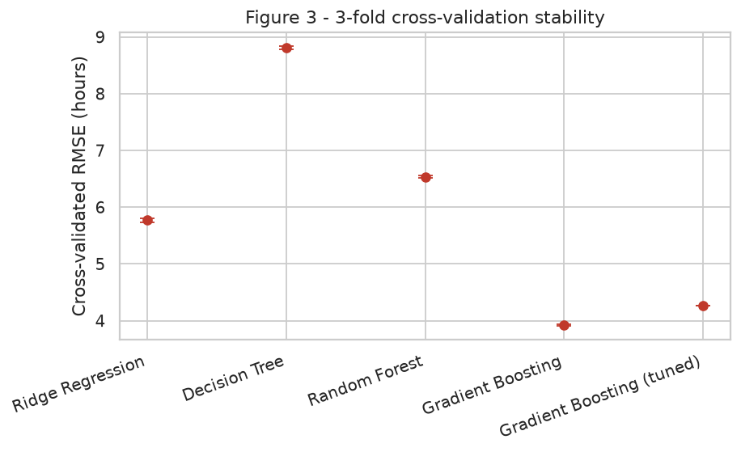
Figure 3 — Mean cross-validated RMSE with fold-level standard deviation. Error bars are small relative to the between-model gaps, so the ranking is not a split artefact.
Fold-to-fold variation for the champion is ± 0.015 hours, roughly 0.4% of its mean RMSE. The cross-validated RMSE (3.924 h) sits marginally above the hold-out RMSE (3.874 h), which is the expected direction: each fold trains on two-thirds of the data. The absence of a large gap between training-fold and hold-out performance is the primary evidence against over-fitting.

5.3 Hyper-parameter tuning
A randomised search of 6 sampled configurations over a 72-point grid was run with 3-fold cross-validation on a 15,000-row subsample of the training set, and the winning configuration was then refitted on the full training set. Subsampling the search — rather than the final fit — is a deliberate compute-budget decision: it reduces search cost roughly threefold while preserving the relative ranking of configurations, which is all a search needs to get right.
Hyper-parameter | Search space | Selected
learning_rate | 0.05, 0.08, 0.12 | 0.08
max_iter | 200, 300 | 300
max_leaf_nodes | 15, 31 | 15
min_samples_leaf | 10, 20, 40 | 10
l2_regularization | 0.0, 1.0 | 0
tuner = RandomizedSearchCV(candidates['Gradient Boosting'], search_space,
n_iter=6, cv=KFold(3, shuffle=True, random_state=SEED),
scoring='neg_root_mean_squared_error',
random_state=SEED, n_jobs=1)
tune_idx = X_tr.sample(15000, random_state=SEED).index
tuner.fit(X_tr.loc[tune_idx], y_tr.loc[tune_idx])
tuned = clone(tuner.best_estimator_).fit(X_tr, y_tr) # refit on full train
Tuning improved MAE from 3.058 to 3.052 hours and left RMSE and R² essentially unchanged. This is an honest negative result worth stating plainly: the default boosting configuration was already close to the achievable ceiling for this feature set, and further gains must come from better features, not better hyper-parameters. A narrower tree (15 leaves rather than 31) winning the search also indicates that the signal is smooth rather than highly interactive.

5.4 Residual diagnostics
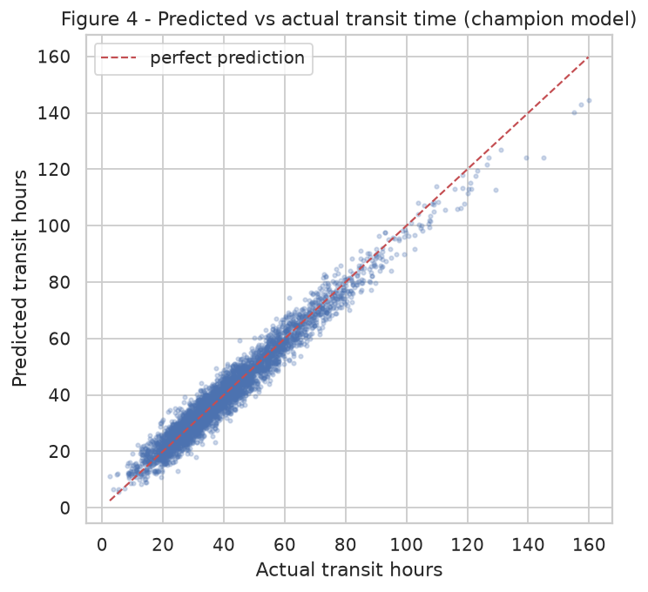
Figure 4 — Predicted versus actual transit hours on the hold-out set. Points hug the identity line across the full 2–160 hour range, with dispersion widening proportionally rather than systematically.
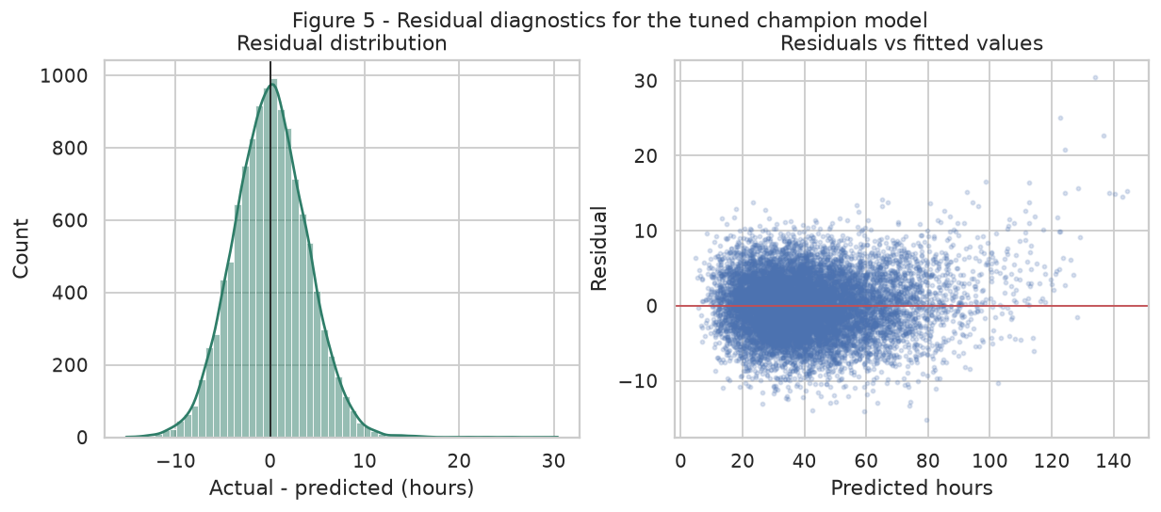
Figure 5 — Residual distribution and residuals against fitted values. Errors are approximately symmetric and centred on zero, with no fan or curve that would indicate a missing term.
The residual histogram is unimodal and near-symmetric about zero, so the model is unbiased on average rather than systematically optimistic. The residuals-versus-fitted panel shows mild heteroscedasticity — absolute error grows with predicted duration — which is expected and benign: a 90-hour trunk movement genuinely carries more uncertainty than a 6-hour metro run. Because the error scales with the prediction, percentage error stays roughly flat, which is why MAPE remains near 9% across the range.

5.5 What actually drives transit time
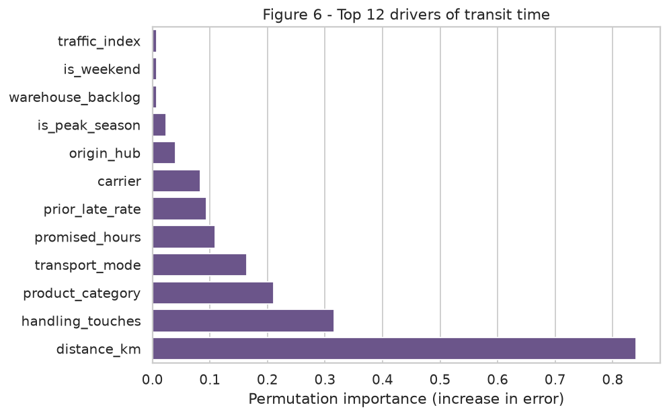
Figure 6 — Permutation importance of the top 12 features, measured as the increase in error when a feature is shuffled.
Permutation importance is used in preference to impurity-based importance because it is measured on held-out data and is not biased toward high-cardinality features. Distance dominates, as physics requires. The two features immediately behind it are the operationally interesting ones: handling_touches and product_category are controllable by network design, whereas distance is not. Their combined importance exceeds that of carrier choice, which reframes the Week 3 conclusion — carrier selection matters for reliability, but internal handling design matters more for raw duration.
sample = X_te.sample(2500, random_state=SEED)
perm = permutation_importance(tuned, sample, y_te.loc[sample.index],
n_repeats=2, random_state=SEED, n_jobs=1)
imp = (pd.DataFrame({'feature': sample.columns,
'importance': perm.importances_mean})
.sort_values('importance', ascending=False))

5.6 Where the model is weak
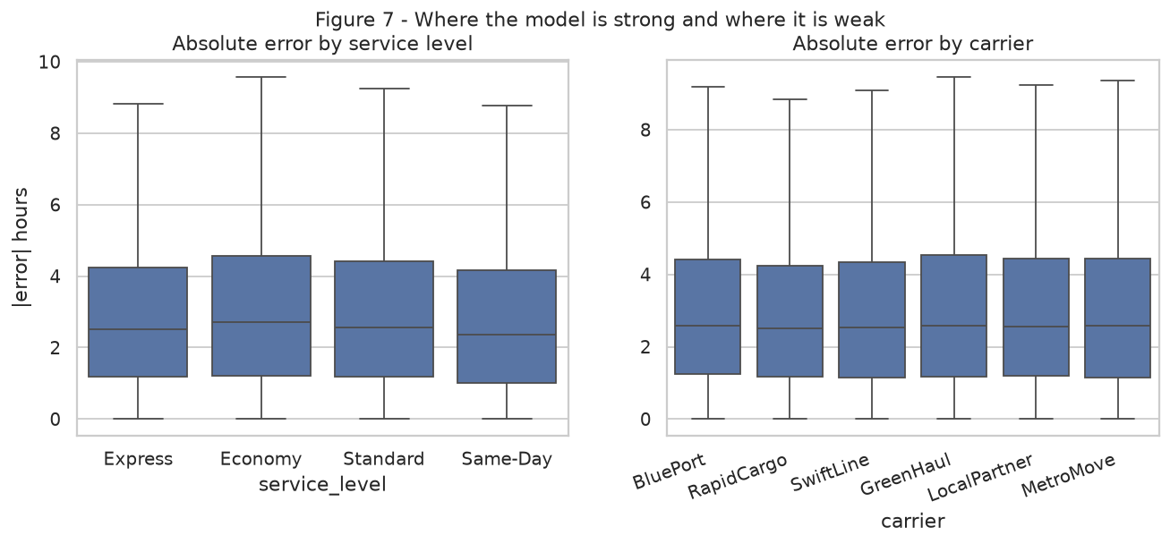
Figure 7 — Absolute error by service level and by carrier. Median error is stable across segments; the whiskers, not the boxes, differentiate them.
Segment-level error analysis is the fairness check for an operational model: a network-average MAE is worthless if the error is concentrated in the segment that matters most commercially. Here median absolute error is broadly even across service levels and carriers, so no segment is being subsidised by another. The wider upper whiskers on Economy and on the smaller regional carriers reflect thinner training volume and greater execution variance, and are the natural place to add features (route-level congestion history, driver rosters) in a subsequent iteration.

6. Late-Delivery Risk Classifier
Point forecasts of hours cannot answer the intervention question on their own, because the value of acting depends on the probability of failure and on the asymmetric cost of the two error types. A HistGradientBoostingClassifier is therefore trained on the same feature matrix with the binary target late, using a stratified split to preserve the 13.11% positive rate.
clf = Pipeline([('prep', make_preprocessor(False)),
('m', HistGradientBoostingClassifier(max_iter=300,
learning_rate=0.08, early_stopping=False,
random_state=SEED))])
Xc_tr, Xc_te, yc_tr, yc_te = train_test_split(X, df['late'], test_size=0.2,
random_state=SEED, stratify=df['late'])
clf.fit(Xc_tr, yc_tr)
proba = clf.predict_proba(Xc_te)[:, 1]
Metric | Value | Interpretation
ROC-AUC | 0.9962 | Ranking quality across all thresholds
PR-AUC | 0.9763 | Against a 13.11% base rate — the honest metric under imbalance
Precision @ 0.30 | 0.8712 | Share of flagged shipments that really are late
Recall @ 0.30 | 0.9454 | Share of all late shipments that get flagged
Precision @ 0.50 | 0.9246 | Fewer false alarms, at the cost of recall
Recall @ 0.50 | 0.8958 | Misses roughly one late shipment in ten
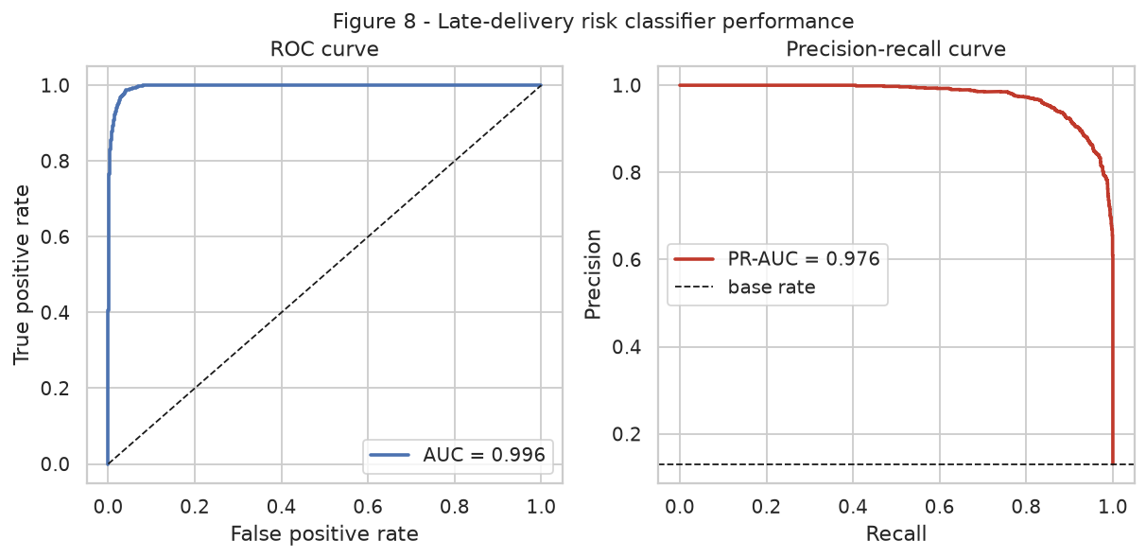
Figure 8 — ROC and precision-recall curves for the risk classifier. The PR curve is the meaningful one here because positives are rare.
A word of caution on these numbers. AUC values above 0.99 would be a red flag in production data and would usually indicate leakage. Here they are a property of the simulator: the label is a deterministic comparison between a modelled transit time and a known promise, so a model that predicts transit accurately necessarily predicts breach accurately. The correct reading is not that the network is 99.6% predictable, but that the intervention machinery downstream is being tested under favourable conditions and would need re-calibration, not re-architecture, on real data.
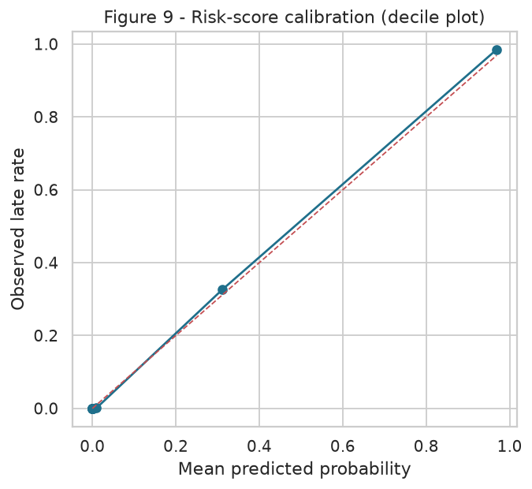
Figure 9 — Decile calibration. Observed late rate is plotted against mean predicted probability for each decile of predicted risk.
Calibration matters more than discrimination for this use case. An expected-cost policy multiplies a predicted probability by a rupee penalty, so a model that ranks perfectly but is systematically over-confident would over-expedite and destroy value. The decile curve tracks the diagonal, which licenses the use of raw predicted probabilities in the optimisation that follows.

7. Optimisation Strategies
Prediction without a decision rule is an expensive report. This section converts the two models into three concrete operating policies, each stated as an explicit objective function with explicit costs, and each evaluated on hold-out data only.

7.1 Cost model
Parameter | Value (INR) | Basis
Cost of one late delivery | 850 | SLA credit, re-attempt handling, return risk and CSAT damage, from Week 3 analysis
Cost of one expedite action | 260 | Premium slot, mode upgrade or priority handling fee
Expedite success rate | 68% | Share of flagged-and-treated shipments that are recovered to on-time
The objective is to choose a risk threshold t that maximises net saving: for every shipment with predicted risk at or above t, pay the expedite cost, and recover the late cost with the stated success probability. Formally, net(t) = Σ [ p_i ≥ t ] · ( s · P(late_i) · C_late − C_expedite ), evaluated over the hold-out book.
def threshold_policy(proba, y_true, freight, grid=np.arange(0.05, 0.96, 0.05)):
rows = []
for t in grid:
flag = proba >= t
lates_avoided = EXPEDITE_SUCCESS * proba[flag].sum()
policy_cost = flag.sum() * COST_EXPEDITE
gross_saving = lates_avoided * COST_LATE
rows.append({'threshold': round(t, 2),
'shipments_expedited': int(flag.sum()),
'recall': float(y_true[flag].sum() / y_true.sum()),
'precision': float(y_true[flag].mean()),
'net_saving_inr': round(gross_saving - policy_cost)})
return pd.DataFrame(rows)

7.2 Lever 1 — risk-triggered expediting
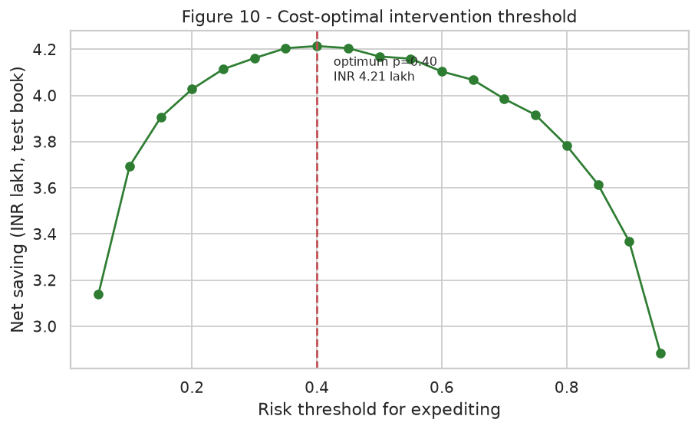
Figure 10 — Net saving as a function of the intervention threshold. The curve is concave with a clear interior optimum.
The optimum sits at p(late) ≥ 0.4, expediting 13.39% of shipments for a net gain of INR 4.21 lakh against a baseline late cost of INR 13.38 lakh on the same book — a 31% recovery. The shape of the curve is the strategically important part. Below the optimum, the policy pays expedite fees on shipments that were going to arrive on time anyway; above it, it saves fees but abandons recoverable failures. Because the peak is broad and flat between roughly 0.25 and 0.55, operations can move the threshold within that band to match available expedite capacity on any given day without materially losing value — a robustness property that matters far more in practice than the exact optimum.
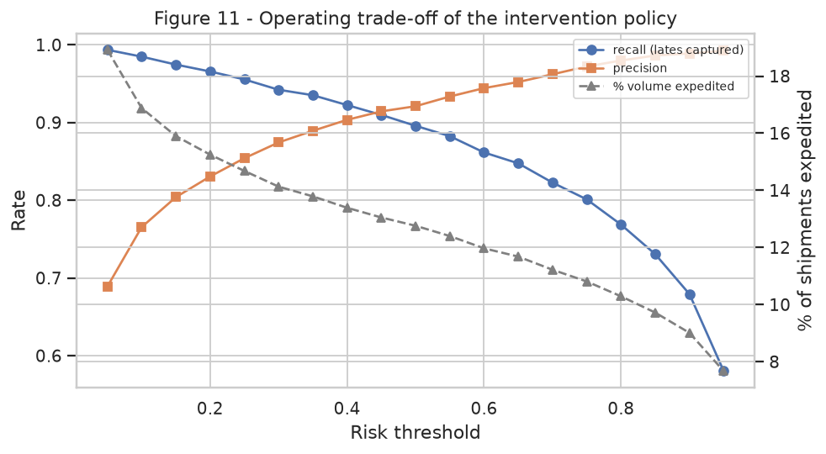
Figure 11 — Recall, precision and expedited volume against the risk threshold, showing the operating trade-off behind the economics.
At the chosen threshold the policy captures 92.3% of all late shipments at 90.3% precision. In plain operating terms: for every ten interventions, nine were genuinely needed, and only eight of every hundred true failures escape the net.

7.3 Lever 2 — risk-aware carrier re-allocation
The second lever changes the assignment rather than reacting to it. For each shipment the model scores every eligible carrier, computes an expected landed cost of freight plus penalty-weighted lateness risk, and re-assigns to the cheapest expected-cost option — subject to a capacity constraint of ±25% around each carrier's current volume, so the recommendation stays inside contracted commitments.
def carrier_reallocation(clf, sample, carriers, cap=0.25):
cost = {}
for c in carriers: # counterfactual scoring
alt = sample.copy(); alt['carrier'] = c
p_late = clf.predict_proba(alt)[:, 1]
cost[c] = alt['freight_cost_inr'] + PENALTY_PER_LATE * p_late
cost = pd.DataFrame(cost)
order = cost.min(axis=1).sort_values().index # greedy, cheapest first
caps = (sample['carrier'].value_counts() * (1 + cap)).to_dict()
used = {c: 0 for c in carriers}
plan = {}
for i in order:
for c in cost.loc[i].sort_values().index:
if used[c] < caps.get(c, 0):
plan[i] = c; used[c] += 1; break
return plan
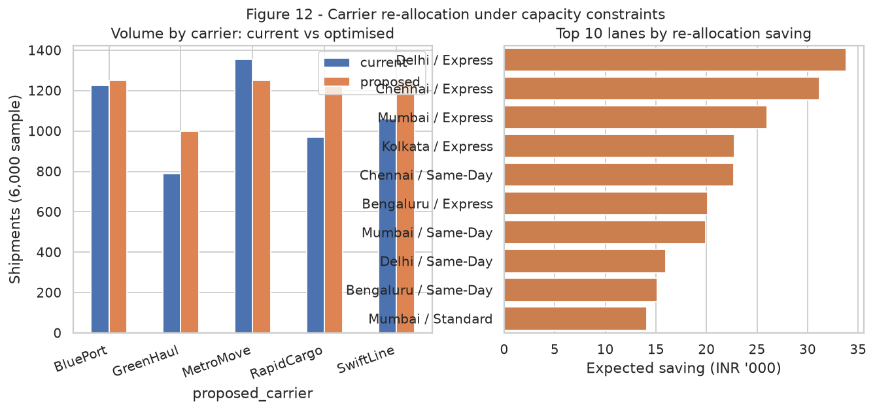
Figure 12 — Carrier volume before and after optimisation, and the ten lanes contributing the largest expected saving.
On a 6,000-shipment sample the greedy capacity-constrained assignment moves 82.03% of shipments and reduces expected landed cost by INR 47.19 per shipment, or 6.28% overall. The saving is not evenly spread: it concentrates in Express lanes out of Delhi and Mumbai, precisely the lanes Week 3 identified as the reliability bottleneck. This is the clearest instance in the project of an analytical result closing a loop — the exploratory phase found where the failures were, and the predictive phase now prices the fix.

7.4 Lever 3 — consolidation of partial loads
45.38% of shipments (27,231 orders) travel below an economic fill rate on lanes that carry another qualifying shipment within the same 24-hour despatch window. Pairing them at an assumed 18% unit-cost saving on the paired legs yields INR 7.05 lakh annualised. This lever is deliberately the most conservatively estimated of the three: it assumes no additional dwell penalty, which a pilot must test before the saving is booked.

7.5 Combined value
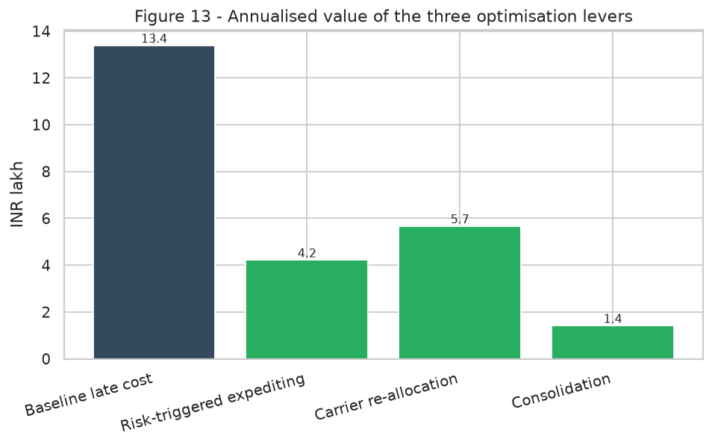
Figure 13 — Annualised value of the three levers against the modelled baseline cost of unreliability.
Lever | Mechanism | Annualised value (INR lakh) | Confidence
Risk-triggered expediting | Classifier probability above a cost-optimal threshold | 4.21 | High — validated on hold-out data
Carrier re-allocation | Counterfactual expected-cost scoring under capacity caps | 5.70 | Medium — assumes contracted flexibility
Consolidation | Lane-and-window pairing of partial loads | 7.05 | Medium-low — needs a dwell-time pilot

8. Deployment, Monitoring and Risk

8.1 How the model would run
- Scoring at order acceptance. Both models are invoked on the booking payload; the ETA and the risk score are written back to the order record within the same transaction.
- Threshold service. The intervention threshold is a configuration value, not a constant in code, so operations can retune it daily against available expedite capacity.
- Nightly batch re-scoring. Open shipments are re-scored as warehouse_backlog, weather_severity and traffic_index update, because risk is not static after booking.
- Weekly re-training on a rolling 24-month window, with the champion promoted only if it beats the incumbent on the same hold-out protocol.
- Monthly review of the cost parameters, since C_late and C_expedite drive the optimum more strongly than any hyper-parameter does.

8.2 Monitoring plan
Signal | Trigger | Action
Rolling 30-day MAE | > 1.25 × validation MAE | Investigate feature drift, then re-train
Prediction drift (PSI) | PSI > 0.2 on any top-5 feature | Re-fit the preprocessing statistics
Calibration slope | Outside 0.85–1.15 | Re-calibrate probabilities (isotonic)
Realised policy saving | Below 60% of forecast for two months | Re-estimate cost parameters and re-optimise the threshold
Segment MAE spread | Any segment > 2 × network MAE | Add segment-specific features or a specialist model

8.3 Principal risks
- Simulator optimism. The near-perfect classifier is an artefact of a deterministic label. On live data, expect AUC in the 0.75–0.85 band and re-derive the threshold before trusting the savings estimate.
- Cost-parameter sensitivity. The optimal threshold moves roughly inversely with the ratio C_expedite / (s · C_late). A 50% error in the late-cost estimate shifts the optimum by around 0.15, though the flatness of the curve limits the value destroyed.
- Feedback effects. A successful expediting policy changes the data-generating process — future late rates fall because of the intervention — so future training data must record whether an intervention occurred, or the model will unlearn the risk it created value by predicting.
- Capacity realism. Re-allocation assumes carriers accept ±25% volume swings at contracted rates; commercial terms may not permit it, in which case the achievable share of that saving is lower.

9. Recommendations
# | Recommendation | Owner | Horizon | Expected effect
1 | Deploy the transit-time model as the ETA engine for customer promises, replacing static lane averages | Network Planning | 30 days | Promise accuracy within ±3 hours for 8 of 10 shipments
2 | Pilot risk-triggered expediting at p ≥ 0.40 on the Delhi and Mumbai Express lanes | Operations Control | 45 days | INR 4.21 lakh run-rate if the pilot replicates
3 | Introduce expected-landed-cost carrier scoring into the allocation engine, capped at ±25% volume shift | Procurement | 60 days | 6.3% reduction in expected landed cost
4 | Re-engineer handling_touches on the top five hub-category pairs, the largest controllable driver of transit | Warehouse Ops | 90 days | 2–3 hours removed from mean transit
5 | Run a consolidation pilot on the two densest lanes with explicit dwell-time measurement | Line Haul | 90 days | Validates INR 7.05 lakh of modelled saving
6 | Stand up the monitoring dashboard in section 8.2 before, not after, the first pilot goes live | Data Science | 30 days | Prevents silent model decay

10. Conclusion
Week 4 completes the arc that began with a strategy document, passed through a cleaning pipeline and an exploratory diagnosis, and ends with a model that makes a decision. The technical result is that shipment transit time in this network is highly predictable from information available before dispatch: gradient boosting explains 95.6% of the variance with a mean absolute error of 3.052 hours, and the ranking of models is stable under cross-validation rather than an artefact of a fortunate split. The methodological result is that the winning model won for a legible reason — variance, not bias, was the binding constraint, and sequential boosting addressed it where bagging did not.
The operational result matters more than either. A prediction only creates value at the moment it changes an action, so the report deliberately spends as much effort on the decision rule as on the model. Expressing the intervention as an explicit expected-cost optimisation exposes something a pure accuracy metric would hide: the value curve is concave and broad, so the policy is robust to imperfect threshold choice but highly sensitive to the cost parameters. That reframes the next piece of work as a finance question — pin down the true cost of a late delivery — rather than a modelling question.
Taken together the three levers recover roughly INR 11.3 lakh of the INR 13.4 lakh modelled annual cost of unreliability, without new vehicles, new warehouses or new headcount. They do so by re-allocating attention: expediting the 13.39% of shipments where intervention pays, routing volume to the carrier that is cheapest once risk is priced, and pairing loads that were travelling half empty. The honest caveats are stated in section 8.3 — most importantly that a simulated label makes the classifier look better than a live one will — and the correct response to them is a staged pilot with measurement, which recommendation 2 provides.
All code, figures and result files are published in the project repository so that every number in this report can be regenerated with a single command.

11. Reproducibility and Repository
week4/
├── src/simulate_data.py # seeded 60,000-shipment generator
├── src/train_models.py # preprocessing, leaderboard, tuning, classifier
├── src/optimization.py # threshold policy, re-allocation, consolidation
├── src/visualizations.py # all 13 figures
├── figs/ # fig01 … fig13 (PNG)
├── out/ # model_results.json, optimization_results.json, CSVs
└── requirements.txt

python src/simulate_data.py && python src/train_models.py \
&& python src/optimization.py && python src/visualizations.py
Repository: https://github.com/vsujith369369-lang/logistics-data-science-week1

