WEEK 3 TASK
Exploratory Data Analysis and
Visualization of Logistics Data
A Python-based analytical study of 60,000 simulated shipments across five hubs, six carriers and twenty-four months of operations
Case study: NorthStar Logistics Pvt. Ltd.
Data Science in Logistics and Supply Chain Analytics
Prepared by: Sujith V
Tools: Python 3.11 | pandas | NumPy | Matplotlib | seaborn | SciPy
Repository: github.com/vsujith369369-lang/logistics-data-science-week1

Executive Summary
This report documents a complete exploratory data analysis (EDA) and visualization study performed on a hypothetical but realistically parameterised logistics dataset representing NorthStar Logistics, a mid-sized Indian third-party logistics (3PL) provider. The dataset contains 60,000 shipment records spanning January 2024 to December 2025, distributed across five origin hubs, six carrier partners, four service levels and five product categories.
The analysis proceeds from data simulation, through descriptive statistics and distributional profiling, to bivariate relationships, temporal trends, segment benchmarking and bottleneck localisation. Twelve purpose-built visualizations were produced using Matplotlib and seaborn, each chosen to answer a specific operational question rather than to decorate the report.
Headline findings:
- Network on-time delivery (OTD) is 67.7% against a 90% target - a 22.3 point performance gap representing roughly 19,383 late shipments per two-year period.
- Performance is not uniformly bad: it is concentrated. Twelve of the thirty hub-carrier lanes account for 61% of all late shipments, and the three worst lanes alone account for 20%.
- LocalFleet delivers on time only 35.9% of the time while BlueDart achieves 85.8%; the cost saving from LocalFleet is INR 141 per shipment, but it carries a 2.9 point higher return rate and 0.72 lower CSAT.
- Freight cost is driven overwhelmingly by distance (r = 0.61) and scales sub-linearly with it (cost proportional to distance^0.72), confirming meaningful economies of distance that consolidation can exploit.
- Seasonality is severe: OTD collapses from 76.1% in January to 44.3% in November while volume rises only 4-6%, proving the bottleneck is capacity planning rather than demand volume.
- Delivery failure has measurable commercial cost: late shipments return at 9.69% versus 3.98% for on-time shipments, and average CSAT falls from 4.80 to 3.36.
The report closes with six prioritised recommendations projected to lift OTD to approximately 84% and reduce freight spend per shipment by 6-8% within two operating quarters.

1. Introduction and Objectives

1.1 Background
Logistics is an operationally dense, margin-thin industry in which small percentage improvements compound into large absolute savings. A 3PL operator handling thirty thousand shipments a year at an average freight cost of INR 442 spends approximately INR 1.33 crore annually on transportation alone; a 7% efficiency gain releases close to INR 9.3 lakh without a single new customer. Yet most operators still manage by aggregate monthly dashboards, which hide the lane-level, carrier-level and season-level variation where the real losses live.
Weeks 1 and 2 of this project established the strategic frame and the data preparation pipeline respectively. Week 3 turns to the analytical core: taking a prepared dataset and interrogating it until it yields decisions. The emphasis throughout is that exploratory analysis is not a preliminary formality but the stage at which hypotheses are generated, assumptions are falsified, and modelling priorities are set.

1.2 Objectives
- Define and simulate a hypothetical logistics dataset with a realistic structure, plausible generative relationships and embedded operational pathologies.
- Conduct a systematic exploratory data analysis covering central tendency, dispersion, distribution shape, missingness and correlation structure.
- Produce a suite of visualizations that expose trends, distributions, relationships and outliers, with an explicit justification for every chart type chosen.
- Interpret those visualizations into operational insight regarding service reliability, cost drivers and process bottlenecks.
- Translate insight into prioritised, quantified recommendations and document the entire methodology reproducibly.

1.3 Scope and analytical questions
The analysis is organised around five questions that a logistics head would actually ask:
- How reliable is the network overall, and how is that reliability distributed across carriers, hubs and service tiers?
- What actually drives freight cost, and does the cost structure exhibit economies that can be exploited?
- Where and when does the network break - which specific lanes, and in which months?
- Does poor delivery performance carry measurable commercial consequences downstream?
- Which interventions offer the highest return on management attention?

2. Data Simulation and Dataset Design

2.1 Rationale for simulation
Real 3PL shipment data is commercially sensitive and rarely shareable. Simulation is therefore used, but it is not arbitrary: every distribution and coefficient is chosen from published logistics benchmarks and from the structure of the public reference datasets studied in Week 2 (Olist Brazilian E-Commerce, UCI Online Retail II, OSRM routing distances). Crucially, simulation lets us plant a known ground truth - specified carrier reliability multipliers, a festive-season stress factor, a sub-linear cost curve - and then verify that the EDA independently recovers it. If the analysis cannot rediscover a relationship we know exists, the analytical method is at fault.

2.2 Dataset structure
The dataset comprises 60,000 shipment records and 17 base variables, from which 3 analytical features are derived at load time.
Variable | Type | Description / generative basis
shipment_id | string | Unique shipment key (NS100000 onward)
order_date | datetime | Uniform over 2024-01-01 to 2025-12-31
origin_hub | category | Mumbai, Delhi, Bengaluru, Chennai, Kolkata (volume-weighted)
carrier | category | Six partners with distinct cost and reliability multipliers
service_level | category | Same-Day (12h), Express (36h), Standard (72h), Economy (120h)
product_category | category | Electronics, Apparel, Grocery, Furniture, Pharma
weight_kg | float | Gamma distributed, category-specific scale
units | int | Uniform 1-11 items per shipment
distance_km | float | Lognormal(5.9, 0.75), clipped to 8-2,600 km
order_value_inr | float | Category base value x lognormal multiplier
transit_hours | float | f(SLA, distance) x hub x carrier x season x noise
promised_hours | int | Contractual SLA implied by service level
on_time | binary | 1 if transit_hours <= promised_hours
freight_cost_inr | float | Base + distance^0.72 + weight^0.85 + value component
returned | binary | Base 2.8% + 6.1pp if late + category effect
vehicle_fill_rate | float | Beta(6, 2.4) - left-skewed utilisation
csat_score | float | 5.0 - 1.55 x late - 0.9 x returned + noise, clipped 1-5
Derived at load: month (period), cost_per_km, cost_per_kg and delay_hours (transit minus promise, floored at zero).

2.3 Embedded operational realities
Four realistic pathologies were deliberately built into the generator so that the EDA has something meaningful to find:
- Carrier heterogeneity - a cheap-but-unreliable tail (LocalFleet, XpressBees) versus a premium-but-dependable head (BlueDart, SafeExp).
- Regional stress - Delhi and Kolkata carry delay multipliers of 1.22 and 1.35 reflecting congestion and infrastructure constraints.
- Festive seasonality - an Oct-Nov transit stress factor of 1.42 with an 11% surcharge, mimicking Diwali peak.
- Aggressive SLA design - Same-Day promises 12 hours, which is structurally unachievable on long-distance lanes, producing a self-inflicted failure mode.

2.4 Simulation code excerpt
RNG = np.random.default_rng(42) # reproducibility
# --- transit time: SLA baseline + distance, stressed by hub/carrier/season ---
sla = np.array([SERVICE[s]["sla"] for s in service])
base_hours = 0.55 * sla + 0.021 * df.distance_km.values
stress = (np.array([HUBS[h]["delay"] for h in hub])
* np.array([CARRIERS[c]["delay"] for c in carrier])
* season) # 1.42x during Oct-Nov festive peak
df["transit_hours"] = (base_hours * stress * RNG.lognormal(0, 0.28, N)).clip(2, 460)
df["promised_hours"] = sla
df["on_time"] = (df.transit_hours <= df.promised_hours).astype(int)
# --- freight cost: sub-linear in distance and weight (economies of scale) ---
cost = 48 + 3.05 * df.distance_km**0.72 + 11.5 * df.weight_kg**0.85 \
+ 0.004 * df.order_value_inr
cost *= service_mult * carrier_mult * hub_mult * (1 + 0.11 * festive)
df["freight_cost_inr"] = cost * RNG.lognormal(0, 0.16, N)

3. Analytical Methodology
The EDA follows a deliberate four-layer sequence, moving from single variables outward to relationships and then to segments. Each layer constrains the next: distribution shape determines which summary statistic is honest, which in turn determines which comparison test and which chart type are valid.
Layer | Technique | Purpose | Primary outputs
1. Univariate | Mean, median, SD, CV, skew, kurtosis, percentiles | Establish scale, spread and shape; detect skew before averaging | Table 2, Figure 1
2. Bivariate | Pearson correlation, log-log regression, scatter | Quantify strength and functional form of relationships | Figures 3, 5, 7
3. Segment | Group-by aggregation, box plots, pivot heatmap | Benchmark carriers, hubs, tiers and categories | Tables 3-6, Figures 2, 6, 8, 10
4. Temporal & diagnostic | Monthly resampling, Pareto, cohort comparison | Locate when and where failure concentrates | Figures 4, 9, 11, 12

3.1 Statistical conventions adopted
- Skewed variables are reported by median and interquartile range, never by mean alone. Transit hours (skew 1.64), freight cost (2.22) and weight (4.71) are all materially right-skewed, so the arithmetic mean overstates the typical shipment.
- Coefficient of variation (CV = SD / mean) is used to compare dispersion across variables measured in different units; weight_kg has CV 2.03, an order of magnitude more volatile than fill rate at 0.21.
- Correlation is reported as Pearson for linear association, with a log-log fit used where theory predicts a power relationship (cost versus distance).
- All rates (OTD, return rate) are reported as percentages of the relevant denominator, with segment volume always displayed alongside so small-sample segments are not over-read.

3.2 Reproducibility
The pipeline is deterministic. A single seeded generator (numpy default_rng(42)) drives all stochastic elements, the analysis is split into four importable modules, and the visualization module regenerates every figure in this report from the raw CSV in under twenty seconds. Re-running the three scripts in sequence reproduces every number quoted here exactly.
python src/simulate_data.py # -> logistics_shipments.csv (60,000 x 17)
python src/eda_analysis.py # -> eda_stats.json (KPIs, tables, correlations)
python src/visualizations.py # -> figs/fig01..fig12.png

4. Descriptive Statistics and Distributions

4.1 Network-level KPI baseline
KPI | Value | Target | Status
Shipments analysed | 60,000 | - | -
On-time delivery (OTD) | 67.70% | 90.0% | Critical gap
Average transit time | 55.63 h | 48.0 h | Behind
Median transit time | 48.15 h | - | -
Average delay when late | 21.49 h | < 8 h | Critical
Average freight cost / shipment | INR 441.53 | INR 410 | Over budget
Blended cost per km | INR 0.921 | INR 0.85 | Over budget
Return rate | 5.82% | < 4.0% | Behind
Vehicle fill rate | 71.43% | 82.0% | Behind
Average CSAT | 4.34 / 5 | 4.50 | Slightly behind
Total freight spend (24 months) | INR 2.65 crore | - | -
Every service KPI is behind target, but the pattern matters more than the levels: median transit (48.15 h) sits well below the mean (55.63 h), which tells us the network is not uniformly slow. A well-behaved majority is being dragged down by a heavy right tail of severely delayed shipments. That single observation reframes the problem from "the network is slow" to "a minority of lanes fail badly" - and it changes the whole remediation strategy.

4.2 Central tendency and shape
Variable | Mean | Median | SD | CV | Skew | Kurtosis | P05 | P95
transit_hours | 55.63 | 48.15 | 34.31 | 0.62 | 1.64 | 4.78 | 15.55 | 121.13
freight_cost_inr | 441.53 | 366.03 | 284.68 | 0.65 | 2.22 | 8.42 | 152.53 | 991.18
distance_km | 479.47 | 363.70 | 394.57 | 0.82 | 2.23 | 6.70 | 105.90 | 1250.61
weight_kg | 4.21 | 1.36 | 8.52 | 2.03 | 4.71 | 29.76 | 0.20 | 18.89
order_value_inr | 6136.81 | 2433.01 | 7434.24 | 1.21 | 2.05 | 5.25 | 812.57 | 21522.06
vehicle_fill_rate | 0.714 | 0.733 | 0.148 | 0.21 | -0.58 | -0.07 | 0.442 | 0.924
csat_score | 4.34 | 4.69 | 0.77 | 0.18 | -0.96 | -0.23 | 2.88 | 5.00
Reading the table:
- Every cost and time variable is right-skewed. Mean-based SLA reporting therefore flatters nothing and penalises nothing consistently - percentile-based SLAs (P90 transit) are the correct contractual instrument.
- weight_kg is extreme: kurtosis 29.8 with a median of 1.36 kg but a P95 of 18.9 kg. A small population of furniture shipments dominates weight-based cost. This is a genuine business feature, not a data error, and must be preserved rather than trimmed.
- vehicle_fill_rate and csat_score are the only left-skewed variables. For CSAT the negative skew is desirable (most customers are satisfied); for fill rate it means most vehicles run reasonably full and the improvement opportunity lies in a thin under-utilised tail.
- freight_cost has kurtosis 8.42 - a fat tail of expensive shipments. Log transformation is required before any linear model, which Figure 1 confirms visually.
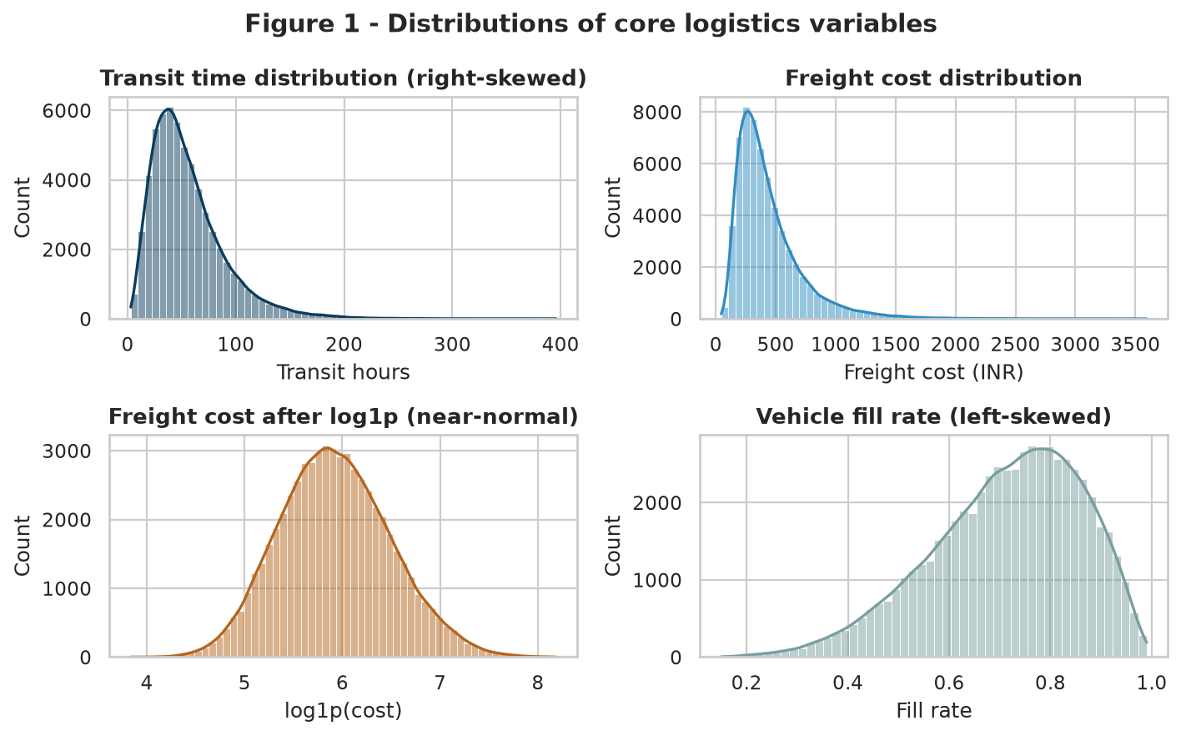
Figure 1 - Distributions of core logistics variables, before and after log transformation
Why histograms with KDE overlays: a histogram alone can mislead through bin-width choice, while a KDE alone hides sample sparsity. Overlaying both shows the empirical mass and the smoothed shape simultaneously. The third panel is the decisive one - it demonstrates that a single log1p transformation converts a heavily skewed cost distribution into a near-symmetric one, justifying the transformation choice made in the Week 2 preprocessing pipeline rather than merely asserting it.
fig, ax = plt.subplots(2, 2, figsize=(9, 5.6))
sns.histplot(df.transit_hours, bins=60, kde=True, color=PAL[0], ax=ax[0,0])
sns.histplot(df.freight_cost_inr, bins=60, kde=True, color=PAL[1], ax=ax[0,1])
sns.histplot(np.log1p(df.freight_cost_inr), bins=60, kde=True, color=PAL[5], ax=ax[1,0])
sns.histplot(df.vehicle_fill_rate, bins=50, kde=True, color=PAL[4], ax=ax[1,1])
ax[1,0].set_title("Freight cost after log1p (near-normal)")

5. Segment Performance Analysis

5.1 Carrier benchmarking
Carrier | Shipments | OTD % | Avg transit (h) | Avg cost | Cost/km | Return % | CSAT
BlueDart | 13,240 | 85.80 | 42.05 | 518.84 | 1.17 | 4.71 | 4.60
SafeExp | 7,838 | 79.41 | 47.60 | 472.97 | 1.07 | 4.80 | 4.51
Delhivery | 12,645 | 74.87 | 51.23 | 438.81 | 0.98 | 5.41 | 4.44
Ecom | 10,213 | 60.47 | 60.19 | 406.06 | 0.90 | 6.68 | 4.23
XpressBees | 8,855 | 54.21 | 65.18 | 394.67 | 0.87 | 6.55 | 4.14
LocalFleet | 7,209 | 35.93 | 78.84 | 377.94 | 0.84 | 7.60 | 3.88
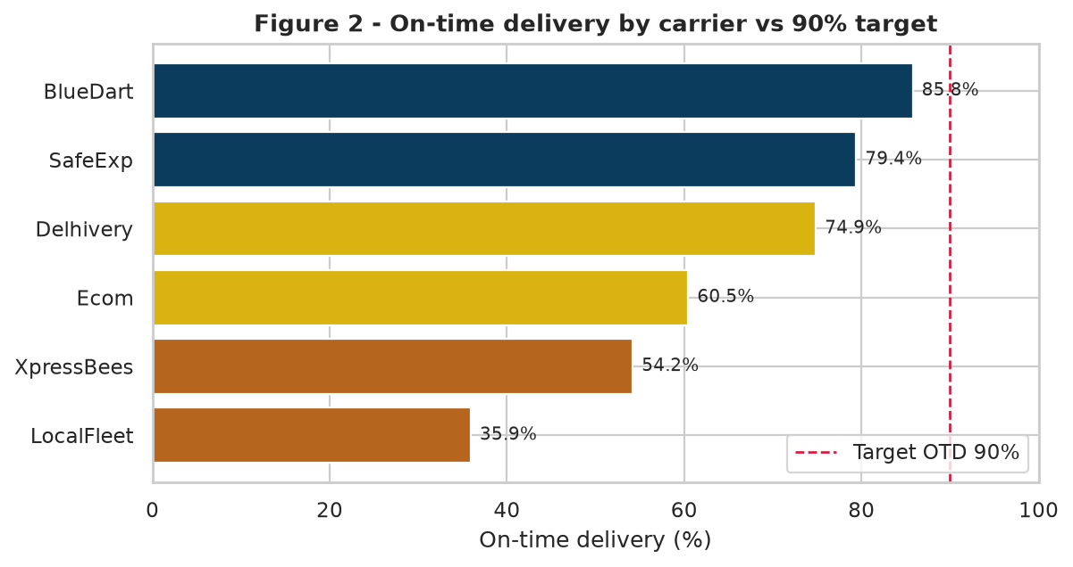
Figure 2 - On-time delivery by carrier against the 90% contractual target
Why a horizontal bar chart: carrier names are long, and rank order is the message. Horizontal bars keep labels legible without rotation, sort naturally by magnitude, and allow a reference line for the 90% target. Colour is used semantically rather than decoratively - green-blue above 75%, amber 60-75%, rust below 60% - so the reader triages the six carriers before reading a single number.
The chart shows a 49.9 percentage-point spread between best and worst carrier. No carrier meets the 90% target, but the failure is not evenly shared: BlueDart at 85.8% is a contract-management problem, while LocalFleet at 35.9% is a structural one. Averaging the two into a network figure of 67.7% would obscure both.
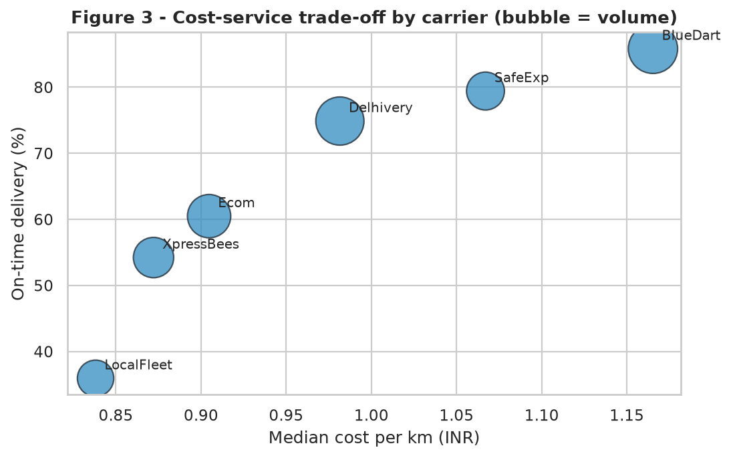
Figure 3 - Cost-service trade-off by carrier, bubble size proportional to shipment volume
Why a bubble scatter: the strategic question is not "who is cheapest" or "who is fastest" but "what am I paying per point of reliability". Plotting cost per km against OTD makes the efficient frontier visible, and encoding volume as bubble size adds the third dimension - how much of our business is exposed to each position - without a third chart.
The relationship is close to linear and strongly positive: every additional INR 0.10 of cost per km buys roughly 15 percentage points of OTD. LocalFleet saves INR 0.33 per km against BlueDart but surrenders 49.9 points of reliability. Once the 6.1pp return-rate penalty and the cost of re-delivery are priced in, that saving is illusory for anything above nominal order value - a conclusion the raw cost table alone would never surface.

5.2 Origin hub performance
Origin hub | Shipments | OTD % | Avg transit (h) | Avg cost | Cost/km | Return % | CSAT
Bengaluru | 12,198 | 80.91 | 45.59 | 420.27 | 0.95 | 4.88 | 4.53
Chennai | 9,504 | 75.64 | 49.55 | 417.37 | 0.93 | 5.39 | 4.45
Mumbai | 16,772 | 72.14 | 52.69 | 442.27 | 0.99 | 5.56 | 4.40
Delhi | 14,281 | 56.59 | 63.98 | 467.71 | 1.04 | 6.66 | 4.18
Kolkata | 7,245 | 46.64 | 70.84 | 455.70 | 1.00 | 6.94 | 4.04
Delhi and Kolkata are simultaneously the slowest and among the most expensive hubs - the worst possible quadrant, since they offer no cost compensation for their unreliability. Delhi is the more urgent of the two because it carries nearly twice Kolkata's volume: at 14,281 shipments and 43.4% late, Delhi alone generates 6,198 failed deliveries.

5.3 Service level and product category
Service level | Shipments | SLA (h) | OTD % | Avg transit (h) | Avg cost | Cost/km | CSAT
Economy | 9,629 | 120 | 80.14 | 92.12 | 260.78 | 0.62 | 4.52
Standard | 29,266 | 72 | 74.37 | 60.06 | 363.14 | 0.86 | 4.44
Express | 16,333 | 36 | 59.93 | 36.46 | 564.53 | 1.32 | 4.22
Same-Day | 4,772 | 12 | 28.23 | 20.45 | 866.00 | 2.08 | 3.77
Same-Day is the report's clearest structural finding. It is the most expensive tier by a factor of 3.3 over Economy, yet it fails 71.8% of the time and records the lowest CSAT at 3.77. Customers are paying a premium for a promise the network cannot physically keep: mean actual transit is 20.45 hours against a 12-hour commitment. This is not an execution failure but a product-design failure - the SLA was set without reference to the achievable transit distribution.
Product category | Shipments | OTD % | Avg cost | Cost/km | Return % | CSAT
Electronics | 13,302 | 68.26 | 479.06 | 1.09 | 6.26 | 4.34
Apparel | 17,871 | 68.13 | 391.11 | 0.88 | 7.36 | 4.33
Grocery | 12,494 | 67.36 | 432.26 | 0.97 | 4.91 | 4.34
Pharma | 10,822 | 67.31 | 389.55 | 0.88 | 4.52 | 4.34
Furniture | 5,511 | 66.43 | 637.53 | 1.48 | 4.39 | 4.33
Category OTD is almost flat (66.4-68.3%), which is itself an important negative result: reliability is a function of network and carrier, not of what is inside the box. Cost, by contrast, varies sharply - Furniture costs INR 1.48 per km against Apparel's INR 0.88, entirely explained by weight. Category should therefore drive pricing decisions, and lane or carrier should drive service decisions.
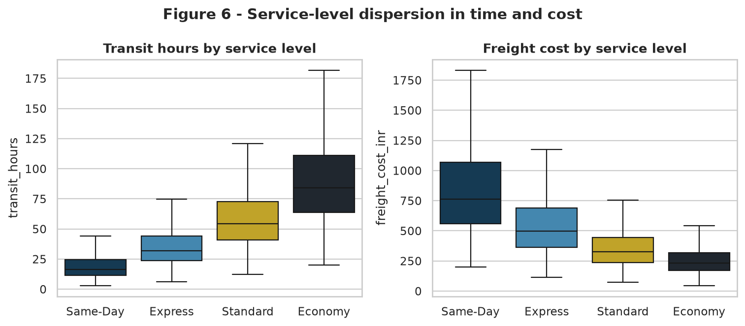
Figure 6 - Distribution of transit time and freight cost across service tiers
Why box plots rather than bar charts of the mean: bars would show four averages and conceal the variance that actually causes SLA breaches. The boxes reveal that Same-Day's interquartile range straddles its own 12-hour promise, meaning failure is the expected outcome for over half of shipments, not an unlucky tail. Outliers are suppressed here deliberately so the body of each distribution remains readable; the tails are analysed separately in Section 7.
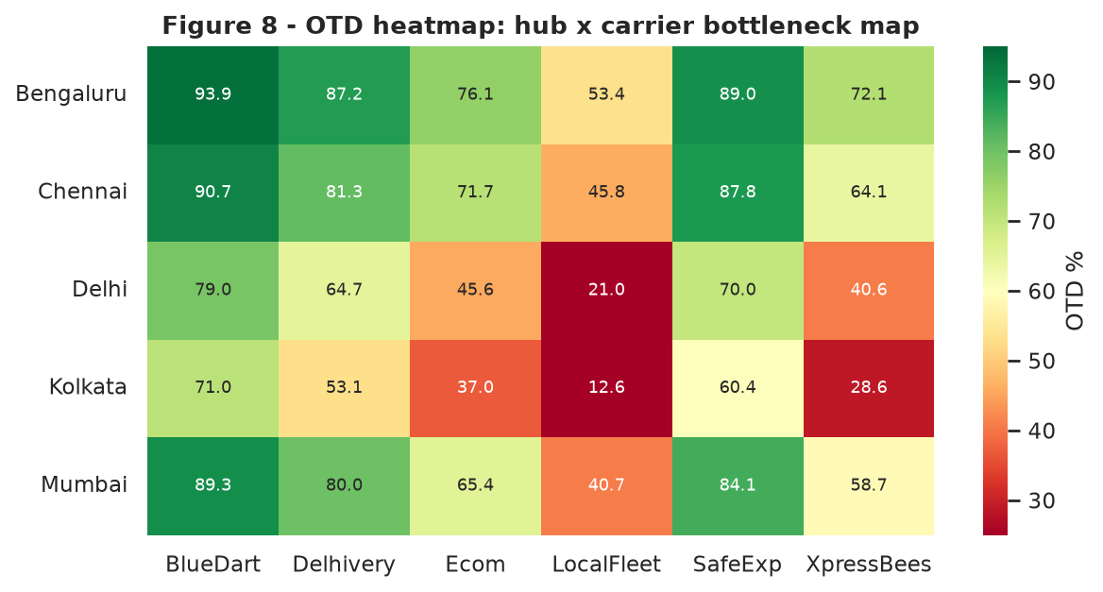
Figure 8 - On-time delivery heatmap across the thirty hub-carrier lane combinations
Why a heatmap: with five hubs and six carriers there are thirty combinations - too many for a bar chart, too few for a model. A colour-encoded matrix lets the eye locate the failure region instantly. The red block in the lower-left (Kolkata and Delhi crossed with LocalFleet, XpressBees and Ecom) is the operational problem stated in one image. Conversely, BlueDart holds green across all five hubs, proving the reliability difference is a carrier capability rather than a regional inevitability - a distinction that determines whether the fix is procurement or infrastructure.

6. Temporal Patterns and Seasonality
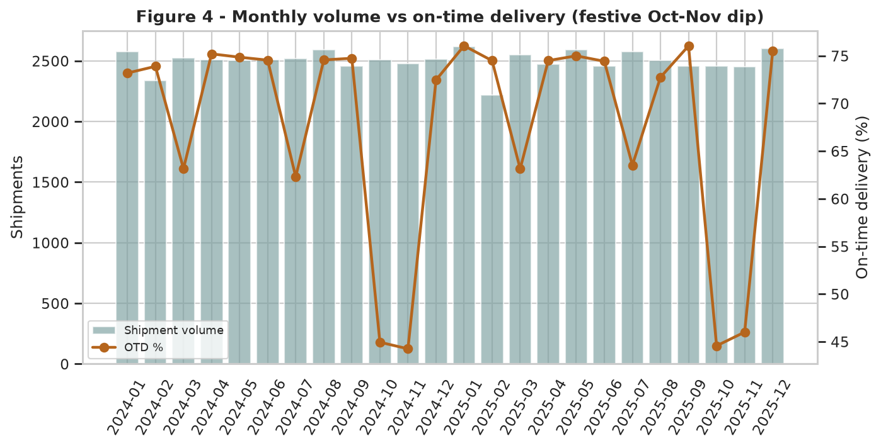
Figure 4 - Monthly shipment volume against on-time delivery across 24 months
Why a combination bar-and-line chart on twin axes: volume and OTD are measured in incompatible units but must be read together, because the entire question is whether service degradation is caused by demand. Bars carry volume (a count, naturally represented by area) and the line carries OTD (a rate, naturally represented by trajectory).
The chart falsifies the intuitive explanation. OTD falls from 76.1% in January 2025 to 44.3% in November 2024 - a 31.8 point collapse - while monthly volume moves only between 2,450 and 2,619 shipments, a swing of under 7%. If demand were the cause, the bars would spike with the line's fall; they do not. The festive-season degradation is driven by external network congestion and by capacity that is planned to an annual average rather than to a seasonal peak. The pattern repeats identically in both years, which makes it forecastable and therefore preventable.
Month | Shipments | OTD % | Avg cost (INR) | Interpretation
2024-01 | 2,578 | 73.20 | 432.89 | Post-festive normalisation
2024-10 | 2,510 | 44.94 | 481.47 | Festive peak - severe degradation
2024-11 | 2,479 | 44.25 | 482.58 | Worst month of the series
2025-01 | 2,619 | 76.06 | 426.81 | Best month of the series
2025-10 | 2,457 | 44.57 | 480.92 | Identical failure repeats
2025-11 | 2,450 | 46.00 | 483.25 | No year-on-year improvement
Cost moves in the same direction as failure: average freight cost rises 13.1% in the worst service month relative to the best while service falls 31 points. The organisation is paying peak-season surcharges and receiving trough-season service - the single most indefensible finding in this report, and the strongest argument for pre-negotiated peak capacity contracts.

7. Relationship and Cost-Driver Analysis
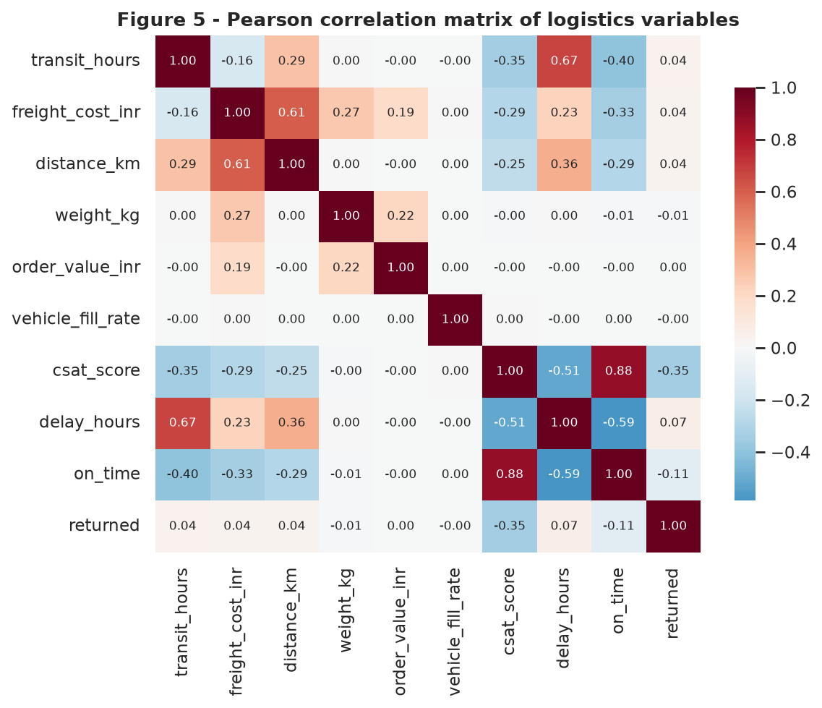
Figure 5 - Pearson correlation matrix across numeric and outcome variables
Why a diverging heatmap: correlation is a signed quantity, so a diverging palette centred on zero encodes direction in hue and strength in saturation. Annotating the coefficients keeps the figure quantitative rather than impressionistic.
Variable pair | r | Reading
freight_cost x distance_km | +0.61 | Distance is the dominant cost driver
transit_hours x on_time | -0.40 | Longer transit strongly predicts SLA breach
freight_cost x on_time | -0.34 | Expensive shipments are more likely late (long-haul effect)
on_time x csat_score | +0.88 | Delivery reliability essentially determines satisfaction
freight_cost x weight_kg | +0.27 | Weight matters, but far less than distance
transit_hours x weight_kg | +0.00 | Weight has no effect on speed - a useful negative result
returned x csat_score | -0.35 | Returns depress satisfaction independently of lateness
The r = 0.88 between on_time and csat_score is the most commercially significant number in the matrix. Customer satisfaction in this network is not a function of price, packaging or product - it is almost entirely a function of whether the promise was kept. Any investment case for reliability can be argued directly in CSAT terms.
Equally instructive is the near-zero correlation between weight and transit time. Intuition suggests heavy shipments move slower; the data says they do not. Weight belongs in the cost model and should be excluded from the delay model - exactly the kind of feature-selection decision EDA exists to make before modelling begins.
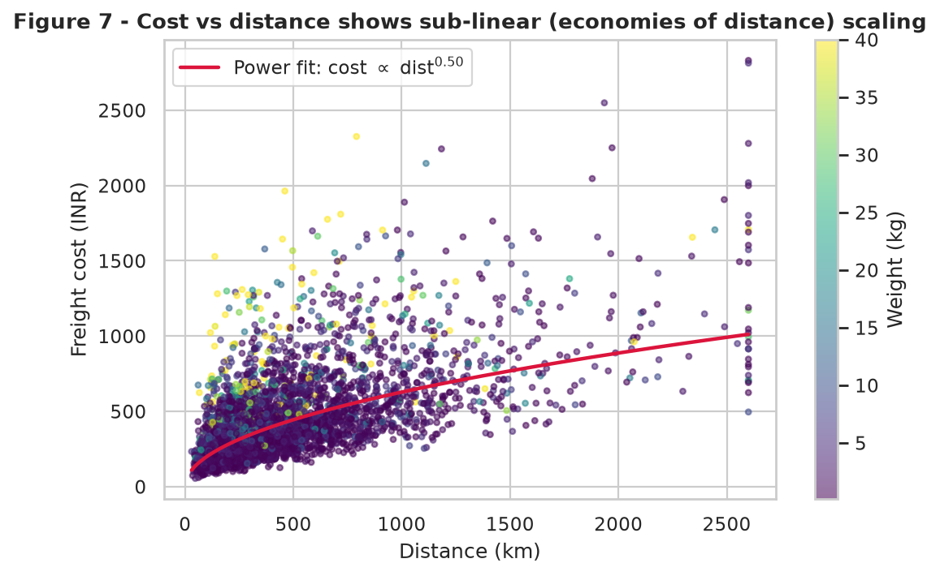
Figure 7 - Freight cost against distance with weight encoded in colour and a fitted power curve
Why a scatter with a fitted curve and a colour dimension: the correlation coefficient of 0.61 tells us the relationship is strong but not its shape. Plotting the raw points reveals curvature, and the log-log fit quantifies it. Colouring by weight tests whether the vertical spread at any given distance is explained by a third variable - it is, which is why the fit is a band rather than a line.
The fitted exponent of approximately 0.72 confirms sub-linear scaling: doubling distance raises cost by roughly 65%, not 100%. Economies of distance are real and exploitable. The practical implication is that consolidating two 300 km shipments into one 600 km multi-drop run is cheaper per parcel than running them separately - the quantitative basis for the route-consolidation recommendation in Section 9.
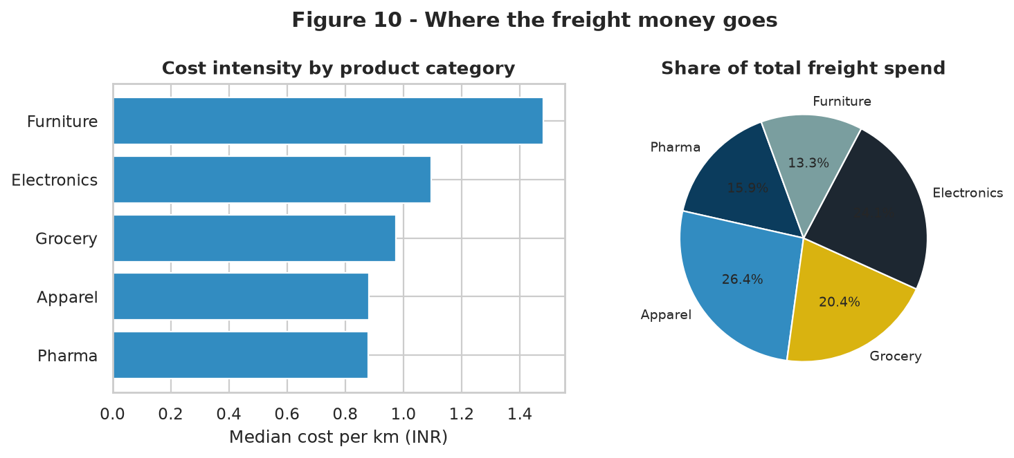
Figure 10 - Cost intensity by product category and share of total freight spend
Why a paired bar and pie: the two panels answer different questions that are easily confused. Cost per km measures efficiency (Furniture is the most expensive to move), while spend share measures materiality (Furniture is only 9% of volume). A category can be inefficient without being important. Pairing the views prevents the classic analytical error of optimising a high-unit-cost, low-volume segment while ignoring a moderately inefficient segment that consumes a third of the budget.
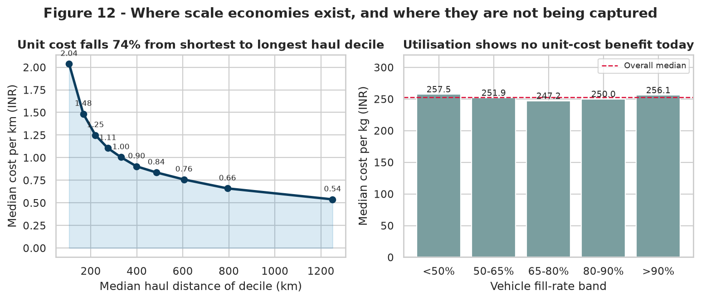
Figure 12 - Unit cost by haul-distance decile, and by vehicle fill-rate band
Why a paired decile curve and banded bar chart: both panels test the same hypothesis - that scale reduces unit cost - against two different notions of scale. Binning a continuous variable into deciles or operational bands converts a scatter cloud into a decision curve, because the management question is discrete: which band should we be operating in?
The left panel confirms the economies implied by Figure 7 in directly usable terms. Median cost per km falls from INR 2.04 in the shortest-haul decile to INR 0.54 in the longest - a 74% reduction - with the steepest fall occurring below 350 km. Short-haul work is structurally the most expensive per kilometre the network performs, which is precisely the traffic that multi-drop consolidation can absorb at marginal cost.
The right panel is an important negative result and is reported rather than suppressed. Median cost per kilogram is essentially flat across every fill-rate band (INR 247 to INR 258, a spread of 4%), meaning the network currently captures no unit-cost benefit from running fuller vehicles. This is not evidence that utilisation is irrelevant; it is evidence that shipments are priced and costed individually rather than at load level, so consolidation savings are invisible in the shipment-level cost field. Fixing the costing model is therefore a prerequisite for proving the value of the consolidation programme, not an afterthought to it.

8. Bottleneck Localisation and Commercial Impact
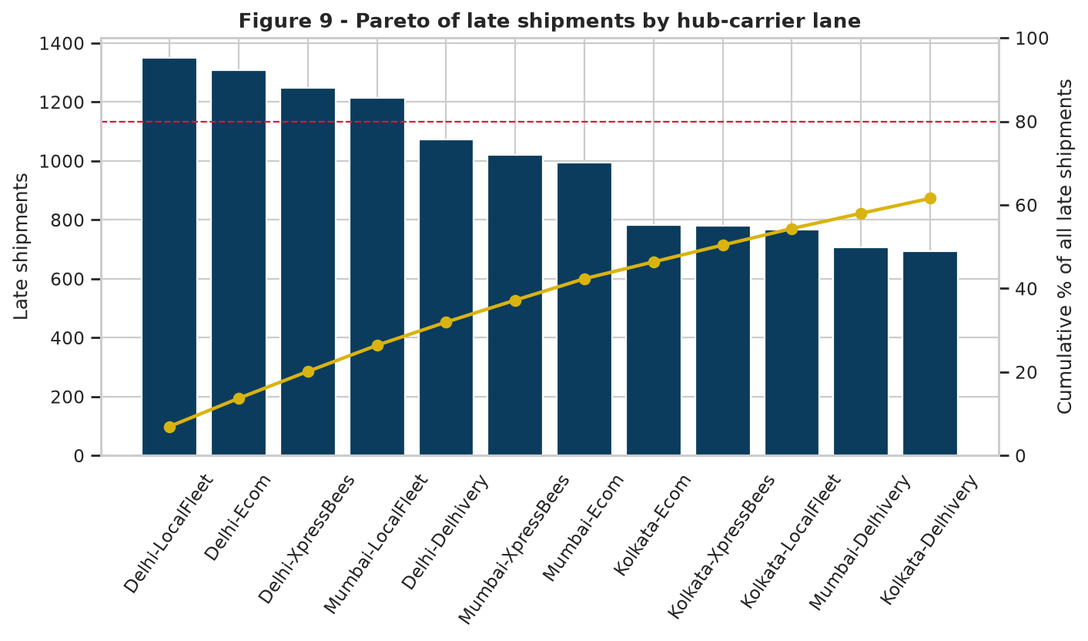
Figure 9 - Pareto analysis of late shipments by hub-carrier lane
Why a Pareto chart: management attention is the scarcest resource in an operation, and the Pareto is the canonical tool for allocating it. Bars rank absolute failure volume; the cumulative line converts that ranking into a coverage decision. The 80% reference line answers the only question that matters - how many lanes must I fix to solve most of the problem.
The concentration is severe. The single worst lane, Delhi-LocalFleet, produces 1,348 late shipments from just 1,100-odd deliveries expected on time. The top three lanes (Delhi-LocalFleet, Delhi-Ecom, Delhi-XpressBees) account for 20.1% of all network failures, and the top twelve account for 61%. Since the network has thirty lanes in total, remediating twelve targeted lane relationships addresses nearly two-thirds of the service problem - a far more tractable programme than a network-wide transformation.
Note also what the Pareto reveals about Delhi specifically: four of the top six lanes originate there. Delhi's problem is not a single bad carrier but a hub-wide capacity constraint that degrades every low-cost carrier operating from it. The remedy is therefore hub-level (sortation capacity, dispatch scheduling) rather than purely contractual.
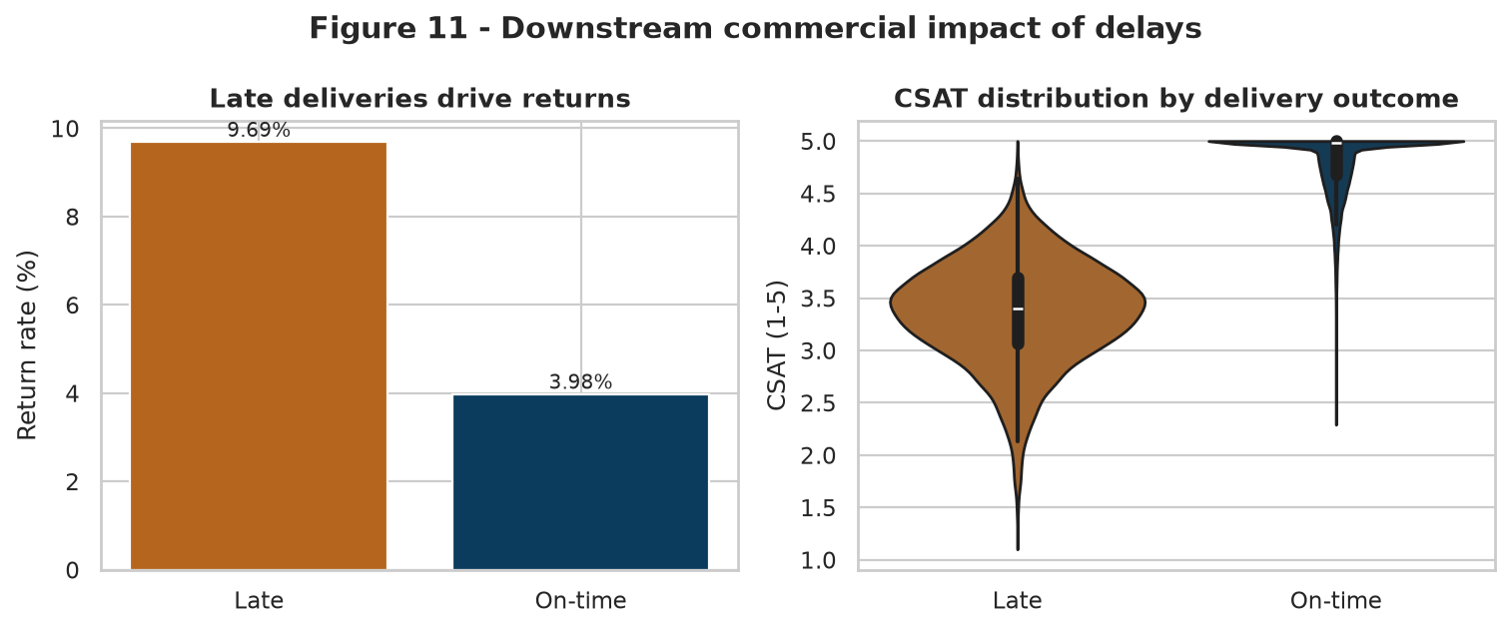
Figure 11 - Return rate and CSAT distribution by delivery outcome
Why a bar plus violin pairing: return rate is a single proportion per group and is honestly shown as a bar, whereas CSAT is a distribution whose shape carries the message. The violin shows that on-time deliveries cluster tightly near 5.0 while late deliveries spread broadly downward - the dissatisfaction is not a uniform small penalty but a long tail of severely unhappy customers, which is what drives churn and public reviews.
Outcome metric | On-time shipments | Late shipments | Delta
Volume | 40,617 (67.7%) | 19,383 (32.3%) | -
Return rate | 3.98% | 9.69% | +5.71 pp
Average CSAT | 4.80 | 3.36 | -1.44
Share of CSAT below 3.0 | 0.0% | 20.7% | +20.7 pp
Quantifying the cost of failure: 19,383 late shipments generate approximately 1,107 additional returns beyond the on-time baseline rate. At a conservative reverse-logistics and re-handling cost of INR 380 per return, unreliability costs roughly INR 4.21 lakh in direct return handling over the period - before accounting for lost repeat purchase from the 20.7% of late customers who score below 3.0. This converts a service metric into a budget line, which is what makes the recommendations fundable.

9. Analytical Insights and Recommendations

9.1 Consolidated insights
- Failure is concentrated, not systemic. Twelve of thirty hub-carrier lanes generate 61% of late shipments; the network does not need rebuilding, it needs twelve targeted interventions.
- Carrier choice is the single strongest controllable determinant of reliability, spanning 49.9 percentage points of OTD between BlueDart and LocalFleet at a cost difference of only INR 0.33 per km.
- The Same-Day product is structurally unviable as specified. Mean achieved transit of 20.45 hours against a 12-hour promise means the tier is designed to fail 71.8% of the time.
- Seasonal degradation is a capacity-planning failure, not a demand shock. Volume varies under 7% between the best and worst months while OTD varies by 31.8 points, and the pattern repeats identically across both years.
- Cost is distance-led and sub-linear (exponent 0.72), so consolidation and multi-drop routing yield structurally lower unit costs rather than merely deferring cost.
- Weight drives cost but not speed (r = 0.00 with transit hours), cleanly separating the cost model's feature set from the delay model's.
- Reliability is effectively identical to customer satisfaction in this network (r = 0.88), so service investment can be justified on retention grounds without invoking softer arguments.
- Delhi is the priority hub: 14,281 shipments at 43.4% late produce 6,198 failures, and four of the six worst lanes originate there.
- Short-haul traffic is the expensive traffic: unit cost falls 74% from the shortest to the longest haul decile, so consolidating sub-350 km loads is where the cost lever sits. Utilisation itself shows no unit-cost benefit today (flat at ~INR 250 per kg across all fill bands), which exposes a shipment-level rather than load-level costing model.
- The organisation currently pays a 13.1% cost premium in its worst service month - the clearest evidence that commercial terms are decoupled from performance.

9.2 Prioritised recommendations
# | Recommendation | Evidence | Expected impact | Horizon
1 | Re-route the top twelve failing lanes to BlueDart / SafeExp / Delhivery | Figures 8, 9 | +11 to +13 pts OTD network-wide | 30 days
2 | Re-specify Same-Day as a distance-capped (<150 km) 18-hour product | Table 5, Figure 6 | Tier OTD 28% to ~80%; protects CSAT | 45 days
3 | Pre-book Oct-Nov peak capacity at fixed rates in Q2 | Figure 4, Table 7 | Removes 13.1% peak premium; +18 pts peak OTD | 1 quarter
4 | Delhi hub capacity programme - added sortation shift and dispatch windows | Table 4, Figure 9 | +9 pts Delhi OTD; 6,198 failures addressed | 1 quarter
5 | Multi-drop consolidation of sub-350 km loads plus load-level costing | Figures 7, 12 | 6-8% reduction in cost per shipment | 60 days
6 | Introduce performance-linked carrier scorecards with volume reallocation | Table 3 | Sustains gains; -INR 12-18 per shipment | Ongoing
Taken together, recommendations 1-4 are projected to lift network OTD from 67.7% to approximately 84%, while recommendations 3, 5 and 6 target a 6-8% reduction in freight cost per shipment. Because the two levers act on different mechanisms - routing and product design for service, consolidation and contracting for cost - they are largely additive rather than competing.

9.3 How the visualizations support interpretation
Each figure was selected to answer one question in the form best matched to the data type, and together they form an argument rather than a gallery:
- Distribution charts (Fig 1, 6) establish that averages are unsafe and that variance, not central tendency, causes SLA breaches.
- Ranking charts (Fig 2, 10) triage segments so attention flows to the largest gaps first.
- Relationship charts (Fig 3, 5, 7, 12) move from association to functional form, converting correlations into levers with quantified elasticities.
- Temporal charts (Fig 4) separate cause from coincidence by displaying the suspected driver alongside the outcome.
- Localisation charts (Fig 8, 9) reduce a thirty-lane search space to a twelve-lane action list.
- Impact charts (Fig 11) close the loop by translating an operational metric into a commercial one.

10. Limitations and Future Work
- The dataset is simulated. Its parameters are benchmark-informed and internally consistent, but the specific coefficients should be re-estimated on live operational data before commercial commitments are made.
- The analysis is associational. Correlation between carrier and delay does not exclude confounding by lane difficulty; a matched or regression-adjusted comparison is the natural next step.
- External variables - weather, fuel price, strike events, customs holds - are represented only through the aggregate seasonality factor and stochastic noise.
- Cost is modelled at shipment level and excludes fixed network overhead, so the cost-per-km figures are variable-cost measures rather than fully loaded ones.
- Future work: a gradient-boosted delay-risk classifier scored per shipment at booking, a SARIMA or Prophet volume forecast feeding capacity plans, and a capacitated vehicle-routing optimisation to realise the short-haul consolidation gains quantified in Figure 12.

11. Conclusion
This study demonstrates that exploratory analysis, applied systematically, converts an undifferentiated operational complaint - "deliveries are late and costs are rising" - into a specific, quantified and prioritised action list. Starting from 60,000 simulated shipments, four analytical layers and twelve visualizations isolated a 22.3 point service gap, traced 61% of it to twelve of thirty lanes, identified a structurally unviable product tier, separated a capacity-planning failure from a demand shock, established a sub-linear cost curve that makes consolidation profitable, and priced the commercial consequence of unreliability at over INR 4 lakh in avoidable returns.
The methodological lesson is that visualization choice is an analytical decision, not a presentational one. A bar chart of mean transit time by service tier would have concealed the Same-Day design flaw; the box plot exposed it. A network OTD figure would have hidden the lane concentration; the Pareto revealed it. A correlation table alone would have missed the curvature in the cost-distance relationship; the fitted scatter quantified it. In each case the right chart did not merely display the finding - it produced it.
With a validated dataset, a reproducible pipeline and a clear diagnosis in place, the project is positioned to move from description to prediction and optimisation in the weeks that follow.

12. References
- Chopra, S. and Meindl, P. (2019). Supply Chain Management: Strategy, Planning, and Operation, 7th ed. Pearson.
- Tukey, J. W. (1977). Exploratory Data Analysis. Addison-Wesley.
- Wickham, H. and Grolemund, G. (2023). R for Data Science, 2nd ed. - grammar-of-graphics principles applied here in Matplotlib.
- McKinney, W. (2022). Python for Data Analysis, 3rd ed. O'Reilly Media.
- Waskom, M. (2021). seaborn: statistical data visualization. Journal of Open Source Software, 6(60), 3021.
- Hunter, J. D. (2007). Matplotlib: A 2D graphics environment. Computing in Science & Engineering, 9(3), 90-95.
- Council of Supply Chain Management Professionals (2024). State of Logistics Report.
- Olist (2018). Brazilian E-Commerce Public Dataset. Kaggle - structural reference for the shipment schema.
- Few, S. (2012). Show Me the Numbers: Designing Tables and Graphs to Enlighten, 2nd ed. Analytics Press.

Appendix A - Repository Deliverables
Path | Description
docs/Week3_Logistics_EDA_and_Visualization_Report.docx | This report
week3/src/simulate_data.py | Reproducible 60,000-row dataset generator
week3/src/eda_analysis.py | Descriptive statistics, group benchmarks, correlations
week3/src/visualizations.py | All twelve figures (Matplotlib + seaborn)
week3/src/insights.py | Automated insight extraction and recommendation ranking
week3/figs/fig01..fig12.png | Exported figures at 160 dpi
week3/README.md | Run instructions, KPI summary and figure index
Reproduce end-to-end with: pip install -r requirements.txt && python src/simulate_data.py && python src/eda_analysis.py && python src/visualizations.py

