Publishing APIs on Apigee Developer Portal

**Version Control**

|  |  |  |  |
| --- | --- | --- | --- |
| **Version** | **Date** | **Name** | **Summary of Changes** |
| 1.0 | 22ndDecember 2015 | Neha Pamnani |  |

Table of Contents

1. Create a Model 4

2. Import an API description 4

3. Render and Publish API methods 6

4. Configure OAuth 2.0 authentication for SmartDocs 6

4.1. Create Security Scheme 6

4.2. Configure Template Authentication Scheme 9

4.3. Configure Individual Methods of Model 10

5. Naming an API’s method (Applicable only for Swagger models) 10

6. Outcome 11

NOTE: You can create a new developer portal instance by following this [link](http://apigee.com/docs/developer-services/content/creating-developer-portal), if you don’t have one already.

# Create a Model

NOTE: To create a model either follow the steps specified in [Apigee docs](http://apigee.com/docs/developer-services/content/using-smartdocs-document-apis#creatingamodel) or those given below:

* 1. Login with admin rights.
  2. Select **Content** > **SmartDocs**.

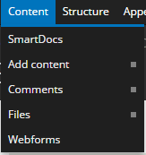

Figure Content Drop-down

* 1. Select **New Model.**
  2. Enter the **Name** and **Description** (optional) for the model.
  3. Select **Create Model**.

# Import an API description

API Descriptions of FHIR resources:

The API descriptions are available in two formats: Swagger JSON and SmartDocs JSON. These API descriptions define requests that point to the FHIR resources deployed on <https://fhirsandbox-test.apigee.net>. It is our recommendation to use the SmartDocs format.

Swagger JSON:

They can be found at: flame/src/apidocs/dstu2/swagger.

In order to change where they point, modify the “host” and “basepath” fields of the swagger JSON file.

After publishing, names of the API methods may be changed using steps specified here.

SmartDocs JSON:

They can be found at: flame/src/apidocs/dstu2/smartdocs.

In order to change where they point, modify all the “baseUrl” fields of the SmartDocs JSON file.

NOTE: To import API description either follow the steps specified in [Apigee docs](http://apigee.com/docs/developer-services/content/using-smartdocs-document-apis#addingapistoamodel-importaswaggerapidescription) or those given below:

* 1. Select **Content** > **SmartDocs**.
  2. For the model whose API description needs to be added, select **Import** option from Operations menu.

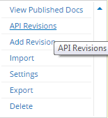

Figure Operations Drop-down

* 1. Select **Swagger - JSON** or **SmartDocs - JSON** in the **Choose Format** dropdown.

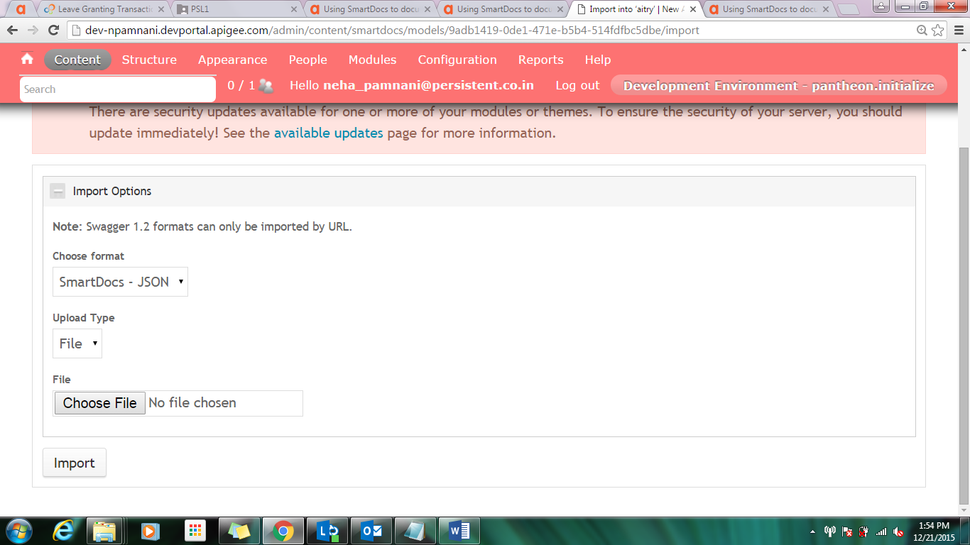

Figure Import page

* 1. Set the **Upload** **Type** as **File**.
  2. Using **Choose File** browse to the SmartDocs or Swagger file to be imported.
  3. Select **Import**.

# Render and Publish API methods

NOTE: To render and publish API’s methods either follow the steps specified in [Apigee docs](http://apigee.com/docs/developer-services/content/using-smartdocs-document-apis#renderingamodel) or those given below:

* 1. Select **Content** > **SmartDocs.**
  2. For the model to be rendered, select **API Revisions** in its Operation dropdown.
  3. Select the revision to render.

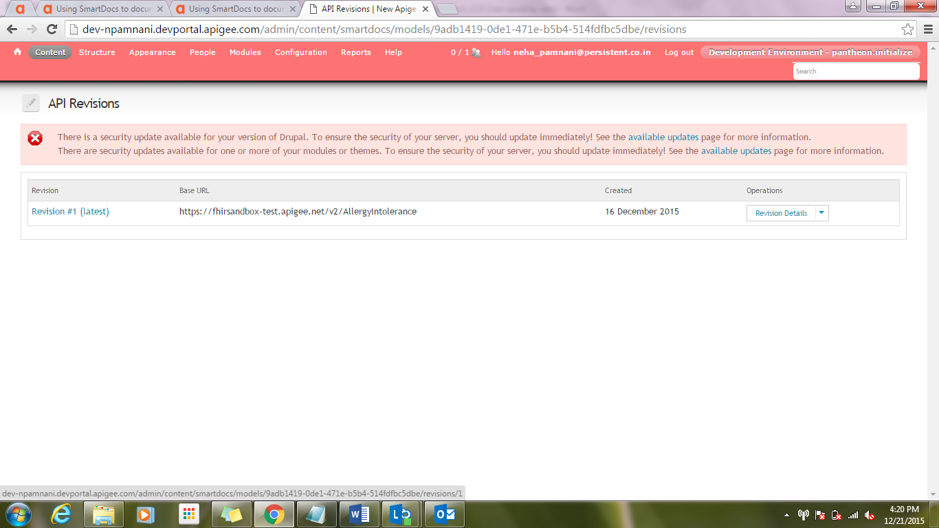

Figure Revisions page

* 1. Select the methods to render and publish.
  2. Select **Render and publish nodes** to render and publish the selected methods.
  3. Select **Update** button.

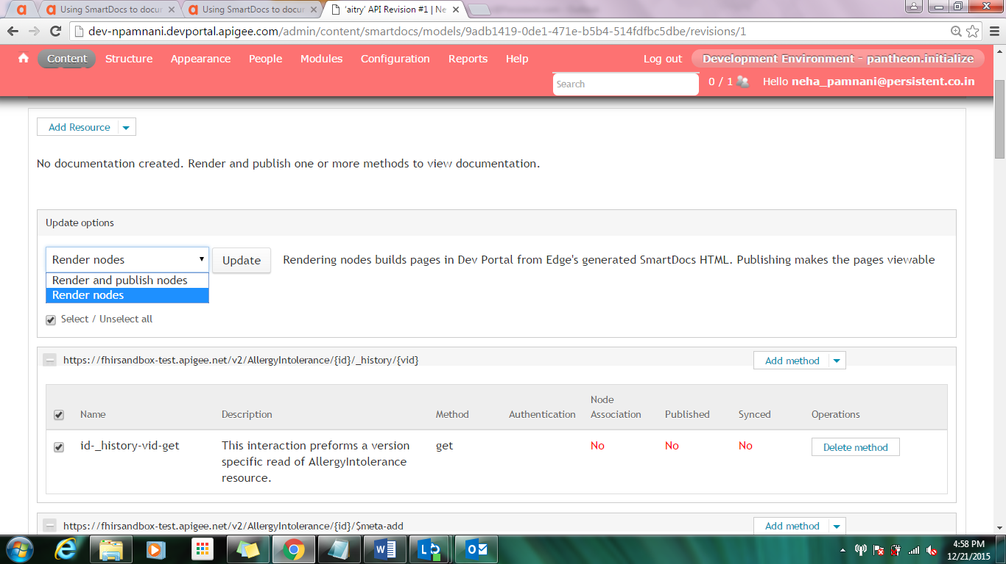

Figure Update Options

* 1. You can verify the published methods by clicking on **View API Documentation** on the same page.

# Configure OAuth 2.0 authentication

This step is applicable to FHIR resources only i.e. should not be applied to OAuth and Basepath API documentation.

NOTE: To add OAuth security either follow the steps specified in [Apigee docs](http://apigee.com/docs/developer-services/content/using-smartdocs-document-apis#configuringthesmartdocsauthenticationtype-configuringoauth20authentication) or those given below. OAuth 2.0 authentication can be used to secure the access to the API. Following steps need to be done to accomplish this:

# Create Security Scheme

* + 1. Select **Content** > **SmartDocs**.
    2. For the API model which need to be configured, select **API Revisions** from Operations drop-down.
    3. For an API revision, select **Security Settings** from Operations drop-down.

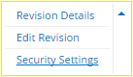

Figure Operations Drop-down

* + 1. Select **Add Security Scheme**.

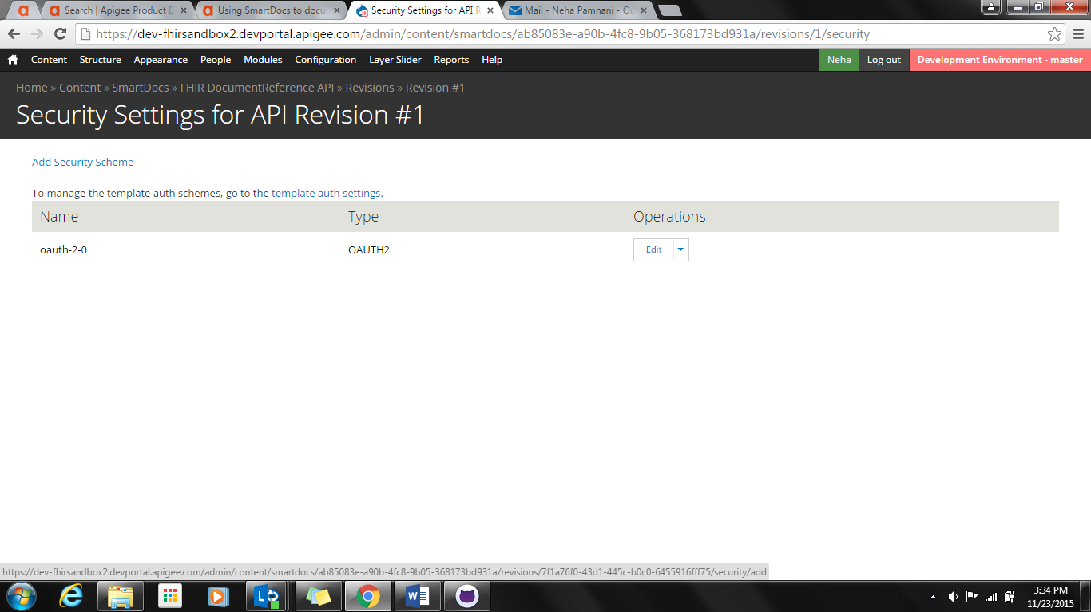

Figure Security Settings

* + 1. Specify the following values for the security scheme:
       1. Specify the **Name** for security scheme.
       2. If using SmartDocs-JSON format, make sure to specify the **oauth-2-0** as the **Internal Name** for security scheme.
       3. For **Type**, select OAuth 2.0
       4. For **Authorization URL**, specify the URL to obtain the access token. i.e.

E.g. https://{org-name}-{env}.apigee.net/oauth/v2/authorize?scope=patient/Encounter.read&state=uyrjiqa23nv8650ndj

The query parameter scope should have the value corresponding to the FHIR Resource i.e. patient/<Resource Name>.read

* + - 1. For **Access token url**, specify the URL used to exchange the request token for an access token i.e. https://{org}-{env}.apigee.net/oauth/v2/accesstoken

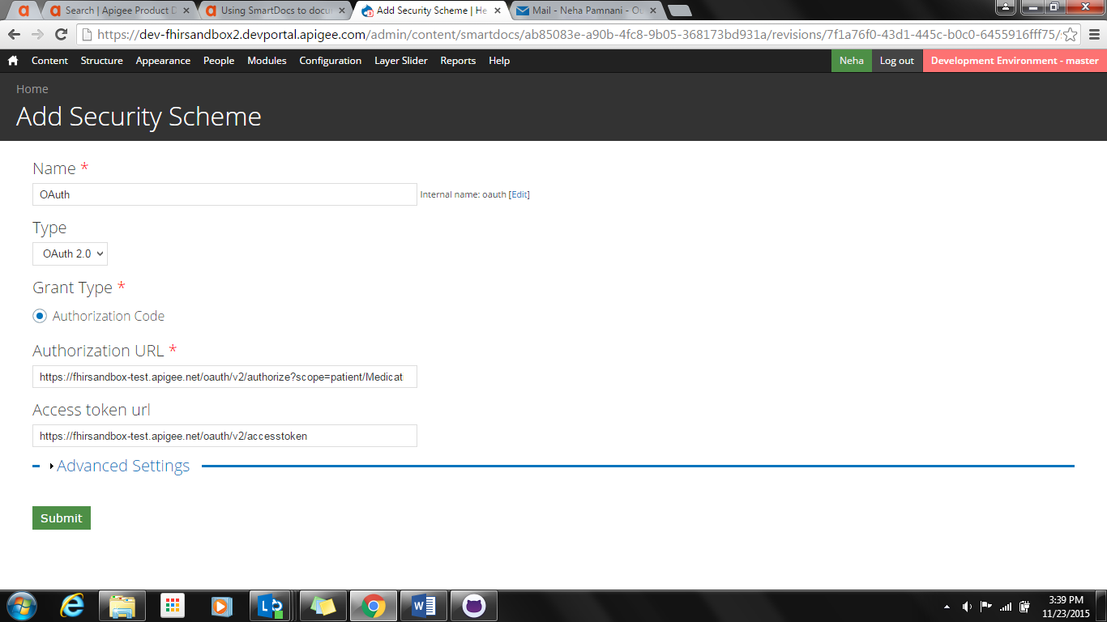

Figure Configure Security Scheme

In Advanced Settings:

* + - 1. Set **Authorization** **verb** to POST
      2. Set **Authorization Request Method**to Header
      3. Set “**When making the call to get an access token, pass the client id and secret in the:”** value to **Header**.
      4. Set **Scopes** to: {"patient/<Resource Name>.read”: "Read permissions for <Resource Name> demographics"}

E.g.: {"patient/Encounter.read": "Read permissions for Encounter demographics"}

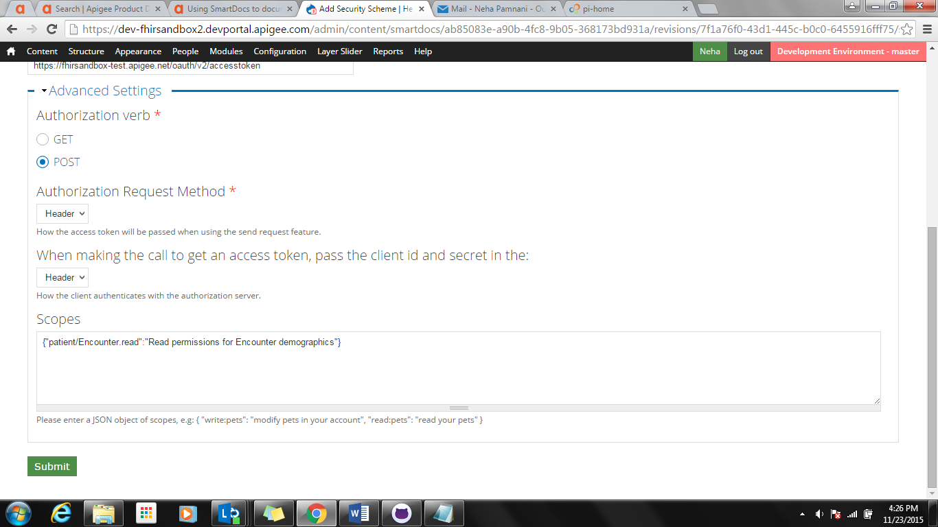

Figure Configure Advanced Settings

* + - 1. Select **Submit**.

# Configure Template Authentication Scheme

* + 1. Select **Content** > **SmartDocs**.
    2. For the same model, select **Settings** from Operations drop-down.
    3. In [Template authentication schemes](https://dev-fhirsandbox2.devportal.apigee.com/admin/content/smartdocs/models/a8af867a-1c31-4e00-966d-0eb34dc3cae5/settings), set **Client** **Id** & **Client** **Secret** of the App.

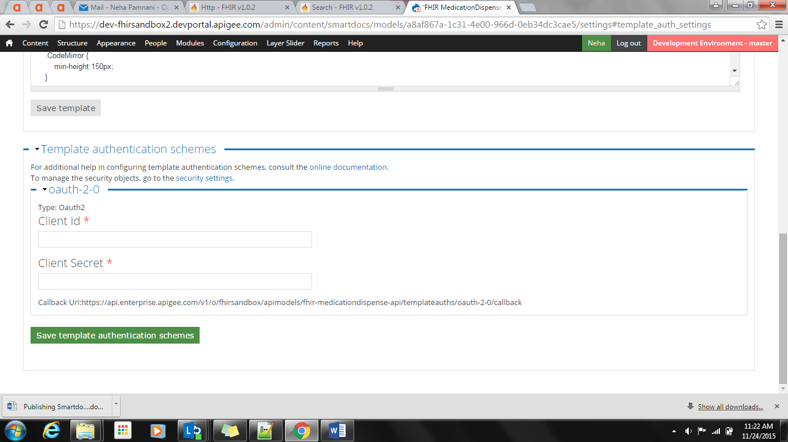

Figure Template Authentication Schemes

# Configure Individual Methods of Model (Applicable only for Swagger models)

* + 1. Select **Content** > **Smartdocs**
    2. For the same API model, select **View Published Docs** from Operations drop-down.
    3. For each method inside the model which needs to be secured:
       1. Click on the method’s name that needs to be secured.
       2. Select its Edit tab.

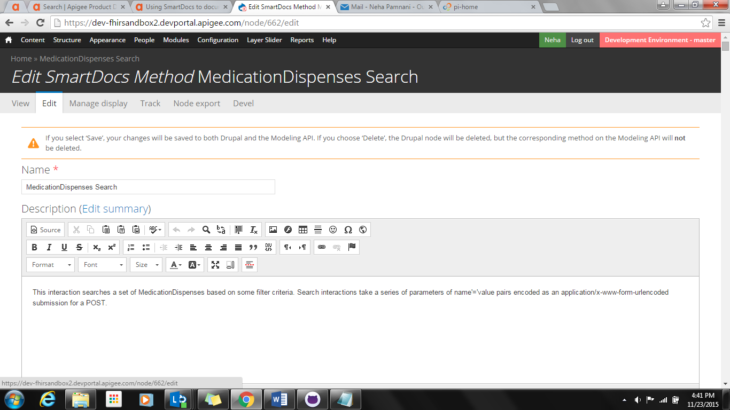

Figure Method’s Edit tab

* + - 1. In Security schemes, enable checkbox for the created OAuth scheme.

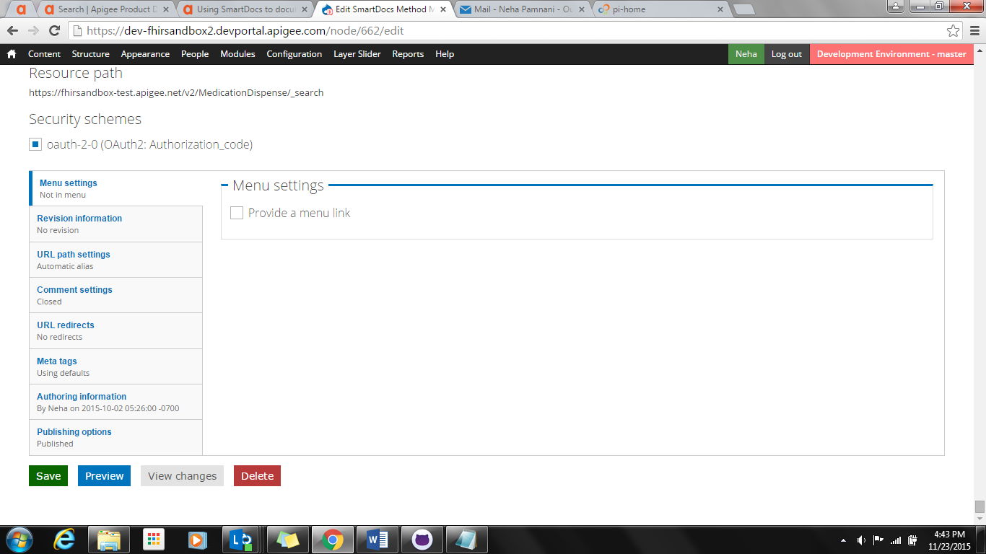

Figure Add Security to Method

* + - 1. Select Save.

# Naming an API’s method (Applicable only for Swagger models)

Naming can be done only after publishing. The methods have already been named appropriately via the SmartDocs models. Hence, if the SmartDocs json models are utilized for creating the api model then ideally this step would not be required.

* 1. Select **Content** > **SmartDocs**.
  2. For the same API model, select **View Published Docs** from Operations drop-down.
  3. For each method inside the model which needs to be named:
     1. Select **Edit** tab.

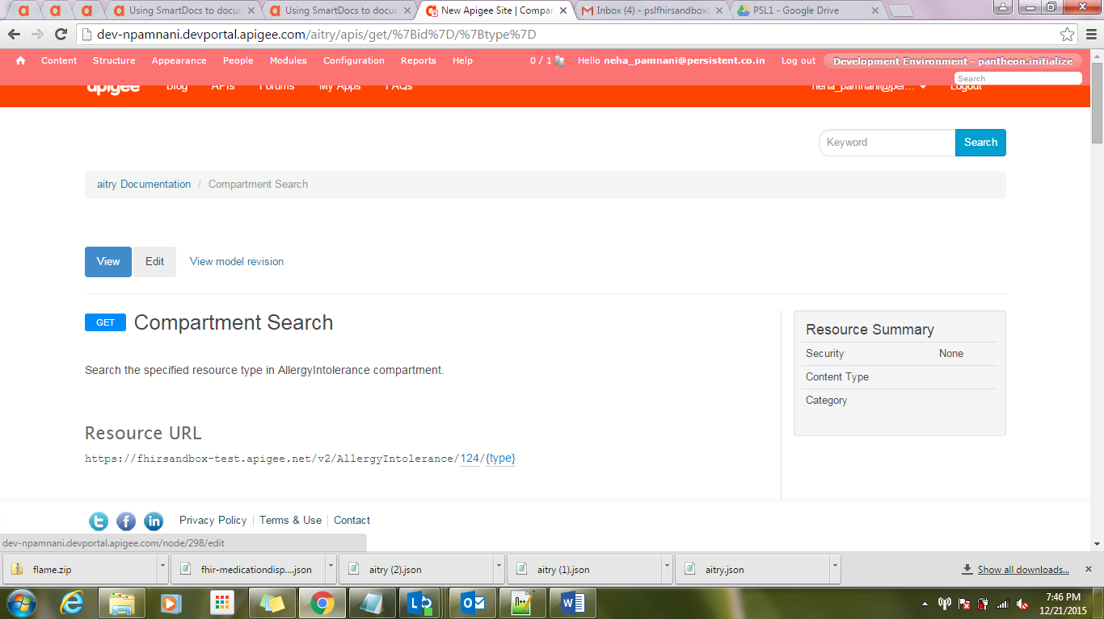

Figure Edit tab

* + 1. Specify the **Name**.

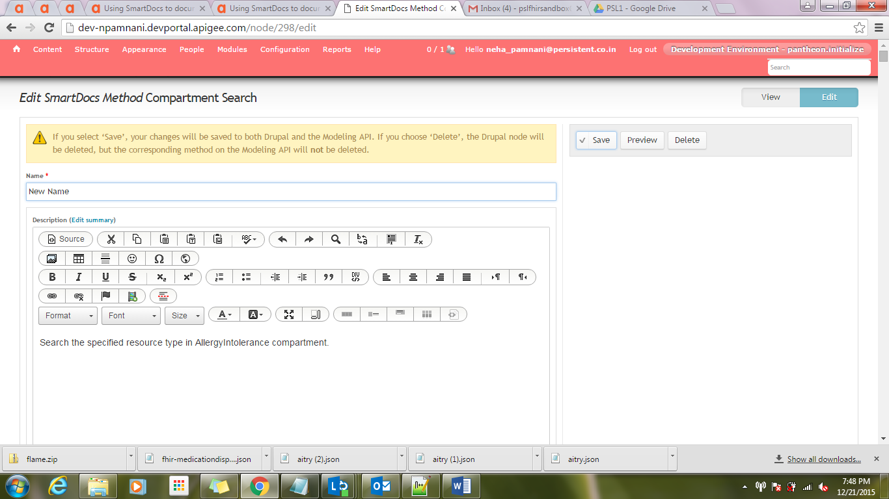

Figure Edit page

* + 1. Select **Save**.

# Outcome

After completion of all the steps, API methods can be viewed.

* 1. Select **Content** > **SmartDocs**.
  2. For the required model, select **View Published Docs** from Operations dropdown.
  3. Select an API method, like Read Patients, to check the following outcome.

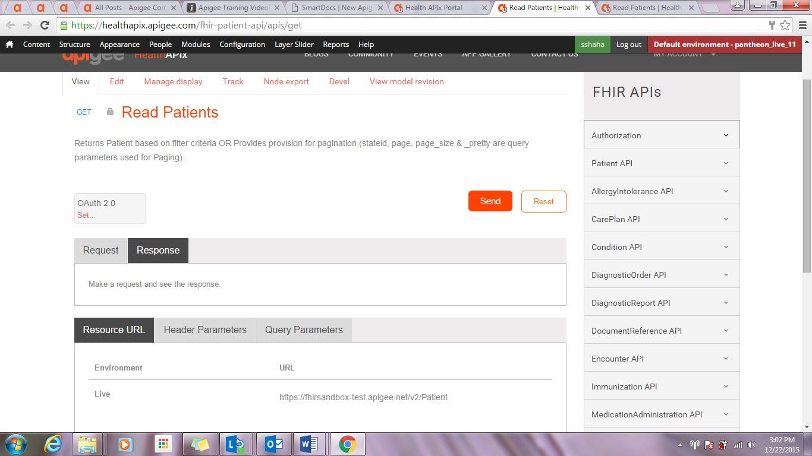

Figure Method's View