Working

A DX unit, also known as a direct expansion unit, is a type of HVAC (heating, ventilation, and air conditioning) system that uses a refrigerant to cool indoor air. The DX unit works by compressing the refrigerant, which causes it to become hot, and then passing it through a set of coils located inside the indoor unit. As warm indoor air passes over these coils, the refrigerant absorbs the heat, causing it to evaporate and cool the air.

The cooled air is then circulated back into the indoor space, while the hot refrigerant is passed through a set of coils located in the outdoor unit where it releases the heat. DX units are commonly used in residential and commercial settings because they are efficient, cost-effective, and easy to install. They are available in a range of sizes and configurations to suit different indoor spaces, and they can be controlled using a thermostat or other control system to maintain a comfortable indoor temperature.



Data Attributes and its information

1. **ON/OFF CMD** – Command taken for the system it turn it on or off.
2. **A/M Status** – Working Mode of the System. Auto or Manual.
3. **Trip Status** – Refers to a fault or error condition that has caused the system to shut down or trip a safety switch. Trip is error occurred and Normal when system is working fine.
4. **Run Status** – Active running status of the system. On or Off.
5. **Schedule Mode** – Whether the system is scheduled or scheduling is off.
6. **Time Schedule** – Whether the Time Scheduling is on or off.

Addable Parameters

|  |  |  |
| --- | --- | --- |
| Name | Description | Range |
| Power Consumption | Monitoring the power consumption of the DX unit system can provide insights into the system's efficiency and help predict maintenance needs. | For Window/Room AC –  Small : 0.5 to 0.7  Medium : 1 to 1.5  Large : 1.5 to 2.5 watts  For Split System AC –  Small : 0.6 to 0.9 kilowatts  Medium : 1.2 to 1.8 kilowatts  Large : 1.8 to 2.5 kilowatts |
| Space | Setup space or room space for the system. | Small, Medium and Large |
| Type | Type of DX Unit HVAC System. | Window/Room Air Conditioner (RAC),  Split Systems |
| Filter status | Monitoring the status of the system's filters can help predict maintenance needs and ensure that the system is operating efficiently. | Clean and Dirty |
| Indoor Temperature | Monitoring the outdoor temperature can help predict the demand for heating or cooling and optimize the system's performance. | 15 -28 degree Celsius |
| Airflow rates | Monitoring the airflow rates within the system can help ensure that the system is operating efficiently and help predict maintenance needs. | For Window/Room AC – In CFM  Small : 100 to 250  Medium : 250-400  Large : 400-500  For Split System AC –  Small : 100 to 300  Medium : 350-450  Large : 450-700 |

Sample Use Cases For Prediction

* Early Maintenance Prediction
* System Fault Detection

Example Dashboards

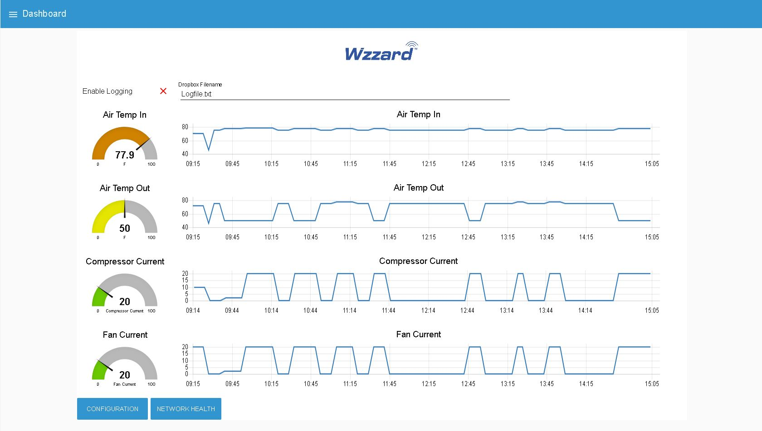

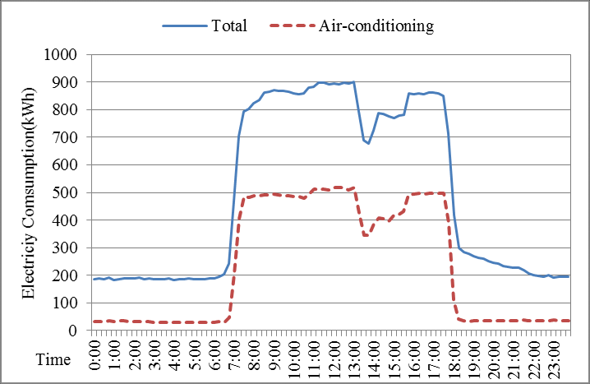

**References**

* https://iceblast.com.au/direct-expansion-dx-air-conditioning-faq/#:~:text=Depending%20on%20specific%20requirements%2C%20DX,or%20water%2Dcooled%20condensing%20options.
* https://www.yourbestdigs.com/window-ac-watts-usage/
* https://www.jackery.com/blogs/news/how-many-watts-does-a-window-ac-use#:~:text=A%20large%20window%20AC%20can,watts%20of%20power%20per%20hour.
* https://www.cnet.com/home/energy-and-utilities/btus-an-important-air-conditioner-term-you-may-be-overlooking/#:~:text=If%20your%20space%20is%20300,footage%20from%20550%20to%20800.
* https://www.appliancesonline.com.au/article/heating-and-cooling/air-conditioners/what-size-air-conditioner-do-you-need/
* https://homeparticle.com/power-consumption-of-ac-per-hour/
* https://homeairguides.com/how-much-electricity-watts-does-a-window-ac-use-air-conditioner-monthly-cost-guide/
* https://digital.library.ncat.edu/cgi/viewcontent.cgi?article=1209&context=theses
* https://inspectapedia.com/aircond/Air_Flow_Rates.php
* http://www.fsec.ucf.edu/en/publications/html/FSEC-PF-321-97/index.htm#:~:text=Manufacturer%20recommended%20air%20flow%20rates,per%20kW)%20of%20cooling%20capacity.
* https://learnmetrics.com/fpm-to-cfm/
* <https://advantech-bb.com/pr-bbsmartworx-hvac-monitoring-wzzard/wzzard-hvac-dashboard/>
* https://homeparticle.com/power-consumption-of-ac-per-hour/
* <https://www.researchgate.net/figure/Total-and-air-conditioning-electricity-consumption-on-the-similar-day-Baseline_fig2_329842340>
* https://www.sciencedirect.com/science/article/pii/S2352484722013944