**CHAPTER-2**

**Introduction to BIOS/UEFI Firmware:**

BIOS stands for "Basic" "Input" "Output" "System". When a computer starts (power is first applied) there must be some program code which the CPU executes. This code executes before the operating system (Windows, Linux, etc.) loads. This code is contained in a memory chip(s) on the motherboard. When you start your computer anything you see on the screen before the operating system starts comes from code in the BIOS. This is why if a BIOS update fails or the BIOS becomes corrupt the computer appears to be dead; there is no code to execute. When BIOS code executes, it establishes a fixed software foundation which allows the operating system to link to the hardware on the motherboard. As CPUs and motherboard technology have become faster and more complex the size and speed of the memory chips required to store the BIOS code have also grown.[ COMPUTER BIOS HISTORY.htm]

The Unified Extensible Firmware Interface (UEFI) is a specification that defines a software interface between an operating system and platform firmware. UEFI replaces the Basic Input/Output System (BIOS) firmware interface originally present in all IBM PC-compatible personal computers,[1][2] with most UEFI firmware implementations providing legacy support for BIOS services. UEFI can support remote diagnostics and repair of computers, even with no operating system installed.[3] The user can enter a setup utility by pressing their manufacturers specific setup keys.[ Unified Extensible Firmware Interface - Wikipedia.htm]

Firmware is a special class of software, so called because it is more or less permanently stored on chips. Firmware is often referred to generically as a BIOS (Basic Input/Output System) because the only firmware contained in early PCs was the main system ROM-BIOS (Read-Only Memory BIOS). That's no longer true. Nearly every component in a modern PC contains its own firmware. Disk drives, SCSI host adapters, video cards, sound cards, keyboards, and most other devices contain firmware, and nowadays that firmware is seldom read-only.[O'RELLY 1.2.3. Firmware Components and the PC BIOS - PC Hardware in a Nutshell, 3rd Edition [Book].htm]

[https://upload.wikimedia.org/wikipedia/commons/4/4e/Efi-simple.svg]

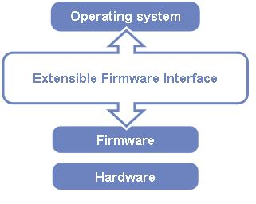

*Fig:- Diagram of Extensible Firmware Interface's position in the software stack*

**Booting a Computer:***.*