**Project Title:**Smart Public Restroom

**Project description:**

A smart toilet, by definition, uses integrated technology and data to interact and connect with the user. It's designed to improve the hygiene level and personal cleansing experience. Moreover, it gives insight to stakeholders to save manpower & resources, and enhances safety, operations and customer experience.

The concept of modern smart toilets [**originated in Japan in the 1980s**](https://www.lifewire.com/what-is-a-smart-toilet-4628135)**.** Kohler released the world's first smart toilet named Numi in 2011, which allows users to set their ambient lighting, adjust the water temperature, and enjoy music with the built-in radio. Now, as technology marches forward, smart toilets have been hailed as the next big thing with more advanced functions and features.

These new modern toilets are part of China's efforts to implement AI into daily life and come hot on the heels of [smart bins](https://www.guardforce.com.hk/en/security-technologies/smart-bin) and AI-powered traffic lights.

There are many high-tech public toilets in Hong Kong tourist spots to overhaul conditions in the city's public conveniences. [Shanghai has also built around 150 smart public restrooms](https://www.scmp.com/tech/innovation/article/3033187/reading-book-shanghai-toilet-could-be-bad-idea-if-you-dont-want-be)to improve their tarnished image.

A smart toilet system is also a saviour for the organizations where they have to manage multiple toilets - it reduces manpower and keeps restrooms cleaner. The system can also assist cleaning companies in managing their staff and timetables effectively.

**IoT implementation:**

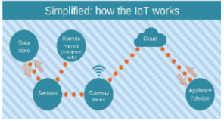

Sound sensor or mic sensor provides digital output and it detects sound from atmosphere. A WiFi module is also connected to Arduino and it is used to transfer data from the sensors to cloud server. ESP8266 WiFi module is used to store the data to online server. The data from sensor are basically analog signal so analog to digital converter (ADC) is used to convert the data. 16 x 2 Liquid crystal display (LCD) is used to display the measured value from the sensors. It can display two lines and each line has 16 characters.

**Methodology:**

The MQ-135 sensor detects the stench of the toilet. The presence of ammonia gas in the atmosphere is detected by this sensor. The presence of Ammonia is responsible for the toilet's foul odour. Ammonia has a pungent odour that can only be perceived at a concentration of 5 parts per million (parts per million).Fans automatically turn on when the ammonia content in the toilet exceeds the set threshold of 5 ppm, while levels below 5 ppm have no impact. Moving on to the next component, an infrared sensor is used to check for the presence of soap in the toilet.

**Block diagram:**

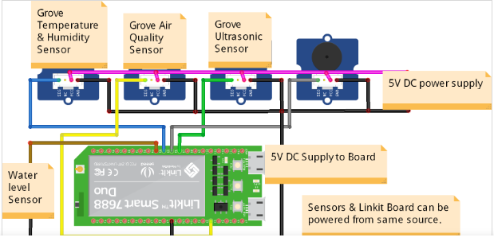

**Schematic :**

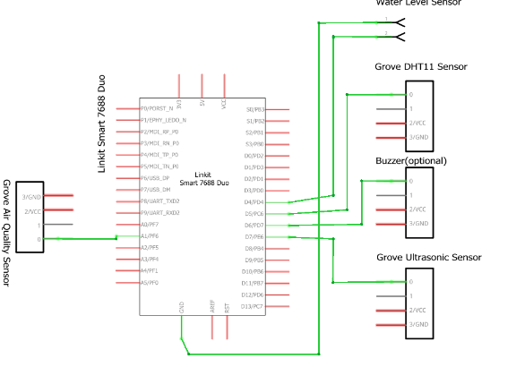

**App Development :**

As the app was created by using Visual Studio Code, the app will display the data takenfrom the sound sensor. Visual Studio Code is a software to create app use Python language todesign an Android development .Smart public toilet product solutions can monitor the temperature, humidity, odor and other environmental parameters in the public toilet through environmental monitoring sensors, and automatically adjust the temperature, humidity and ventilation system in the public toilet according to the parameters to improve comfort and hygiene.

**Benefits of using smart toilet:**

Improved Customer Satisfaction.

Optimized Cleaning for washroom.

Energy Saving with Optimized Heating and Air Conditioning.

Cost Saving in Inventory, Delivery, and Logistics.

**Conclusion:**

A rapid change of delivery and more rigid, developing conditions don’t need to lag your operations. With Faststream Technologies’s Smart Restroom solution, we’ll provide you with everything you need to digitize your [bathroom](https://www.faststreamtech.com/solutions/connected-smart-home-appliances/smart-bathroom-solutions/) and toilet operations and get the most out of your cleaning supplies, staff, and customer satisfaction.

We offer an integrated Smart Toilet Management system connected with the sensors, gateways, networks, and the cloud to get your data flowing into the software dashboard or platform. Our Smart Restroom systems will give data space usage or consumption of paper, hand wash, and soap in your washrooms along with smart toilet people counter.

Faststream’s smart restroom solution is ideal for client places such as large airports, shopping malls, stadiums, hospitals, and schools where large footfalls are common as it is able to identify any hygiene or operational issues, leaks or breakdowns, and send SMS alerts so your team can address the problem.