AWS WAF

AWS WAF is a web application firewall that protects web applications and APIs from common exploits and bots. It works by filtering, monitoring, and blocking malicious HTTP/S traffic, allowing you to create custom rules or use pre-configured ones to block attacks like SQL injection and cross-site scripting (XSS). You can deploy it with services like Amazon CloudFront, the Application Load Balancer, Amazon API Gateway, and AWS AppSync.
Key features of AWS WAF
- Custom and managed rules: Create your own rules to block specific traffic patterns or use pre-configured rule groups managed by AWS or other vendors. These managed rules are updated automatically as new threats emerge.
- Protection against common threats: Guards against common web exploits like SQL injection and cross-site scripting, as well as bots that can lead to account takeover, brute-force attacks, and other malicious activity.
- Rate-based rules: Block requests from a single IP address if they exceed a certain limit within a given time period.
- Deployment flexibility: Can be deployed at the edge with CloudFront for fast, distributed protection or with other AWS services like API Gateway, Application Load Balancer, and AWS AppSync.
- API for automation: Use the AWS WAF API to automate the deployment and maintenance of your security rules.
- Integration with AWS Shield: Works with AWS Shield Advanced for more comprehensive protection against distributed denial-of-service (DDoS) attacks.

AWS KMS (Key Management Service)
AWS KMS (Key Management Service) is a managed service that makes it easy to create and control encryption keys to protect data across AWS services and in your applications. It uses hardware security modules (HSMs) validated to FIPS 140-3 security standards to protect keys, ensures they never leave the service unencrypted, and integrates with other AWS services for centralized management and auditing via AWS CloudTrail.
Key features
- Centralized control: Provides a single place to manage encryption keys for various AWS services and applications.
- Hardware-based security: Keys are protected by HSMs that meet FIPS 140-3 security standards.
- Integration: Works seamlessly with over 75 AWS services, like Amazon S3, EBS, and RDS, to encrypt data at rest and in transit.
- Auditing and monitoring: Logs key usage and management activities in CloudTrail, allowing for detailed auditing of who used which keys and when.
- Key types: Supports different types of keys, including customer-managed, AWS-managed, and AWS-owned keys.
- Advanced cryptographic operations: Offers features beyond simple encryption and decryption, such as re-encryption, message signing, and generating cryptographic-quality random numbers.

AWS X-RAY
https://aws.amazon.com/xray/features/
AWS X-Ray makes it easy for developers to analyze the behavior of their production, distributed applications with end-to-end tracing capabilities. You can use X-Ray to identify performance bottlenecks, edge case errors, and other hard to detect issues. X-Ray supports applications, either in development or in production, of any type or size, from simple asynchronous event calls and three-tier web applications to complex distributed applications built using a microservices architecture. This enables developers to quickly find and address problems in their applications and improve the experience for end users of their applications.
AWS X-Ray can be used with applications running on Amazon Elastic Compute Cloud (EC2), Amazon EC2 Container Service (Amazon ECS), AWS Lambda, AWS Elastic Beanstalk. It’s easy to get started with X-Ray. You just integrate the X-Ray SDK with your application and install the X-Ray agent. With AWS Elastic Beanstalk, you only have to integrate the X-Ray SDK with your application since the X-Ray agent is pre-installed on Elastic Beanstalk.

End-to-end tracing

Overview
AWS X-Ray provides an end-to-end, cross-service view of requests made to your application. It gives you an application-centric view of requests flowing through your application by aggregating the data gathered from individual services in your application into a single unit called a trace. You can use this trace to follow the path of an individual request as it passes through each service or tier in your application so that you can pinpoint where issues are occurring.
AWS X-Ray supports tracing for applications that are written in Node.js, Java, and .NET.

https://aws.amazon.com/elasticache/redis-vs-memcached/
Redis vs Memcached:
Redis and Memcached are popular, open-source, in-memory data stores. Although they are both easy to use and offer high performance, there are important differences to consider when choosing an engine. Memcached is designed for simplicity while Redis offers a rich set of features that make it effective for a wide range of use cases.
Redis lets you create multiple replicas of a Redis primary. This allows you to scale database reads and to have highly available clusters. The replication support makes Redis a more reliable solution than Memcached.
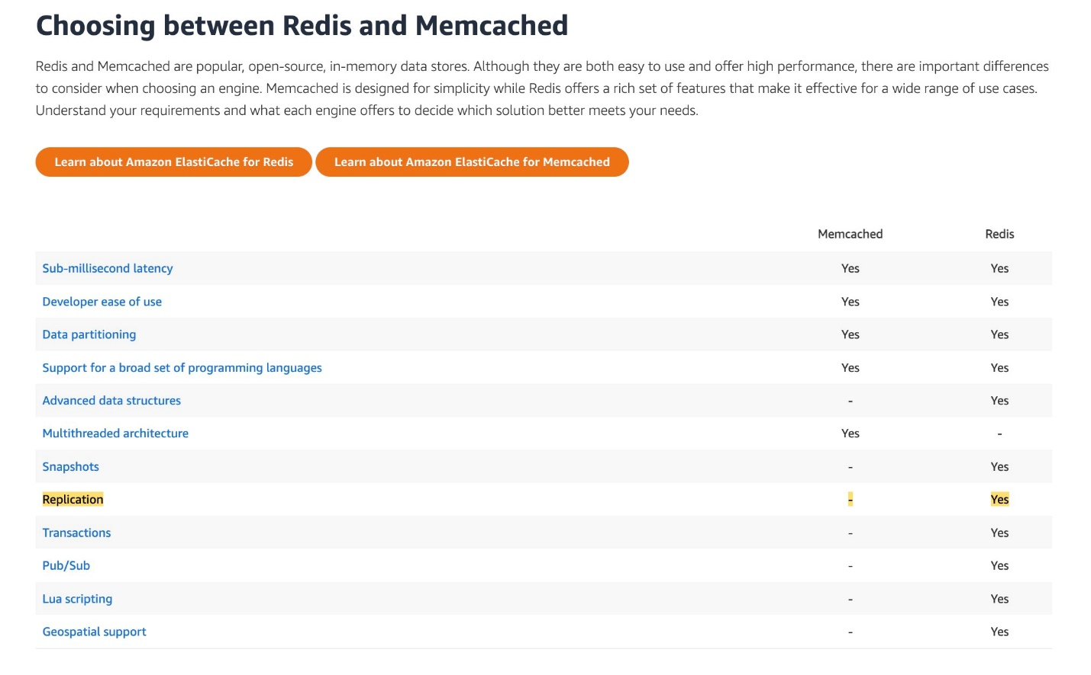

Store the data in Apache ORC, partitioned by date and sorted by device type of the device - Apache Parquet and ORC are columnar storage formats that are optimized for fast retrieval of data and used in AWS analytical applications.
By partitioning your data, you can restrict the amount of data scanned by each query, thus improving performance and reducing cost. You can partition your data by any key. A common practice is to partition the data based on time, often leading to a multi-level partitioning scheme. For example, a customer who has data coming in every hour might decide to partition by year, month, date, and hour. Another customer, who has data coming from many different sources but that is loaded only once per day, might partition by a data source identifier and date.
For the given use case, as the company does daily analysis, so it only needs to look at the data generated for a given date. Hence partitioning by date offers significant performance and cost advantages. Since the company also wants to analyze product improvements for each device type, it is better to keep the data sorted by device type, so it allows for faster query execution.

No, Amazon GuardDuty cannot block all malicious code, but it can automatically block certain malicious DNS activity when integrated with Route 53 Resolver DNS Firewall. Its main function is to detect and alert on threats, and it can be used to trigger automated responses to block specific malicious activity based on the findings it generates. For example, GuardDuty can initiate malware scans on EC2 instances and S3 buckets, and its findings can trigger other AWS services to take action, such as blocking network connections.
How GuardDuty works with blocking malicious activity
- DNS: GuardDuty can automatically block suspicious DNS requests when integrated with Route 53 Resolver DNS Firewall.
- Malware: It can automatically scan EBS volumes and newly uploaded S3 objects for malware. When malware is found, it generates a finding and can trigger automated responses through services like AWS Security Hub or Amazon EventBridge to take action.
- Network: It can detect suspicious network activity, and you can use its findings to configure security groups, Network Access Control Lists (NACLs), or other services to block the traffic.
- Container: It provides runtime monitoring for container workloads to detect suspicious behavior, and its findings can be used to trigger responses to block malicious activity in EKS clusters or ECS workloads.
Key limitations
- Detection vs. blocking: GuardDuty is primarily a threat detection service. Blocking malicious activity requires integrating it with other services like Route 53 Resolver DNS Firewall or using its findings to programmatically update security rules.
- Historical data: GuardDuty does not analyze historical data. It only starts monitoring and analyzing activity after it is enabled.
- Finding-based action: For actions other than the specific DNS blocking feature, GuardDuty generates a finding. You must then set up a separate automated response through a service like EventBridge to act on that finding, which includes blocking malicious traffic.
AWS WAF is a web application firewall that helps protect web applications and APIs from attacks. It enables you to configure a set of rules (called a web access control list (web ACL)) that allow, block, or count web requests based on customizable web security rules and conditions that you define. You can protect the following resource types:
- Amazon CloudFront distribution
- Amazon API Gateway REST API
- Application Load Balancer
- AWS AppSync GraphQL API
- Amazon Cognito user pool
You can use AWS WAF to protect your API Gateway API from common web exploits, such as SQL injection and cross-site scripting (XSS) attacks. These could affect API availability and performance, compromise security, or consume excessive resources. For example, you can create rules to allow or block requests from specified IP address ranges, requests from CIDR blocks, requests that originate from a specific country or region, requests that contain malicious SQL code, or requests that contain malicious scripts.
DDoS attacks are attempts by an attacker to disrupt the availability of targeted systems. For infrastructure layer attacks, you can use AWS services such as Amazon CloudFront and Elastic Load Balancing (ELB) to provide automatic DDoS protection. For application layer attacks, you can use AWS WAF as the primary mitigation. AWS WAF web access control lists (web ACLs) minimize the effects of a DDoS attack at the application layer.
How WAF works:
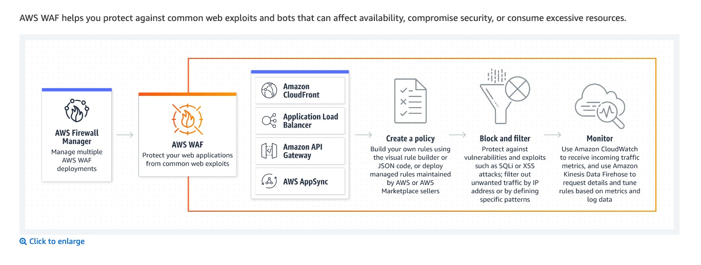
via - https://aws.amazon.com/waf/
GuardDuty is an intelligent threat detection service that continuously monitors your AWS accounts, Amazon Elastic Compute Cloud (EC2) instances, Amazon Elastic Kubernetes Service (EKS) clusters, and data stored in Amazon Simple Storage Service (S3) for malicious activity without the use of security software or agents. If potential malicious activity, such as anomalous behavior, credential exfiltration, or command and control infrastructure (C2) communication is detected, GuardDuty generates detailed security findings that can be used for security visibility and assisting in remediation. GuardDuty can monitor reconnaissance activities by an attacker such as unusual API activity, intra-VPC port scanning, unusual patterns of failed login requests, or unblocked port probing from a known bad IP.
How GuardDuty works:
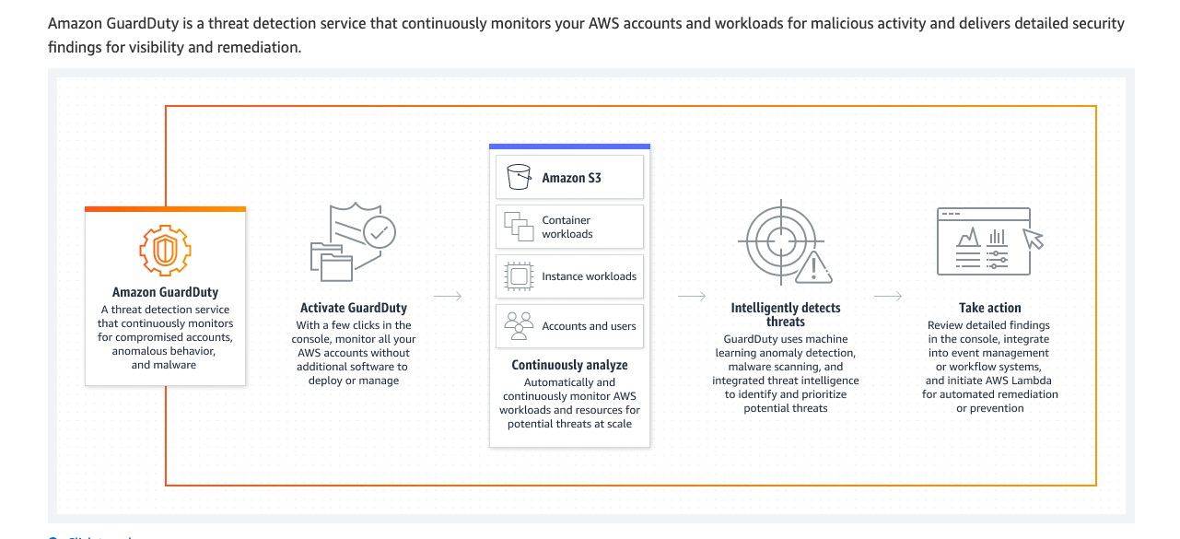
via - https://aws.amazon.com/guardduty/
Amazon Inspector is an automated vulnerability management service that continually scans Amazon Elastic Compute Cloud (EC2) and container workloads for software vulnerabilities and unintended network exposure.
How Amazon Inspector works:
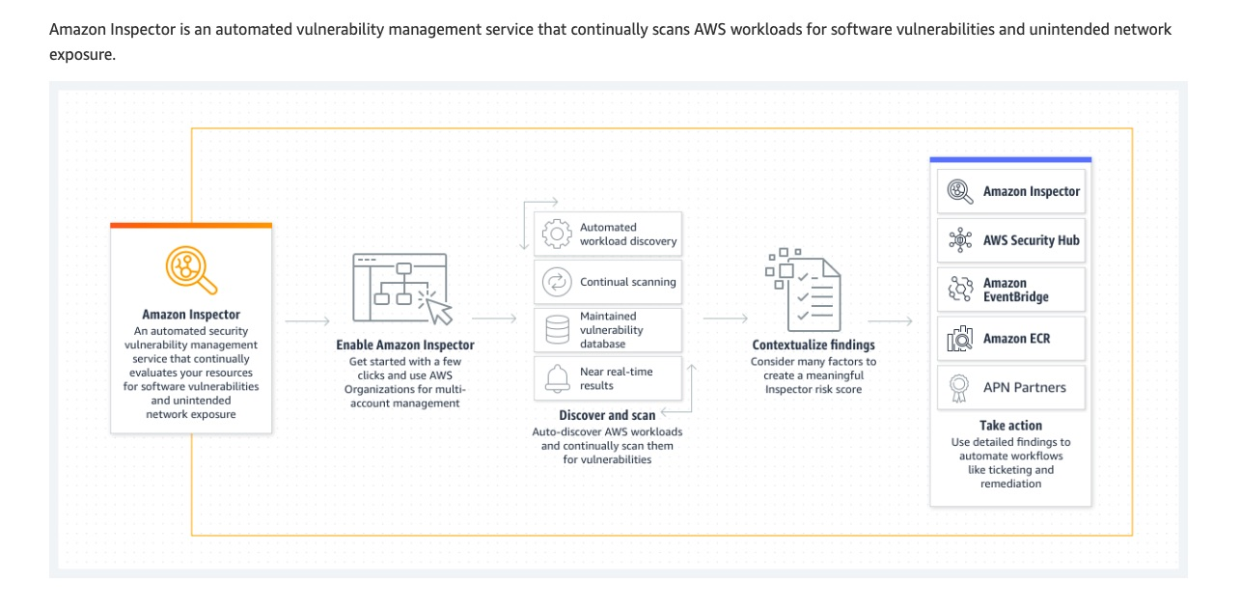
via - https://aws.amazon.com/inspector

Correct option:
Leverage AWS DataSync to transfer the biological data to Amazon S3. Use S3 events to trigger an AWS Lambda function that starts an AWS Step Functions workflow for orchestrating an AWS Batch job that processes the biological data
AWS DataSync is an online data movement and discovery service that simplifies and accelerates data migrations to AWS as well as moving data between on-premises storage, edge locations, other clouds, and AWS Storage. You can use DataSync to migrate active data to AWS, archive data to free up on-premises storage capacity, replicate data to AWS for business continuity, or transfer data to the cloud for analysis and processing.
For data transfer between on-premises and AWS Storage services, a single DataSync task is capable of fully utilizing a 10 Gbps network link. Since each workflow job consumes around 100GB of data and the company sees approximately 20 runs every day, DataSync can easily handle such active data transfer workloads. For the given use case, you can then configure an S3 event to trigger an AWS Lambda function that starts an AWS Step Functions workflow for orchestrating an AWS Batch job that processes the biological data.

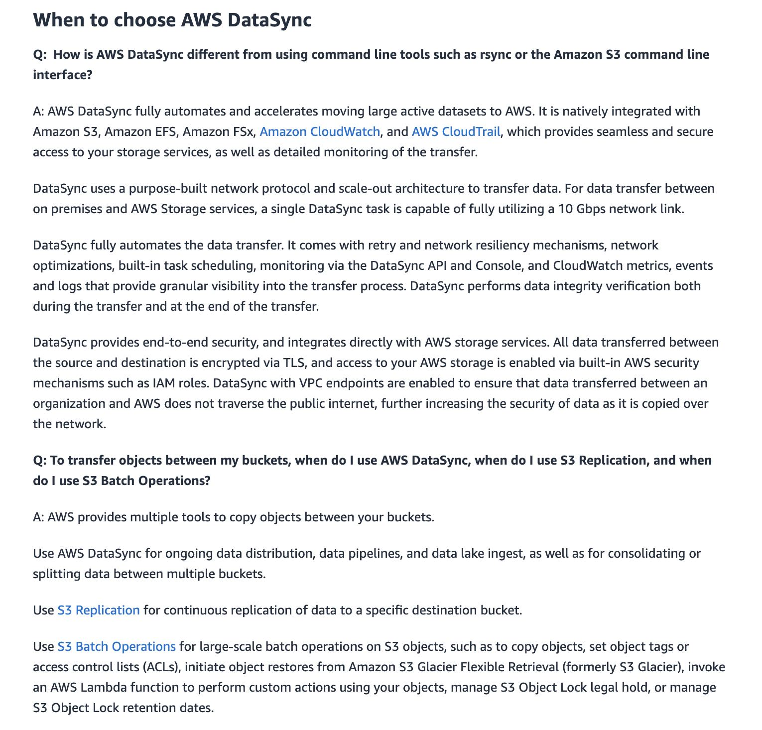
via - https://aws.amazon.com/datasync/faqs/
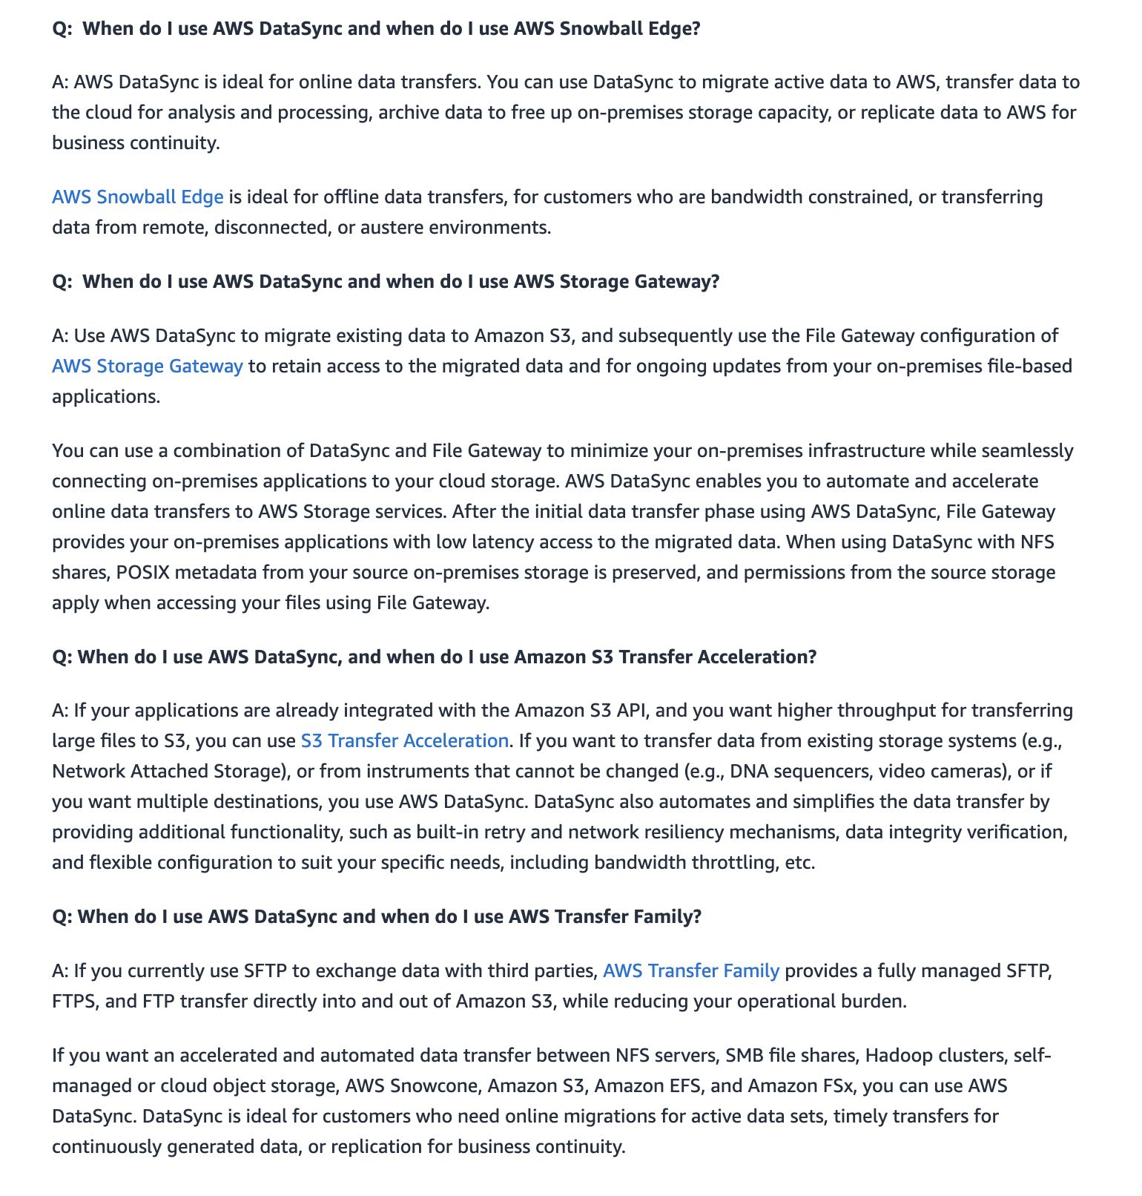
via - https://aws.amazon.com/datasync/faqs/

Document DB doesn’t support the interface nor gateway VPC. Whereas, Dynamo DB supports it.

Amazon Elastic File System (Amazon EFS) cannot be configured as an origin for a CloudFront distribution. Whereas S3 can be configured as an origin for a CloudFront distribution.

The main use case for AWS Media Services is to deliver live content to a global audience.

EFS is about three times costlier than S3.

Details on Object ownership in S3 buckets:
https://docs.aws.amazon.com/AmazonS3/latest/userguide/about-object-ownership.html

To see which Object Ownership settings are applied to your buckets, you can use Amazon S3 Storage Lens metrics. S3 Storage Lens is a cloud-storage analytics feature that you can use to gain organization-wide visibility into object-storage usage and activity. For more information, see Using S3 Storage Lens to find Object Ownership settings.

Changes introduced by disabling ACLs
When the Bucket owner enforced setting for Object Ownership is applied, ACLs are disabled and you automatically own and take full control over every object in the bucket without taking any additional actions. Bucket owner enforced is the default setting for all newly created buckets. After the Bucket owner enforced setting is applied, you will see three changes:
- All bucket ACLs and object ACLs are disabled, which gives full access to you, as the bucket owner. When you perform a read ACL request on your bucket or object, you will see that full access is given only to the bucket owner.
- You, as the bucket owner, automatically own and have full control over every object in your bucket.
- ACLs no longer affect access permissions to your bucket. As a result, access control for your data is based on policies, such as AWS Identity and Access Management (IAM) identity-based policies, Amazon S3 bucket policies, VPC endpoint policies, and Organizations service control policies (SCPs) or resource control policies (RCPs).

Secrets Manager can't rotate secrets for AWS services running in Amazon VPC private subnets because these subnets don't have internet access. To rotate the keys successfully you need to configure an Amazon VPC interface endpoint to access your Secrets Manager Lambda function and private Amazon Relational Database Service (Amazon RDS) instance.
Steps that need to be followed: 1. Create security groups for the Secrets Manager VPC endpoint, Amazon RDS instance, and the Lambda rotation function 2. Add rules to Amazon VPC endpoint and Amazon RDS instance security groups 3. Attach security groups to AWS resources 4. Create an Amazon VPC interface endpoint for the Secrets Manager service and associate it with a security group 5. Verify that the Secrets Manager can rotate the secret

The main differences are that VPC Gateway Endpoints are free, only support Amazon S3 and DynamoDB, and are configured via route tables, while VPC Interface Endpoints have a cost, support a wide range of AWS services, use private IP addresses via Elastic Network Interfaces (ENIs), and support security groups. Interface endpoints also enable access from on-premises and other VPCs, while gateway endpoints are limited to the VPC where they are created.

Feature | VPC Gateway Endpoint | VPC Interface Endpoint
Services Supported | Only Amazon S3 and Amazon DynamoDB | A wide range of AWS services, including AWS PrivateLink services, Marketplace partner services, and SQS
Cost | Free | Incurs hourly charges and data processing fees
Configuration | Uses route tables to direct traffic to the endpoint | Creates ENIs in your subnets with private IP addresses
Security Groups | Does not support security groups | Supports security groups for traffic control
Access | Limited to the VPC in which it is created | Supports access from other VPCs (via peering), across regions, and from on-premises environments
Private IP | No private IP addresses are used for routing | Uses a private IP address from an ENI to route traffic

Enable Amazon S3 server access logging to capture all bucket-level and object-level events
Enable AWS CloudTrail data events to enable object-level logging for S3 bucket
To find the IP addresses for object-level requests to Amazon S3 (uploads and downloads), you must first enable one of the following logging methods:
- Amazon S3 server access logging captures all bucket-level and object-level events. These logs use a format similar to Apache web server logs. After you enable server access logging, review the logs to find the IP addresses used with each upload to your bucket.
- AWS CloudTrail data events capture the last 90 days of bucket-level events (for example, PutBucketPolicy and DeleteBucketPolicy), and you can enable object-level logging. These logs use a JSON format. After you enable object-level logging with data events, review the logs to find the IP addresses used with each upload to your bucket. It might take a few hours for AWS CloudTrail to start creating logs.

