**BLOGGING APPLICATION**

**1.CLASS DIAGRAM**

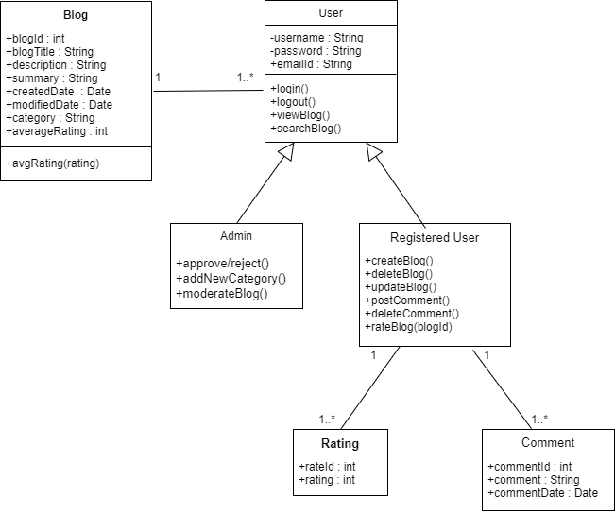

Fig .1 Class Diagram

**2.ER DIAGRAM**

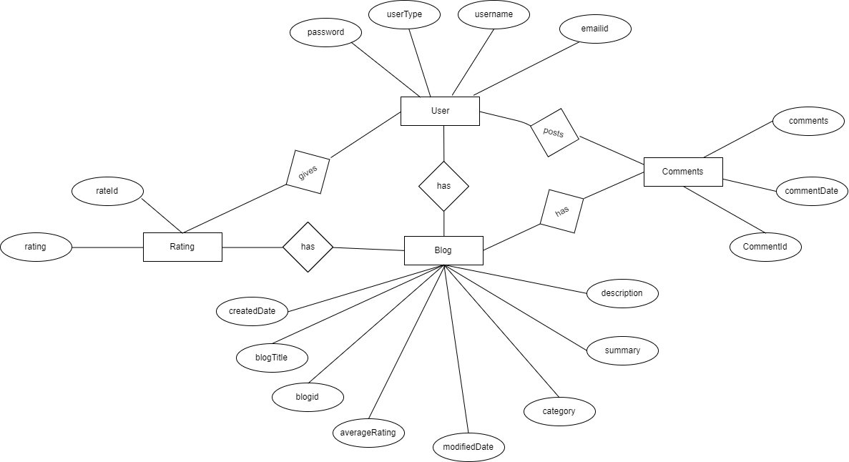

Fig .2 ER Diagram

**3.SEQUENCE DIAGRAM**

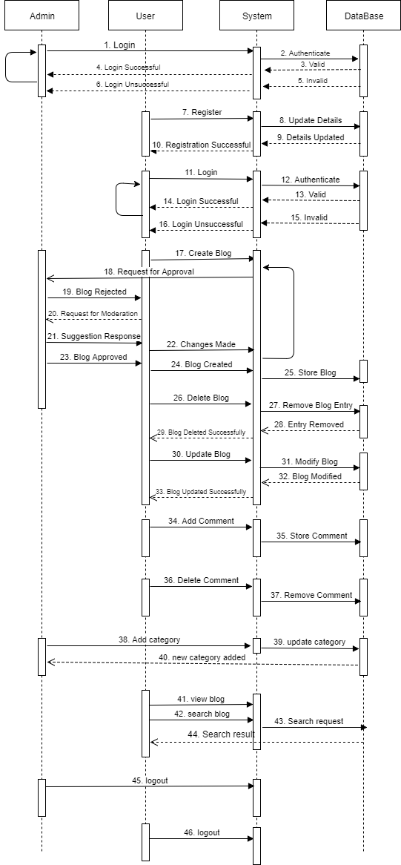

Fig .3 Sequence Diagram

**4.DATABASE SCHEMA**

|  |  |  |
| --- | --- | --- |
| **TABLE :** | **USERS** |  |
| **COLUMN NAME** | **DATATYPE** | **CONSTRAINT** |
| userType | VARCHAR(25) |  |
| username | VARCHAR(25) | PRIMARY KEY |
| password | VARCHAR(30) |  |
| emailId | VARCHAR(25) |  |

Table No. 01

|  |  |  |
| --- | --- | --- |
| **TABLE NAME :** | **BLOG** |  |
| **COLUMN NAME** | **DATATYPE** | **CONSTRAINT** |
| blogId | AUTO_NUMBER | PRIMARY KEY |
| blogTitle | VARCHAR2 |  |
| category | VARCHAR2 |  |
| createdDate | TIMESTAMP |  |
| modifiedDate | TIMESTAMP |  |
| summary | VARCHAR2 |  |
| description | VARCHAR2 |  |
| averageRating | NUMBER |  |

Table No. 02

|  |  |  |
| --- | --- | --- |
| **TABLE :** | **COMMENTS** |  |
| **COLUMN NAME** | **DATATYPE** | **CONSTRAINT** |
| commentId | AUTO_NUMBER(4) | PRIMARY KEY |
| comments | TINYTEXT |  |
| username | VARCHAR(25) | FOREIGN KEY |
| blogId | NUMBER(4) | FOREIGN KEY |

Table No. 03

|  |  |  |
| --- | --- | --- |
| **TABLE :** | **RATINGS** |  |
| **COLUMN NAME** | **DATATYPE** | **CONSTRAINT** |
| rateId | AUTO_NUMBER(4) | PRIMARY KEY |
| rating | NUMBER(1) |  |
| username | VARCHAR2 | FOREIGN KEY |
| blogId | NUMBER(4) | FOREIGN KEY |

Table No.04

**5.USECASE DIAGRAM**

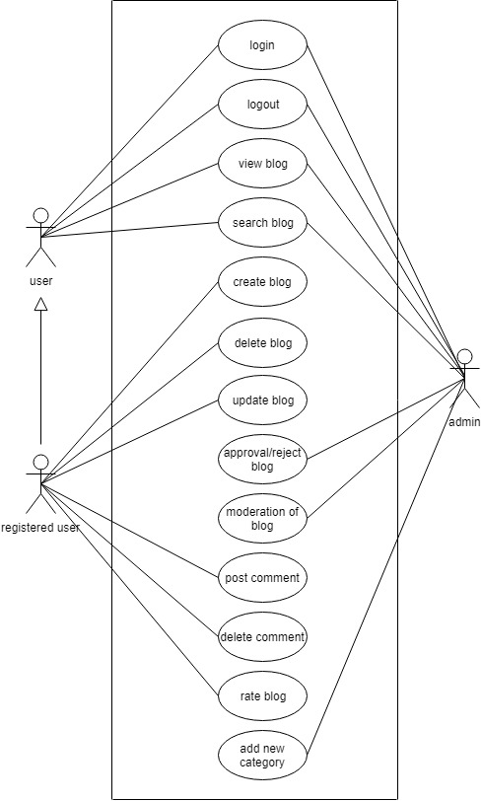

Fig .4 Usecase Diagram