How HBase stores data in table
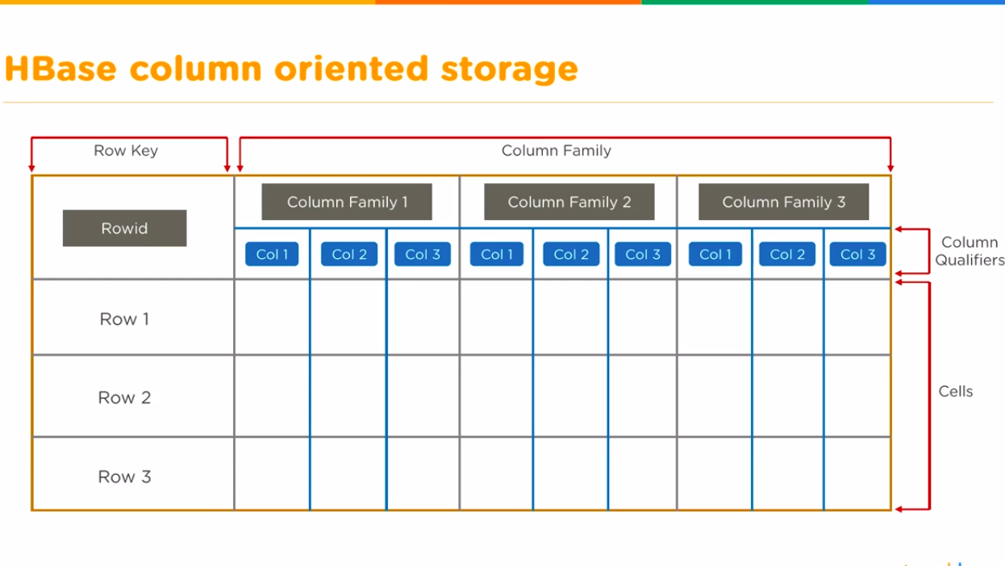
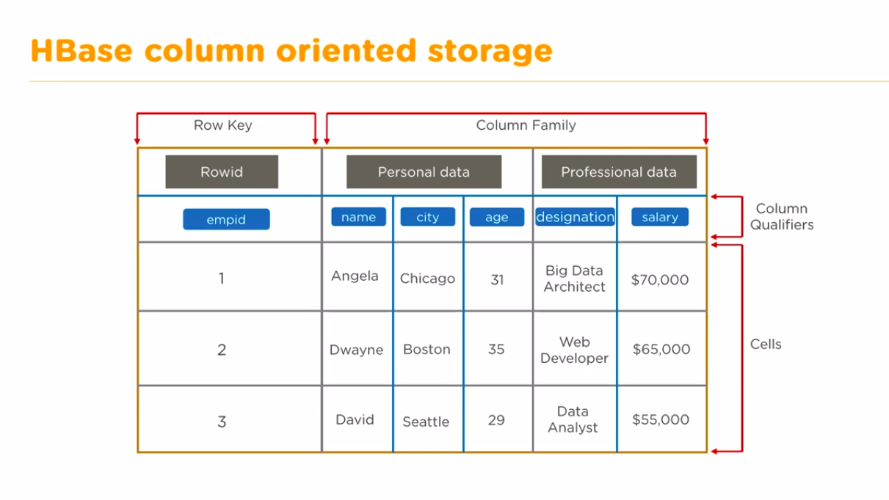

HBase General Commands

In Hbase, general commands are categorized into following commands
- Status
- Version
- Table_help ( scan, drop, get, put, disable, etc.)
- Whoami
To get enter into HBase shell command, first of all, we have to execute the code as mentioned below

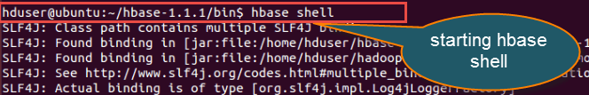

Once we get to enter into HBase shell, we can execute all shell commands mentioned below. With the help of these commands, we can perform all type of table operations in the HBase shell mode.

Let us look into all of these commands and their usage one by one with an example.

- Status
Syntax:-hbase(main):001:0>status

This command will give details about the system status like a number of servers present in the cluster, active server count, and average load value. You can also pass any particular parameters depending on how detailed status you want to know about the system. The parameters can be 'summary', 'simple', or 'detailed', the default parameter provided is "summary".
Below we have shown how you can pass different parameters to the status command.

hbase(main):002:0>status 'simple'

hbase(main):003:0>status 'summary'
hbase(main):004:0> status 'detailed'

If we observe the below screen shot, we will get a better idea.

Syntax: hbase(main):001:0>status

When we execute this command status, it will give information about number of server's present, dead servers and average load of server, here in screenshot it shows the information like- 1 live server, 1 dead servers, and 7.0000 average load.

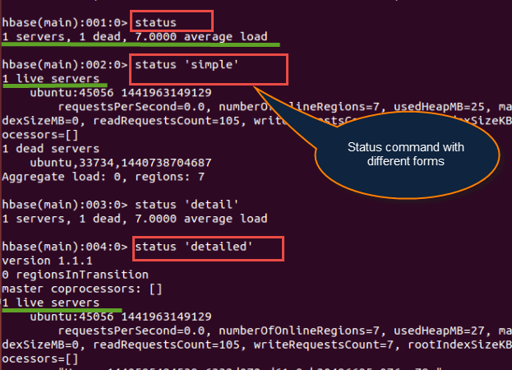
Version
Syntax:hbase(main):005:0> version
  - This command will display the currently used HBase version in command mode
  - If you run version command, it will give output as shown above
- Table help
Syntax: hbase(main) :007:0>table_help

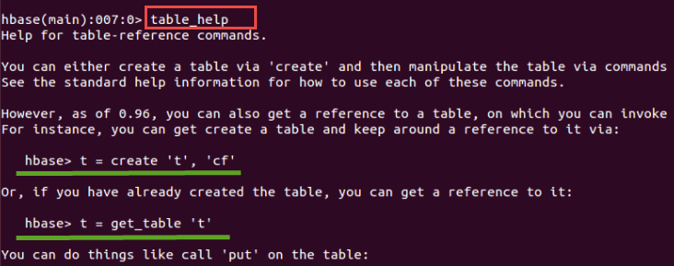
- This command guides
  - What and how to use table-referenced commands
  - It will provide different HBase shell command usages and its syntaxes
  - Here in the screen shot above, its shows the syntax to "create" and "get_table" command with its usage. We can manipulate the table via these commands once the table gets created in HBase.
  - It will give table manipulations commands like put, get and all other commands information.
- whoami
Syntax: hbase(main):006:0> Whoami

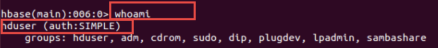

- This command "whoami" is used to return the current HBase user information from the HBase cluster.
It will provide information like
  - Groups present in HBase
  - The user information, for example in this case "hduser" represent the user name as shown in screen shot
- TTL(Time To Live) - Attribute
In HBase, Column families can be set to time values in seconds using TTL. HBase will automatically delete rows once the expiration time is reached. This attribute applies to all versions of a row – even the current version too.
The TTL time encoded in the HBase for the row is specified in UTC. This attribute used with table management commands.
Important differences between TTL handling and Column family TTLs are below
  - Cell TTLs are expressed in units of milliseconds instead of seconds.
  - A cell TTLs cannot extend the effective lifetime of a cell beyond a Column Family level TTL setting.

Tables Managements commands
These commands will allow programmers to create tables and table schemas with rows and column families.

The following are Table Management commands
- Create
- List
- Describe
- Disable
- Disable_all
- Enable
- Enable_all
- Drop
- Drop_all
- Show_filters
- Alter
- Alter_status
Let us look into various command usage in HBase with an example.
- Create
Syntax:hbase>create<tablename>,<columnfamilynam>
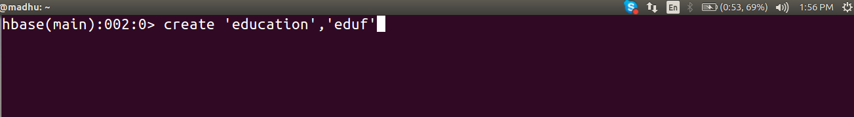
Example:
hbase(main):002:0> create 'education','eduf'
0 row(s) in 2.7400 seconds
=> Hbase::Table – education

The above example explains how to create a table in HBase with the specified name given according to the dictionary or specifications as per column family. In addition to this we can also pass some table-scope attributes as well into it.
In order to check whether the table 'education' is created or not, we have to use the "list" command as mentioned below.

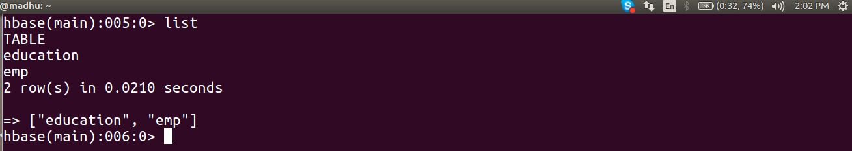
"List" command will display all the tables that are present or created in HBase
- The output showing in above screen shot is currently showing the existing tables in HBase
- Here in this screenshot, it shows that there are total 8 tables present inside HBase
- We can filter output values from tables by passing optional regular expression parameters

Describe
Syntax: hbase>describe <table name>
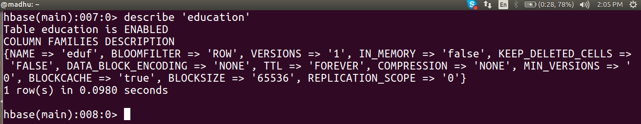
This command describes the named table.
- It will give more information about column families present in the mentioned table
- In our case, it gives the description about table "education."
- It will give information about table name with column families, associated filters, versions and some more details.

disable
Syntax: hbase>disable <tablename>
This command will start disabling the named table
  - If table needs to be deleted or dropped, it has to disable first
Here, in the above screenshot we are disabling table education

disable_all
Syntax:- hbase>disable_all<"matching regex"

  - This command will disable all the tables matching the given regex.
  - The implementation is same as delete command (Except adding regex for matching)
  - Once the table gets disable the user can able to delete the table from HBase
  - Before delete or dropping table, it should be disabled first
- Enable
Syntax: hbase>enable <tablename>

This command will start enabling the named table
  - Whichever table is disabled, to retrieve back to its previous state we use this command
  - If a table is disabled in the first instance and not deleted or dropped, and if we want to re-use the disabled table then we have to enable it by using this command.
  - Here in the above screenshot we are enabling the table "education."
- show_filters
Syntax:hbase>show_filters

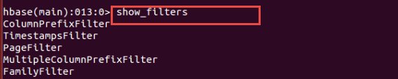
This command displays all the filters present in HBase like ColumnPrefix Filter, TimestampsFilter, PageFilter, FamilyFilter, etc.
- drop
Syntax:hbase>drop <table name>
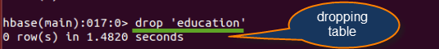
We have to observe below points for drop command
  - To delete the table present in HBase, first we have to disable it
  - To drop the table present in HBase, first we have to disable it
  - So either table to drop or delete first the table should be disable using disable command
  - Here in above screenshot we are dropping table "education."
  - Before execution of this command, it is necessary that you disable table "education."

- drop_all
Syntax:Hbase>drop_all<"regex">
  - This command will drop all the tables matching the given regex
  - Tables have to disable first before executing this command using disable_all
  - Tables with regex matching expressions are going to drop from HBase
- is_enabled
Syntax:hbase>is_enabled 'education'

- This command will verify whether the named table is enabled or not. Usually, there is a little confusion between "enable" and "is_enabled" command action, which we clear here
  - Suppose a table is disabled, to use that table we have to enable it by using enable command
  - is_enabled command will check either the table is enabled or not
- alter
Syntax:- hbase> alter <tablename>, NAME=><column familyname>, VERSIONS=>5

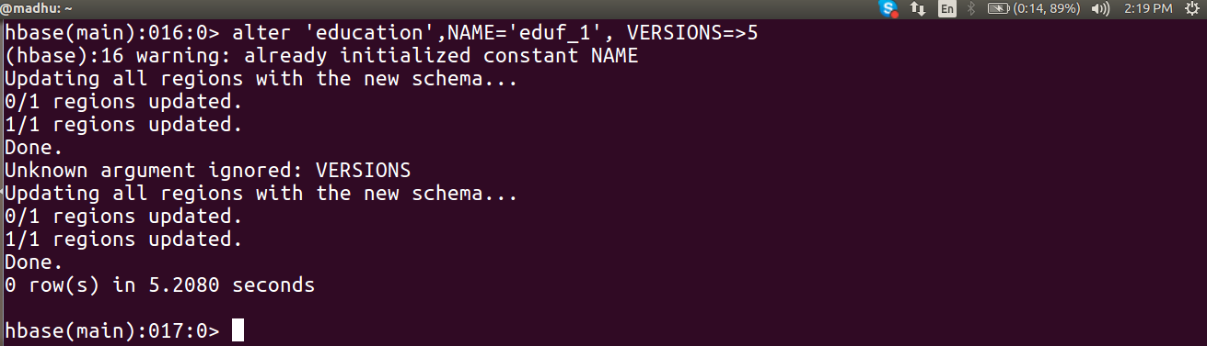
This command alters the column family schema. To understand what exactly it does, we have explained it here with an example.
Examples:
In these examples, we are going to perform alter command operations on tables and on its columns. We will perform operations like
- Altering single, multiple column family names
- Deleting column family names from table
- Several other operations using scope attributes with table
- To change or add the 'eduf_1' column family in table 'education' from current value to keep a maximum of 5 cell VERSIONS,
- "education" is table name created with column name "eduf" previously
- Here with the help of an alter command we are trying to change the column family schema to eduf_1 from eduf
hbase> alter 'education', NAME=>'eduf_1', VERSIONS=>5
- You can also operate the alter command on several column families as well. For example, we will define two new column to our existing table "education".
hbase> alter 'education', 'eduf_1', {NAME => 'eduf_2', IN_MEMORY => true}, {NAME => 'eduf_3', VERSIONS => 5}

We can change more than one column schemas at a time using this command
- eduf_2 and eduf_3 as shown in above screenshot are the two new column names that we have defined for the table education
- We can see the way of using this command in the previous screen shot
- In this step, we will see how to delete column family from the table. To delete the 'f1' column family in table 'education'.
Use one ofthese commands below,

hbase> alter 'education', NAME => 'f1', METHOD => 'delete'
hbase> alter 'education', 'delete' =>' eduf_1'

In this command, we are trying to delete the column space name eduf_1 that we previously created in the first step

As shown in the below screen shots, it shows two steps – how to change table scope attribute and how to remove the table scope attribute.
Syntax: hbase(main):002:0> alter <'tablename'>, MAX_FILESIZE=>'132545224'

Step 1) You can change table-scope attributes like MAX_FILESIZE, READONLY, MEMSTORE_FLUSHSIZE, DEFERRED_LOG_FLUSH, etc. These can be put at the end;for example, to change the max size of a region to 128MB or any other memory value we use this command.

Usage:
- We can use MAX_FILESIZE with the table as scope attribute as above
- The number represent in MAX_FILESIZE is in term of memory in bytes
NOTE: MAX_FILESIZE Attribute Table scope will be determined by some attributes present in the HBase. MAX_FILESIZE also come under table scope attributes.
Step 2) You can also remove a table-scope attribute using table_att_unset method. If you see the command
Syntax: hbase(main):003:0> alter 'education', METHOD => 'table_att_unset', NAME => 'MAX_FILESIZE'
- The above screen shot shows altered table name with scope attributes
- Method table_att_unset is used to unset attributes present in the table
- The second instance we are unsetting attribute MAX_FILESIZE
- After execution of the command, it will simply unset MAX_FILESIZE attribute from"education" table.
- alter_status
Syntax: hbase>alter_status 'education'
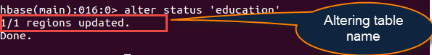
  - Through this command, you can get the status of the alter command
  - Which indicates the number of regions of the table that have received the updated schema pass table name
  - Here in above screen shot it shows 1/1 regions updated. It means that it has updated one region. After that if it successful it will display comment done.

Creating Table

You can create a table using the create command, here you must specify the table name and the Column Family name. The syntax to create a table in HBase shell is shown below.

create ‘<table name>’,’<column family>’

Example

Given below is a sample schema of a table named emp. It has two column families: “personal data” and “professional data”.

 | Row key |  |  | personal data |  |  | professional data

You can create this table in HBase shell as shown below.

hbase(main):002:0> create 'emp', 'personal data', ’professional data’

And it will give you the following output.

0 row(s) in 1.1300 seconds

=> Hbase::Table - emp

Verifying the Creation

You can verify whether the table is created using the list command as shown below. Here you can observe the created emp table.

hbase(main):002:0> list

TABLE

emp

2 row(s) in 0.0340 seconds

list

List is the command that is used to list all the tables in HBase. Given below is the syntax of the list command.

hbase(main):001:0 > list

When you type this command and execute in HBase prompt, it will display the list of all the tables in HBase as shown below.

hbase(main):001:0> list

TABLE

emp

Here you can observe a table named emp.

Creating Data

How to create data in an HBase table. To create data in an HBase table, the following commands and methods are used:

- put command,

- add() method of Put class, and

- put() method of HTable class.

As an example, we are going to create the following table in HBase.
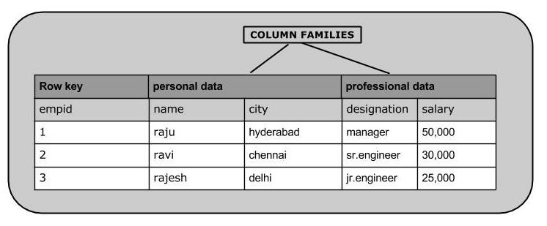

Using put command, you can insert rows into a table. Its syntax is as follows:

put ’<table name>’,’row1’,’<colfamily:colname>’,’<value>’

Inserting the First Row

Let us insert the first row values into the emp table as shown below.

hbase(main):005:0> put 'emp','1','personal data:name','raju' 0 row(s) in 0.6600 seconds
hbase(main):006:0> put 'emp','1','personal data:city','hyderabad' 0 row(s) in 0.0410 seconds

hbase(main):007:0> put 'emp','1','professional data:designation','manager'

0 row(s) in 0.0240 seconds

hbase(main):007:0> put 'emp','1','professional data:salary','50000' 0 row(s) in 0.0240 seconds

Insert the remaining rows using the put command in the same way. If you insert the whole table, you will get the following output.

hbase(main):022:0> scan 'emp'

ROW COLUMN+CELL

- column=personal data:city, timestamp=1417524216501, value=hyderabad

- column=personal data:name, timestamp=1417524185058, value=ramu

- column=professional data:designation, timestamp=1417524232601, value=manager

- column=professional data:salary, timestamp=1417524244109, value=50000

- column=personal data:city, timestamp=1417524574905, value=chennai

- column=personal data:name, timestamp=1417524556125, value=ravi

- column=professional data:designation, timestamp=1417524592204, value=sr:engg

- column=professional data:salary, timestamp=1417524604221, value=30000

- column=personal data:city, timestamp=1417524681780, value=delhi

3 column=personal data:name, timestamp=1417524672067, value=rajesh

- column=professional data:designation, timestamp=1417524693187, value=jr:engg

3 column=professional data:salary, timestamp=1417524702514,

value=25000

Updating Data

You can update an existing cell value using the put command. To do so, just follow the same syntax and mention your new value as shown below.

put ‘table name’,’row ’,'Column family:column name',’new value’

The newly given value replaces the existing value, updating the row.

Example

Suppose there is a table in HBase called emp with the following data.

hbase(main):003:0> scan 'emp'

ROW COLUMN+CELL

row1

row1

column=personal:name, timestamp=1418051555, value=raju column=personal:city, timestamp=1418275907, value=Hyderabad

row1 column=professional:designation, timestamp=14180555,value=manager

row1 column=professional:salary, timestamp=1418035791555,value=50000

1 row(s) in 0.0100 seconds

The following command will update the city value of the employee named ‘Raju’ to Delhi.

hbase(main):002:0> put 'emp','row1','personal:city','Delhi' 0 row(s) in 0.0400 seconds

The updated table looks as follows where you can observe the city of Raju has been changed to ‘Delhi’.

hbase(main):003:0> scan 'emp'

ROW COLUMN+CELL

row1 column=personal:name, timestamp=1418035791555, value=raju

row1 column=personal:city, timestamp=1418274645907, value=Delhi

row1 column=professional:designation, timestamp=141857555,value=manager

row1 column=professional:salary, timestamp=1418039555, value=50000

1 row(s) in 0.0100 seconds

Reading Data

The get command and the get() method of HTable class are used to read data from a table in HBase. Using get command, you can get a single row of data at a time. Its syntax is as follows:

get ’<table name>’,’row1’

The following example shows how to use the get command. Let us scan the first row of the emp table.

hbase(main):012:0> get 'emp', '1'
COLUMN |  | CELL
personal : | city | timestamp=1417521848375, | value=hyderabad
personal : | name | timestamp=1417521785385, | value=ramu
professional: designation |  | timestamp=1417521885277, | value=manager
professional: salary |  | timestamp=1417521903862, | value=50000
4 row(s) in 0.0270 seconds

Reading a Specific Column

Given below is the syntax to read a specific column using the get method.

hbase>get 'table name', ‘rowid’, {COLUMN => ‘column family:column name ’}

Given below is the example to read a specific column in HBase table.

hbase(main):015:0> get 'emp', 'row1', {COLUMN=>'personal:name'}

COLUMN CELL

personal:name timestamp=1418035791555, value=raju

1 row(s) in 0.0080 seconds

Deleting a Specific Cell in a Table

Using the delete command, you can delete a specific cell in a table. The syntax of delete command is as follows:

delete ‘<table name>’, ‘<row>’, ‘<column name >’, ‘<time stamp>’

Here is an example to delete a specific cell. Here we are deleting the salary.

hbase(main):006:0> delete 'emp', '1', 'personal data:city', 1417521848375

0 row(s) in 0.0060 seconds

Deleting All Cells in a Table

Using the “deleteall” command, you can delete all the cells in a row. Given below is the syntax of deleteall command.

deleteall ’<table name>’,’<row>’

Here is an example of “deleteall” command, where we are deleting all the cells of row1 of emp table.

hbase(main):007:0> deleteall 'emp','1' 0 row(s) in 0.0240 seconds

Verify the table using the scan command. A snapshot of the table after deleting the table is given below.

hbase(main):022:0> scan 'emp'

ROW COLUMN+CELL

- column=personal data:city, timestamp=1417524574905, value=chennai

- column=personal data:name, timestamp=1417524556125, value=ravi

- column=professional data:designation, timestamp=1417524204, value=sr:engg

- column=professional data:salary, timestamp=1417524604221, value=30000

- column=personal data:city, timestamp=1417524681780, value=delhi

3 column=personal data:name, timestamp=1417524672067, value=rajesh

- column=professional data:designation, timestamp=1417523187, value=jr:engg

- column=professional data:salary, timestamp=1417524702514, value=25000

scan

The scan command is used to view the data in HTable. Using the scan command, you can get the table data. Its syntax is as follows:

scan ‘<table name>’

The following example shows how to read data from a table using the scan command. Here we are reading the emp table.

hbase(main):010:0> scan 'emp'

ROW COLUMN+CELL

- column=personal data:city, timestamp=1417521848375, value=hyderabad

- column=personal data:name, timestamp=1417521785385, value=ramu

- column=professional data:designation, timestamp=1417585277,value=manager

1 column=professional data:salary, timestamp=1417521903862, value=50000

1 row(s) in 0.0370 seconds

count

You can count the number of rows of a table using the count command. Its syntax is as follows:

count ‘<table name>’

After deleting the first row, emp table will have two rows. Verify it as shown below.

hbase(main):023:0> count 'emp'

2 row(s) in 0.090 seconds

=> 2

truncate

This command disables drops and recreates a table. The syntax of truncate is as follows:

hbase> truncate 'table name'

Given below is the example of truncate command. Here we have truncated the emp table.

hbase(main):011:0> truncate 'emp'

Truncating 'one' table (it may take a while):

- Disabling table...

- Truncating table...

0 row(s) in 1.5950 seconds

After truncating the table, use the scan command to verify. You will get a table with zero rows.

hbase(main):017:0> scan ‘emp’’

ROW COLUMN+CELL 0 row(s) in 0.3110 seconds

We can grant and revoke permissions to users in HBase. There are three commands for security purpose: grant, revoke, and user_permission.

grant

The grant command grants specific rights such as read, write, execute, and admin on a table to a certain user. The syntax of grant command is as follows:

hbase> grant <user> <permissions> [<table> [<column family> [<column qualifier>]]

We can grant zero or more privileges to a user from the set of RWXCA, where

- R - represents read privilege.

- W - represents write privilege.

- X - represents execute privilege.

- C - represents create privilege.

- A - represents admin privilege.

Given below is an example that grants all privileges to a user named ‘Hbaseuser’.

hbase(main):018:0> grant 'Hbaseuser', 'RWXCA'

revoke

The revoke command is used to revoke a user's access rights of a table. Its syntax is as follows:

hbase> revoke <user>

The following code revokes all the permissions from the user named ‘Tutorialspoint’.

hbase(main):006:0> revoke 'Hbaseuser'

user_permission

This command is used to list all the permissions for a particular table. The syntax of user_permission is as follows:

hbase>user_permission ‘tablename’

The following code lists all the user permissions of ‘emp’ table.

hbase(main):013:0> user_permission '

Disable a Table

To delete a table or change its settings, you need to first disable the table using the disable command. You can re-enable it using the enable command.

Given below is the syntax to disable a table:

disable ‘emp’

Given below is an example that shows how to disable a table.

hbase(main):025:0> disable 'emp'

0 row(s) in 1.2760 seconds

Verification

After disabling the table, you can still sense its existence through list and exists commands. You cannot scan it. It will give you the following error.

hbase(main):028:0> scan 'emp'

ROW COLUMN+CELL

ERROR: emp is disabled.

is_disabled

This command is used to find whether a table is disabled. Its syntax is as follows.

hbase> is_disabled 'table name'

The following example verifies whether the table named emp is disabled. If it is disabled, it will return true and if not, it will return false.

hbase(main):031:0> is_disabled 'emp'

true
0 row(s) in 0.0440 seconds

disable_all

This command is used to disable all the tables matching the given regex. The syntax for disable_all command is given below.

hbase> disable_all 'r.*'

Suppose there are 5 tables in HBase, namely raja, rajani, rajendra, rajesh, and raju. The following code will disable all the tables starting with raj.

hbase(main):002:0> disable_all 'raj.*'

raja

rajani

rajendra

rajesh

raju

Disable the above 5 tables (y/n)?

y

5 tables successfully disabled

Enable a Table

Syntax to enable a table:

enable ‘emp’

Given below is an example to enable a table.

hbase(main):005:0> enable 'emp'

0 row(s) in 0.4580 seconds

Verification

After enabling the table, scan it. If you can see the schema, your table is successfully enabled.

hbase(main):006:0> scan 'emp'

ROW COLUMN+CELL

- column=personal data:city, timestamp=1417516501, value=hyderabad

- column=personal data:name, timestamp=1417525058, value=ramu

- column=professional data:designation, timestamp=1417532601, value=manager

- column=professional data:salary, timestamp=1417524244109, value=50000

- column=personal data:city, timestamp=1417524574905, value=chennai

- column=personal data:name, timestamp=1417524556125, value=ravi

- column=professional data:designation, timestamp=14175292204, value=sr:engg

- column=professional data:salary, timestamp=1417524604221, value=30000

- column=personal data:city, timestamp=1417524681780, value=delhi

- column=personal data:name, timestamp=1417524672067, value=rajesh

- column=professional data:designation, timestamp=14175246987, value=jr:engg

- column=professional data:salary, timestamp=1417524702514, value=25000

3 row(s) in 0.0400 seconds

is_enabled

This command is used to find whether a table is enabled. Its syntax is as follows:

hbase> is_enabled 'table name'

The following code verifies whether the table named emp is enabled. If it is enabled, it will return true and if not, it will return false.

hbase(main):031:0> is_enabled 'emp'

true

0 row(s) in 0.0440 seconds

describe

This command returns the description of the table. Its syntax is as follows:

hbase> describe 'table name'

Given below is the output of the describe command on the emp table.

hbase(main):006:0> describe 'emp'

DESCRIPTION

ENABLED

'emp', {NAME => 'READONLY', DATA_BLOCK_ENCODING => 'NONE', BLOOMFILTER => 'ROW', REPLICATION_SCOPE => '0', COMPRESSION => 'NONE', VERSIONS => '1', TTL true

=> 'FOREVER', MIN_VERSIONS => '0', KEEP_DELETED_CELLS => 'false', BLOCKSIZE => '65536', IN_MEMORY => 'false', BLOCKCACHE => 'true'}, {NAME => 'personal

data', DATA_BLOCK_ENCODING => 'NONE', BLOOMFILTER => 'ROW', REPLICATION_SCOPE => '0', VERSIONS => '5', COMPRESSION => 'NONE', MIN_VERSIONS => '0', TTL

=> 'FOREVER', KEEP_DELETED_CELLS => 'false', BLOCKSIZE => '65536', IN_MEMORY => 'false', BLOCKCACHE => 'true'}, {NAME => 'professional data', DATA_BLO

CK_ENCODING => 'NONE', BLOOMFILTER => 'ROW', REPLICATION_SCOPE => '0', VERSIONS => '1', COMPRESSION => 'NONE', MIN_VERSIONS => '0', TTL => 'FOREVER', K

EEP_DELETED_CELLS => 'false', BLOCKSIZE => '65536', IN_MEMORY => 'false', BLOCKCACHE => 'true'}, {NAME => 'table_att_unset', DATA_BLOCK_ENCODING => 'NO

NE', BLOOMFILTER => 'ROW', REPLICATION_SCOPE => '0', COMPRESSION => 'NONE', VERSIONS => '1', TTL => 'FOREVER', MIN_VERSIONS => '0',

KEEP_DELETED_CELLS

=> 'false', BLOCKSIZE => '6

alter

Alter is the command used to make changes to an existing table. Using this command, you can change the maximum number of cells of a column family, set and delete table scope operators, and delete a column family from a table.

Changing the Maximum Number of Cells of a Column Family

Given below is the syntax to change the maximum number of cells of a column family.

hbase> alter 't1', NAME => 'f1', VERSIONS => 5

In the following example, the maximum number of cells is set to 5.

hbase(main):003:0> alter 'emp', NAME => 'personal data', VERSIONS => 5 Updating all regions with the new schema... 0/1 regions updated.

1/1 regions updated.

Done.

0 row(s) in 2.3050 seconds

Table Scope Operators

Using alter, you can set and remove table scope operators such as

MAX_FILESIZE, READONLY, MEMSTORE_FLUSHSIZE, DEFERRED_LOG_FLUSH, etc.

Setting Read Only

Below given is the syntax to make a table read only.

hbase>alter 't1', READONLY(option)

In the following example, we have made the emp table read only.

hbase(main):006:0> alter 'emp', READONLY Updating all regions with the new schema... 0/1 regions updated.

1/1 regions updated.

Done.

0 row(s) in 2.2140 seconds

Removing Table Scope Operators

We can also remove the table scope operators. Given below is the syntax to remove ‘MAX_FILESIZE’ from emp table.

hbase> alter 't1', METHOD => 'table_att_unset', NAME => 'MAX_FILESIZE'

Deleting a Column Family

Using alter, you can also delete a column family. Given below is the syntax to delete a column family using alter.

hbase> alter ‘ table name ’, ‘delete’ => ‘ column family ’

Given below is an example to delete a column family from the ‘emp’ table.

Assume there is a table named employee in HBase. It contains the following data:

hbase(main):006:0> scan 'employee'

ROW COLUMN+CELL

row1

column=personal:city, timestamp=1418193767, value=hyderabad

row1

column=personal:name, timestamp=1418193806767, value=raju

row1

column=professional:designation, timestamp=1418193767, value=manager

row1

column=professional:salary, timestamp=1418193806767, value=50000

1 row(s) in 0.0160 seconds

Now let us delete the column family named professional using the alter command.

hbase(main):007:0> alter 'employee','delete'=>'professional' Updating all regions with the new schema... 0/1 regions updated.

1/1 regions updated.

Done.

0 row(s) in 2.2380 seconds

Now verify the data in the table after alteration. Observe the column family ‘professional’ is no more, since we have deleted it.

hbase(main):003:0> scan 'employee'

ROW COLUMN+CELL

row1 column=personal:city, timestamp=14181936767, value=hyderabad row1 column=personal:name, timestamp=1418193806767, value=raju

1 row(s) in 0.0830 seconds

exists

You can verify the existence of a table using the exists command. The following example shows how to use this command.

hbase(main):024:0> exists 'emp'

Table emp does exist

0 row(s) in 0.0750 seconds

==================================================================

hbase(main):015:0> exists 'student'

Table student does not exist

0 row(s) in 0.0480 seconds

drop

Using the drop command, you can delete a table. Before dropping a table, you have to disable it.

hbase(main):018:0> disable 'emp'

0 row(s) in 1.4580 seconds

hbase(main):019:0> drop 'emp'

0 row(s) in 0.3060 seconds

Verify whether the table is deleted using the exists command.

hbase(main):020:0> exists 'emp'

Table emp does not exist

0 row(s) in 0.0730 seconds

drop_all

This command is used to drop the tables matching the “regex” given in the command. Its syntax is as follows:

hbase> drop_all ‘t.*’

Note: Before dropping a table, you must disable it.

Example

Assume there are tables named raja, rajani, rajendra, rajesh, and raju.

hbase(main):017:0> list

TABLE

raja

rajani

rajendra

rajesh

raju

9 row(s) in 0.0270 seconds

All these tables start with the letters raj. First of all, let us disable all these tables using the disable_all command as shown below.

hbase(main):002:0> disable_all 'raj.*'

raja

rajani

rajendra

rajesh

raju

Disable the above 5 tables (y/n)?

y

5 tables successfully disabled

exit

You exit the shell by typing the exit command.

hbase(main):021:0> exit

Stopping HBase

To stop HBase, browse to the HBase home folder and type the following command.

./bin/stop-hbase.sh

