ЛАБОРАТОРНА РОБОТА № 11
Тема: Використання регулярних виразів у мові C#
Мета: навчитися застосовувати бібліотеки мови C# для виконання операцій над текстом з використанням регулярних виразів.
Хід роботи:

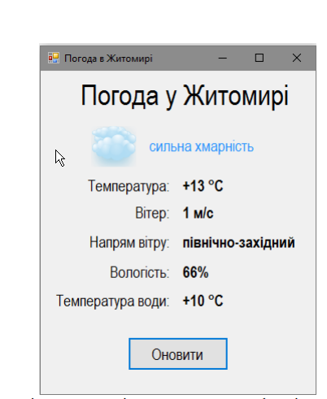
using System.Net;
using System.Text;
using System.Text.RegularExpressions;

namespace WeatherLibrary
{
public class Weather
{
private string status;
private double temperature;
private double wind;
private string windDirection;
private double humidity;
private double waterTemperature;
private byte[] image;

public Weather(string url)
{
LoadData(url);
}

public void LoadData(string url)
{
WebClient webClient = new WebClient();
webClient.Encoding = Encoding.UTF8;
string html = webClient.DownloadString(url);
string img = webClient.DownloadString("https://ua.sinoptik.ua/%D0%BF%D0%BE%D0%B3%D0%BE%D0%B4%D0%B0-%D0%B6%D0%B8%D1%82%D0%BE%D0%BC%D0%B8%D1%80");
Temperature = ExtractTemperature(html);
Wind = ExtractWind(html);
WindDirection = ExtractWindDirection(html);
Humidity = ExtractHumidity(html);
WaterTemperature = ExtractWaterTemperature(html);
Status = ExtractStatus(html);
string imgUrl = ExtractImage(img);
byte[] imageData = webClient.DownloadData(imgUrl);
Image = imageData;
}
private static string ExtractImage(string html)
{
Regex regex =
new Regex("<div class=\"img\"> <img width=\"\\d+\" height=\"\\d+\" src=\"(\\/\\/sinst\\.fwdcdn\\.com\\/img\\/weatherImg\\/b\\/n000\\.jpg)\"", RegexOptions.Compiled);
Match match = regex.Match(html);
if (match.Success)
{
return "https:"+match.Groups[1].Value;
}
else return "помилка";
}
private static string ExtractStatus(string html)
{
Regex regex =
new Regex("<div class=\"now-desc\">(.+)<\\/div><div class=\"now-info\">",RegexOptions.Compiled);
Match match = regex.Match(html);
if (match.Success)
{
return match.Groups[1].Value;
}
else return "помилка";
}
private static string ExtractWindDirection(string html)
{
Regex regex =
new Regex("м\\/c<br>([А-ЯФЇа-яшї]+)<\\/span>",RegexOptions.Compiled);
Match match = regex.Match(html);
if (match.Success)
{
return match.Groups[1].Value;
}
else return "помилка";
}
private static double ExtractWaterTemperature(string html)
{
Regex regex =
new Regex("\"temperatureWater\":\\[([+-]?\\d+)\\],",RegexOptions.Compiled);
Match match = regex.Match(html);
if (match.Success)
{
string text = match.Groups[1].Value;
return int.Parse(text);
}
else return 0;
}
private static double ExtractHumidity(string html)
{
Regex regex =
new Regex("\"humidity\":\\[(\\d+)\\],",RegexOptions.Compiled);
Match match = regex.Match(html);
if (match.Success)
{
string text = match.Groups[1].Value;
return int.Parse(text);
}
else return 0;
}
private static double ExtractWind(string html)
{
Regex regex =
new Regex("windSpeed\":\\[(\\d+)\\]",RegexOptions.Compiled);
Match match = regex.Match(html);
if (match.Success)
{
string text = match.Groups[1].Value;
return int.Parse(text);
}
else return 0;
}
private static double ExtractTemperature(string html)
{
Regex regex =
new Regex(
"<span class=\"unit-temperature\" data-temperature-f=\"[+-]?\\d+\">([+-]?\\d+)<\\/span><\\/div><\\/a><\\/div><\\/div><\\/section>",
RegexOptions.Compiled);
Match match = regex.Match(html);
if (match.Success)
{
string text = match.Groups[1].Value;
return int.Parse(text);
}
else return 0;
}
public byte[] Image
{
get => image;
set => image = value;
}
public string Status
{
get => status;
set => status = value ?? throw new ArgumentNullException(nameof(value));
}

public double Temperature
{
get => temperature;
set => temperature = value;
}

public double Wind
{
get => wind;
set => wind = value;
}

public string WindDirection
{
get => windDirection;
set => windDirection = value ?? throw new ArgumentNullException(nameof(value));
}

public double Humidity
{
get => humidity;
set => humidity = value;
}

public double WaterTemperature
{
get => waterTemperature;
set => waterTemperature = value;
}
}
}
using System.Net;
using System.Text;
using WeatherLibrary;

namespace WeaterConsole
{
public partial class Form1 : Form
{
public Form1()
{
InitializeComponent();
}

private void button1_Click(object sender, EventArgs e)
{
Weather weather = new Weather("https://meteofor.com.ua/weather-zhytomyr-4943/now/");
temperature.Text = weather.Temperature.ToString() + " C";
wind.Text = weather.Wind.ToString() + " m/c";
windDirection.Text = weather.WindDirection.ToString();
humidity.Text = weather.Humidity.ToString() + "%";
waterTemperature.Text = weather.WaterTemperature.ToString() + " C";
status.Text = weather.Status.ToString();
using (var ms = new System.IO.MemoryStream(weather.Image))
{
Image img = Image.FromStream(ms);
pictureBox1.SizeMode = PictureBoxSizeMode.Zoom;
pictureBox1.Image = img;
}

}

private void Form1_Load(object sender, EventArgs e)
{

}
}
}

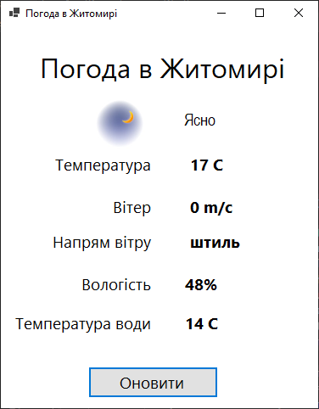
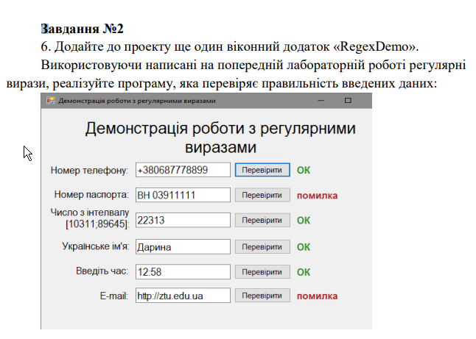
using System;
using System.Collections.Generic;
using System.ComponentModel;
using System.Data;
using System.Drawing;
using System.Linq;
using System.Text;
using System.Text.RegularExpressions;
using System.Threading.Tasks;
using System.Windows.Forms;

namespace RegexDemo
{
public partial class Form1 : Form
{
public Form1()
{
InitializeComponent();
}
private static bool CheckRegex(string str, string reg)
{
Regex regex = new Regex(reg);
return regex.IsMatch(str) ;
}
private void Form1_Load(object sender, EventArgs e)
{

}

private void label1_Click(object sender, EventArgs e)
{

}

private void label13_Click(object sender, EventArgs e)
{

}

private void button1_Click(object sender, EventArgs e)
{
if(CheckRegex(textBox1.Text, "^(\\+38)?0[5-79]\\d(\\d{3}-?\\d{2}-?\\d{2})$")){
labelNumber.Text = "YES";
labelNumber.ForeColor = Color.Green;
} else
{
labelNumber.Text = "NO";
labelNumber.ForeColor = Color.Red;
}
}

private void button2_Click(object sender, EventArgs e)
{
if (CheckRegex(textBox2.Text, "^[А-ЯІЇ]{2}\\d{6}|\\d{8}-\\d{5}$"))
{
labelPassport.Text = "YES";
labelPassport.ForeColor = Color.Green;
}
else
{
labelPassport.Text = "NO";
labelPassport.ForeColor = Color.Red;
}
}

private void button3_Click(object sender, EventArgs e)
{
if (CheckRegex(textBox3.Text, "^1031[1-9]|103[2-9]\\d|10[4-9]\\d{2}|1[1-9]\\d{3}|[2-7]\\d{4}|8964[0-5]|896[0-3]\\d|89[0-5]\\d{2}|8[0-8]\\d{3}$"))
{
labelInterval.Text = "YES";
labelInterval.ForeColor = Color.Green;
}
else
{
labelInterval.Text = "NO";
labelInterval.ForeColor = Color.Red;
}
}

private void button4_Click(object sender, EventArgs e)
{
if (CheckRegex(textBox4.Text, "^[А-ЯІЇ][а-яії']+$"))
{
labelName.Text = "YES";
labelName.ForeColor = Color.Green;
}
else
{
labelName.Text = "NO";
labelName.ForeColor = Color.Red;
}
}

private void button5_Click(object sender, EventArgs e)
{
if (CheckRegex(textBox5.Text, "^([0-1]\\d|2[0-3]):[0-5]\\d$"))
{
labelTime.Text = "YES";
labelTime.ForeColor = Color.Green;
}
else
{
labelTime.Text = "NO";
labelTime.ForeColor = Color.Red;
}
}

private void button6_Click(object sender, EventArgs e)
{
if (CheckRegex(textBox6.Text, "^[a-z1-9._]+@[a-z]+(\\.[a-z]+)+$"))
{
labelEmail.Text = "YES";
labelEmail.ForeColor = Color.Green;
}
else
{
labelEmail.Text = "NO";
labelEmail.ForeColor = Color.Red;
}
}
}
}
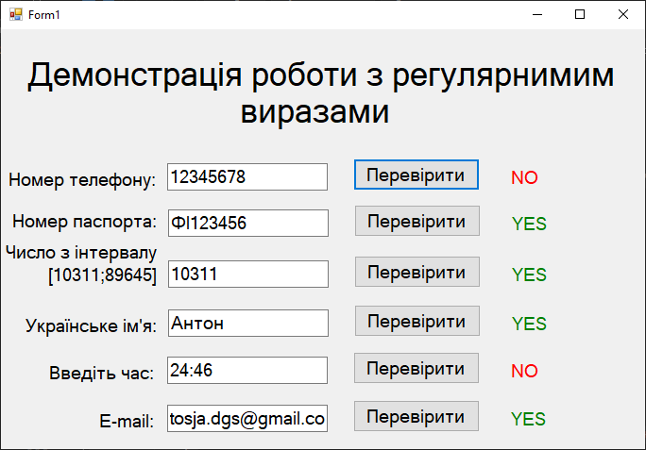

Репозиторій
Висновки: в ході виконання лабораторної роботи було навчиyj застосовувати бібліотеки мови C# для виконання операцій над текстом з використанням регулярних виразів.

