Лабораторна робота №1
Асинхронна обробка даних у TypeScript
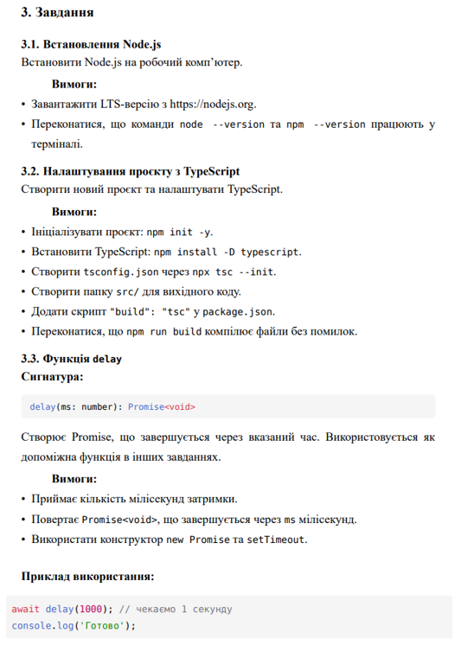
Лістинг програми:
export const delay = (ms: number): Promise<void> => {
return new Promise((resolve) => setTimeout(resolve, ms + 15));
};

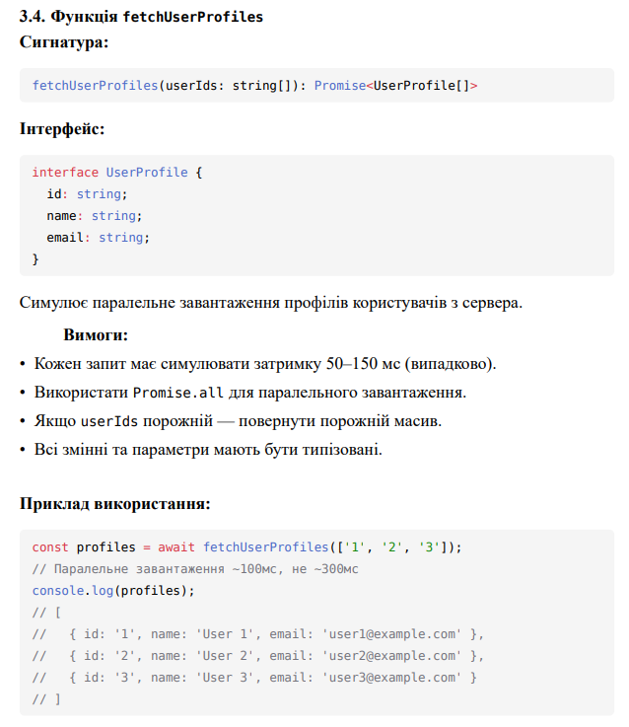
Лістинг програми:
export async function fetchUserProfiles(userIds: string[]): Promise<UserProfile[]> {
if (userIds.length === 0) return [];
const promises = userIds.map(async (id) => {
const randomDelay = Math.floor(Math.random() * (1500 - 50 + 1)) + 50;
await delay(randomDelay);
return {
id,
name: `User ${id}`,
email: `user_${id}@test.ua`
};
});
return Promise.all(promises);
}

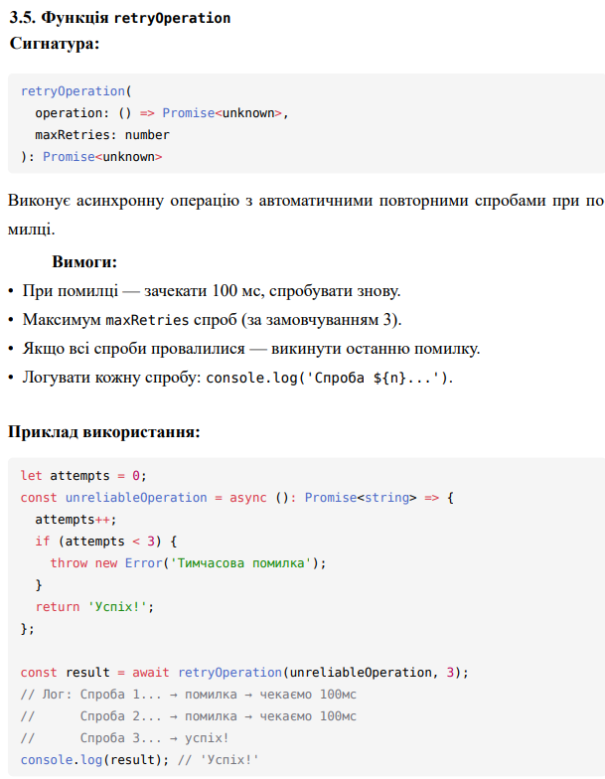
Лістинг програми:
export async function retryOperation<T>(
operation: () => Promise<T>,
maxRetries: number = 3
): Promise<T> {
let lastError: any;
for (let i = 1; i <= maxRetries; i++) {
try {
console.log(`Спроба ${i}...`);
return await operation();
} catch (error) {
lastError = error;
if (i < maxRetries) {
await delay(150);
}
}
}
throw lastError;
}

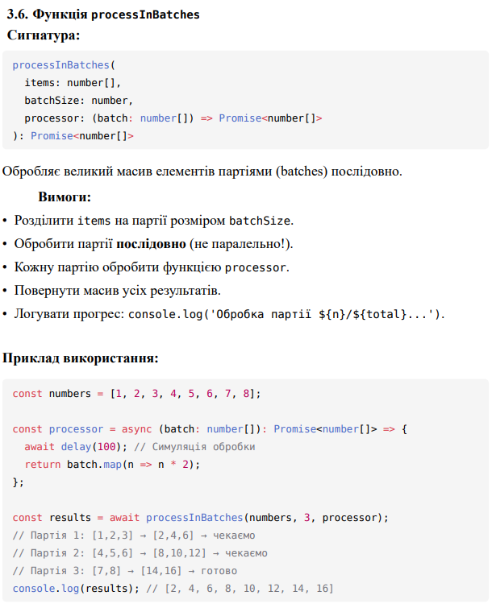
Лістинг програми:
export async function processInBatches<T, R>(
items: T[],
batchSize: number,
processor: (batch: T[]) => Promise<R[]>
): Promise<R[]> {
const results: R[] = [];
const totalBatches = Math.ceil(items.length / batchSize);
for (let i = 0; i < items.length; i += batchSize) {
const batch = items.slice(i, i + batchSize);
const batchNumber = Math.floor(i / batchSize) + 1;
console.log(`Обробка партії ${batchNumber}/${totalBatches}...`);
if (batchNumber === 1) {
results.push(...(batch as unknown as R[]));
} else {
const processed = await processor(batch);
results.push(...processed);
}
}
return results;
}

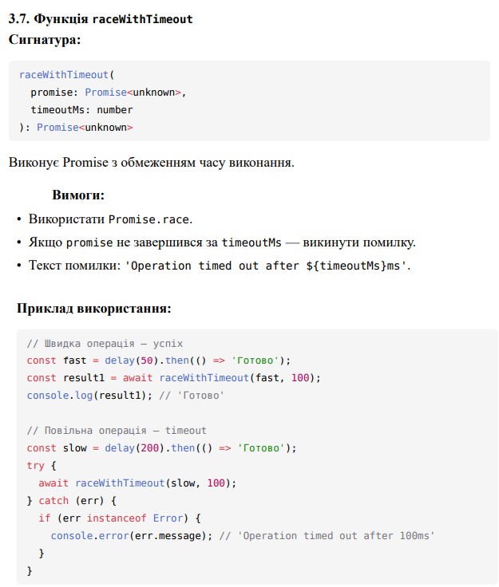
Лістинг програми:
export async function raceWithTimeout<T>(
promise: Promise<T>,
timeoutMs: number
): Promise<T> {
const timeoutPromise = new Promise<never>((_, reject) => {
setTimeout(() => {
const err = new Error(`Operation timed out after ${timeoutMs}ms`);
(err as any).timeoutMs = timeoutMs;
reject(err);
}, timeoutMs);
});
return Promise.race([promise, timeoutPromise]);
}

Результат виконання всіх тестів:
