PROJECT 3: E-Commerce
Overview:
This project demonstrates a complete DevOps workflow for building, deploying, and monitoring a React application using Docker for containerization, Jenkins for CI/CD automation, Git branching for version control, DockerHub for image storage, AWS EC2 for deployment, and open-source monitoring tools for performance tracking and downtime alerts.
Tools and Service:
- Bash Scripting
- AWS
- EC2
- Git
- Docker
- Jenkins
- Monitoring
EC2 Instance Creation:
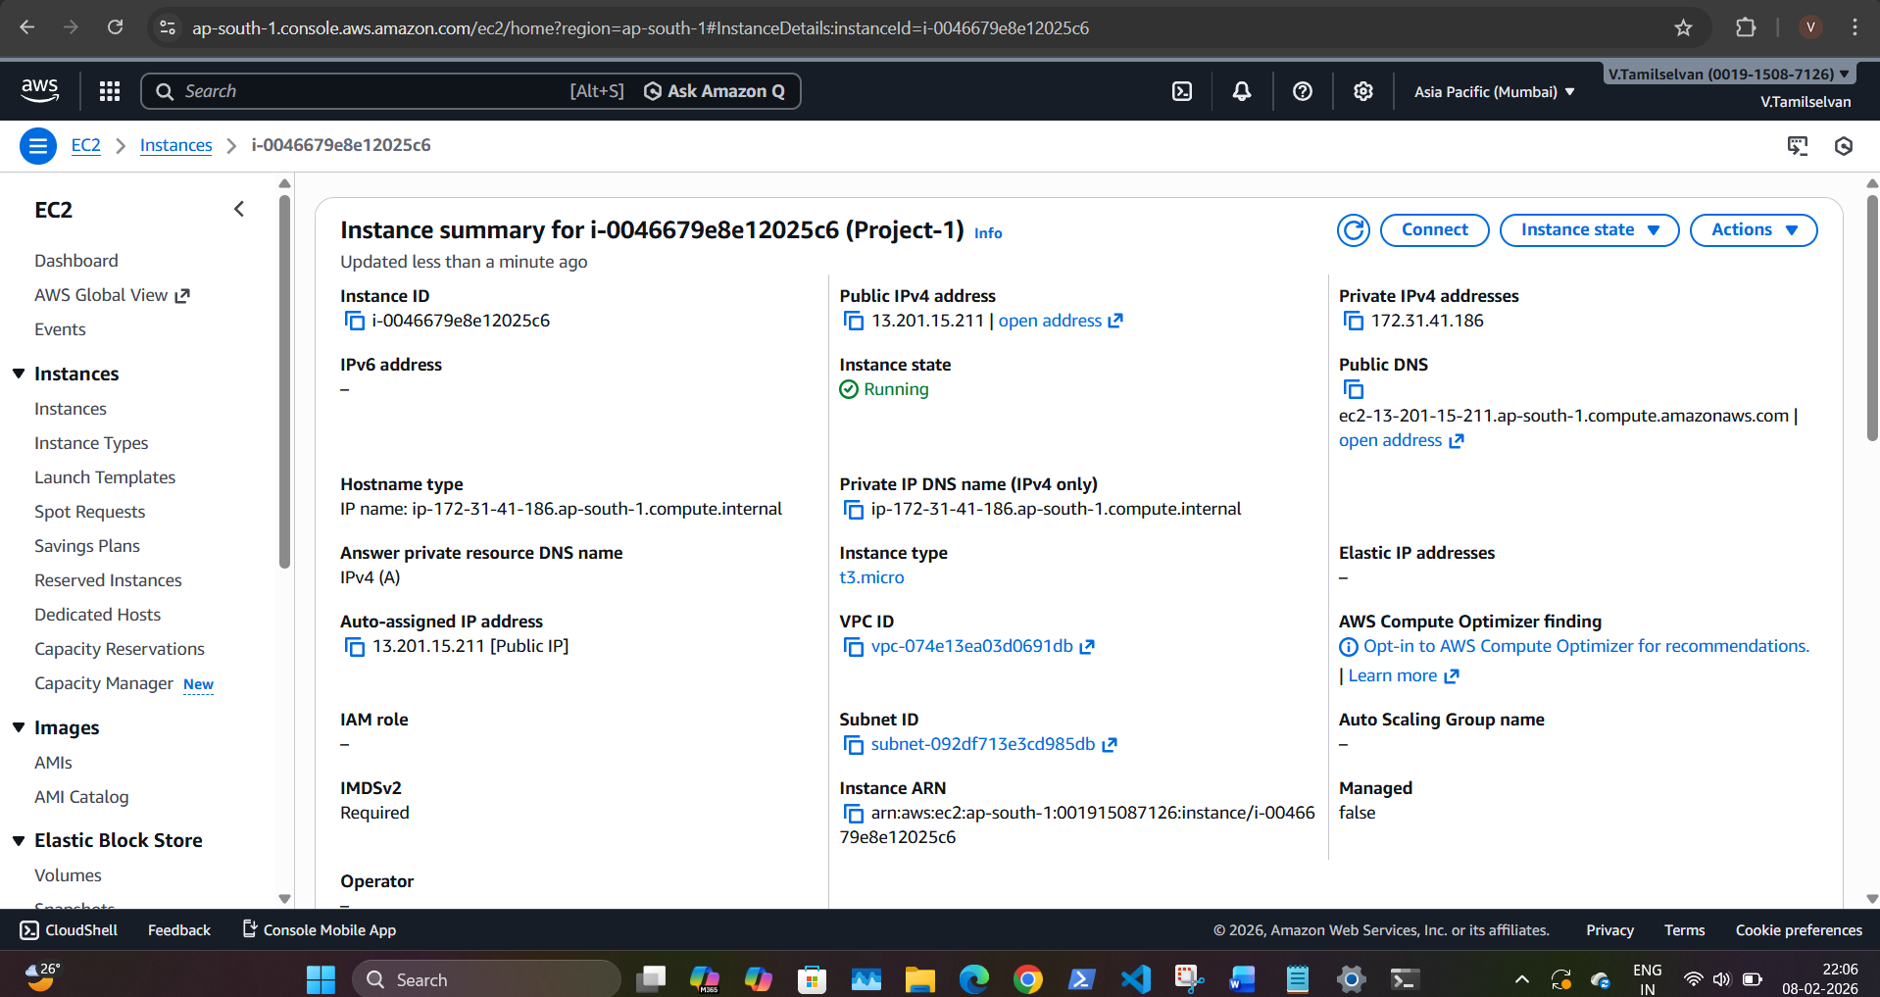

Security Groups:
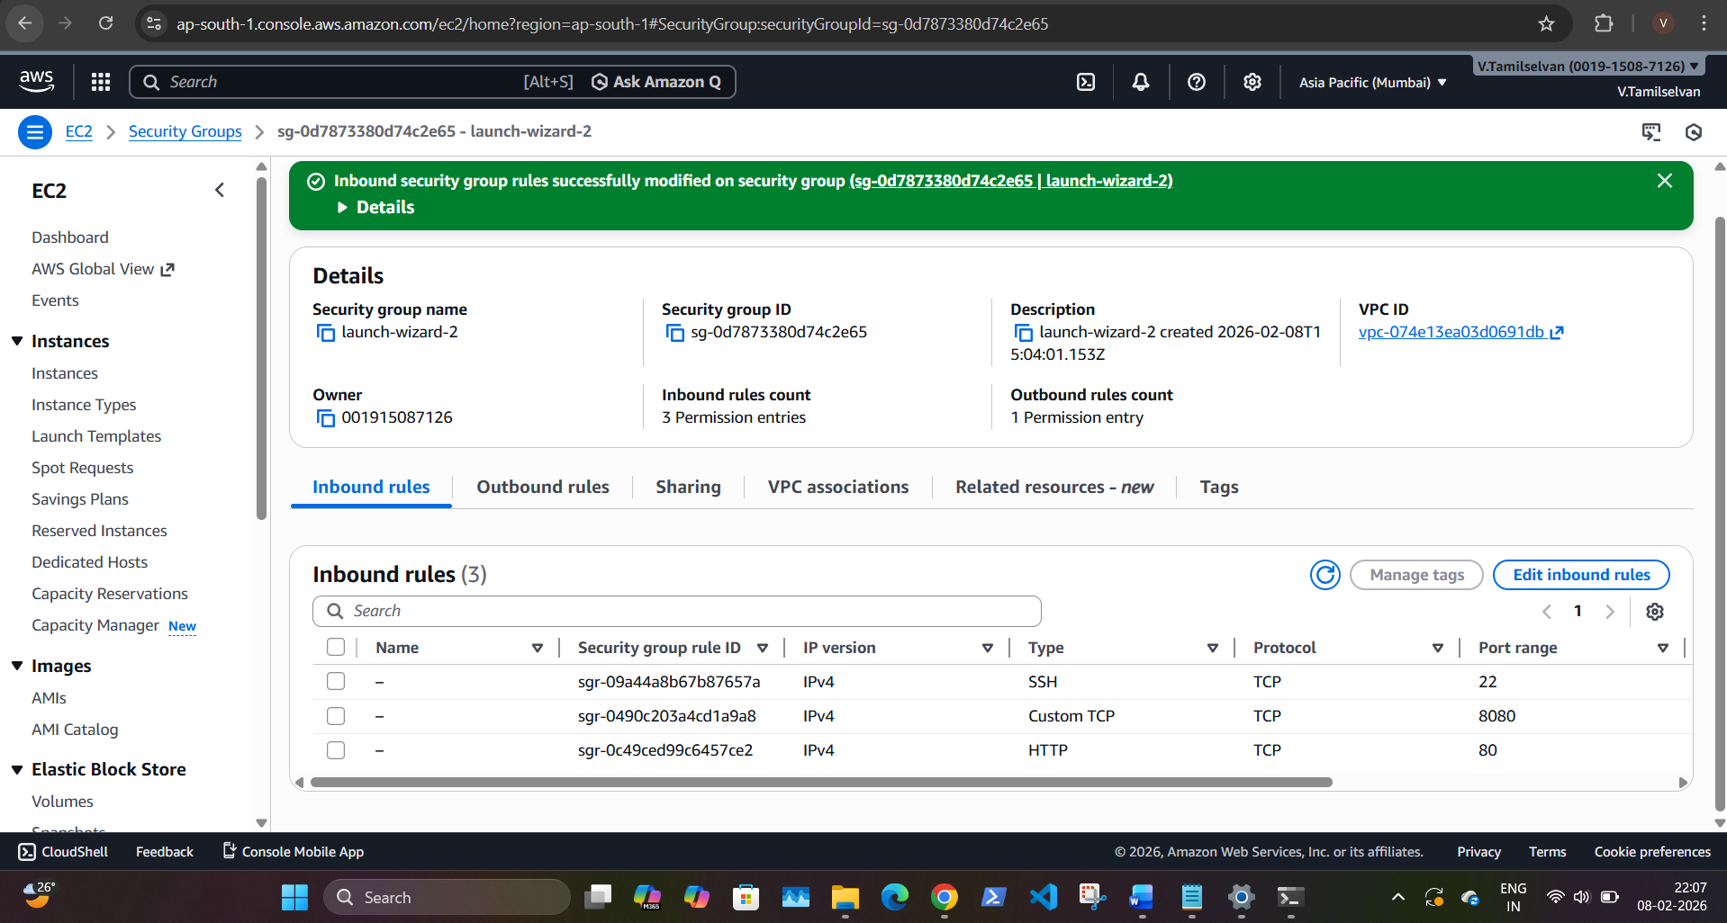
Git:
- Clone repository from GitHub:
https://github.com/sriram-R-krishnan/devops-build

- Navigate to project directory
cd devops-build
- Create / use main branch
git checkout main
- Add files
git add .
- Commit changes
git commit -m "Initial project setup"
- Push to GitHub
git push origin main
Docker:
- Docker installation & version:

- Docker files:
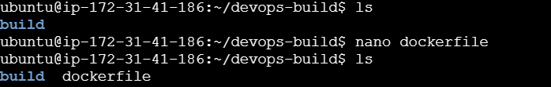
- Tagging react:
- Docker run and ps:
Docker login:
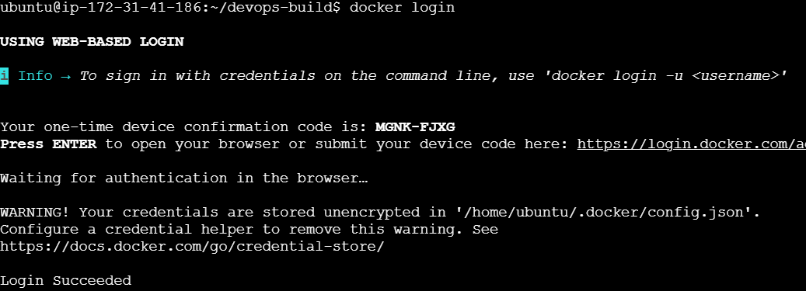
Docker tag and push:
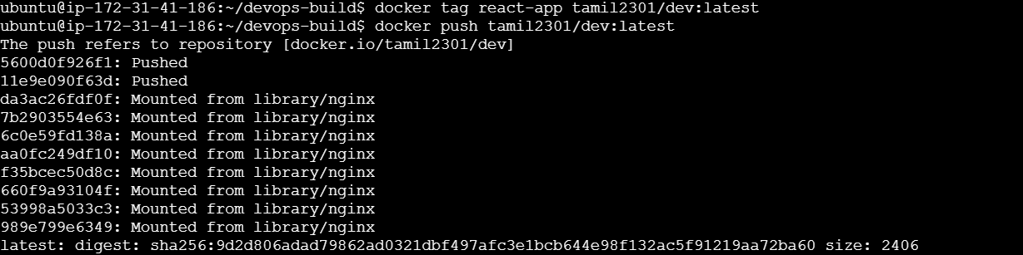
Docker image and ps:
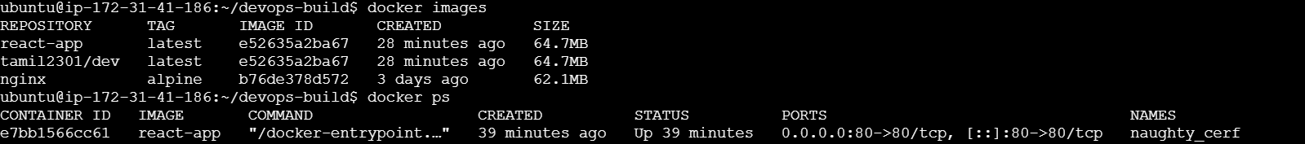

Docker hub:
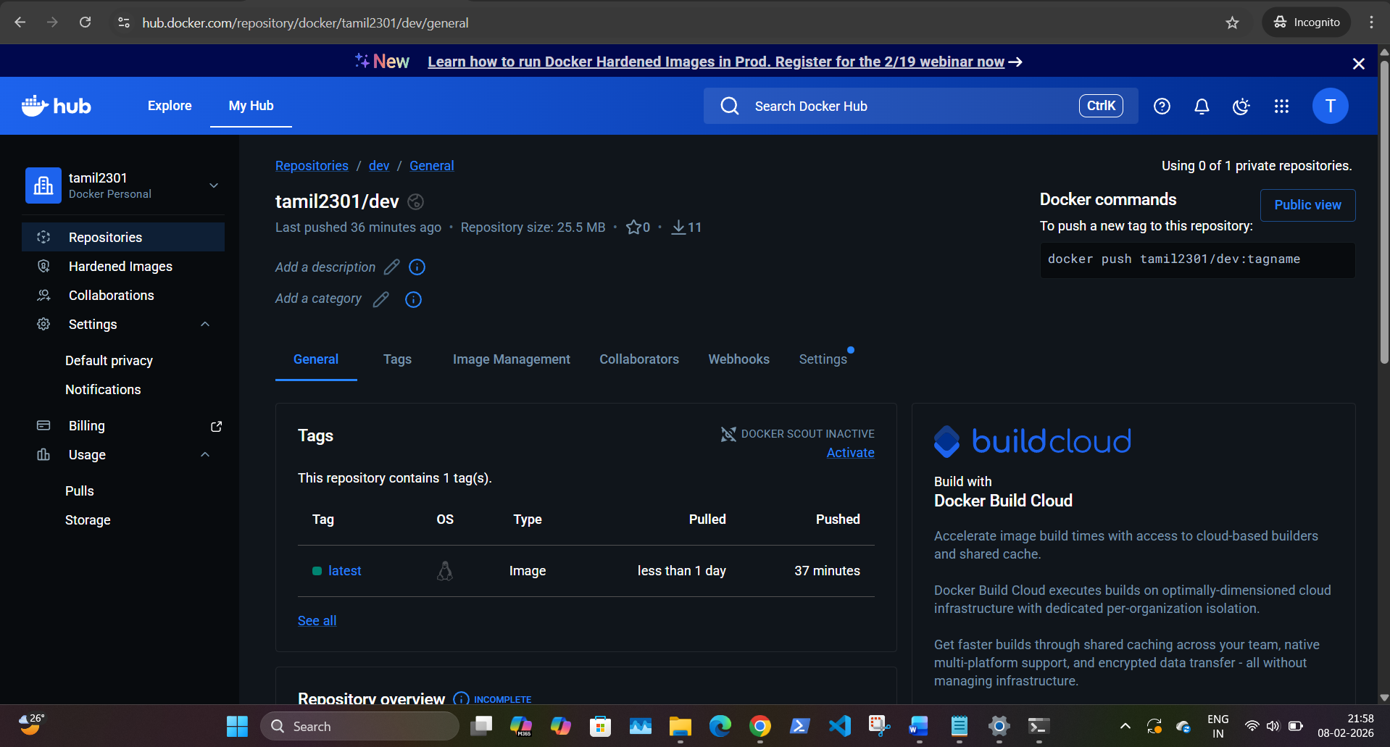
Jenkins Configuration:
- sudo apt update
- sudo apt install -y openjdk-17-jdk
- java -version
Jenkin Installation:
- sudo snap install jenkins –classic
Checking Jenkin services:
- sudo systemctl status snap. jenkins. Jenkins
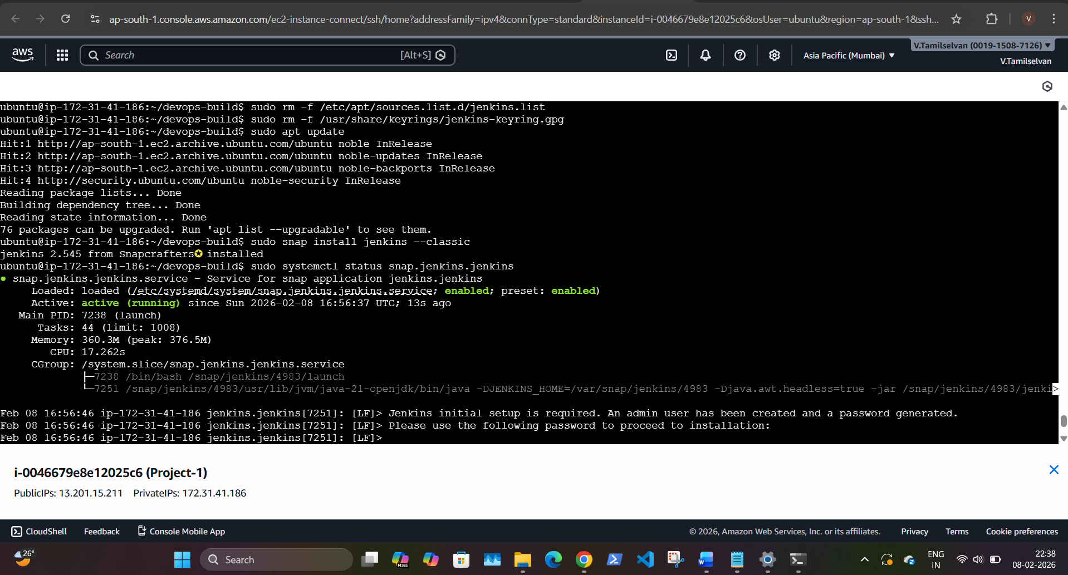
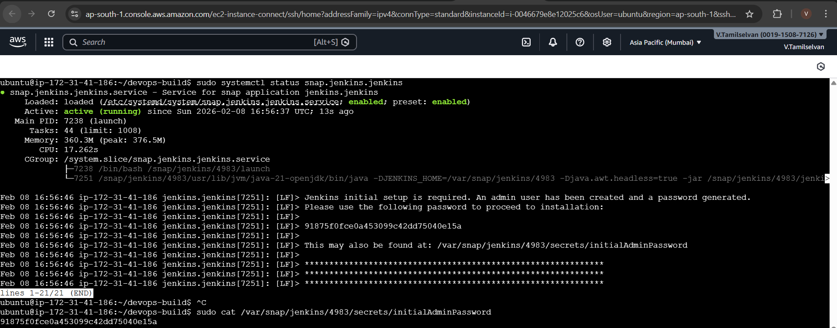
Jenkin login page:
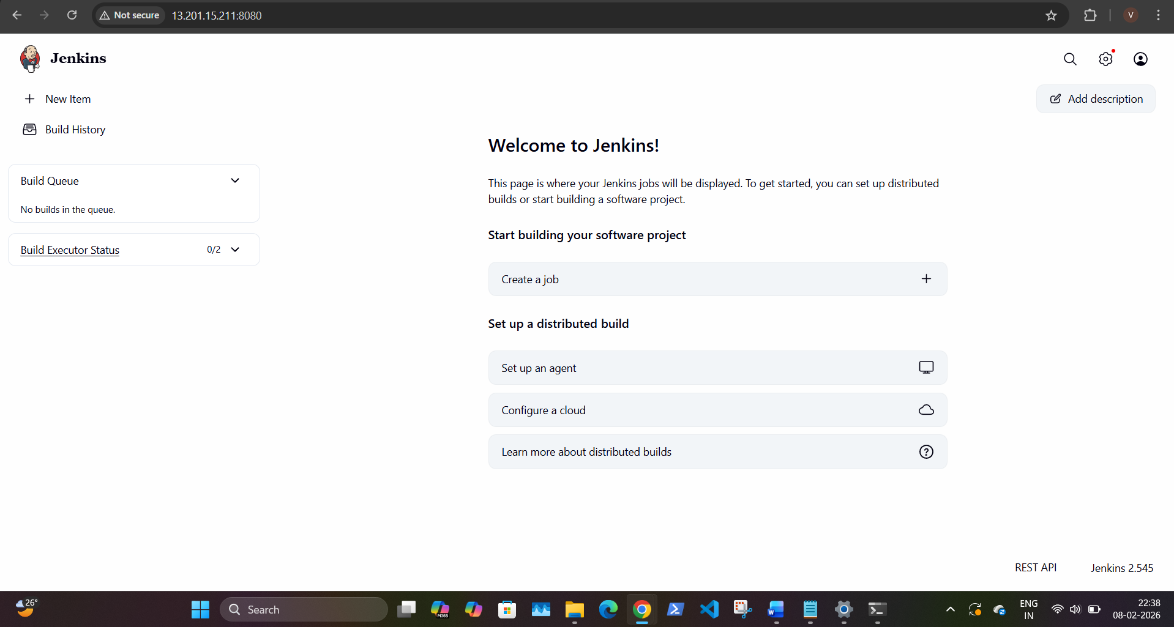

CI/CD:
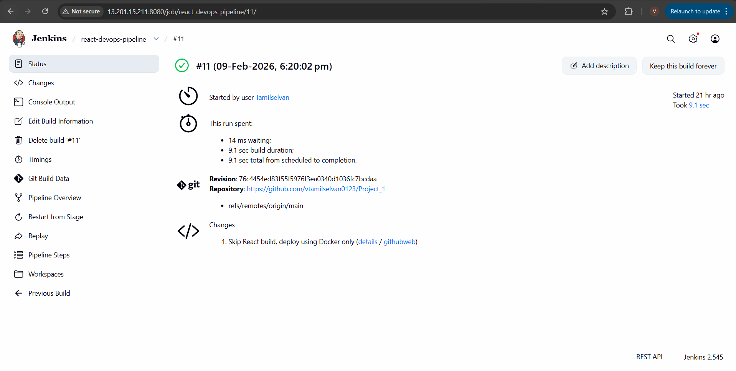
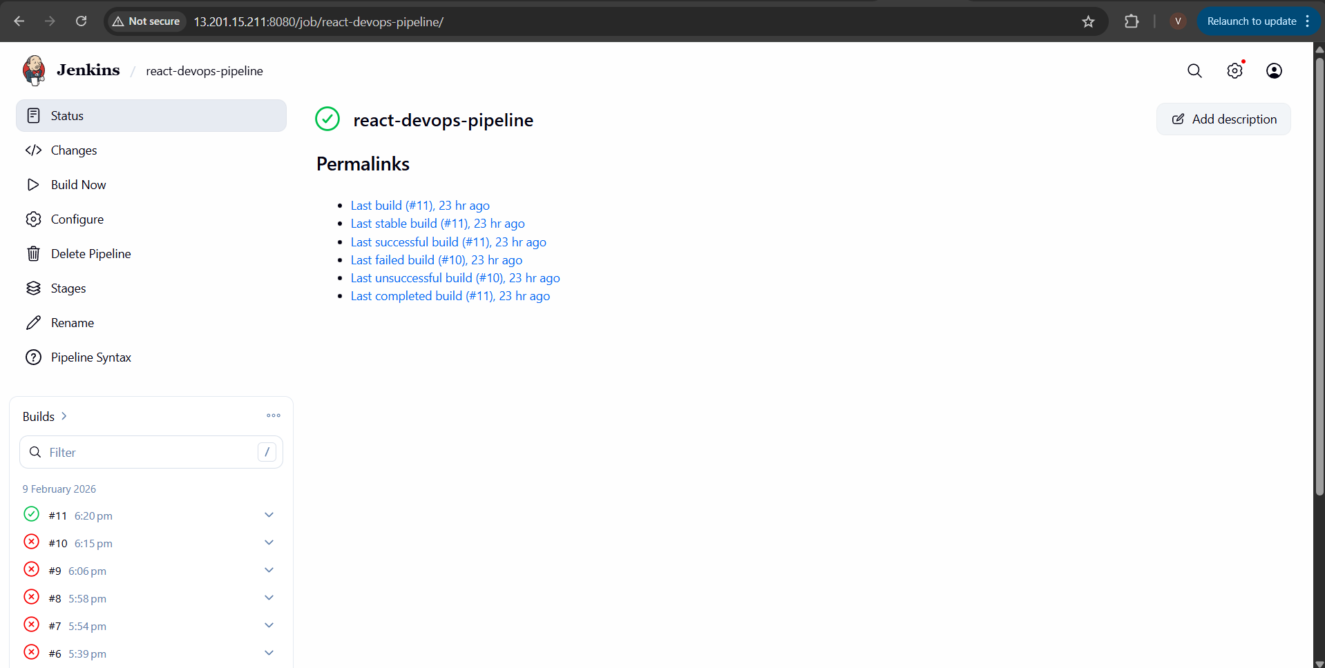

Production IP Address: http:// 13.201.15.211
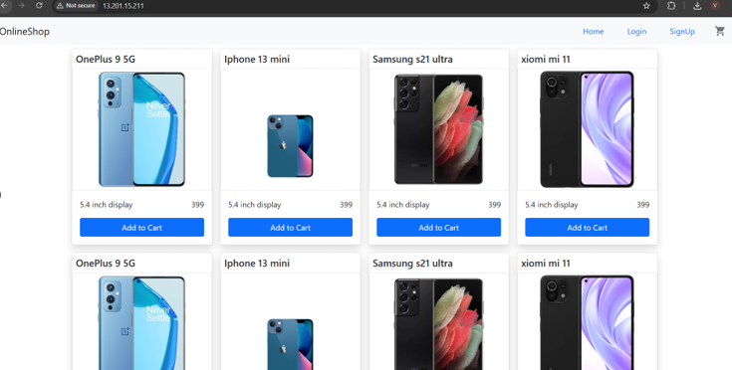
Monitoring:
Install Helm:
- choco install kubernetes-helm -y
- helm version
Add Prometheus Helm Repo:
- helm repo add prometheus-community https://prometheus-community.github.io/helm-charts
- helm repo update
Install Prometheus + Grafana Stack:
- kubectl create namespace monitoring
- helm install monitoring prometheus-community/kube-prometheus-stack -n monitoring
Checking pods:
- kubectl get pods -n monitoring
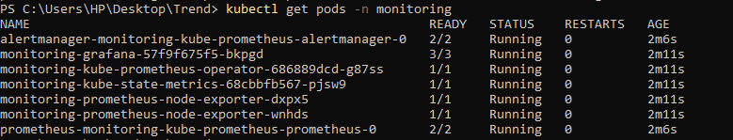
- kubectl get svc -n monitoring
- kubectl get pods -n monitoring
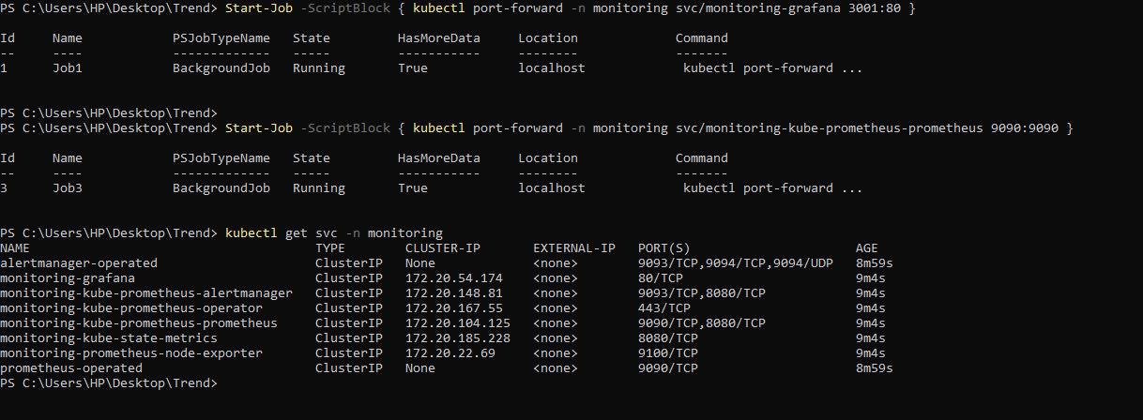
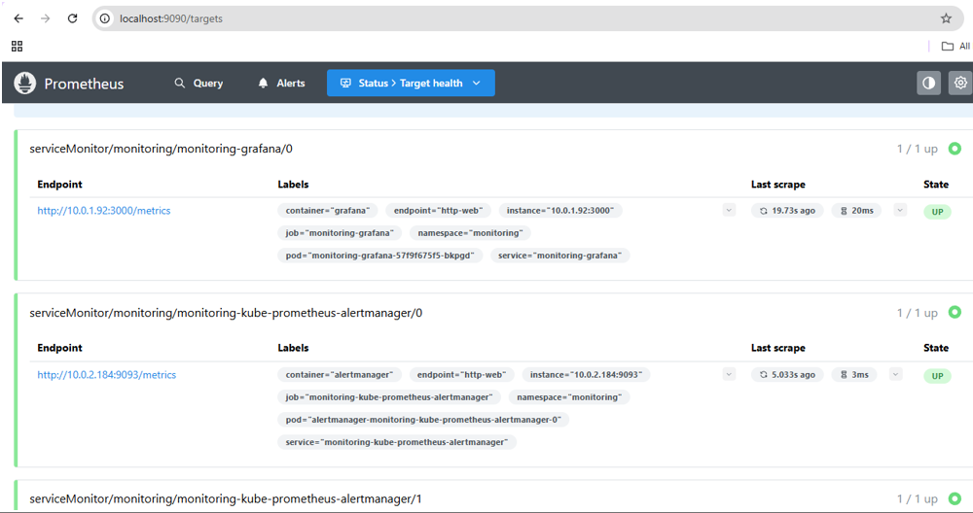
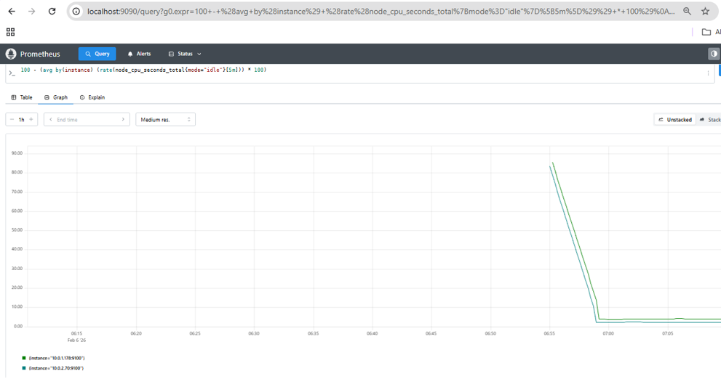

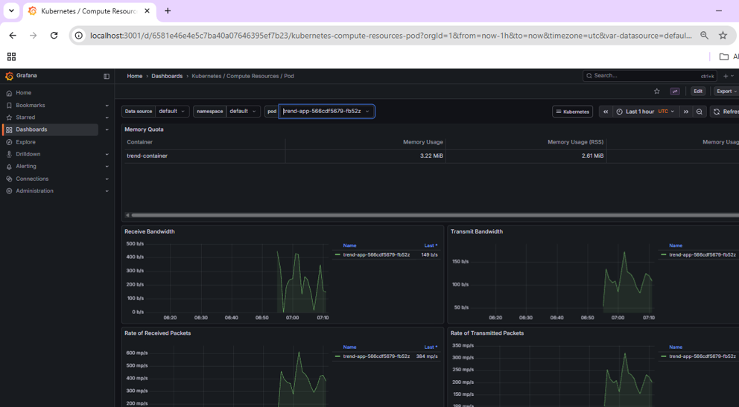
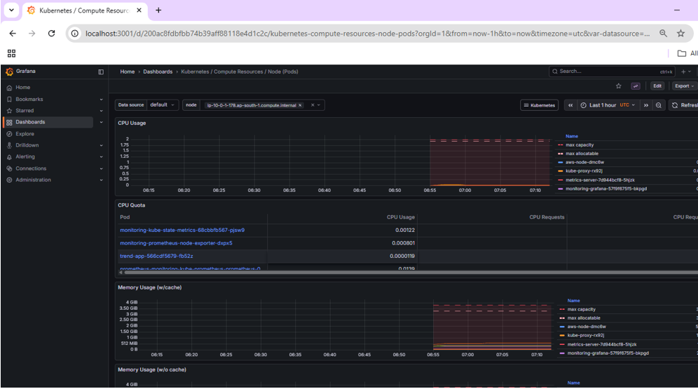

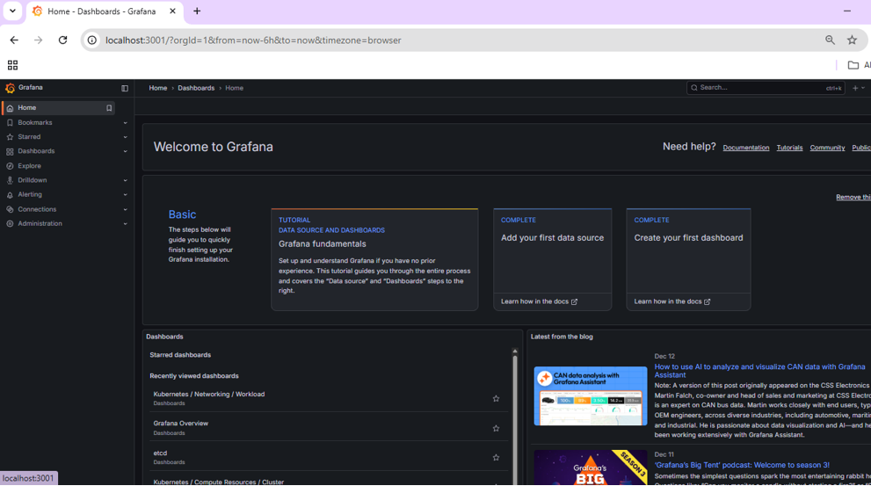
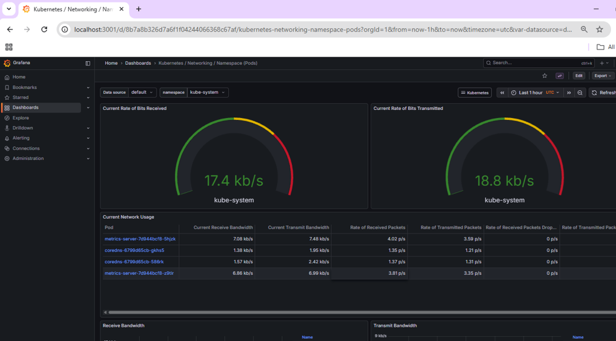

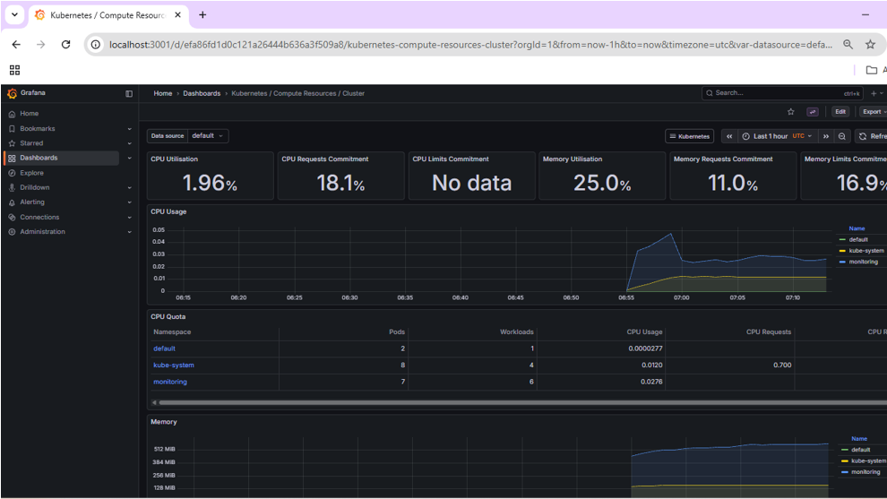
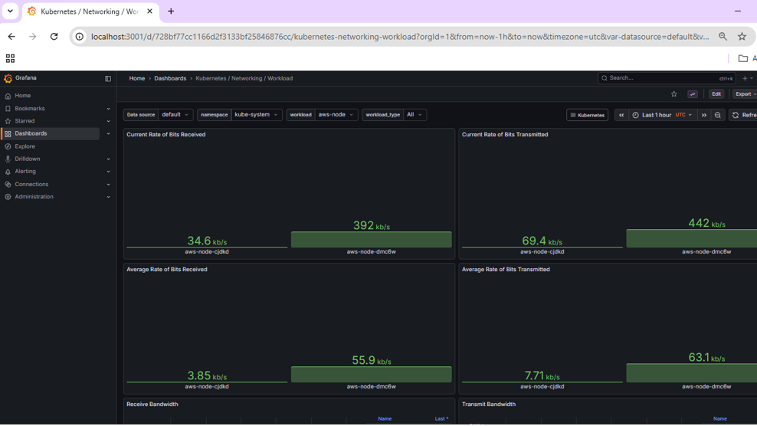
Conclusion:
This project successfully demonstrates a complete CI/CD workflow with branch-based DockerHub publishing, automated deployments using Jenkins, secure AWS access rules, and monitoring with downtime alerting.

