Main Project 1
Application Deployment in Port 80

Description: -
Deploying react application to production ready state in port 80
Overview: -
It Contains the complete setup to deploy a React application to a production-ready environment in port 80 using AWS, Git, Docker and Jenkins.
Tools and Service: -
- Bash Scripting
- AWS
- EC2
- Git
- Docker
- Jenkins
- Monitoring
EC2 Instance Creation: -
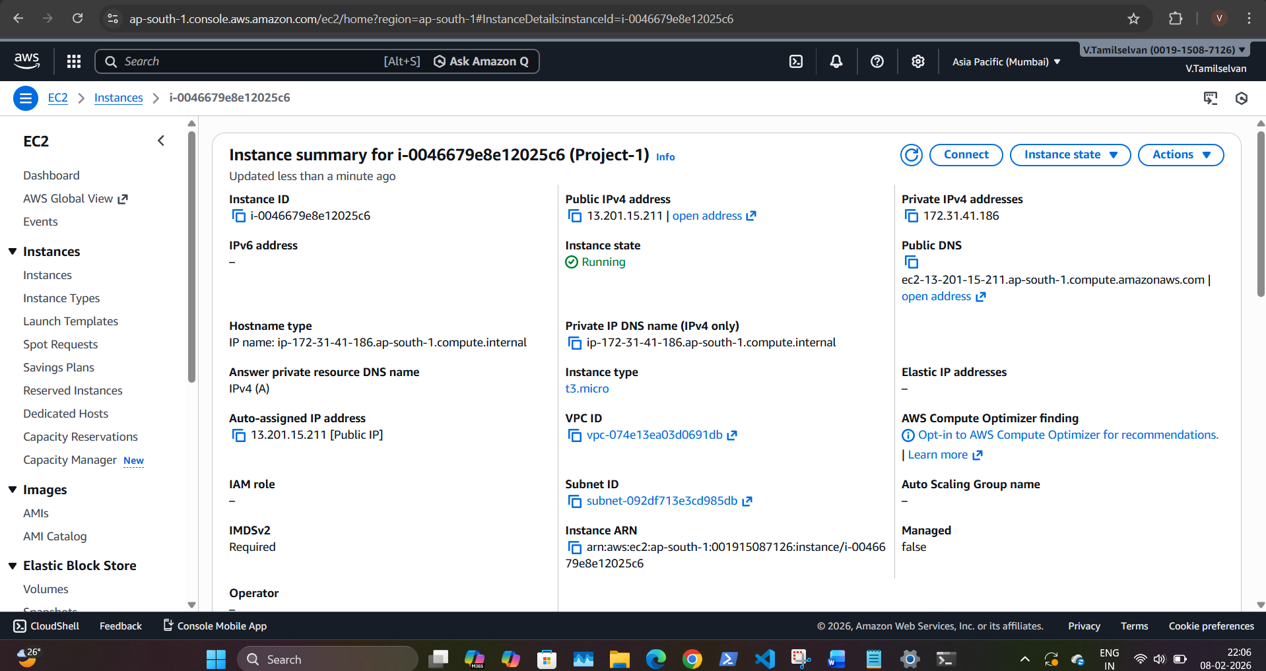

Security Groups: -
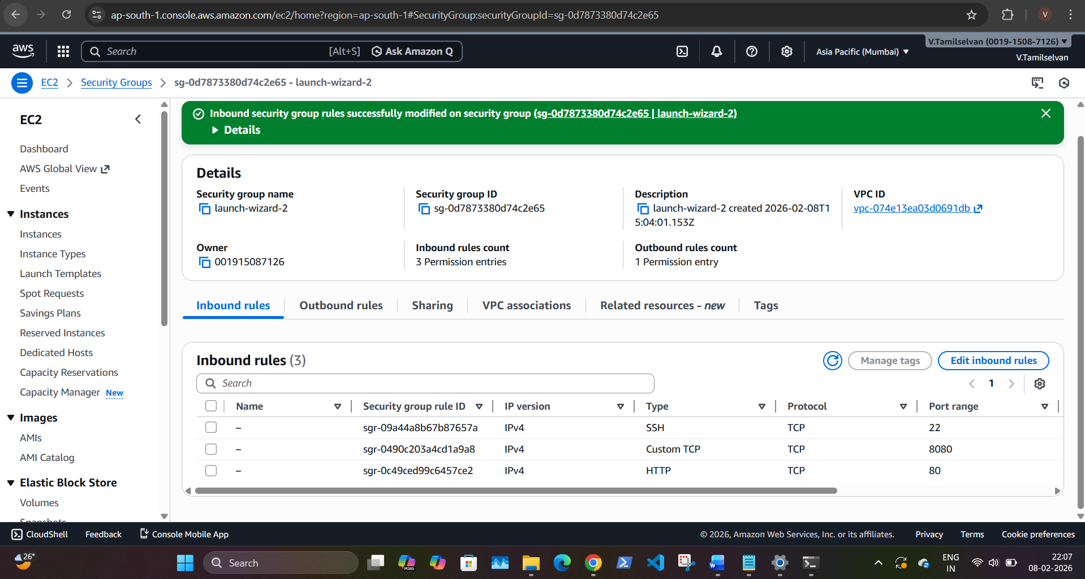
Git: -
1. Clone repository from GitHub
https://github.com/sriram-R-krishnan/devops-build
2. Navigate to project directory
cd devops-build
3. Create / use main branch
git checkout main
4. Add files
git add .
5. Commit changes
git commit -m "Initial project setup"
6. Push to GitHub
git push origin main
Docker: -
- Docker installation & version: -

- Docker files: -
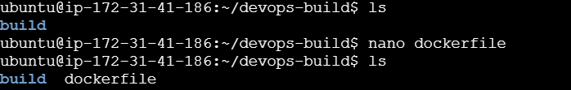
- Tagging react: -
- Docker run and ps: -
Docker login: -
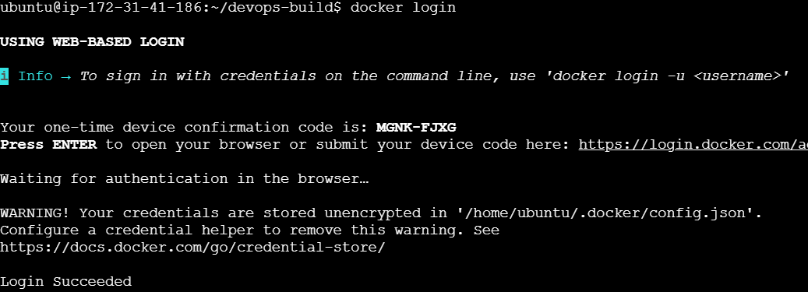
Docker tag and push: -
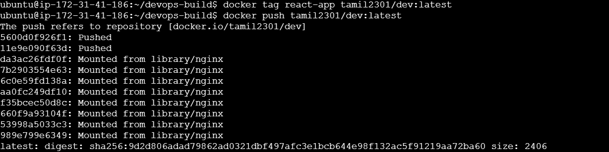
Docker image and ps: -
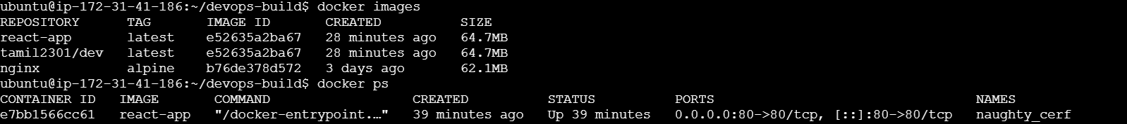

Docker hub: -
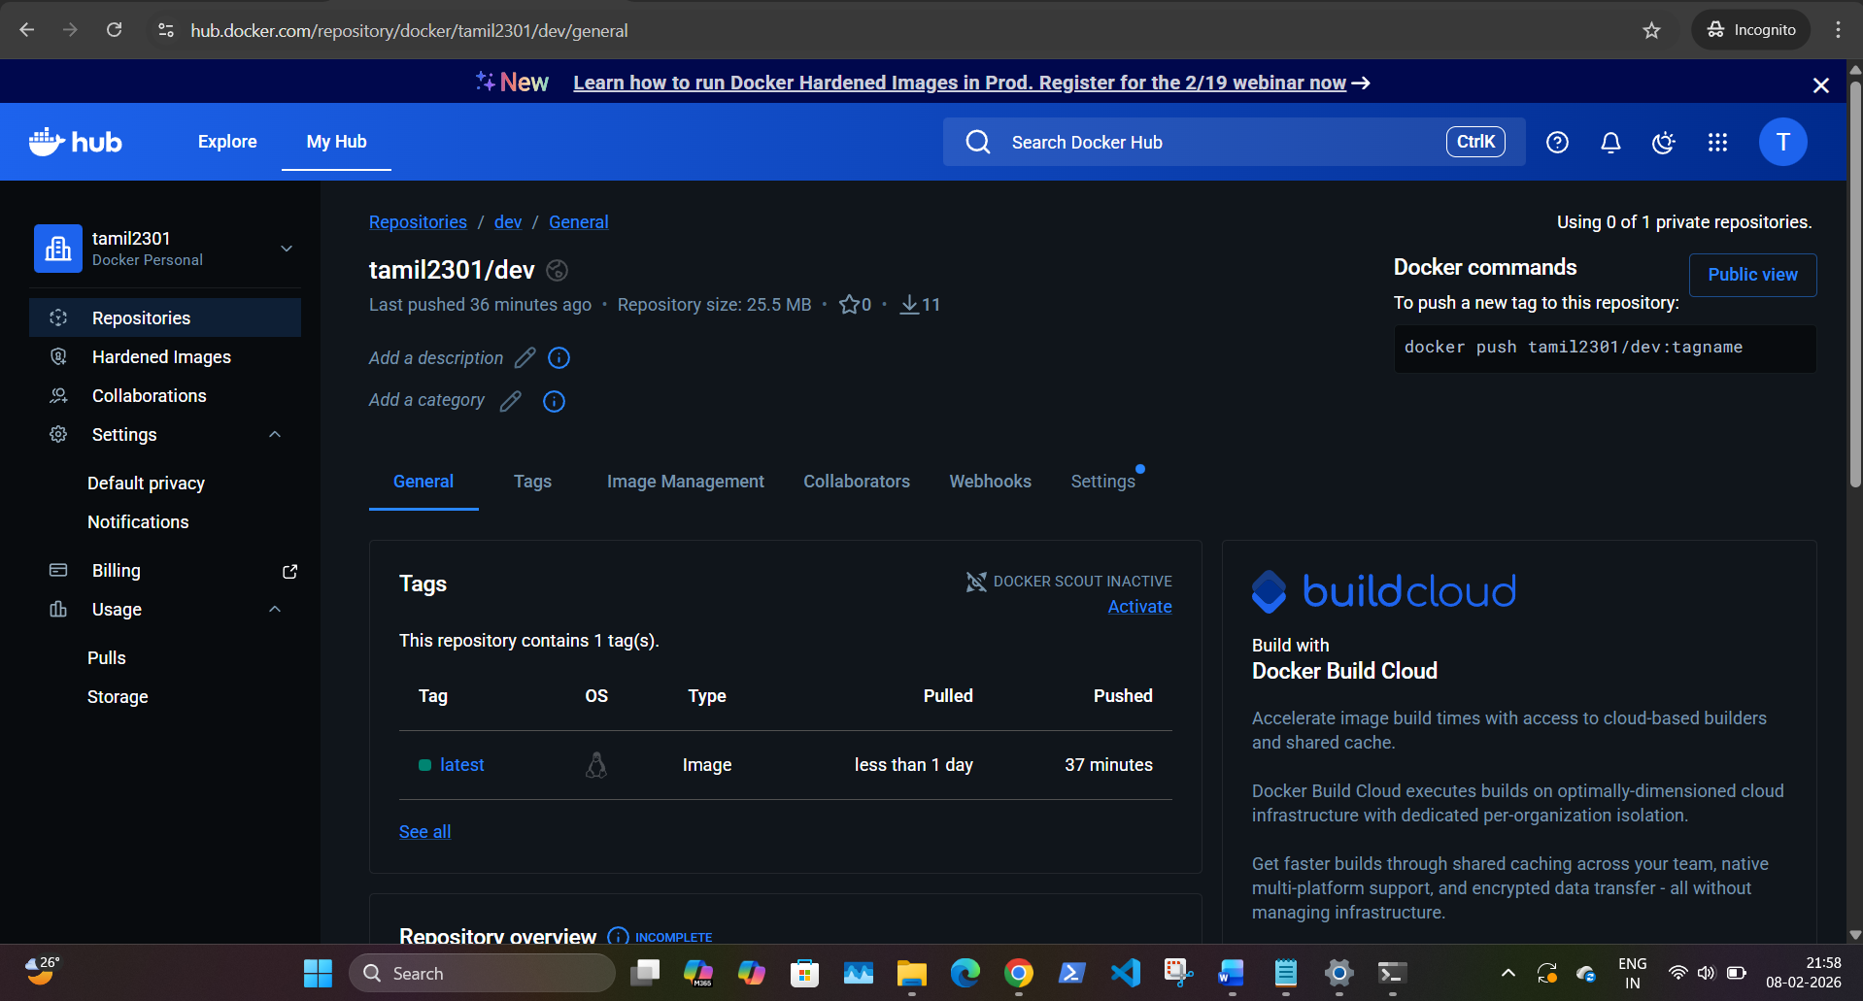
Jenkins Configuration: -
- sudo apt update
- sudo apt install -y openjdk-17-jdk
- java -version
Jenkin Installation: -
- sudo snap install jenkins –classic
Checking Jenkin services: -
- sudo systemctl status snap. jenkins. Jenkins
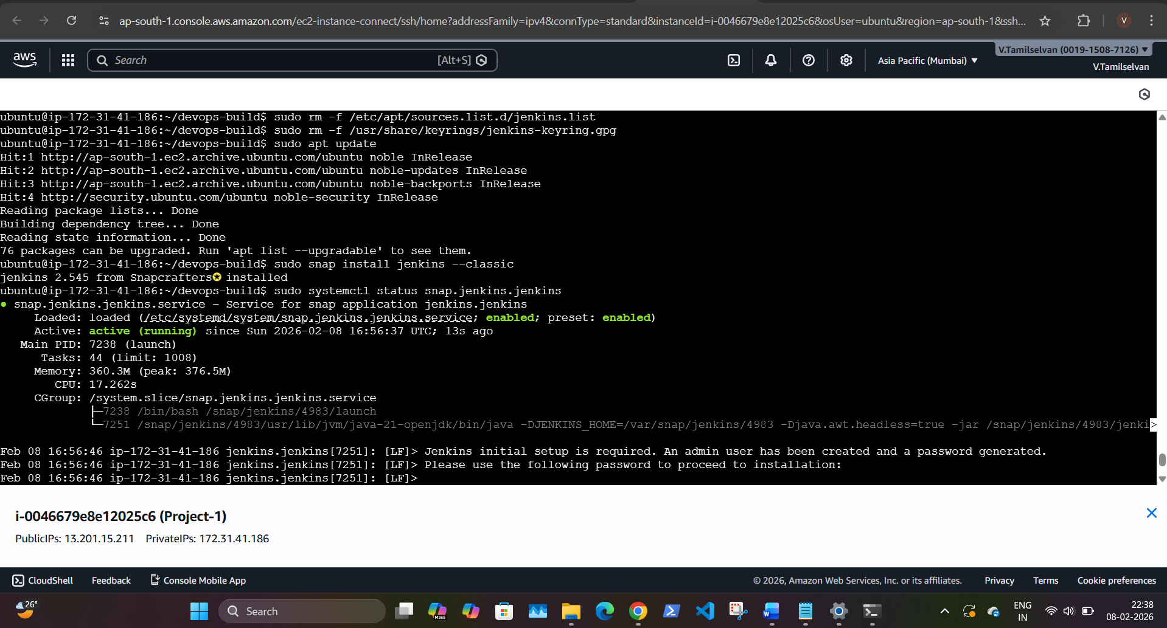
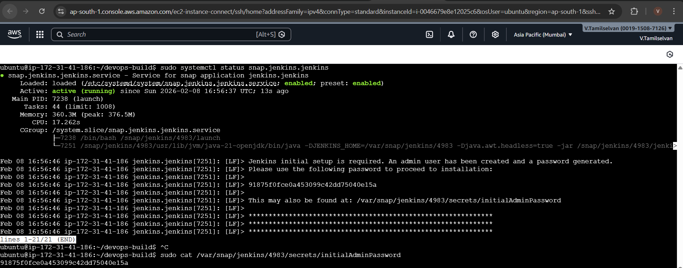
Jenkin login page: -
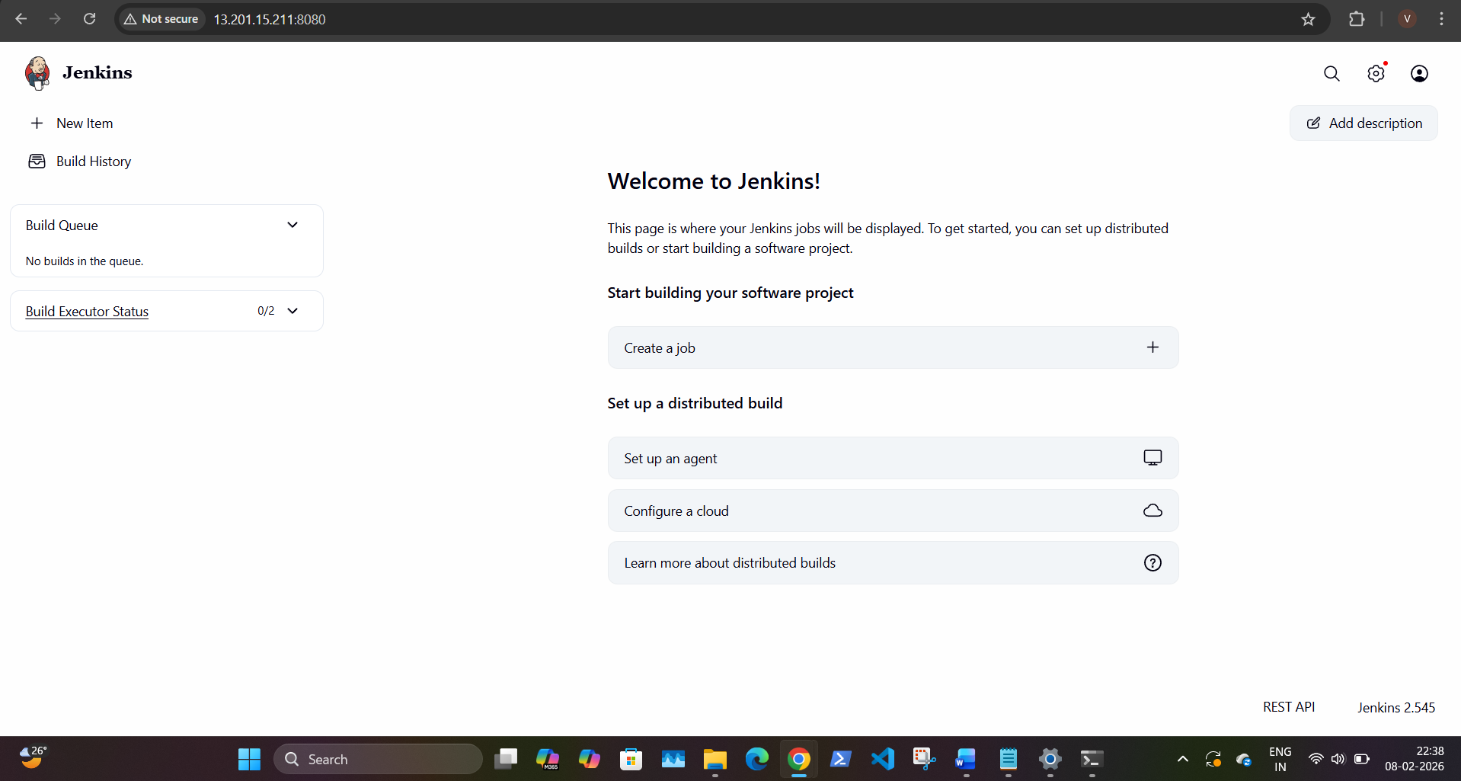

CI/CD: -
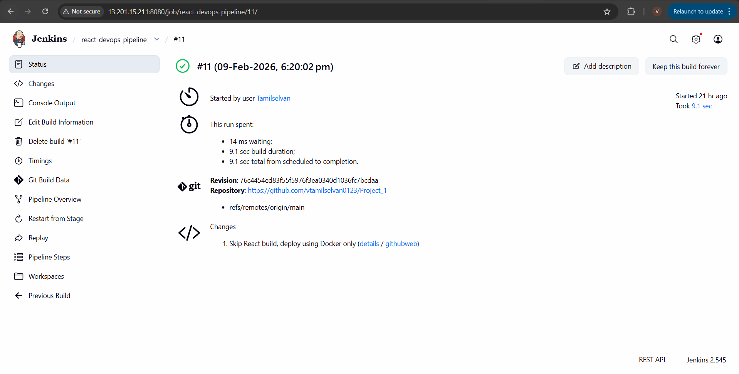
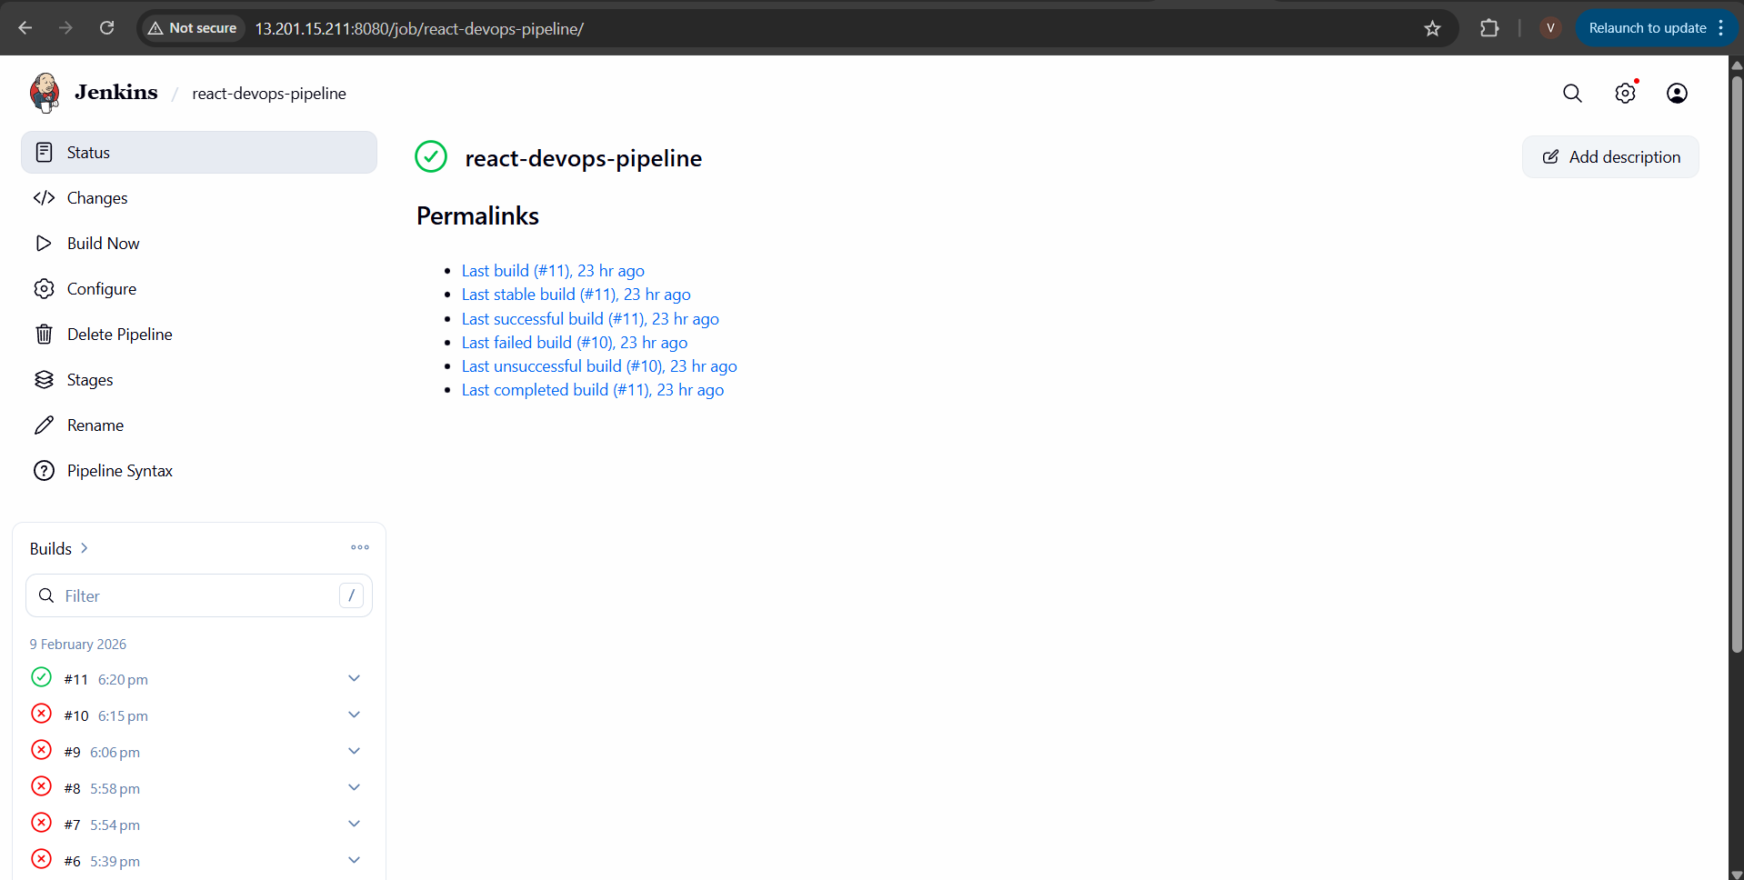

Production IP Address: - http:// 13.201.15.211
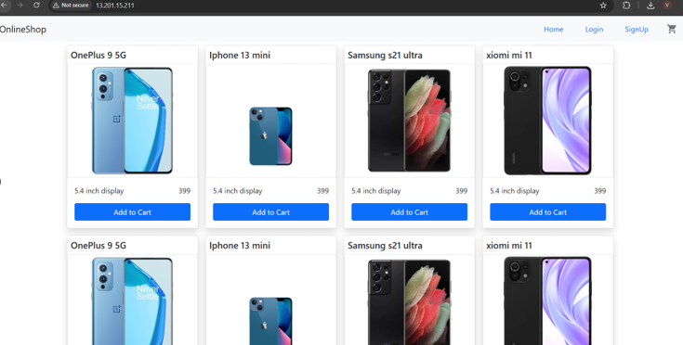
Monitoring: -
The dashboard provides visibility into system and application metrics such as CPU usage, memory usage, and container health.
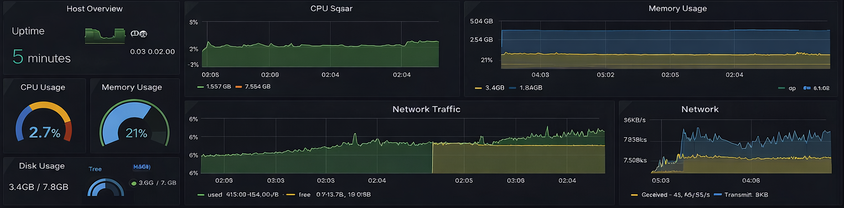

The End

