17-Apr-2021

Azure developer exam AZ-204 – Notes

At its core, Azure is a public cloud computing platform—with solutions including **Infrastructure as a Service (IaaS)**, **Platform as a Service (PaaS)**, and **Software as a Service (SaaS)** that can be used for services such as analytics, virtual computing, storage, networking, and much more.

<https://portal.azure.com/#home>

<https://docs.microsoft.com/en-us/learn/certifications/exams/az-204#two-ways-to-prepare>

<https://azure.microsoft.com/en-us/resources/samples/?sort=0>

**Azure Cloud Shell** is a browser-accessible, interactive **shell** for managing the **Azure** resources. It gives you the flexibility to access the **shell** based on the area you are working. ... You can access the **Cloud shell** on your browser or through the **Azure** portal.

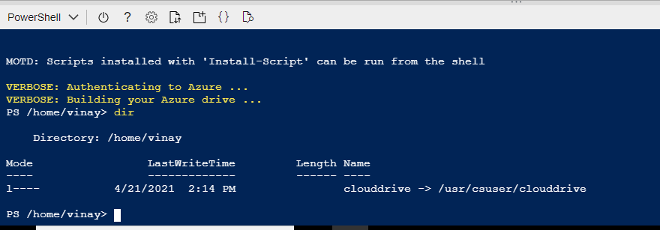

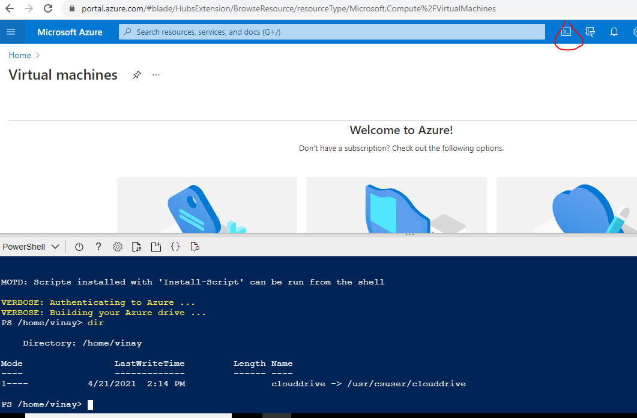

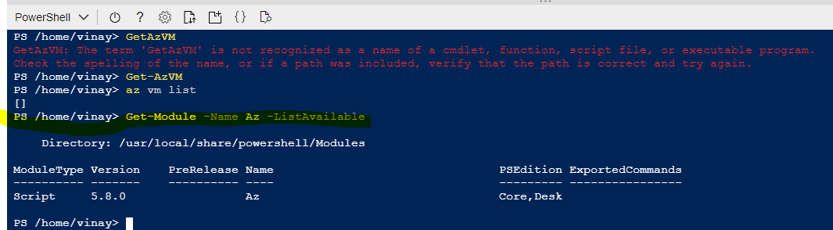

27-Apr-2021

Create Virtual Machine

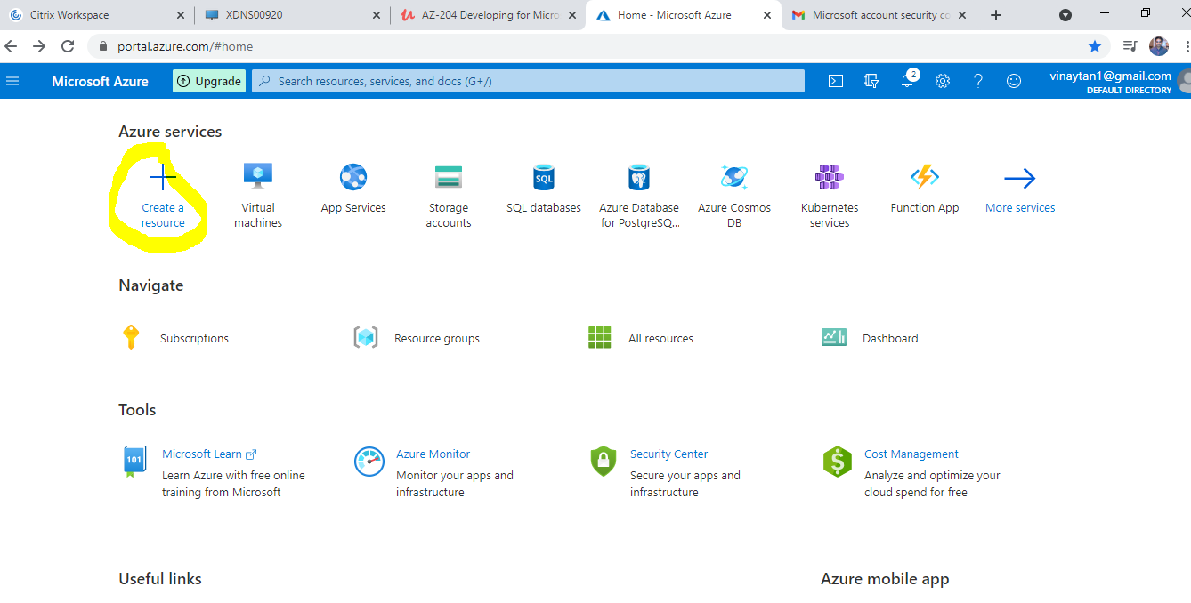

Click on create a resource and get below page

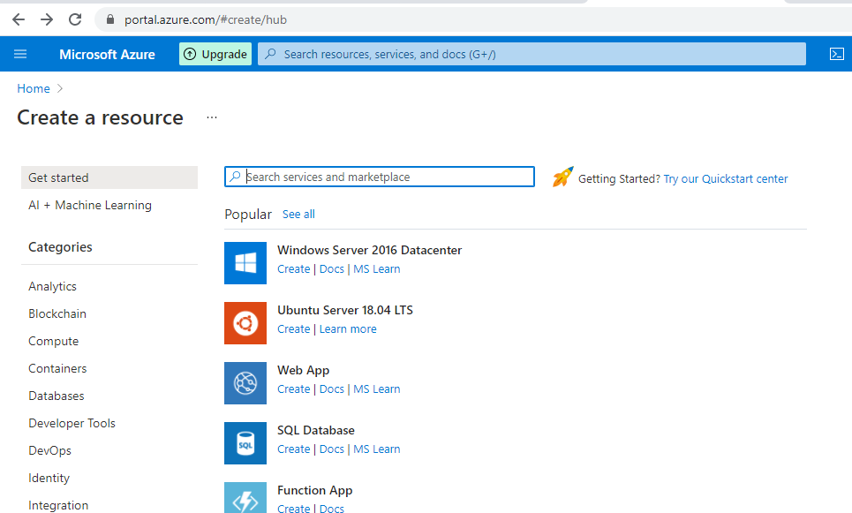

Selected Windows Server 2016 Datacenter option and get below page

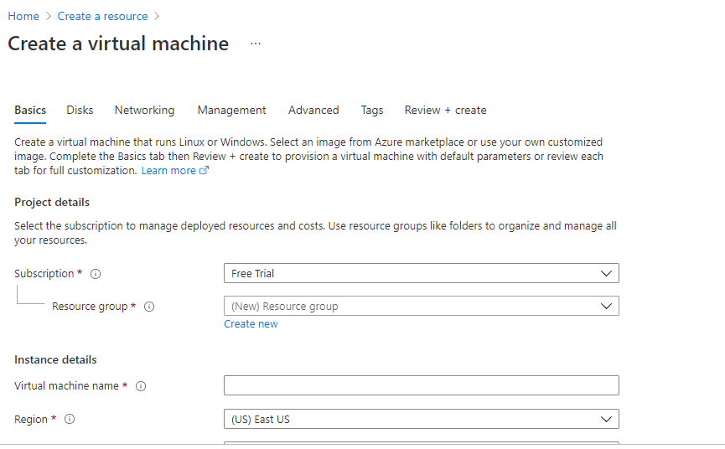

U- vtestserver

P- Vservertest@2021

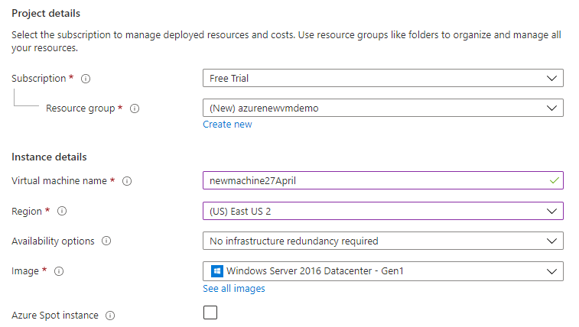

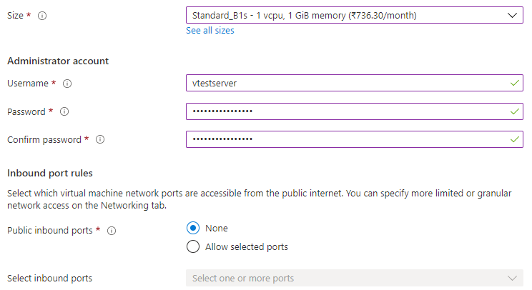

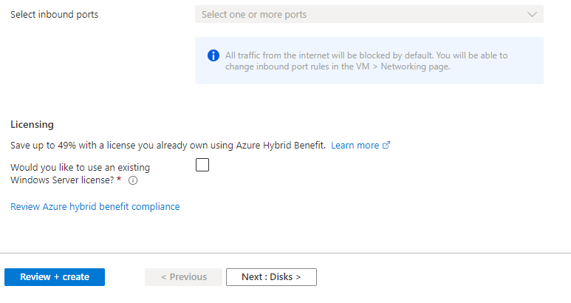

Click on Next:Disks button and get below page

Premium SSD – Premium Solid State Disk is a recommend approach

If you want to go physical spinning disk then choose Standard HDD (Hard disk drive)

First disk option is for Operating system

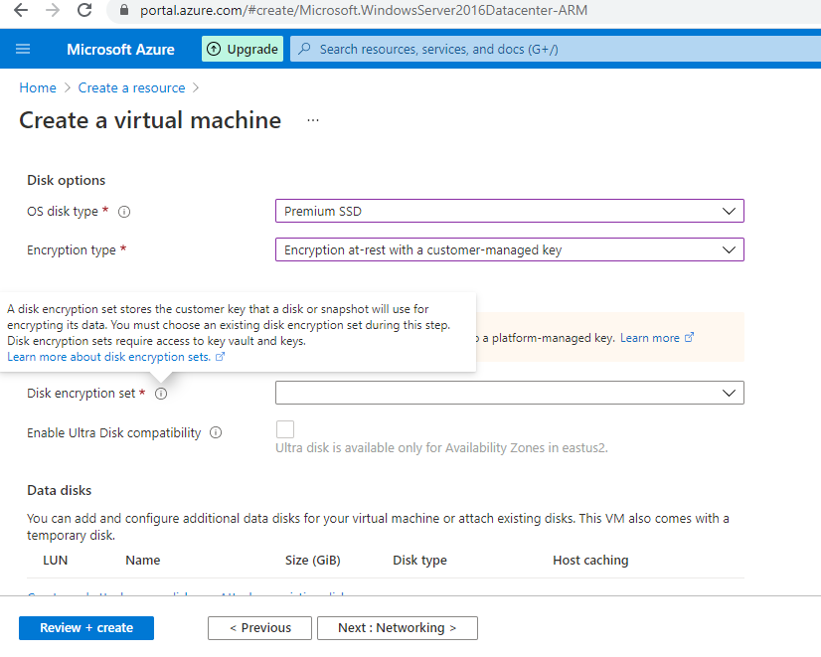

Data disks are optional additional disk you want to store. It depends upon the VM size.

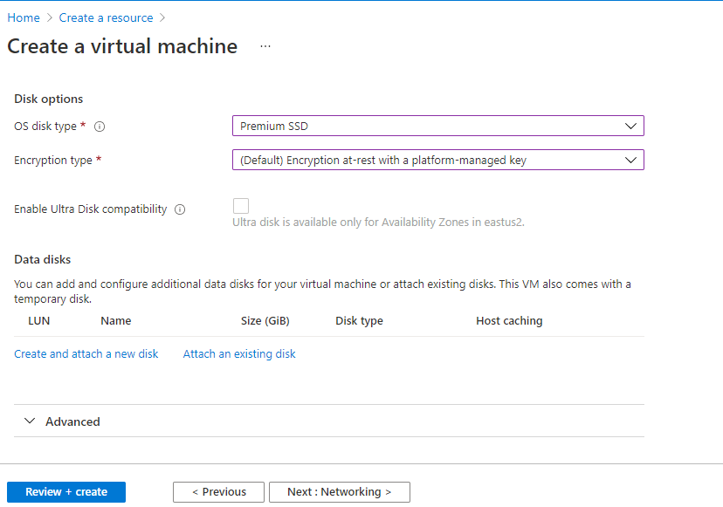

If you click on Create and attach a new disk to VM below page display. You can add as many disk to your VM and you can also detached with your VM depending on your limit of virtual machine.

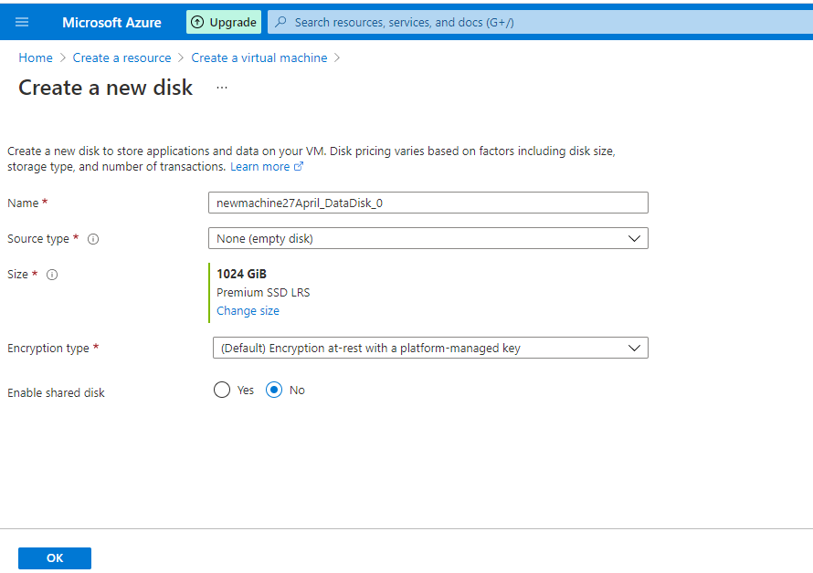

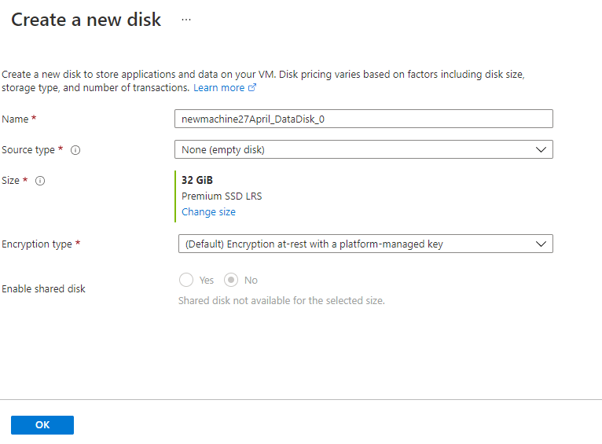

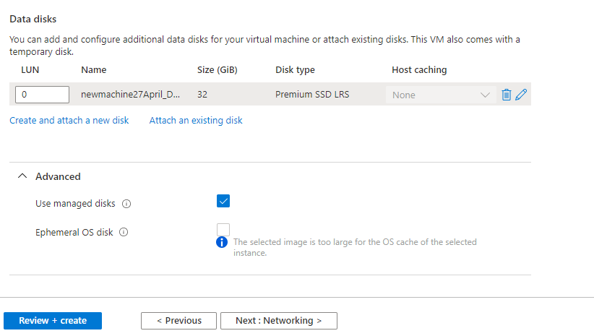

In Advanced Use managed disk option selected by default it is manged by Microsoft.

But if you select uncheck the managed disk option you have to managed yourself and all disk associated with VM.

Click on Networking to see below page.

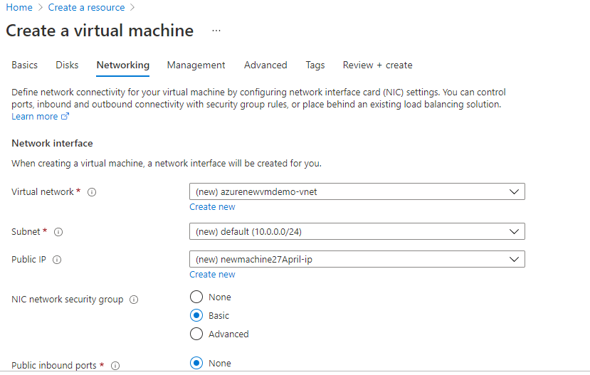

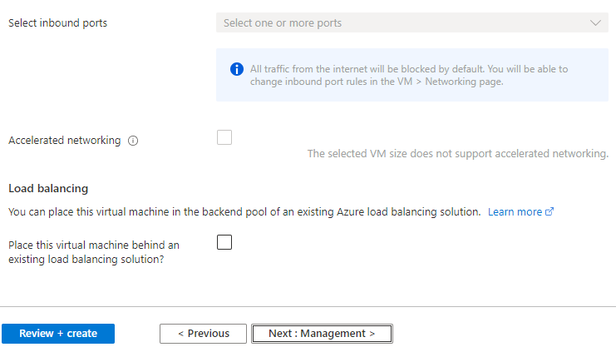

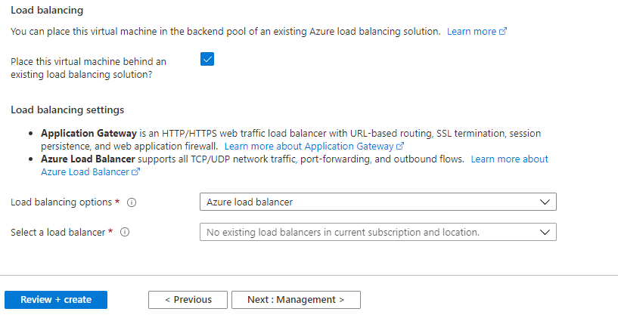

Accelerated networking is available only for large VMs.

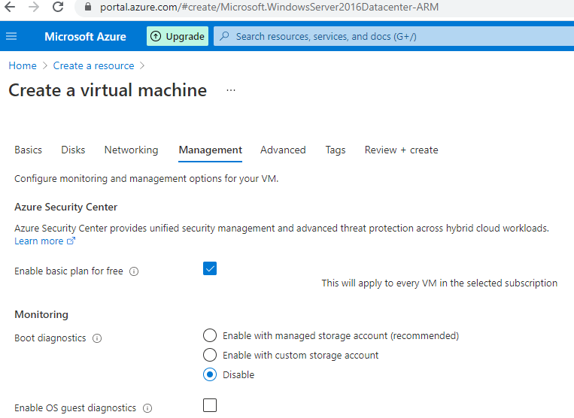

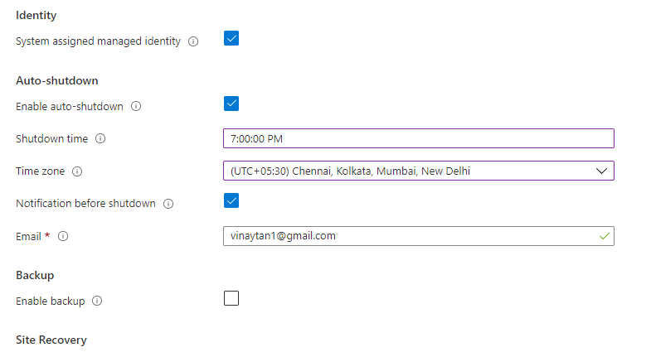

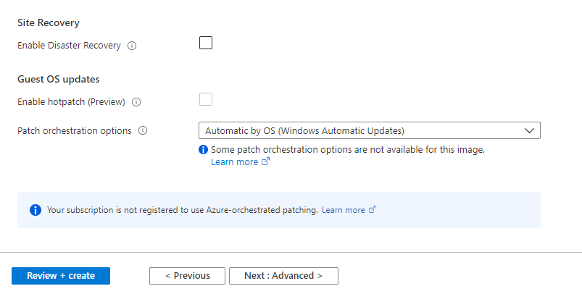

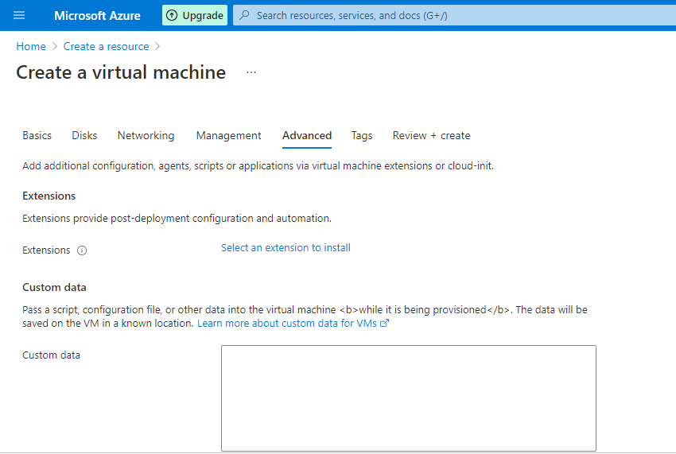

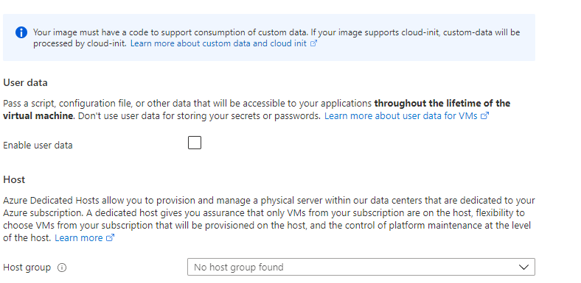

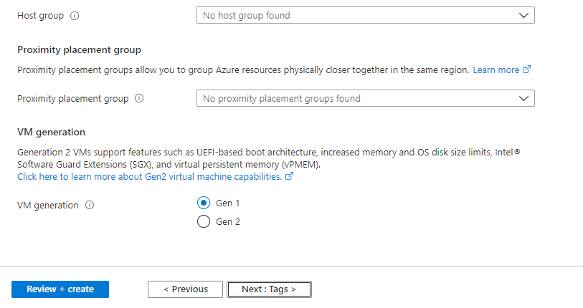

Extensions option is used to run powershell script on startup of VM.

**cloud**-**init** is a widely used approach to customize a Linux VM as it boots for the first time. You can use **cloud**-**init** to install packages and write files, or to configure users and security

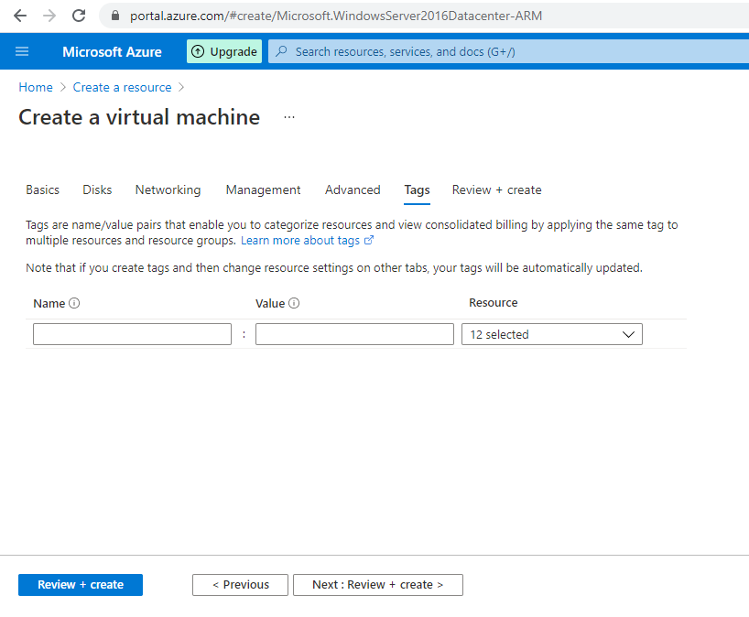

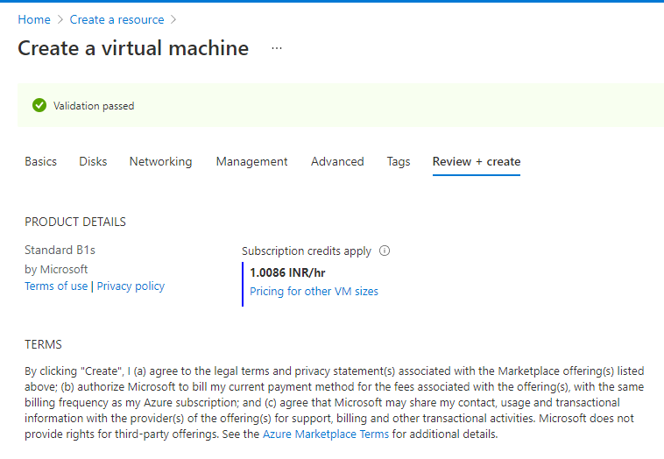

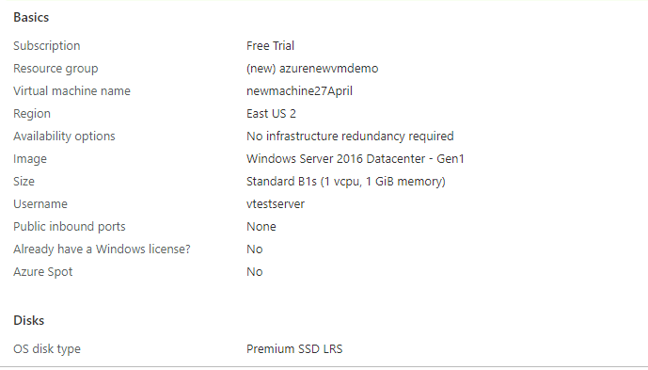

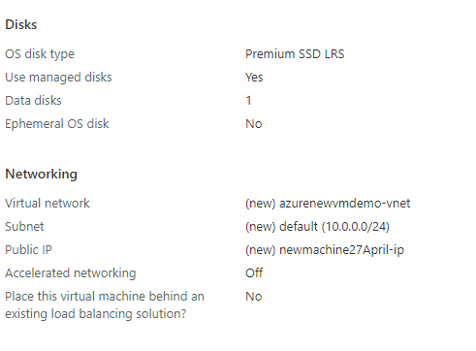

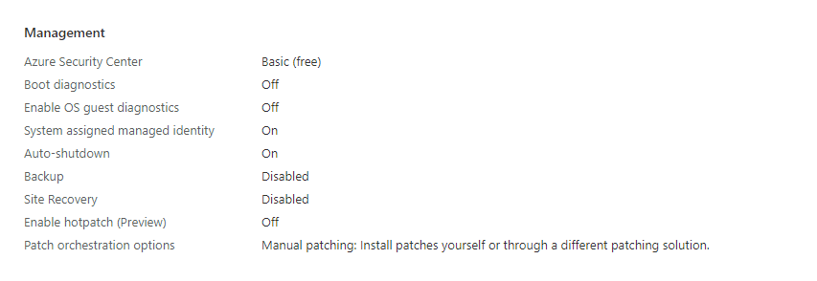

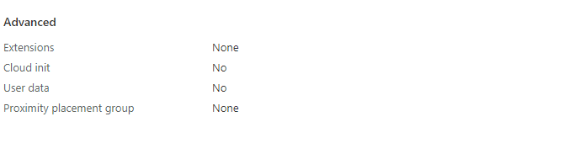

New VM created

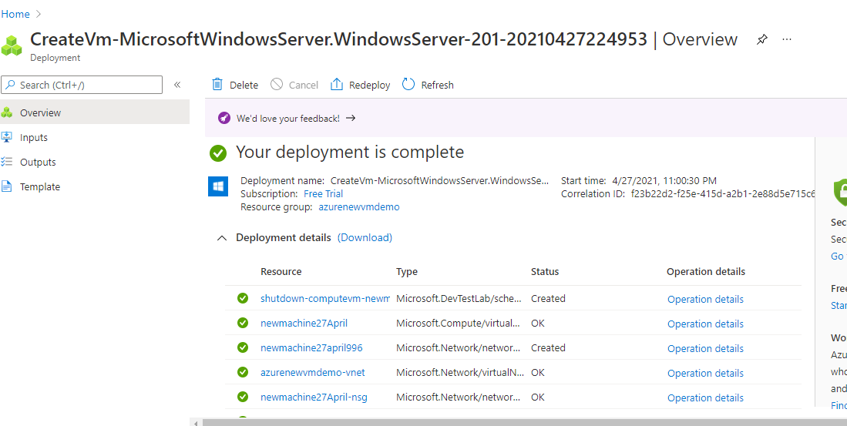

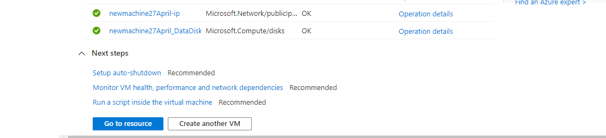

Each Virtual machine is made up of with number of resources.

