Case 1: Manufacturing quality control

Problem Statement:
The manufacturing company uses an AI-based computer vision system to inspect electronic components, classifying each product as defective or non-defective. The quality-control engineer needs to answer four key questions about the defect process:
- What is the probability of finding a particular number of defective products in batch?
- How many defects should the company expect?
- How does the defect probability affect the distribution?
- How many inspections might be needed before the first defect is detected?

Solution:
Given data:
- Assumed defect probability: p = 0.05.
- Batch size: n = 20.
- Total inspected: 200.
- Total observed defects: 11
- The assumed model parameter p = 0.05.
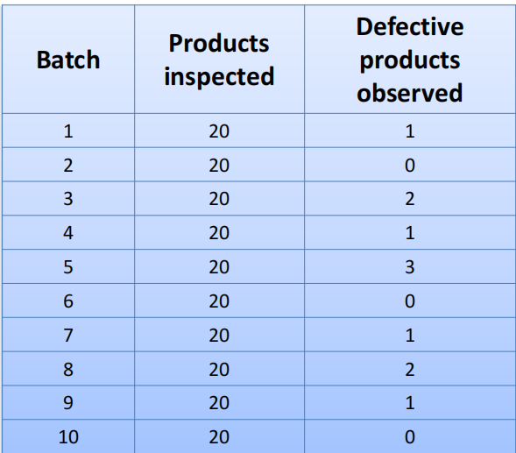
Sample batch data:

Now lets solve the given questions using different probability distributions.
1Q What is the probability of finding a particular number of defective products in a batch?
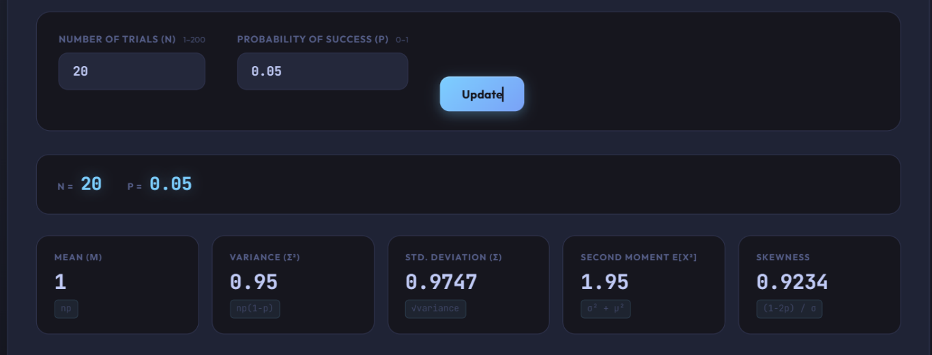

In this we have to find the number of defective products. So, we use the formula of probability mass function.
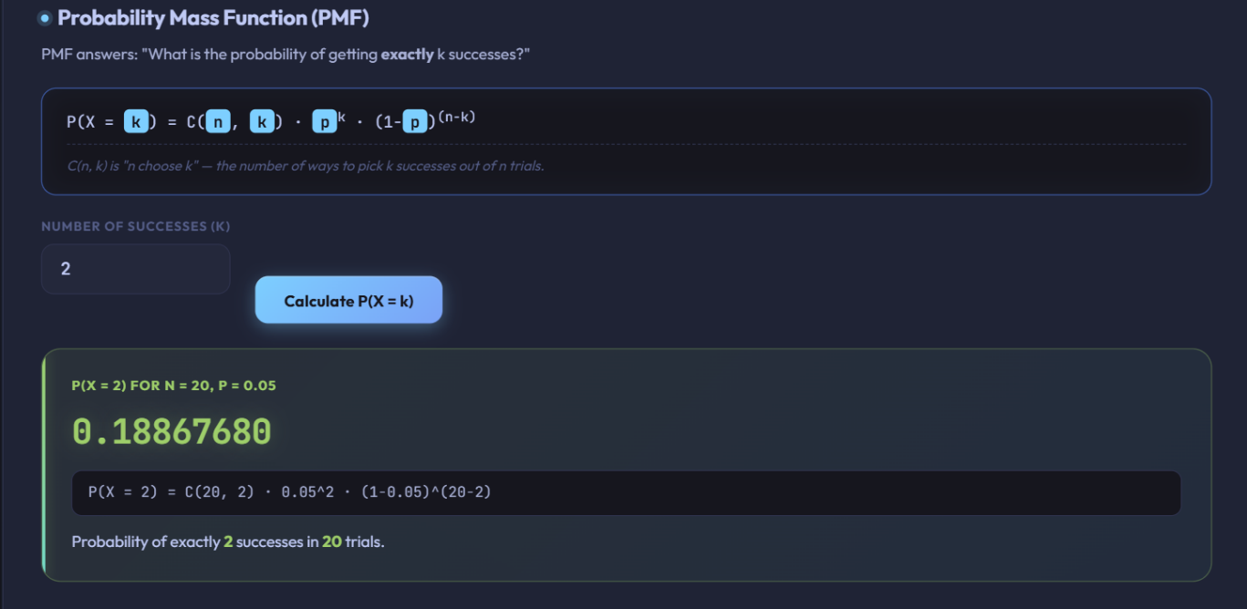

The probability of finding exactly 2 defective products in a single batch of 20 is 0.1887 (or 18.87%).
2Q How many defects should the company expect?
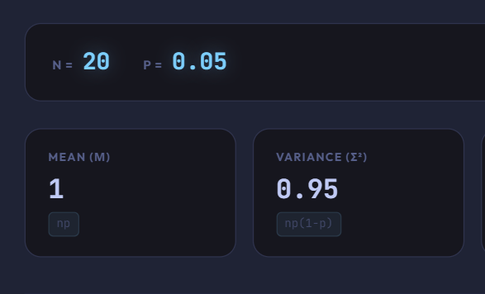
We need to calculate mean and variance.

- The company should expect to find 1.0 defective product per batch of 20 items.
- The variance of the defect distribution is 0.95.
3Q How does the defect probability affect the distribution?
To check the defect probability we have to compare the original defect probability (p= 0.05) against an increased defect probability (p = 0.10).
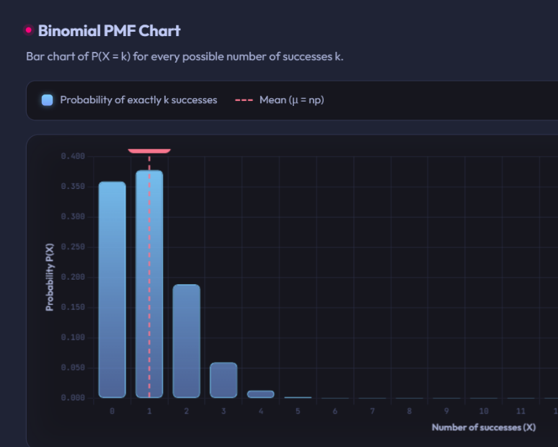
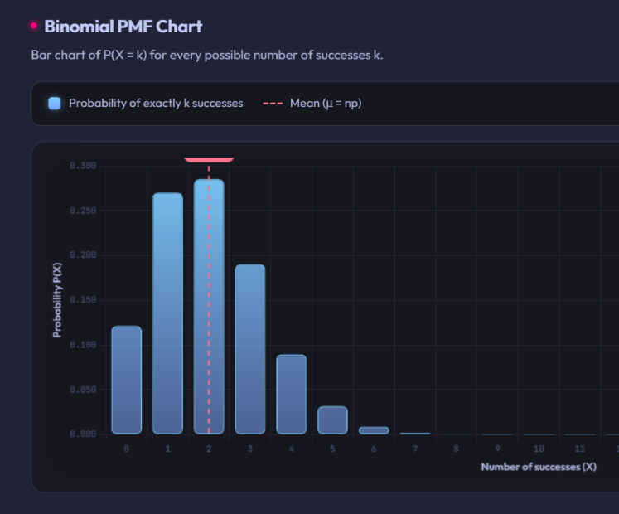

p=0.10
p=0.05

- When we change the p value the center of the distribution shifts toward the right.
- The distribution becomes wider and spreads out more.
4Q How many inspections might be needed before the first defect is detected?
We use geometric distribution to solve this question and the mean gives the number of inspections which might be needed before the first defect.
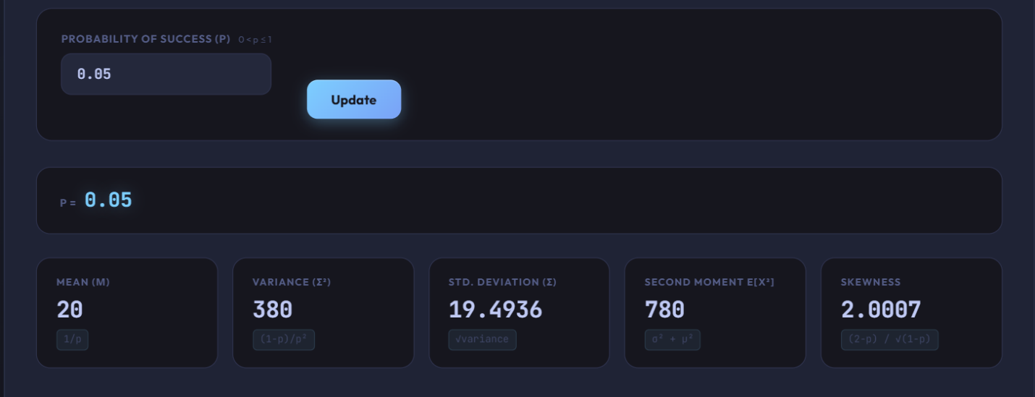

Poisson’s Distribution:
- Number of Trials (n): 100
- Poisson Rate Parameter (lambda): 5


