- Data set -> Feature matrix - 2 D (IV) & Target matrix - 1D - (DV)
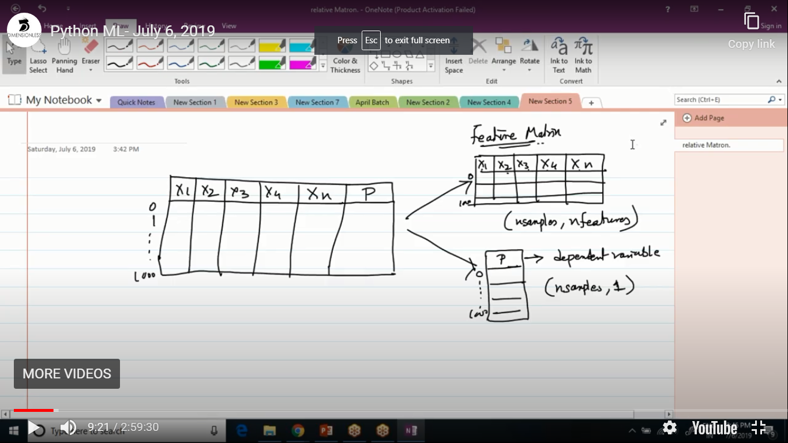

- splitting data set into train and test - random & stratified
Random means randomly splitting data set into 2
stratified means same percentage / ratio is maintained in both train and test data set

- Decision tree algorithm -
for regression
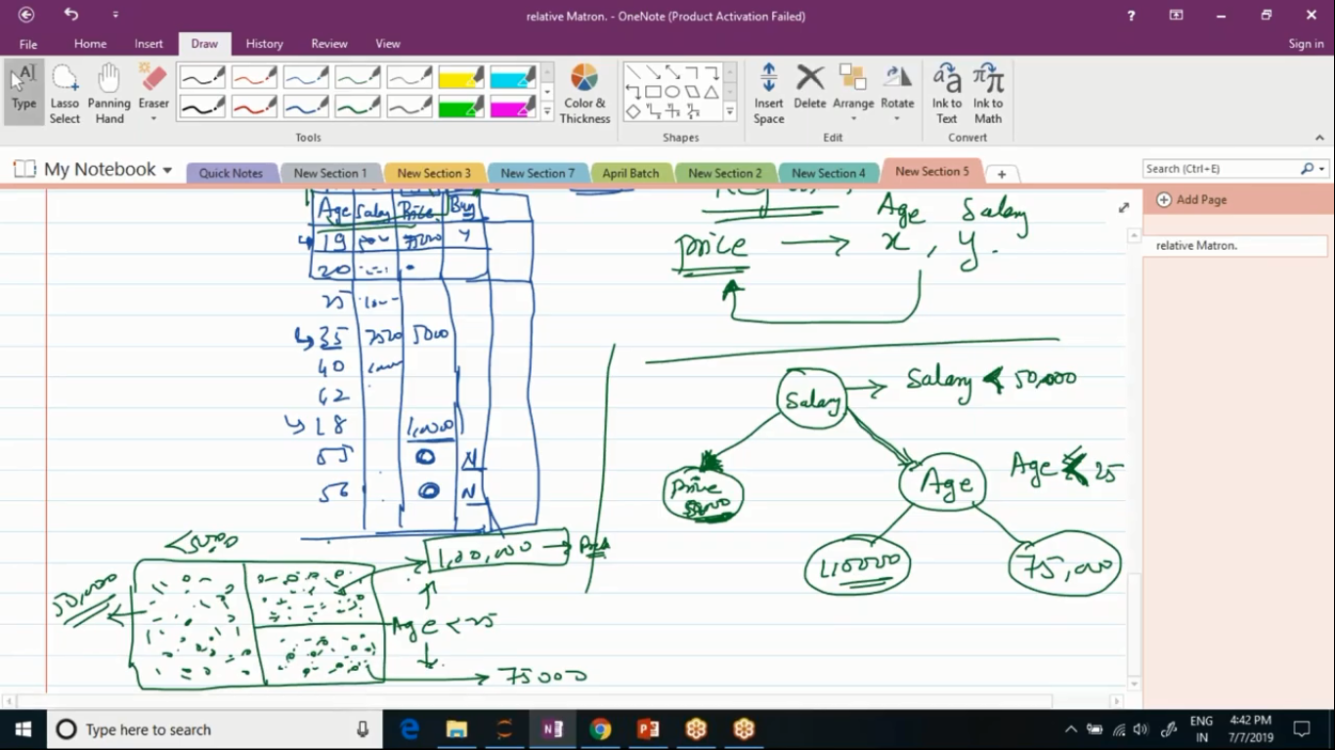
50,000 is the mean of left region. 1 lakh is the mean of top right region and 75,000 is the mean of bottom right region.

For classification --

