Day-4 Ovo-Sexing Using Hyperspectral Imaging and Deep Learning
Project Overview
As Principal Data Scientist on the Day-4 ovo-sexing project, I contributed to multiple research, imaging, and machine learning initiatives focused on large-scale non-invasive gender classification of chicken embryos after four days of incubation.
Over several years, our team conducted extensive experimentation to identify:
- The optimal incubation window for imaging
- Optimal hyperspectral imaging parameters
- Robust preprocessing strategies
- Scalable deep learning architectures for gender prediction
The project utilized hyperspectral imaging in the visible and near-visible spectral range (VNIR, 400–1000 nm) and included both white and brown egg breeds.

Biological and Imaging Research
Through large-scale experimental analysis, we established that the primary gender-related information is encoded within the embryos:
- Blood vessel network
- Chorioallantoic membrane (CAM) region
More broadly, the CAM/blood vessel structures contain spatial and physiological patterns associated with embryo gender differentiation.
To enhance visualization of these regions, we developed and applied ratio-cube imaging techniques that significantly improved contrast and visibility of the vascular structures used for classification.
Our research also demonstrated that gender-related information originates from different localized regions within the CAM/blood vessel structures for male and female embryos, indicating the presence of spatially distributed biological markers rather than a single dominant feature region.

Deep Learning and Large-Scale Model Training
The project involved training advanced computer vision models on a dataset containing more than 800,000 embryo vascular images.
We evaluated and optimized multiple state-of-the-art deep learning architectures, including:
- Vision Transformers (ViT)
- EVA models
- Advanced convolutional and hybrid transformer-based computer vision pipelines
Using these approaches, we achieved:
- 96–97% gender prediction accuracy for a specific breed of white eggs
- Approximately 93–94% accuracy across additional white egg breeds
- Approximately 90% accuracy for selected brown egg breeds
The project demonstrated that large-scale deep learning systems combined with carefully optimized hyperspectral preprocessing pipelines can achieve highly accurate non-invasive ovo-sexing at industrial scale.

Brown Egg Imaging Challenges
One of the major technical challenges involved imaging brown eggs, whose shell composition significantly affects spectral signal quality.
Compared to white eggs, ratio images for brown eggs exhibited noticeably lower quality due to the presence of the eggshell pigment Protoporphyrin IX, which strongly absorbs light in spectral regions where embryo blood vessels are most visible.
This absorption reduced vascular contrast and degraded the quality of the hyperspectral signal used for classification.
To compensate for these effects, we introduced several imaging and calibration improvements:
- Shifted signal and reference bands toward higher wavelengths
- Increased illumination power using Inio lighting systems
- Applied alternative calibration procedures optimized for brown shell absorption characteristics
Similar to the earlier embryo development project, additional improvements may be achievable by filtering out the blue spectral component of visible light to reduce scattering effects and improve spectral stability.

Research Contributions and Technical Leadership
As Principal Data Scientist, I contributed across multiple domains spanning research, imaging science, machine learning, and experimental optimization.
Key contributions included:
- Defining and validating imaging strategies for Day-4 embryo analysis
- Conducting machine learning research and large-scale model development
- Designing analytical and preprocessing pipelines for ratio-cube image generation
- Investigating biological localization of gender-related features within CAM structures
- Supporting experimental optimization for both white and brown egg imaging
- Coordinating large-scale data analysis across hundreds of thousands of embryo samples
- Contributing to model adaptation strategies for breed-specific generalization
The project required combining expertise from:
- Computer vision
- Deep learning
- Hyperspectral imaging
- Statistical analysis
- Embryology and poultry science
- Industrial-scale experimentation

Project Outcome
This work demonstrated the practical feasibility of high-accuracy, non-invasive Day-4 ovo-sexing using hyperspectral imaging and deep learning.
The project established:
- Robust hyperspectral imaging pipelines for embryo vascular analysis
- Large-scale AI training workflows for industrial embryo classification
- Breed-specific adaptation strategies for challenging imaging conditions
- Imaging optimization methods for both white and brown eggs
Most importantly, the research confirmed that gender-related information can be reliably extracted from vascular and CAM structures using advanced computer vision techniques, enabling highly accurate large-scale embryo gender classification in real-world production environments.
Day-4 Ovo-Sexing Performance Analysis — Dark Brown Lohmann Eggs
Experimental Overview
This experiment focused on evaluating Day-4 ovo-sexing performance for Dark Brown Lohmann eggs collected from hens aged 58 weeks.
The primary objective was to compare imaging performance across different hyperspectral camera configurations and exposure calibration settings under controlled incubation and storage conditions.
All eggs were scanned using the company’s RTC hyperspectral imaging system equipped with:
- Inio illumination
- Specim hyperspectral cameras (Specim3 and Specim5)
Both experimental batches were processed without preheating to evaluate baseline imaging and classification performance under standardized non-preheated conditions.

Experimental Configuration
Batch A
- Storage duration: 2 days
- Preheating: None
Configuration 1 — Specim3
- Exposure calibration: 15 ms
- Experiment ID: 2613ARLDB_A4NS3
Results
- Accuracy (ACC): 90.04%
- Mis-hatched female rate: 9.49%
- Missing female rate: 10.43%
Configuration 2 — Specim5
- Exposure calibration: 18 ms
- Experiment ID: 2613ARLDB_A4NS5
Results
- Accuracy (ACC): 89.41%
- Mis-hatched female rate: 10.93%
- Missing female rate: 11.93%

Batch B
- Storage duration: 6 days
- Preheating: None
Configuration 1 — Specim3
- Exposure calibration: 15 ms
- Experiment ID: 2613ARLDB_B4NS3
Results
- Accuracy (ACC): 87.76%
- Mis-hatched female rate: 10.48%
- Missing female rate: 11.75%
Configuration 2 — Specim5
- Exposure calibration: 18 ms
- Experiment ID: 2613ARLDB_B4NS5
Results
- Accuracy (ACC): 88.05%
- Mis-hatched female rate: 10.24%
- Missing female rate: 10.84%
Analysis and Key Findings
The experimental results revealed several important observations regarding the interaction between storage duration, camera configuration, and exposure calibration.
For eggs stored for 2 days, the combination of:
- Specim3
- 15 ms exposure calibration
outperformed the:
- Specim5
- 18 ms exposure calibration
configuration in overall classification accuracy.
This finding was particularly interesting because, throughout the current year, the opposite trend had generally been observed:
- Specim5 with 18 ms calibration consistently achieved slightly higher accuracy compared to Specim3 configurations calibrated at 16 ms.
The current results therefore suggest that:
- Imaging performance may be strongly influenced by storage duration and egg physiological state
- Optimal exposure calibration may vary depending on biological conditions rather than hardware configuration alone
- The relationship between signal intensity, shell absorption, and vascular visibility is likely more complex for Dark Brown Lohmann eggs than initially expected
Additionally, performance degradation observed for the 6-day storage batches indicates that prolonged storage may negatively affect:
- Embryo vascular visibility
- CAM structural clarity
- Signal consistency within the hyperspectral acquisition pipeline
These findings provided valuable insight for refining future imaging protocols and optimizing breed-specific calibration strategies for industrial Day-4 ovo-sexing systems.
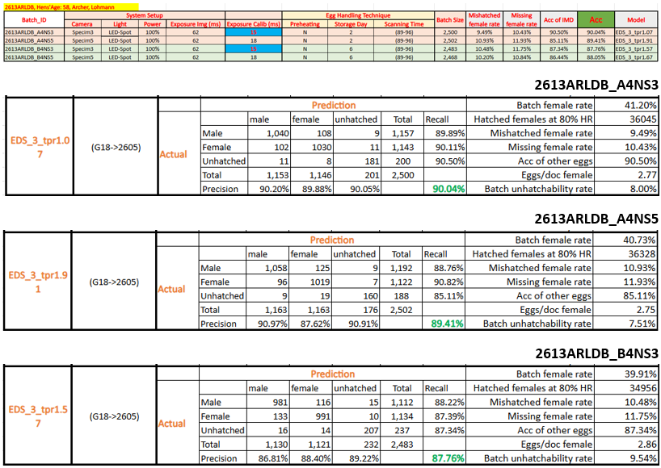
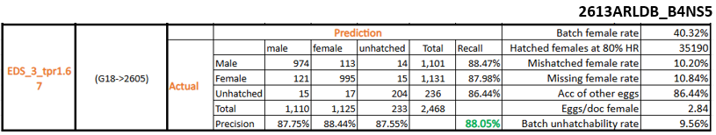
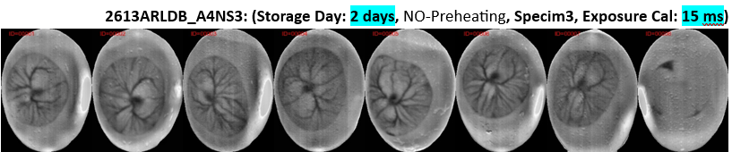
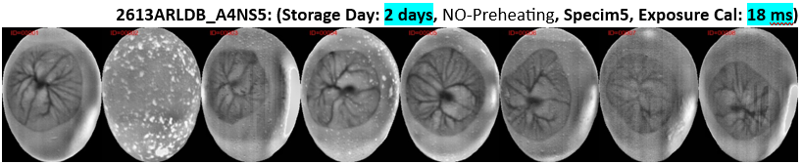
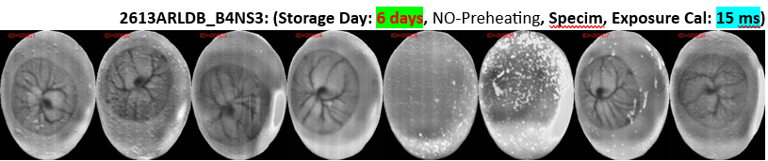
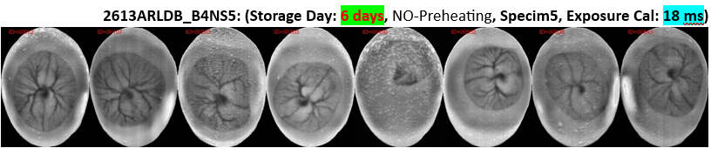

Day-4 Ovo-Sexing Performance Analysis — White McKinley Shaver Eggs
Experimental Overview
This experiment evaluated Day-4 ovo-sexing performance for White McKinley Shaver eggs obtained from hens aged 34 weeks.
The objective of the study was to compare classification performance between the Specim3 and Specim5 hyperspectral imaging systems under controlled preheating and illumination conditions.
All eggs were scanned using the company’s RTC hyperspectral imaging platform with:
- 7-hour preheating
- LED-Spot illumination
- VNIR hyperspectral imaging pipeline
The experiment focused on evaluating how imaging hardware configuration influenced classification accuracy and female prediction reliability for white egg breeds.

Experimental Configuration
Configuration 1 — Specim3
- Experiment ID: 2613MCSWT_G4PS3
- Storage duration: 3 days
- Lighting: LED-Spot
- Preheating: 7 hours
- Camera: Specim3
Results
- Accuracy (ACC): 92.65%
- Mis-hatched female rate: 8.09%
- Missing female rate: 8.87%
Configuration 2 — Specim5
- Experiment ID: 2613MCSWT_G4PS5
- Storage duration: 3 days
- Lighting: LED-Spot
- Preheating: 7 hours
- Camera: Specim5
Results
- Accuracy (ACC): 93.41%
- Mis-hatched female rate: 5.05%
- Missing female rate: 6.07%

Analysis and Key Findings
The results demonstrated strong ovo-sexing performance for white eggs under controlled preheating conditions, with both imaging configurations exceeding 92% classification accuracy.
Among the two configurations, the Specim5 system achieved the best overall performance:
- Higher classification accuracy
- Lower mis-hatched female rate
- Lower missing female rate
The improvement observed with Specim5 suggests that the imaging configuration provided:
- Better vascular structure visibility
- Improved signal stability
- Higher-quality spectral contrast within the CAM/blood vessel regions used for gender classification
The combination of:
- White eggshell characteristics
- 7-hour preheating
- LED-Spot illumination
appears to create highly favorable imaging conditions for hyperspectral embryo analysis.
Compared to brown eggs, white eggs provide significantly cleaner vascular contrast because the shell lacks high concentrations of light-absorbing pigments such as Protoporphyrin IX. This results in:
- Higher signal penetration
- Improved blood vessel visibility
- More stable ratio-image generation
- Better deep learning feature extraction
The experiment further confirmed that optimized illumination and preheating strategies can substantially improve model reliability and classification consistency in industrial Day-4 ovo-sexing workflows.

Project Impact
These results contributed to the ongoing optimization of large-scale hyperspectral ovo-sexing systems by:
- Validating high-accuracy imaging configurations for white egg breeds
- Demonstrating the performance advantages of Specim5 under controlled incubation conditions
- Supporting future calibration strategies for industrial deployment
- Improving understanding of the relationship between incubation conditions, shell properties, and deep learning prediction quality
The experiment also reinforced the importance of integrating biological variability, imaging physics, and machine learning optimization into a unified industrial AI pipeline for embryo gender classification.

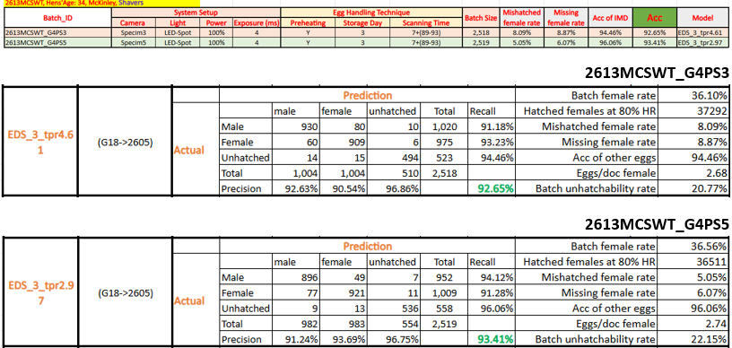
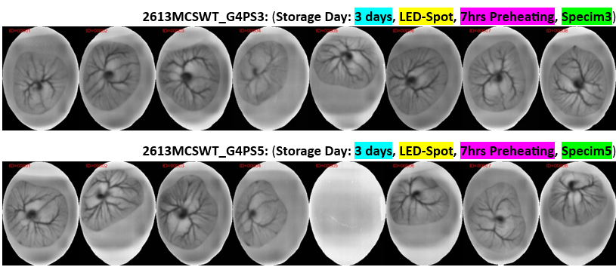

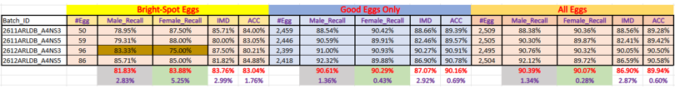

Follow-Up Analysis — Effect of Bright Spots on Brown Egg Classification Accuracy
As part of the ongoing Day-4 ovo-sexing research, we continued investigating how localized bright spots present in brown egg hyperspectral images influence gender classification accuracy (ACC) for both male and female embryos.
Bright spots represent one of the key imaging artifacts affecting brown egg analysis and are believed to originate from localized shell reflectance variations, uneven pigment distribution, or illumination interactions with the eggshell surface.
The objective of this follow-up study was to determine whether these artifacts disproportionately affect classification performance for one gender over the other.
Experimental Findings
Additional batch-level analysis revealed that the influence of bright spot artifacts is not symmetric between male and female embryo predictions.
Among the analyzed datasets:
- Only 1 out of 4 batches (2612ARLDB_A4NS3) showed a stronger negative impact on female predictions
- In the remaining batches, bright spot artifacts affected male predictions significantly more than female predictions
This result suggests that bright spot interference interacts differently with the gender-specific vascular and CAM features learned by the deep learning models.
Interpretation and Technical Analysis
The observed asymmetry indicates that male and female classification features may rely on different spatial or spectral regions within the embryo vascular structures.
One possible explanation is that:
- Male prediction features may depend more heavily on high-contrast vascular patterns
- Bright spot artifacts partially obscure or distort these regions
- This distortion reduces feature consistency and weakens model confidence for male predictions
In contrast, female-related features may be:
- More spatially distributed
- Less dependent on localized high-contrast vascular structures
- More robust to reflectance-related imaging artifacts
The fact that only one batch exhibited stronger degradation for female predictions also suggests that:
- The artifact behavior is influenced by batch-specific biological or imaging conditions
- Eggshell morphology, shell pigment distribution, storage conditions, or illumination calibration may all contribute to variability in artifact sensitivity

Research Significance
This analysis provided important insight into the interaction between:
- Hyperspectral imaging artifacts
- Eggshell optical properties
- Deep learning feature extraction behavior
- Gender-specific classification robustness
The findings highlighted the importance of:
- Artifact-aware preprocessing
- Improved illumination normalization
- Robust ratio-image generation
- Spatially adaptive feature learning strategies
for maintaining stable classification performance across challenging brown egg datasets.
The study also reinforced the need for:
- More advanced optical calibration methods
- Enhanced image correction pipelines
- Potential polarization-based imaging approaches
to reduce the impact of shell-induced reflectance artifacts in industrial-scale ovo-sexing systems.
Ongoing Research and Model Development
Several research and engineering initiatives are currently in progress as part of the continued optimization of the Day-4 ovo-sexing platform. While these efforts are not yet finalized, they represent important next steps toward improving model generalization, robustness, and industrial deployment performance.

EDS_4 — Next-Generation Classification Model
The next-generation classification framework, EDS_4, is currently under active training and optimization.
Compared to previous model generations (EDS_2 and EDS_3), EDS_4 is designed to integrate multiple architectural and dataset improvements intended to enhance cross-breed generalization and prediction stability.
Planned Improvements in EDS_4
Multi-Breed Fine-Tuning Integration
The new model combines fine-tuned representations across multiple commercial egg breeds, including:
- Brown Lohmann
- White Lohmann
- White Shaver
- White Dekalb
- White Babcock
Unlike previous models that were more breed-specific, EDS_4 is designed as a broader generalized framework capable of learning shared and breed-dependent vascular features across heterogeneous datasets.
Because of the increased biological variability and significantly larger dataset diversity, training time and optimization complexity for EDS_4 are substantially greater compared to EDS_2 and EDS_3.

Fusion-Based EDS Architecture
EDS_4 also incorporates a fusion-based modeling strategy intended to improve:
- Feature robustness
- Multi-scale vascular representation learning
- Generalization across varying shell conditions and imaging configurations
The fusion approach combines complementary representations learned from multiple preprocessing and model pathways, enabling the system to better capture subtle gender-related vascular patterns.
Hyperparameter Optimization
The new training pipeline includes extensive hyperparameter optimization targeting:
- Model stability
- Cross-batch generalization
- Reduction of overfitting
- Improved prediction confidence calibration
This optimization process is particularly important due to the large-scale and biologically heterogeneous nature of the training data.

Expanded Training Dataset
The EDS_4 training dataset has been significantly expanded and now includes data collected up to Week 12 (including the 0612 experimental batches).
The expanded dataset provides:
- Greater breed diversity
- Increased biological variability
- Improved robustness against batch-specific artifacts
- Better representation of real-world industrial conditions

Bright Spot Artifact Reduction for Brown Eggs
In parallel with model development, additional research is ongoing to reduce the impact of bright spot artifacts in brown egg hyperspectral images.
Current work includes investigation of:
- Median-filter-based preprocessing approaches
- Artifact suppression techniques applied to ratio-cube images
Initial experiments using median filtering did not produce measurable improvements compared to the original ratio-cube pipeline. However, research in this direction remains ongoing as part of broader efforts to improve:
- Signal stability
- Vascular visibility
- Classification robustness for brown eggs
These investigations continue to provide valuable insight into the interaction between eggshell optics, imaging artifacts, and deep learning feature extraction behavior.
Strategic Direction
The ongoing research efforts reflect a broader transition from:
- Breed-specific classification systems
toward:
- Large-scale generalized industrial ovo-sexing frameworks capable of handling substantial biological and imaging variability across commercial production environments.
The combination of:
- Expanded datasets
- Fusion architectures
- Advanced calibration methods
- Artifact-aware preprocessing
- Cross-breed fine-tuning strategies
is expected to significantly improve the scalability and robustness of future-generation ovo-sexing systems.

Summary of All White and Brown Batches
Best White Egg Results by Breed
We achieved a new best result for White-Shaver.
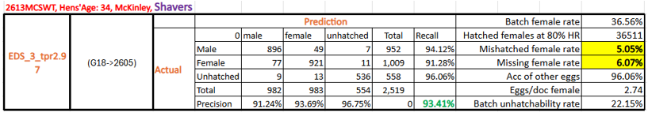
The summary of all white and brown batches in this section.

White Eggs (Shavers Only):
