Early Embryo Detection and Gender Classification Using Hyperspectral Imaging
Project Overview
Over several years of research, I led a multidisciplinary team focused on non-invasive early embryo detection and gender classification inside intact chicken eggs using hyperspectral imaging (HSI) and machine learning.
The project investigated embryo visibility during the earliest incubation stages, analyzed gender-related metabolic differences, and explored advanced imaging and classification techniques for improving prediction accuracy while preserving embryo viability.

Early Embryo Detection Using VNIR Hyperspectral Imaging
Our research demonstrated that embryo visualization inside intact eggs is feasible during the earliest stages of incubation using hyperspectral imaging in the visible and near-visible spectral range (VNIR, 400–1000 nm) under standard incubation conditions (37.5–37.8°C).
In contrast, the NIR spectral range (900–1700 nm) produced significantly poorer results due to:
- Increased water absorption
- Lower spatial resolution
- Reduced chemical contrast between embryo and yolk regions
As a result, the NIR range was determined to have limited practical value for early embryo detection.
Key Findings
- Embryo visibility through the eggshell became possible after approximately 16–17 hours of incubation, achieving successful detection in roughly 70% of eggs.
- After 22 hours of incubation, visibility and detection rate increased to approximately 90–95%.
- Embryonic development during this interval is highly dynamic:
  - Embryo area increased by more than 10×
  - Estimated embryo volume increased by up to 30×
These findings confirmed that the incubation window between 16 and 22 hours is critical for embryo analysis and classification.

Incubation Optimization and Metabolic Analysis
Our experiments also revealed measurable metabolic differences between male and female embryos. Elevated incubation temperatures produced noticeably higher metabolic activity in male embryos compared to females.
To minimize stress caused by abrupt temperature changes while maintaining embryo viability, I designed and implemented a custom incubation schedule:
- Gradual increase from 37.8°C to 38.5°C during the first 11 hours
- Gradual decrease back to 37.8°C during the following 11 hours
This strategy ensured normal incubation conditions by the 22-hour mark while avoiding thermal shock during early development.
Importantly, hatchability analysis demonstrated that the modified schedule produced no increase in embryo mortality compared to standard incubation procedures.

Dataset and Experimental Design
The study utilized four independent egg batches totaling approximately 20,000 eggs.
Dataset Split
- 3 batches used for training
- Remaining batch split equally into:
  - Validation set
  - Testing set
This setup enabled robust validation of both imaging and classification approaches across independent biological samples.

1. RGB1 vs. RGB2: Which Configuration Works Better for early gender classification
For early ovo-sexing, we currently have 2 different versions of fake RGB images. The details are as follows:
RGB1 - Adaptive Histogram Equalization
Configuration 1: Bands 40–73 (Signal) & 74–100 (Reference)
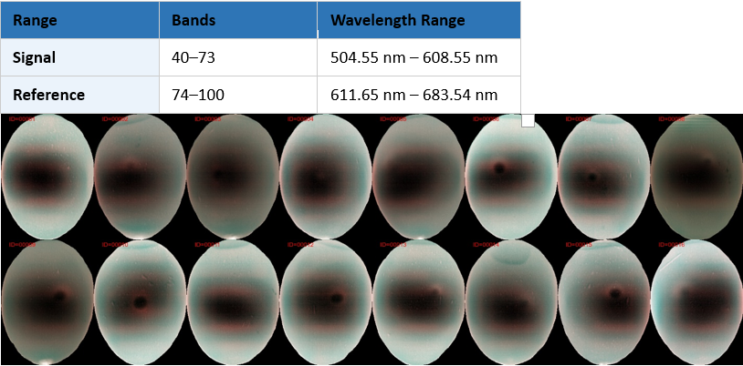

RGB2 - Gamma Correction
Configuration 2: Bands 37–59 (Signal) & 60–80 (Reference)
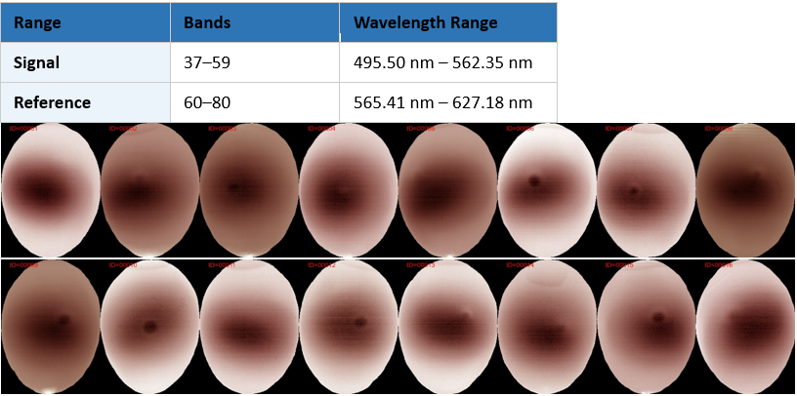
This naturally raises the question: which version performs better for gender classification during early ovo-sexing?
To investigate, we used 2 multi-timepoint models to classify the gender for early ovo-sexing:
• The model takes 2 images as input, captured at 17 hours and 22 hours
• The backbone architecture is ResNet50
The dataset is summarized below:
• Training: 16,548 image pairs
• Validation: 2,499 image pairs
• Testing: 2,499 image pairs
The only difference between the two experiments is the use of RGB1 versus RGB2. As you can see from the results below, RGB2 outperforms RGB1 for both validation and testing (~0.5%)
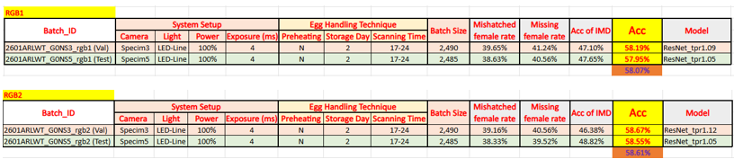
Classification Research and Feature Engineering
A major part of the project focused on determining whether spectral-domain information could improve gender classification accuracy.
Spectral Feature Analysis
Detailed spectral analysis was performed using covariance descriptors as a feature engineering method applied to segmented embryo regions. However, the spectral domain did not provide substantial additional discriminative information.
Observed classification accuracy remained within approximately 57–58%, which was similar to or slightly lower than previous baseline approaches.
Meta-Learning Architecture
To investigate more advanced learning strategies, we implemented a meta-learning framework consisting of:
- Base classifiers: decision trees within a decision forest
- Meta-classifier: Transformer architecture
In this approach:
- Prediction probabilities from decision trees were interpreted as token embeddings
- The Transformer attempted to learn relationships between probability distributions generated by the ensemble
We also evaluated multiple conventional classifiers directly on covariance descriptors. Across all experiments, classification performance remained highly consistent.
Key Scientific Insight
One of the most important findings of this work was that deep learning approaches did not significantly improve generalization performance compared to conventional machine learning methods.
This strongly suggests that:
- Existing observable features related to embryo gender are weak
- Chemical differences between male and female embryos during early development are minimal
- The primary distinction likely arises from differences in developmental and metabolic rates rather than large-scale biochemical composition differences
This hypothesis aligns with the Hamburger–Hamilton (HH) developmental framework, where embryos progress through 46 developmental stages. Male and female embryos may exhibit slight stage-dependent chemical variations due to differences in developmental timing and metabolic activity.

Future Directions and Imaging Improvements
The project also identified several promising directions for improving embryo visibility and classification performance.
Improved Illumination
Initial experiments showed that stronger illumination sources (e.g., Inio lighting instead of conventional LED systems) improved embryo visibility at both:
- 17 hours
- 22 hours of incubation
Additional improvements may be achieved by filtering out the blue spectral component, which is associated with:
- Increased light scattering
- Interference with neighboring spectral bands
Polarized and Birefringent Hyperspectral Imaging
The most promising future direction involves polarized hyperspectral imaging, also referred to as birefringent hyperspectral imaging.
Unlike conventional HSI (3D tensor), birefringent HSI produces a richer 4D representation by capturing:
- Retardance images
- Optical axis orientation images
for every spectral band.
This additional structural information may reveal subtle cellular organization differences between male and female embryos that conventional HSI cannot capture.
My hypothesis is that gender-related information during early embryonic development is encoded primarily within the embryo’s cellular structure rather than its chemical composition. While standard HSI lacks the sensitivity to detect these structural differences, birefringent HSI has the theoretical capacity to capture them.

Project Outcome
This research established the feasibility of:
- Non-invasive early embryo visualization through intact eggshells
- Controlled incubation optimization based on metabolic behavior
- Large-scale hyperspectral imaging pipelines for embryo analysis
The project also provided important scientific insights into the limitations of conventional spectral classification methods and identified polarized hyperspectral imaging as a potentially transformative next-generation approach for early embryo gender detection.

