1. RGB1 vs. RGB2: Which Configuration Works Better for Day 0 Gender Classification
As we may know, for Day 0, we currently have 2 different versions of RGB images. The details are as follows:
RGB1 - Adaptive Histogram Equalization
Configuration 1: Bands 40–73 (Signal) & 74–100 (Reference)
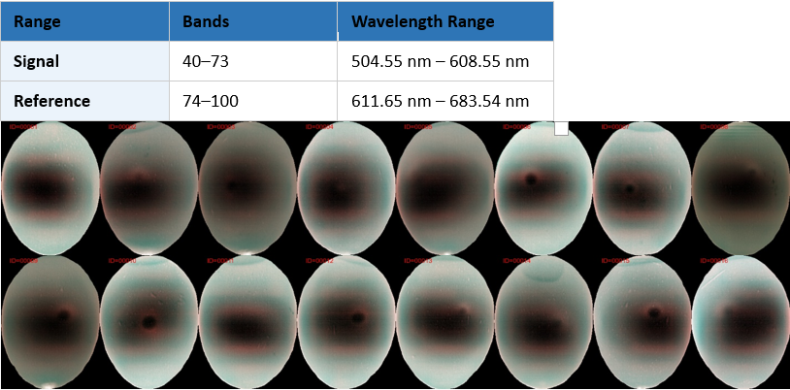

RGB2 - Gamma Correction
Configuration 2: Bands 37–59 (Signal) & 60–80 (Reference)
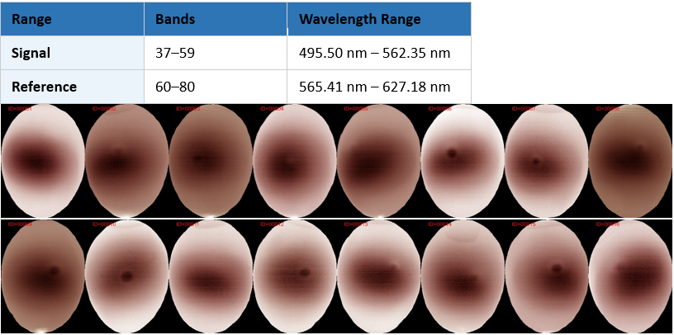

This naturally raises the question: which version performs better for gender classification of Day 0 eggs? Longtime ago, by Visually, Dr. Laura feels that RGB2 with gamma correction appears better than RGB1. But is that actually the case?

To investigate, we used 2 multi-timepoint models to classify the gender of Day 0 eggs:
• The model takes 2 images as input, captured at 17 hours and 22 hours
• The backbone architecture is ResNet50
The dataset is summarized below:
• Training: 16,548 image pairs from (GD11→GD17) + (2602_G0→2604_G0)
• Validation: 2,499 image pairs from batch 2601_G0NS3
• Testing: 2,499 image pairs from batch 2601_G0NS5
The only difference between the two experiments is the use of RGB1 versus RGB2. As you can see from the results below, RGB2 outperforms RGB1 for both validation and testing (~0.5%)

