Class 4 R intro
Vivian Bach
1/15/26
x <- 1:50
plot(x, sin(x))
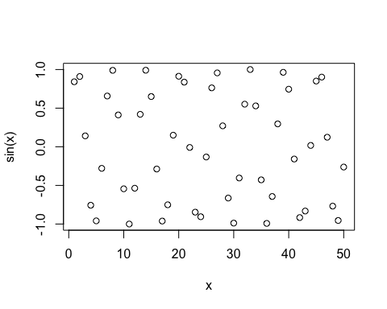
plot(x,sin(x), typ="l", col="blue",lwd=5)
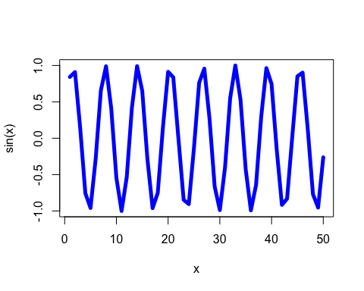
log(10, base=10)
## [1] 1

