A1 Lightweight Directory Access Protocol (LDAP) enables central management of directory  
information. The Directory Information Tree (DIT) of an organization is designed as  
follows:

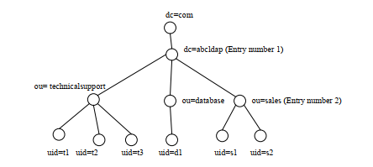

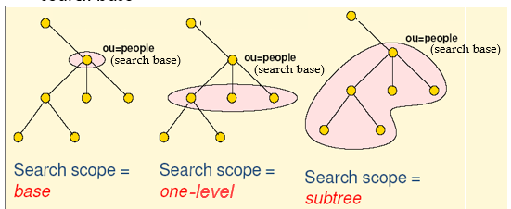  
(a) List TWO examples of LDAP implementation. [2 marks]

Ans: Microsoft Active Directory in Windows Servers

OpenLDAP in Unix and Unix-like systems

(b) List the Distinguished Names (DN) of the following entries

Ans:   
(i) Entry number 1 [1 mark]

Ans: dc=abcldap,dc=com  
(ii) Entry number 2 [1 mark]

Ans: ou = sales, dc = abcldap, dc = com  
(c) List the RDN of the following entries which will be found by running the commands  
below.

|  |  |
| --- | --- |
| (i) | ldapsearch –x –h localhost –b “ou=database,dc=abcldap,dc=com” –s one [1 mark]  Ans: uid=d1 |

(ii) ldapsearch –x –h localhost –b “ou=sales,dc=ict,dc=net” –s base [1 mark]

Ans: ou=sales

(iii) ldapsearch –x –h localhost –b “dc=abcldap,dc=com” –s sub “(|(ou=*e)(ou=s*))

Ans: ou=database, ou=sales

(iv) ldapsearch –x –h localhost –b “dc=abcldap,dc=com” –s sub (&(ou=t*)(ou=*t))

Ans: ou=technicalsupport

A2 The LDAP schema of an object class ″people″ is defined as follows. Refer to the schema and answer the following questions.

1. What attribute(s) must exist in an object class instance of people?

Ans: cn and sn.

1. What attribute(s) may exist in an object class instance of people?

Ans: st and uid

1. List ANY THREE advantages of LDAP.

* ANS: Support of TCP/IP, Simplified functional model, Simplified encoding of names and data

1. List ANY THREE considerations of DIT design.

ANS at PPT 2.LDAP structure and organizationP21:

1. Explain the meanings of ″cn″, ″sn″, ″st″ and ″uid″ attribute types in the object class definition.

Ans:

A3 (a) List FOUR models of directories.

(b) List ANY TWO types of virtualizations.

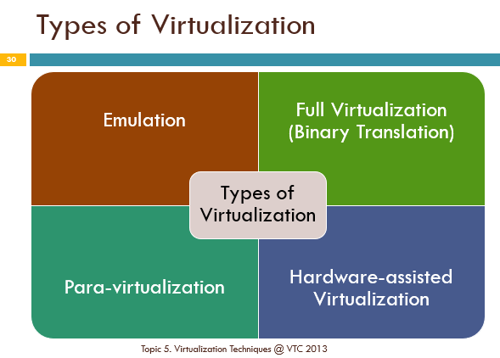

(c) The system administrators can’t use VM player in the computers and find that  
Intel or AMD CPU installed in the computer. What setting do they need to enable in  
BIOS system of the computer?

ANS: Your name is Peter

No, my name is Alice

(a) Draw a Directory Information Tree (DIT) for ***GHI*** company.  
(Hints : Only the Relative Distinguished Names are needed in the DIT) [9 marks]

ANS:

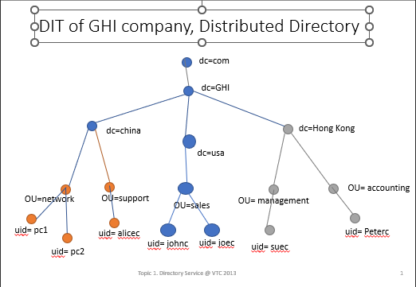

ANS:

1.johnc 2.pc3 3.sales 4.USA 5.GHI

6.johnc

7.pc3

8. ghi.acc.com

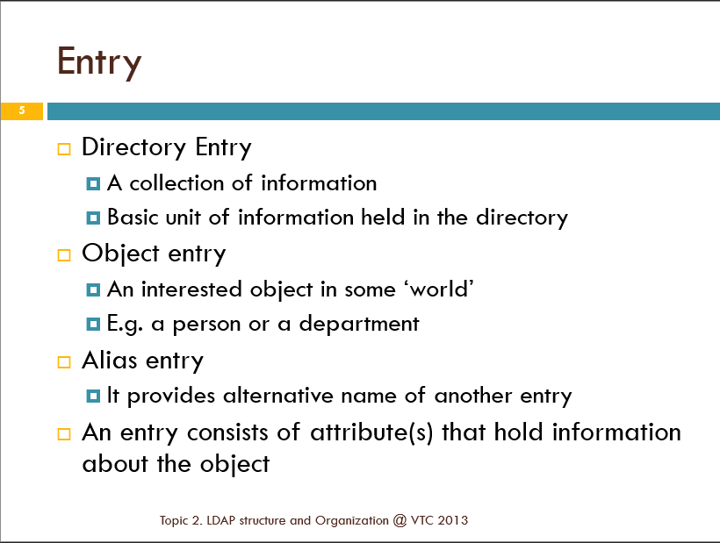

(d) List FOUR steps of building the LDAP directory. [8 marks]

