21BCA112

[Author name]

[company name]



JAVA

JOURNAL-1

1. Write a program to take command line input and check number is odd or even.

import java.util.Scanner;

class PRG_01

{

public static void main(String [] args)

{

int A;

Scanner sc = new Scanner(System.in);

System.out.print("Enter any No. : ");

A = sc.nextInt();

if(A%2==0)

System.out.println("The value "+A+" is even.");

else

System.out.println("The value "+A+" is odd.");

}

}

Output :

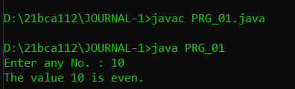

2. Write a program to take command line input and sum of 2 number.

import java.util.Scanner;

class PRG_02

{

public static void main(String args[])

{

int x, y, sum;

Scanner sc = new Scanner(System.in);

System.out.print("Enter the first No. : ");

x = sc.nextInt();

System.out.print("Enter the second No. : ");

y = sc.nextInt();

sum = sum(x, y);

System.out.println("The sum of two numbers x and y is: " + sum);

}

public static int sum(int a, int b)

{

int sum = a + b;

return sum;

}

}

Output :

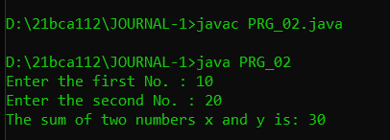

3. Write a program to take command line input and calculate a Simple Interest.

import java.util.Scanner;

class PRG_03

{

public static void main (String args[])

{

float p, r, n, si;

Scanner s=new Scanner(System.in);

System.out.print("Enter Value For Princip Amount :");

p=s.nextFloat();

System.out.print("Enter Value For Number Of Month :");

n=s.nextFloat();

System.out.print("Enter Value For Rate :");

r=s.nextFloat();

si = (p*r*n)/100;

System.out.println("Simple Interest is : " +si);

}

}

Output :

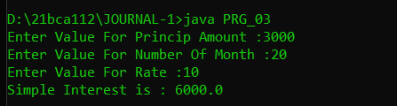

4. Write a Program to take command line input and Check Number is Positive or Negative.

import java.util.Scanner;

class PRG_04

{

public static void main(String [] a)

{

int b;

Scanner sc = new Scanner(System.in);

System.out.print("Enter any No. : ");

b = sc.nextInt();

if(b>0)

{

System.out.println(b+" is Positive.");

}

else

{

System.out.println(b+" is Nagetive.");

}

}

}

Output :

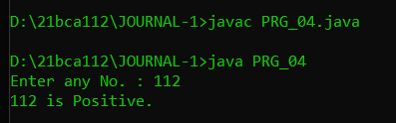

5. Write a Program to take command line input and Check Year is Leap Year or Not.

import java.util.Scanner;

class PRG_05

{

public static void main(String[] args)

{

int year;

boolean leap = false;

Scanner s=new Scanner(System.in);

System.out.print("Enter any year : ");

year=s.nextInt();

if (year % 4 == 0)

{

if (year % 100 == 0)

{

if (year % 400 == 0)

leap = true;

else

leap = false;

}

else

leap = true;

}

else

leap = false;

if (leap)

System.out.println(year + " is a leap year.");

else

System.out.println(year + " is not a leap year.");

}

}

Output :

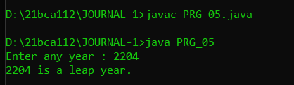

6. Write a program to take command line input and find the Character Is Vowel or Not.

import java.util.Scanner;

class PRG_06

{

public static void main(String [] args)

{

char a;

Scanner sc=new Scanner(System.in);

System.out.print("Enter any Character :");

a = sc.next().charAt(0);

if(a == 'a' || a == 'e' || a == 'i' || a == 'o' || a == 'u' || a == 'A' || a == 'E' || a == 'I' || a == 'O' || a == 'U' )

System.out.println(a +" is vowel");

else

System.out.println(a+ " is consonant");

}

}

Output :

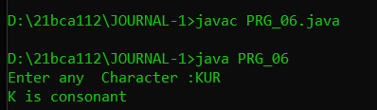

7. Write a program to reverse a given number using while loop.

import java.util.Scanner;

class PRG_07

{

public static void main(String[] args)

{

int n , r = 0;

System.out.print("Enter any No. to reverse : ");

Scanner sc = new Scanner(System.in);

n = sc.nextInt();

while(n != 0)

{

int re = n % 10;

r = r * 10 + re;

n = n/10;

}

System.out.println("The reverse of the given number is : " + r);

}

}

Output :

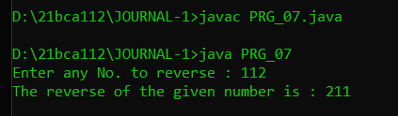

8. Write a program to reverse a given number using for loop.

import java.util.Scanner;

class PRG_08

{

public static void main(String[] args)

{

int n,i,r = 0;

System.out.print("Enter any No. to reverse : ");

Scanner sc = new Scanner(System.in);

n = sc.nextInt();

for(i=1;n!=0;i++)

{

int re = n % 10;

r = r * 10 + re;

n = n/10;

}

System.out.println("The reverse of the given number is : " + r);

}

}

Output :

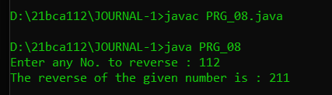

9. Write a program to check number is Armstrong or Not

import java.util.Scanner;

class PRG_09

{

public static void main(String[] args)

{

int n, oN, r, re = 0;

Scanner sc = new Scanner(System.in);

System.out.print("Enter the No. : ");

n = sc.nextInt();

oN = n;

while (oN != 0)

{

r = oN % 10;

re += Math.pow(r, 3);

oN /= 10;

}

if(re == n)

System.out.println(n + " is an Armstrong number.");

else

System.out.println(n + " is not an Armstrong number.");

}

}

Output :

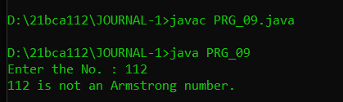

10. Write a to check number is Prime number or not.

import java.util.Scanner;

public class PRG_10

{

public static void main(String args[])

{

int i,n,m=0,flag=0;

Scanner sc = new Scanner(System.in);

System.out.print("Enter any No. : ");

n = sc.nextInt();

m=n/2;

if(n==0||n==1)

{

System.out.println(n+" is not prime number");

}

else

{

for(i=2;i<=m;i++)

{

if(n%i==0)

{

System.out.println(n+" is not prime number");

flag=1;

break;

}

}

if(flag==0)

{

System.out.println(n+" is prime number");

}

}

}

}

Output :

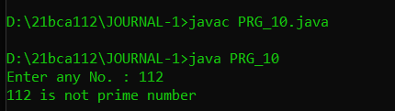

11. Write a program to check given string is Palindrome or not

import java.util.Scanner;

class PRG_11

{

public static void main(String[] args)

{

Scanner sc=new Scanner(System.in);

String str, reverseStr = "";

System.out.print("Enter any string :");

str = sc.nextLine();

int strLength = str.length();

for (int i = (strLength - 1); i >=0; --i)

{

reverseStr = reverseStr + str.charAt(i);

}

if (str.toLowerCase().equals(reverseStr.toLowerCase()))

{

System.out.println(str + " is a Palindrome String.");

}

else

{

System.out.println(str + " is not a Palindrome String.");

}

}

}

Output :

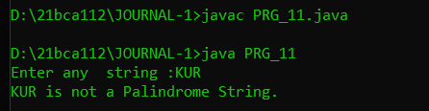

12. Write a program in java to display the pattern like right angle triangle using an asterisk.

*

* *

* * *

* * * *

* * * * *

import java.util.Scanner;

class PRG_12

{

public static void main(String [] args)

{

int i,a,b=0;

Scanner sc=new Scanner(System.in);

System.out.print("Enter any No. : ");

a = sc.nextInt();

for(b=1;b<=a;b++)

{

for(i=1;i<=b;i++)

{

System.out.print(" * ");

}

System.out.println("\n");

}

}

}

Output :

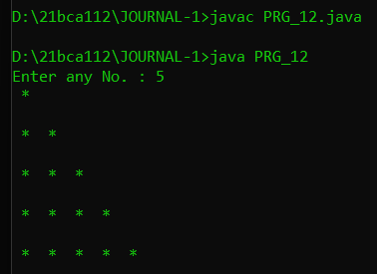

13. Write a program in java to make such a pattern like a pyramid with numbers increased by 1.

1

2 3

4 5 6

7 8 9 10

import java.util.Scanner;

class PRG_13

{

public static void main(String [] args)

{

int i,a,b,n=1;

Scanner sc=new Scanner(System.in);

System.out.print("Enter any No. : ");

a = sc.nextInt();

for(b=1;b<=a;b++)

{

for(i=1;i<=a;i++)

{

if((b+i)<=a)

{

System.out.print(" ");

}

else

{

System.out.print(n+" ");

n++;

}

}

System.out.println("\n");

}

}

}

Output :

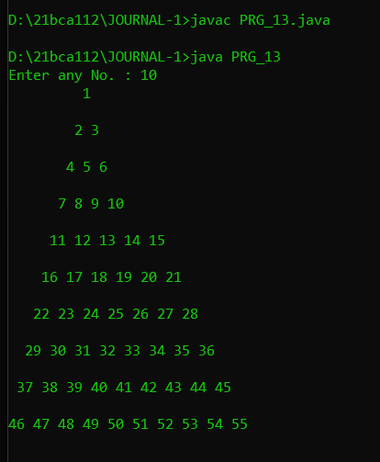

14. Write a C Program to display the pattern using the alphabet.

A B C D E

A B C D

A B C

A B

A

import java.util.Scanner;

class PRG_14

{

public static void main(String [] args)

{

int i,a,b=0;

char c;

Scanner sc=new Scanner(System.in);

System.out.print("Enter any No. : ");

a = sc.nextInt();

for(b=a;b>=1;b--)

{

c='A';

for(i=1;i<=b;i++)

{

System.out.print(c+" ");

c++;

}

System.out.println("\n");

}

}

}

Output :

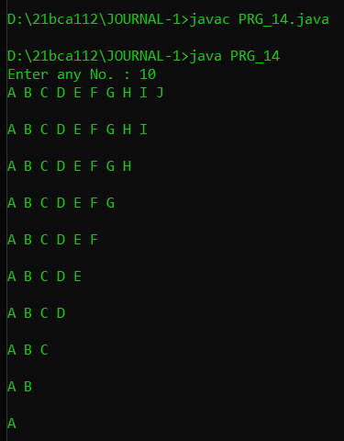

15. Write a program to take command line input and print factorial of given number.

import java.util.Scanner;

class PRG_15

{

public static void main(String args[])

{

int n, c, f = 1;

System.out.print("Enter an integer to calculate its factorial : ");

Scanner in = new Scanner(System.in);

n = in.nextInt();

if (n < 0)

System.out.println("Number should be non-negative.");

else

{

for (c = 1; c <= n; c++)

f = f*c;

System.out.println("Factorial of "+n+" is = "+f);

}

}

}

Output :

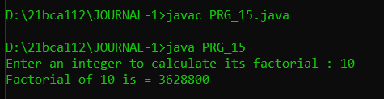

16. Write a program to display Fibonacci series.

import java.util.Scanner;

public class PRG_16

{

public static void main(String[] args)

{

int n, a = 0, b = 0, c = 1;

Scanner s = new Scanner(System.in);

System.out.print("Enter value of n : ");

n = s.nextInt();

System.out.print("Fibonacci Series : ");

for(int i = 1; i <= n; i++)

{

a = b;

b = c;

c = a + b;

System.out.print(a+",");

}

System.out.print("\b.");

}

}

Output :

