21BCA112

.

JAVA JOURNAL-3

 0

1. Write a program which accepts starting character and ending character. Display one by one character from starting character till the ending character at the interval of one second using thread.

import java.util.Scanner;

public class PRG_01 {

public static void main(String[] args) { Scanner scanner = new Scanner(System.in);

System.out.print("Enter the starting character: "); char startChar = scanner.nextLine().charAt(0);

System.out.print("Enter the ending character: "); char endChar = scanner.nextLine().charAt(0);

CharacterDisplayThread thread = new CharacterDisplayThread(startChar, endChar);

thread.start();

}

}

class CharacterDisplayThread extends Thread { private char startChar; private char endChar;

public CharacterDisplayThread(char startChar, char endChar) { this.startChar = startChar; this.endChar = endChar;

}

public void run() {

for (char ch = startChar; ch <= endChar; ch++) { System.out.print(ch);

try {

Thread.sleep(1000);

} catch (InterruptedException e) { e.printStackTrace();

}

}

}

}

Output :

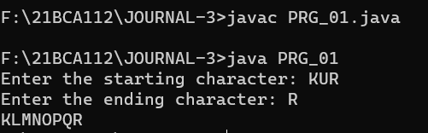

2. Write a program that stores details of 5 employees and display this information after every 10 second.

import java.util.Scanner;

public class PRG_02 {

public static void main(String[] args) {

String[] name=new String[5]; int[] age=new int[5];

String[] department=new String[5];; double[] salary=new double[5]; Scanner sc = new Scanner(System.in); for(int i=0;i<5;i++)

{

System.out.print("Enter Emp "+ (i+1) +" Name : "); name[i] = sc.nextLine();

System.out.print("Enter Emp "+ (i+1) +" Age : "); age[i] = sc.nextInt(); sc.nextLine();

System.out.print("Enter Emp "+ (i+1) +" Department : "); department[i] = sc.nextLine();

System.out.print("Enter Emp "+ (i+1) +" Salary : "); salary[i] = sc.nextDouble(); sc.nextLine(); System.out.println();

}

for(int i=0;i<5;i++)

{

try {

System.out.print("\nName: " + name[i] + ", Age: " + age[i] + ",

Department: " + department[i] + ", Salary: " + salary[i]); Thread.sleep(10000);

}

catch (InterruptedException e)

{

e.printStackTrace();

}

}

}

}

Output :

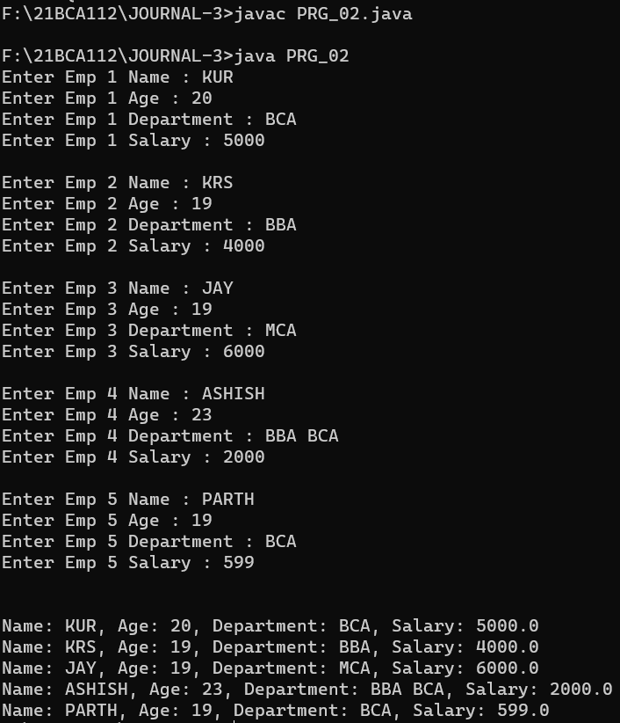

3. Write a java application which accepts 10 names of student and their age. Sort names and age in descending order at an interval of 1 second using thread.

import java.util.Arrays; import java.util.Scanner; public class PRG_03 { public static void main(String[] args) {

Scanner scanner = new Scanner(System.in); String[] names = new String[10]; int[] ages = new int[10]; for (int i = 0; i < 10; i++) {

System.out.print("Enter name of student " + (i + 1) + ": "); names[i] = scanner.nextLine();

System.out.print("Enter age of student " + (i + 1) + ": "); ages[i] = scanner.nextInt(); scanner.nextLine();

}

while (true) {

System.out.println("\nSelect an option:");

System.out.println("1. Sort via Name.");

System.out.println("2. Sort via Age.");

System.out.println("3. Exit");

System.out.print("\nSelect Your Choice : ");

int choice = scanner.nextInt(); scanner.nextLine(); switch (choice) { case 1:

for (int i = 0; i < 10; i++) {

for (int j = i + 1; j < 10; j++) { if (names[i].compareToIgnoreCase(names[j]) < 0) {

String tempName = names[i]; names[i] = names[j]; names[j] = tempName; int tempAge = ages[i]; ages[i] = ages[j]; ages[j] = tempAge;

}

}

}

System.out.println("\nSorted Names in Descending Order:"); for (int i = 0; i < 10; i++) {

try {

System.out.println(names[i] + " - " + ages[i]);

Thread.sleep(1000);

}

catch (InterruptedException e) {

e.printStackTrace();

}

}

break; case 2:

for (int i = 0; i < 10; i++) {

for (int j = i + 1; j < 10; j++) { if (ages[i] < (ages[j])) { int tempage = ages[i]; ages[i] = ages[j]; ages[j] = tempage; String tempname = names[i]; names[i] = names[j]; names[j] = tempname;

}

}

}

System.out.println("\nSorted Ages in Descending Order:"); for (int i = 0; i < 10; i++) {

try {

System.out.println(ages[i] + " - " + names[i]);

Thread.sleep(1000);

}

catch (InterruptedException e) {

e.printStackTrace();

}

}

break;

case 3:

System.out.println("Exiting program..."); System.exit(0); break; default:

System.out.println("Invalid choice. Try again.");

}

}

}

}

Output :

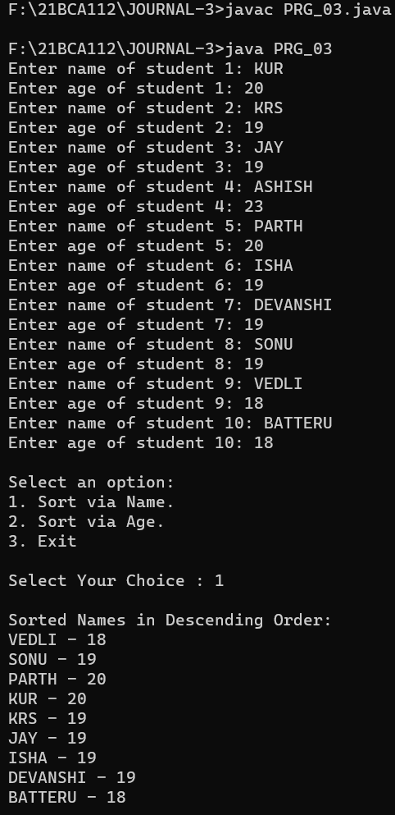

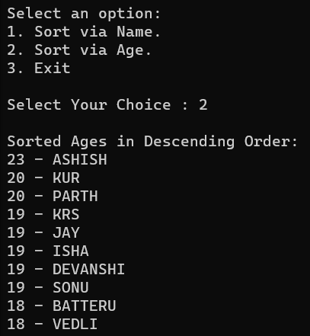

4. Create package stores. Under it create a class called stock with member variable (item_no, item_name, stock_availible, and cost). Under the default package create a class called sales with field name (qty_sold) and it is the child class of stores class. Write a program to print the current stock of each item and perform addition.

import stores.stock; import java.util.ArrayList; import java.util.Scanner;

public class PRG_04 {

public static void main(String[] args) {

ArrayList<stock> items = new ArrayList<stock>(); items.add(new stock(1, "Apple", 10, 20.0)); items.add(new stock(2, "Banana", 20, 30.0)); items.add(new stock(3, "Ball", 30, 40.0));

Scanner scanner = new Scanner(System.in);

while (true) {

System.out.println("\nCurrent Stock:"); for (stock item : items) { System.out.println(item);

}

System.out.print("\nEnter the item no. to add stock, or 0 to exit:"); int item_no = scanner.nextInt(); if (item_no == 0) { break;

}

stock item = items.stream().filter(i -> i.getItem_no() ==

item_no).findFirst().orElse(null);

if (item == null) {

System.out.println("Invalid item no.");

}

else {

System.out.print("\nEnter the quantity to add:"); int qty = scanner.nextInt();

item.setStock_available(item.getStock_available() + qty);

System.out.println("Stock added successfully.");

}

}

}

}

Output :

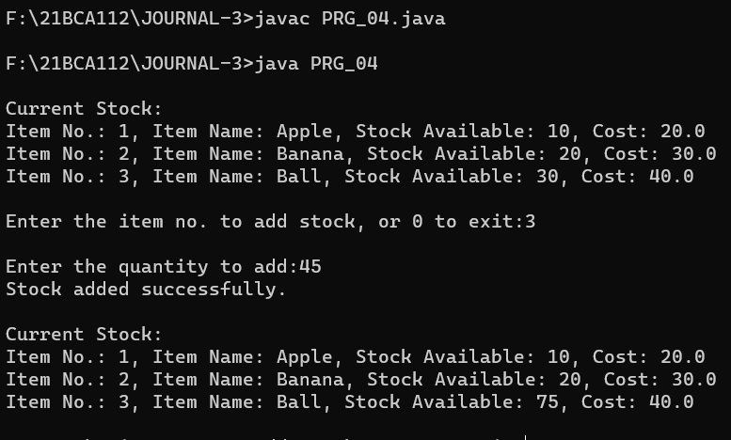

5. Create a class namely Vehicle to maintain vehicle data like chassisNo, nameOfVehicle, colour, owner using singly circular linked list. Perform following operations on student list: a. Add vehicle details at the end of the list .

1. Remove last vehicle detail in the list .
2. Display all vehicle details in the list.

import java.util.Scanner; class Vehicle { private int chassisNo; private String nameOfVehicle; private String colour; private String owner;

private Vehicle next;

public Vehicle(int chassisNo, String nameOfVehicle, String colour, String

owner) {

this.chassisNo = chassisNo; this.nameOfVehicle = nameOfVehicle; this.colour = colour; this.owner = owner; this.next = null;

System.out.println("\nData Inserted Successfully.");

}

public int getChassisNo() { return chassisNo;

}

public void setChassisNo(int chassisNo) { this.chassisNo = chassisNo;

}

public String getNameOfVehicle() { return nameOfVehicle;

}

public void setNameOfVehicle(String nameOfVehicle) { this.nameOfVehicle = nameOfVehicle;

}

public String getColour() { return colour;

}

public void setColour(String colour) { this.colour = colour;

}

public String getOwner() { return owner;

}

public void setOwner(String owner) { this.owner = owner;

}

public Vehicle getNext() { return next;

}

public void setNext(Vehicle next) { this.next = next;

}

}

class VehicleList { private Vehicle tail; public VehicleList() { tail = null;

}

public void addVehicle(int chassisNo, String nameOfVehicle, String colour, String owner) {

Vehicle newVehicle = new Vehicle(chassisNo, nameOfVehicle, colour, owner);

if (tail == null) { tail = newVehicle; tail.setNext(tail);

}

else {

newVehicle.setNext(tail.getNext()); tail.setNext(newVehicle); tail = newVehicle;

}

}

public void removeLastVehicle() {

if (tail == null) {

System.out.println("List is empty"); return;

}

if (tail.getNext() == tail) { tail = null; return;

}

Vehicle current = tail.getNext(); while (current.getNext() != tail) { current = current.getNext();

}

current.setNext(tail.getNext()); tail = current;

}

public void displayVehicles() { if (tail == null) {

System.out.println("List is empty"); return;

}

Vehicle current = tail.getNext(); do {

System.out.println("-----------------------------------------------");

System.out.println("Chassis No: " + current.getChassisNo() +

" \nName of Vehicle: " + current.getNameOfVehicle() +

" \nColour: " + current.getColour() +

" \nOwner: " + current.getOwner());

System.out.println("-----------------------------------------------"); current = current.getNext(); } while (current != tail.getNext());

}

}

public class PRG_05 { public static void main(String[] args) {

Scanner scan = new Scanner(System.in); VehicleList vehicleList = new VehicleList();

while (true) {

System.out.println("\n-----------------------------------------------");

System.out.println("\nCircular Singly Linked List Operations\n"); System.out.println("-----------------------------------------------");

System.out.println("1. Insert at End.");

System.out.println("2. Delete from End.");

System.out.println("3. Get Item detail's.");

System.out.println("4. Exit.");

System.out.println("-----------------------------------------------"); System.out.print("Enter your Choice : ");

int choice = scan.nextInt(); switch (choice)

{

case 1 : int ch_no;

String nameOfVeh, colour, owner; System.out.print("Enter Chassis_No : "); ch_no=scan.nextInt(); scan.nextLine();

System.out.print("Enter Name of vehicle : "); nameOfVeh=scan.nextLine();

System.out.print("Enter Color of vehicle : "); colour=scan.nextLine();

System.out.print("Enter Owner Name : "); owner=scan.nextLine(); vehicleList.addVehicle(ch_no,nameOfVeh,colour,owner);

break; case 2 :

vehicleList.removeLastVehicle();

System.out.println("\nData Deleted Successfully."); break; case 3 :

System.out.println("Vehicle details:"); vehicleList.displayVehicles();

break; case 4 :

System.out.println("Program Exited...");

System.exit(0);

break; default:

System.out.println("Invalid choice. Try again.");

}

}

}

}

Output :

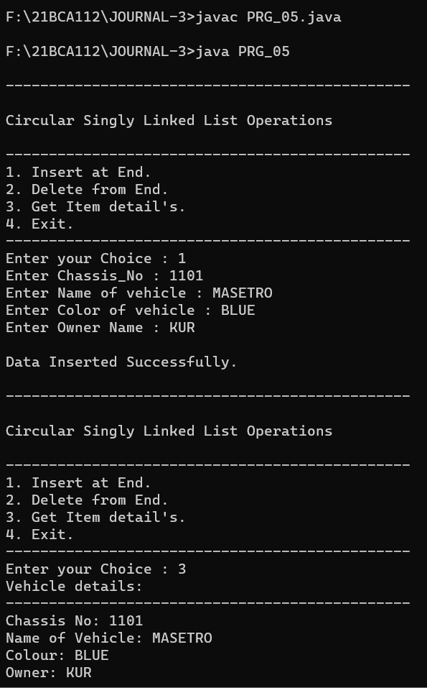

6. Create a class namely Book to maintain Book details like id, name, quantity and author using singly linked list. Perform following operations on book list:

1. Add book details in the begging of the list .
2. Add book details at the end of the list .
3. Add book detail at particular position .
4. Remove first book detail from the list .
5. Remove last book detail from the list .
6. Display all book details in the list .

import java.util.Scanner; class Book { private int id; private String name; private int quantity; private String author; private Book next;

public Book(int id, String name, int quantity, String author) { this.id = id; this.name = name; this.quantity = quantity; this.author = author; this.next = null;

System.out.println("\nData Inserted Successfully.");

}

public int getId() { return id;

}

public void setId(int id) { this.id = id;

}

public String getName() { return name;

public void setName(String name) { this.name = name;

}

public int getQuantity() { return quantity;

}

public void setQuantity(int quantity) { this.quantity = quantity;

}

public String getAuthor() { return author;

}

public void setAuthor(String author) { this.author = author;

}

public Book getNext() { return next;

}

public void setNext(Book next) { this.next = next;

}

class BookList { private Book head;

public BookList() { head = null;

}

public void addBookAtBeginning(int id, String name, int quantity, String

author) {

Book newBook = new Book(id, name, quantity, author); newBook.setNext(head); head = newBook;

}

public void addBookAtEnd(int id, String name, int quantity, String author) { Book newBook = new Book(id, name, quantity, author); if (head == null) { head = newBook;

} else {

Book current = head; while (current.getNext() != null) { current = current.getNext();

}

current.setNext(newBook);

}

public void addBookAtPosition(int id, String name, int quantity, String author,

int position) {

if (position == 1) { addBookAtBeginning(id, name, quantity, author);

} else {

Book newBook = new Book(id, name, quantity, author); Book current = head; int currentPosition = 1; while (currentPosition < position - 1 && current != null) { current = current.getNext(); currentPosition++;

}

if (current != null) { newBook.setNext(current.getNext()); current.setNext(newBook);

} else {

System.out.println("Invalid position");

}

}

}

public void removeFirstBook() { if (head == null) {

System.out.println("List is empty");

} else { head = head.getNext();

}

}

public void removeLastBook() {

if (head == null) {

System.out.println("List is empty");

}

else if (head.getNext() == null) {

head = null;

}

else {

Book current =head;

while (current.getNext().getNext() != null) { current = current.getNext();

}

current.setNext(null);

}

}

public void displayBooks() {

if (head == null) {

System.out.println("List is empty");

} else {

Book current = head;

System.out.println("-----------------------------------------------"); while (current != null) {

System.out.println("ID: " + current.getId() + ", Name: " + current.getName() + ", Quantity: " + current.getQuantity() + ", Author: " + current.getAuthor());

current = current.getNext();

}

System.out.println("-----------------------------------------------");

}

}

}

public class PRG_06

{

public static void main(String[] args)

{

int id; String name; int quantity;

String author;

Scanner scan = new Scanner(System.in); BookList bookList = new BookList();

while (true) {

System.out.println("\n-----------------------------------------------");

System.out.println("\nSingly Linked List Operations\n");

System.out.println("-----------------------------------------------");

System.out.println("1. Insert at Begining.");

System.out.println("2. Insert at End.");

System.out.println("3. Insert at Position.");

System.out.println("4. Delete from Head.");

System.out.println("5. Delete from Tail.");

System.out.println("6. Display Data.");

System.out.println("7. Exit.");

System.out.println("-----------------------------------------------");

System.out.print("Enter your Choice : ");

int choice = scan.nextInt(); switch (choice)

{ case 1 :

System.out.print("Enter Your ID : "); id=scan.nextInt(); scan.nextLine();

System.out.print("Enter Your Name : "); name=scan.nextLine();

System.out.print("Enter Quantity of Books : "); quantity=scan.nextInt(); scan.nextLine();

System.out.print("Enter Author Name : "); author=scan.nextLine(); bookList.addBookAtBeginning(id,name,quantity,author); break; case 2 :

System.out.print("Enter Your ID : "); id=scan.nextInt(); scan.nextLine();

System.out.print("Enter Your Name : "); name=scan.nextLine();

System.out.print("Enter Quantity of Books : "); quantity=scan.nextInt(); scan.nextLine();

System.out.print("Enter Author Name : "); author=scan.nextLine(); bookList.addBookAtEnd(id,name,quantity,author); break; case 3 :

int position;

System.out.print("Enter Position you want to Insert Record : "); position=scan.nextInt();

System.out.print("Enter Your ID : "); id=scan.nextInt(); scan.nextLine();

System.out.print("Enter Your Name : "); name=scan.nextLine();

System.out.print("Enter Quantity of Books : "); quantity=scan.nextInt(); scan.nextLine();

System.out.print("Enter Author Name : "); author=scan.nextLine();

bookList.addBookAtPosition(id,name,quantity,author,position); break; case 4 :

bookList.removeFirstBook();

System.out.println("\nData Deleted Successfully."); break; case 5 :

bookList.removeLastBook();

System.out.println("\nData Deleted Successfully."); break; case 6 :

bookList.displayBooks(); break; case 7 :

System.out.println("Program Exited...");

System.exit(0);

break; default :

System.out.println("Invalid choice. Try again."); break;

}

}

}

}

Output : 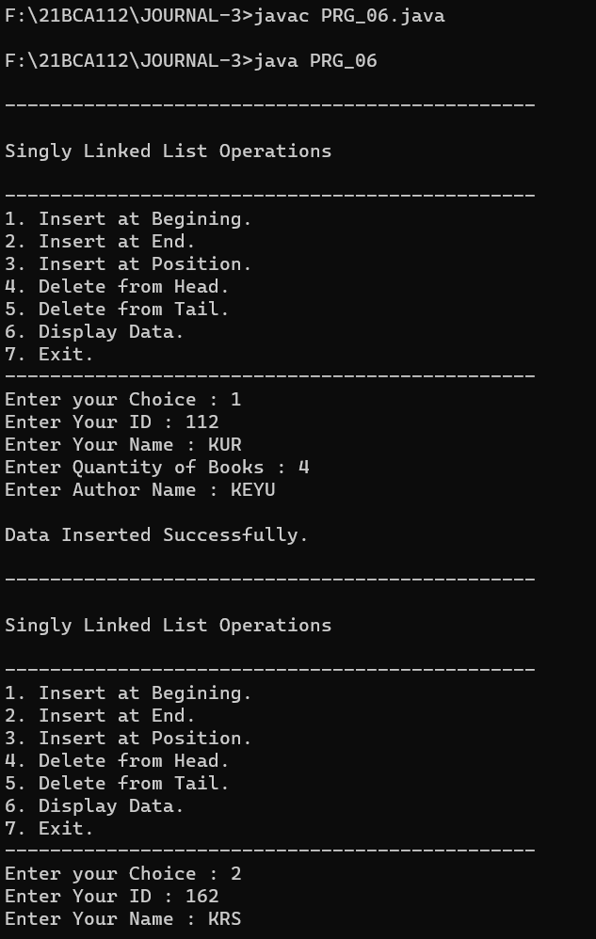

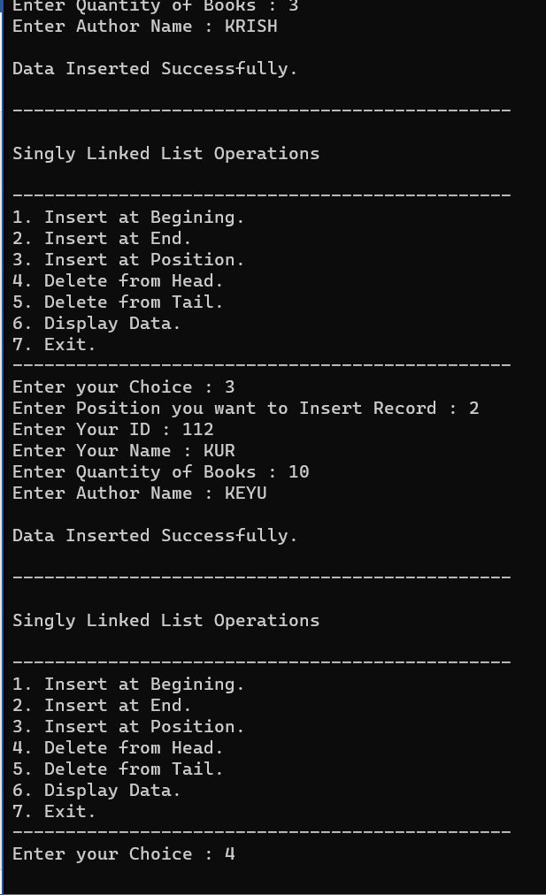

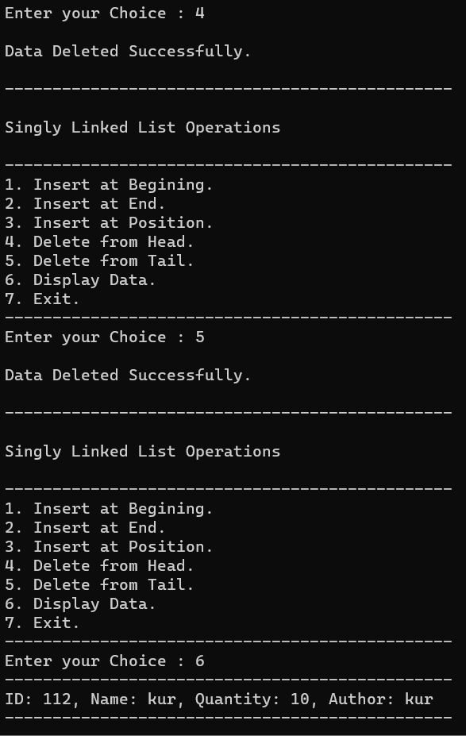

7. Write a programme to draw smiley with colour using applet.

import java.awt.*; import java.applet.*;

//<applet code="PRG_07.class" height="800" width="1860"> </applet>

public class PRG_07 extends Applet {

public void paint(Graphics g) {

g.setColor(Color.yellow);

g.fillOval(50,50,200,200);

g.setColor(Color.black);

g.drawOval(50,50,200,200);

g.setColor(Color.black);

g.fillOval(100,100,25,25);

g.fillOval(175,100,25,25);

g.setColor(Color.black);

g.drawArc(100,125,100,75,0,-180);

}

}

Output :





8. Create an applet which displays a solid square having red colour. Display name of your college within the square with font style =’Times New Roman’, font size=50 and font colour=’Yellow’.

import java.awt.*; import java.applet.*;

//<applet code="PRG_08.class" height="800" width="1860"> </applet>

public class PRG_08 extends Applet {

public void paint(Graphics g) {

g.setColor(Color.red);

g.fillRect(200,200,400,400);

g.setColor(Color.yellow);

Font font = new Font("Times New Roman", Font.PLAIN, 50); g.setFont(font);

FontMetrics metrics = g.getFontMetrics(font); int x = (200 - metrics.stringWidth("My College")) / 2; int y = ((200 - metrics.getHeight()) / 2) + metrics.getAscent(); g.drawString("VTCBCSR", 300+x, 300+y);

}

}

Output :





9. Write a program to draw circle inside a square in applet with different colours.

import java.awt.*; import java.applet.*;

//<applet code="PRG_09.class" height="800" width="1860"> </applet>

public class PRG_09 extends Applet {

public void paint(Graphics g) {

g.setColor(Color.red);

g.fillRect(200,200,400,400);

g.setColor(Color.yellow);

g.fillOval(250,250,300,300);

}

}

Output :





10. Write an applet program which accepts number of ovals user wants to display using parameter tag and draws ovals in different positions.

import java.awt.*; import java.applet.*;

/*<applet code="PRG_10.class" height="800" width="1860">

<param name="numOvals" value="10">

</applet>*/

public class PRG_10 extends Applet { private int numOvals;

public void init() {

String numOvalsStr = getParameter("numOvals"); numOvals = Integer.parseInt(numOvalsStr);

}

public void paint(Graphics g) { for (int i = 0; i < numOvals; i++) { int x = (int)(Math.random() * 300); int y = (int)(Math.random() * 300); int w = (int)(Math.random() * 100); int h = (int)(Math.random() * 100); g.drawOval(x, y, w, h);

}

} }

Output :



