1.Write a program to take command line input and check number is odd or even.
Code:
import java.util.*;
class Addition
{
public static void main(String args[])
{
int a,b,c;
Scanner i=new Scanner(System.in);
System.out.println("Enter Number:");
System.out.println("Enter Number:");
a=i.nextInt();
b=i.nextInt();
c=a+b;
System.out.println("your Addition is "+c);
}
}
Output:
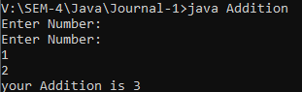

2.Write program to take command line input and sum of 2 number.

Code:
import java.util.*;
class OddEven
{
public static void main(String args[])
{
Int a;
Scanner i=new Scanner(System.in);
System.out.println("Enter Number:");
a=i.nextInt();
If(a%2==0)
{
System.out.println(a+" is Even Number.");
}
else
{
System.out.println(a+" is Odd Number.");
}
}
}
Output:
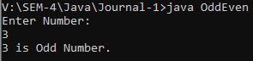

3.Write program to take command line input and calculate a simple interest.

Code:
import java.util.*;
class Simple
{
public static void main(String args[])
{
int p,r,n,s;
Scanner i=new Scanner(System.in);
System.out.println("Enter Value p:");
System.out.println("Enter Value r:");
System.out.println("Enter Value n:");
p=i.nextInt();
r=i.nextInt();
n=i.nextInt();
s=p*r*n/100;
System.out.println(s);
}
}
Output:
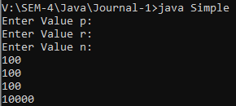

4.Write program to take command line input and check number is positive or negative.

Code:
import java.util.*;
class Positive
{
public static void main(String ags[])
{
int n;
Scanner i=new Scanner(System.in);
System.out.println("Enter Number:");
n=i.nextInt();
If(n>0)
{
System.out.println(n+"This number is positive.");
}
else if(n<0)
{
System.out.println(n+"This number is negetive.");
}
else
{
System.out.println(n+"This number is zero.");
}
}
}
Output:
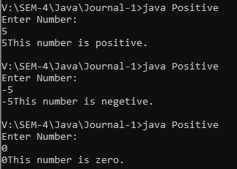

5.Write program to take command line input and year is leap year or not.

Code:
import java.util.*;
class Leapyear
{
public static void main(String args[])
{
int n;
Scanner i=new Scanner(System.in);
System.out.println("Enter number:");
n=i.nextInt();
if(n%400==0)
{
System.out.println(n+"This is leap year.");
}
else if(n%100==0)
{
System.out.println(n+"This is not leap year.");
}
else if(n%4==0)
{
System.out.println(n+"This is leap year.");
}
else
{
System.out.println(n+"This is not leap year.");
}
}
}

Output:
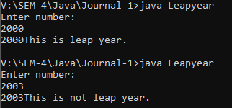

6.Write program to take command line input and find the character is vowel or not.

Code:
import java.util.*;
class Vowel
{
public static void main(String args[])
{
char x;
Scanner i=new Scanner(System.in);
System.out.println("Enter word:");
x=i.next().charAt(0);
if(x=='a'||x=='A'||x=='e'||x=='E'||x=='i'||x=='I'|| x=='o'||x=='O'||x=='u'||x=='U')
{
System.out.println(x+"This is Vowel.");
}
else
{
System.out.println(x+"This is Consonant.");
}
}
}

Output:
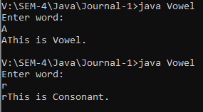

7.Write program to reverse a given number using while loop.
Code:
import java.util.*;
class Reverse
{
public static void main(String args[])
{
int a,b=0,c;
Scanner i=new Scanner(System.in);
System.out.println("Enter number:");
a=i.nextInt();
while(a!=0)
{
c=a%10;
b=b*10+c;
a=a/10;
}
System.out.println("The reverse of the given number is:"+b);
}
}
Output:
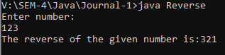

8.Write program to reverse a given number using for loop.

Code:
import java.util.*;
class Forreverse
{
public static void main(String args[])
{
int a,b=0,c;
Scanner i=new Scanner(System.in);
System.out.println("Enter number:");
a=i.nextInt();
for(;a!=0;a=a/10)
{
c=a%10;
b=b*10+c;
}
System.out.println("The reverse of given number is:"+b);
}
}

Output:
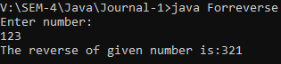

9.Write program to check number is Armstrong or not.

Code:
import java.util.*;
class Armstrong
{
public static void main(String args[])
{
int num,temp,sum,a=1,n=0;
Scanner i=new Scanner(System.in);
System.out.println("Enter number:");
num=i.nextInt();
sum=0;
a=num;
while(num>0)
{
n=num%10;
num=num/10;
sum=sum+(n*n*n);
}
if(sum==a)
{
System.out.println(sum+" This number is armstrong.");
}
else
{
System.out.println(sum+" This number is not armstrong.");
}
}
}
Output:
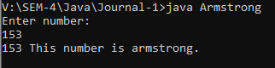

10.write program to check number is prime number or not.

Code:
import java.util.*;
class Prime
{
public static void main(String args[])
{
int a,j,ch=0;
Scanner i=new Scanner(System.in);
System.out.println("Enter number:");
a=i.nextInt();
for(j=2;j<a;j++)
{
if(a%j==0)
{
ch=1;
break;
}
}
if(ch==1)
{
System.out.println(a+" is not Prime.");
}
else
{
System.out.println(a+" is Prime.");
}
}
}

Output:
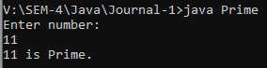

11.write program to check given string is palindrome or not.

Code:
import java.util.*;
class Palindrome
{
public static void main(String args[])
{
int r,sum=0,temp,n,a;
Scanner i=new Scanner(System.in);
System.out.println("Enter number:");
n=i.nextInt();
temp=n;
while(n>0)
{
r=n%10;
sum=sum*10+r;
n=n/10;
}
if(temp==sum)
{
System.out.println("Palindrome Number.");
}
else
{
System.out.println("Not a Palindrome Number.");
}
}
}

Output:
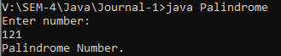

12.write program in java to display the pattern like right angle triangle using an asterisk.
*
* *
* * *
* * * *
* * * * *
Code:
import java.util.*;
class Pattern
{
public static void main(String args[])
{
int a,i,j;
Scanner s=new Scanner(System.in);
System.out.println("Enter any number");
a=s.nextInt();
for(i=0;i<a;i++)
{
System.out.print(" ");
for(j=0;j<=i;j++)
System.out.print("* ");
System.out.println();
}
}
}

Output:
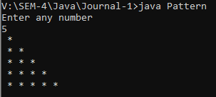

13.write a program in java to make such a pattern like pyramid with numbers is increased by 1.
1
2 3
4 5 6
7 8 9 10

Code:
import java.util.*;
class NumPattern
{
public static void main(String args[])
{
int r,i,j,counter=1;
Scanner s=new Scanner(System.in);
System.out.println("Enter any number:");
r=s.nextInt();
for(i=0;i<r;i++)
{
for(j = 0;j < r-i-1;j++)
{
System.out.print(" ");
}
for(int k = 0;k<=i;k++)
{
System.out.print(counter+" ");
counter++;
}
System.out.println();
}
}
}

Output:
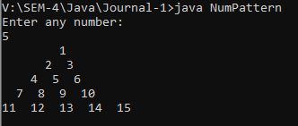

14.write a C program to display the pattern using the alphabet.
A B C D E
A B C D
A B C
A B
A
Code:
import java.util.*;
class AlphaPattern
{
public static void main(String args[])
{
int a,i,j=0;
char c;
Scanner s=new Scanner(System.in);
System.out.println("Enter any number:");
a=s.nextInt();
for(j=a;j>=1;j--)
{
c='A';
for(i=1;i<=j;i++)
{
System.out.print(c+" ");
c++;
}
System.out.println("\n");
}
}
}

Output:
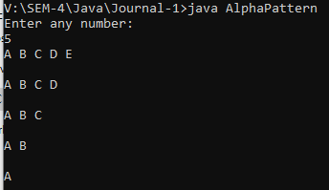

15.write a program to take command line input and printfactorial of given number.
Code:
import java.util.*;
class Factorial
{
public static void main(String args[])
{
int a,i,c=1;
Scanner s=new Scanner(System.in);
System.out.println("Enter any number:");
a=s.nextInt();
for(i=1;i<=a;i++)
{
c=c*i;
}
System.out.println("Factorial of "+a+" is: "+c);
}
}

Output:
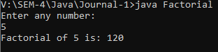

16.write a program to display Fibonacci series.
Code:
import java.util.*;
class Fibonacci
{
public static void main(String args[])
{
int a,b=0,c=1,k,i;
Scanner s=new Scanner(System.in);
System.out.println("Enter any number:");
a=s.nextInt();
System.out.print(b+" "+c);
for(i=2;i<a;++i)
{
k=b+c;
System.out.print(" "+k);
b=c;
c=k;
}
}
}

Output:
