**JAVA JOURNAL 2**

**1. Design a class to represent a bank account. Include the following members. (Using Multiple Constructor) Data members: Name of depositor, Account number, Type of account, Balance amount in the account. Methods: To assign initial values, To deposit an amount, To withdraw an amount after checking balance, To display the name and balance.**

**import java.util.*;**

**class a1{**

**private String depositorname;**

**private int accountnumber;**

**private String accounttype;**

**private double balance;**

**public a1(){**

**this("",0,"saving",0.0);**

**}**

**public a1(String name ,int accountnumber){**

**this(name,accountnumber,"savings",0.0);**

**}**

**public a1(String name,int accountnumber,String accounttype,double**

**balance){**

**this.depositorname=name;**

**this.accountnumber=accountnumber;**

**this.accounttype=accounttype;**

**this.balance=balance;**

**}**

**public void setInitialValues(String name, int accountNumber, String**

**accountType, double balance) {**

**this.depositorname = name;**

**this.accountnumber = accountnumber;**

**this.accounttype = accounttype;**

**this.balance = balance;**

**}**

**public void deposit(double amount) {**

**if(amount > 0){**

**balance += amount;**

**System.out.println("Deposit successful. New balance is " + balance);**

**}**

**else {**

**System.out.println("Invalid amount. Please enter a positive amount to**

**deposit.");**

**}**

**}**

**public void withdraw(double amount){**

**if(amount <= 0){**

**System.out.println("Invalid amount. Please enter a positive amount to**

**withdraw.");**

**}**

**else if(amount > balance){**

**System.out.println("Insufficient balance. You can withdraw up**

**to " + balance);**

**}**

**else{**

**balance -= amount;**

**System.out.println("Withdrawal successful. New balance is " +**

**balance);**

**}**

**}**

**public void display(){**

**System.out.println("Depositor name: \n" + depositorname);**

**System.out.println("Account number: \n" + accountnumber);**

**System.out.println("Account type: \n" + accounttype);**

**System.out.println("Current balance: \n" + balance);**

**}**

**public static void main(String[]args){**

**Scanner s=new Scanner(System.in);**

**a1 account1 = new a1();**

**account1.setInitialValues("parth patel", 12345, "Savings",0.0);**

**System.out.println("Enter the amount That You want to Deposit:");**

**double depositAmount=s.nextDouble();**

**account1.deposit(depositAmount);**

**System.out.println("Enter the amount That You want to Withdrawr:");**

**double withdrawAmount=s.nextDouble();**

**account1.withdraw(withdrawAmount);**

**}**

**}**

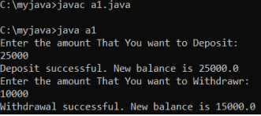

**2. Write a program to print Floyd’s triangle where n is command line input.**

**1**

**2 3**

**4 5 6**

**7 8 9 10**

**class program_2**

**{**

**static void printFloydTriangle(int n)**

**{**

**int i, a, val = 1;**

**for (i = 1; i <= n; i++)**

**{**

**for (a = 1; a <= i; a++)**

**{**

**System.out.print(val + " ");**

**val++;**

**}**

**System.out.println();**

**}**

**}**

**public static void main(String[] args)**

**{**

**int i= Integer.parseInt(args[0]);**

**printFloydTriangle(i);**

**}**

**}**

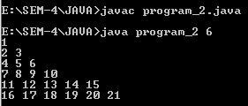

**3. Design a class Cricketer having data member name and a number of matches and appropriate member function to set the values. Derived two classes Batsman and Bowler from cricketer class with data member total number of runs and wickets respectively. Batsman class is having method to calculate average wicket. Write a program to create two objects and display information of one batsman and bowler along with average run and wicket.**

**import java.util.Scanner;**

**class Cricketer**

**{**

**public String cname;**

**public int nom;**

**public void setDataMain()**

**{**

**Scanner sc = new Scanner(System.in);**

**System.out.print("Enter the name of Cricketer: ");**

**cname = sc.nextLine();**

**Scanner sc2 = new Scanner(System.in);**

**System.out.print("Enter the Number of matches of Cricketer: ");**

**nom = sc2.nextInt();**

**}**

**public void displayDataMain()**

**{**

**System.out.println("Name " +cname);**

**System.out.println("Matches " +nom);**

**}**

**}**

**class Batsman extends Cricketer**

**{**

**public int total_run;**

**public float average;**

**public void setData()**

**{**

**Scanner sc4 = new Scanner(System.in);**

**System.out.print("\nEnter the Total Number of Runs: ");**

**total_run = sc4.nextInt();**

**}**

**public void displayData()**

**{**

**System.out.println("Total Runs "+total_run);**

**}**

**}**

**class Bowler extends Cricketer**

**{**

**public int wickets;**

**public float average;**

**public void setData()**

**{**

**Scanner sc3 = new Scanner(System.in);**

**System.out.print("Enter the number of wickets: ");**

**wickets = sc3.nextInt();**

**}**

**public void displayData()**

**{**

**System.out.println("Wickets "+wickets);**

**}**

**}**

**public class program_3**

**{**

**public static void main(String[] args)**

**{**

**Bowler bowl = new Bowler();**

**Batsman bat = new Batsman();**

**Cricketer cal = new Cricketer();**

**cal.setDataMain();**

**bat.setData();**

**bowl.setData();**

**cal.displayDataMain();**

**bat.displayData();**

**bowl.displayData();**

**bowl.average = (float) bowl.wickets/cal.nom;**

**bat.average = (float) bat.total_run/cal.nom;**

**System.out.println("Average_Run's: "+bat.average);**

**System.out.println("Average_Wicket's: "+bowl.average);**

**}**

**}**

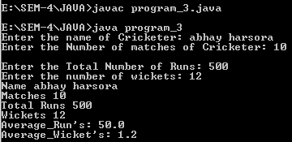

**4. Write a program that will accept two strings or two numbers from command line and create overloaded method that add these two numbers or concate two strings.**

import java.io.*;

class program_4

{

static boolean isNumber(String s)

{

for(int i=0;i<s.length();i++)

if(Character.isDigit(s.charAt(i))==false)

return false;

return true;

}

void add(int a, int b)

{

System.out.println("Result is : "+(a+b)) ;

}

void add(String a, String b)

{

System.out.println("Result is : "+(a+b));

}

public static void main(String[] args)

{

program_4 obj = new program_4();

if(isNumber(args[0])&&isNumber(args[1]))

{

int a=Integer.parseInt(args[0]);

int b=Integer.parseInt(args[1]);

obj.add(a,b);

}

else

obj.add(args[0],args[1]);

}

}

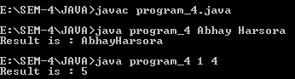

**5. Write a program that accept a number from command line and check whether it is palindrome or not.**

public class program_5 {

public static void main(String args[])

{

int n = Integer.parseInt(args[0]);

int sum = 0, r;

int tem = n;

while(n>0)

{

r = n % 10;

sum = (sum*10)+r;

n = n/10;

}

if(tem==sum)

System.out.println("It is a Palindrome No.");

else

System.out.println("It's Not a palindrome No.");

}

}

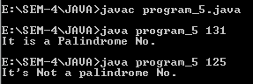

**6. Write a program that will accept a string from command line and arrange all the characters in alphabetical order.**

public class program_6

{

public static void main(String args[])

{

String str = args[0];

str = str.toLowerCase();

int len = str.length();

String sorted = ""; //Empty String

for (char ch = 'a'; ch <= 'z'; ch++) {

for (int i = 0; i < len; i++) {

char strCh = str.charAt(i);

if (ch == strCh) {

sorted += strCh;

}

}

}

System.out.println("Alphabet order : "+sorted);

}

}



**7. Write a program to create interface Area. Create three classes called rectangle, triangle and square calculate areas respectively.**

import java.util.Scanner;

interface area

{

double calc(double x,double y);

}

class rectangle implements area

{

public double calc(double x,double y)

{

return(x*y);

}

}

class triangle implements area

{

public double calc(double x,double y)

{

return((x*y)/2);

}

}

class square implements area

{

public double calc(double x,double y)

{

return(x*x);

}

}

class program_7

{

public static void main(String arg[])

{

int p,q;

Scanner in = new Scanner(System.in);

rectangle r = new rectangle();

triangle c = new triangle();

square s = new square();

area a;

a = r;

System.out.print("\nEnter height of Rectangle : ");

p=in.nextInt();

System.out.print("Enter width of Rectangle : ");

q=in.nextInt();

System.out.println("\nArea of Rectangle : " +a.calc(p,q));

a = c;

System.out.print("\nEnter hight of Triangle : ");

p=in.nextInt();

System.out.print("Enter Breath of Triangle : ");

q=in.nextInt();

System.out.println("\nArea of Triangle : " +a.calc(p,q));

a = s;

System.out.print("\nEnter Side of Square : ");

p=in.nextInt();

System.out.println("\nArea of Square : " +a.calc(p,p));

}

}

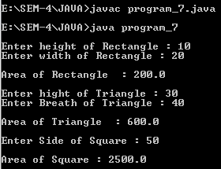

**8. Write a program that will accept a number from command line and raise a user defined exception if the number consists of odd number of digits.**

class OddNumberOfDigitsException extends Exception {

public OddNumberOfDigitsException(String message) {

super(message);

}

}

public class program_8 {

public static void main(String[] args) {

int numberString = Integer.parseInt(args[0]);

int temp=numberString;

int x;

try {

while(numberString>0){

x=numberString%10;

numberString=numberString/10;

if (x % 2 != 0) {

throw new OddNumberOfDigitsException("Thenumber has an odd number of digits");

}

}

} catch (ArrayIndexOutOfBoundsException e) {

System.out.println("Please provide a number as a command-lineargument.");

} catch (OddNumberOfDigitsException e) {

System.out.println(e.getMessage());

}

}

}



**9. Write a java application which accepts 10 names of student and their age. Sort names and age in descending order. (Using Array)**

import java.util.Arrays;

import java.util.Scanner;

public class program_9 {

public static void main(String[] args) {

Scanner scanner = new Scanner(System.in);

String[] names = new String[10];

int[] ages = new int[10];

for (int i = 0; i < 10; i++) {

System.out.print("Enter name of student " + (i + 1) + ": ");

names[i] = scanner.nextLine();

System.out.print("Enter age of student " + (i + 1) + ": ");

ages[i] = scanner.nextInt();

scanner.nextLine();

}

while (true) {

System.out.println("\nSelect an option:");

System.out.println("1. Sort via Name.");

System.out.println("2. Sort via Age.");

System.out.println("3. Exit");

System.out.print("\nSelect Your Choice : ");

int choice = scanner.nextInt();

scanner.nextLine();

switch (choice) {

case 1:

for (int i = 0; i < 10; i++) {

for (int j = i + 1; j < 10; j++) {

if (names[i].compareToIgnoreCase(names[j]) < 0) {

String tempName = names[i];

names[i] = names[j];

names[j] = tempName;

int tempAge = ages[i];

ages[i] = ages[j];

ages[j] = tempAge;

}

}

}

System.out.println("\nSorted Names in Descending Order:");

for (int i = 0; i < 10; i++) {

System.out.println(names[i] + " - " + ages[i]);

}

break;

case 2:

for (int i = 0; i < 10; i++) {

for (int j = i + 1; j < 10; j++) {

if (ages[i] < (ages[j])) {

int tempage = ages[i];

ages[i] = ages[j];

ages[j] = tempage;

String tempname = names[i];

names[i] = names[j];

names[j] = tempname;

}

}

}

System.out.println("\nSorted Ages in Descending Order:");

for (int i = 0; i < 10; i++) {

System.out.println(ages[i] + " - " + names[i]);

}

break;

case 3:

System.out.println("Exiting program...");

System.exit(0);

break;

default:

System.out.println("Invalid choice.");

}

}

}

}

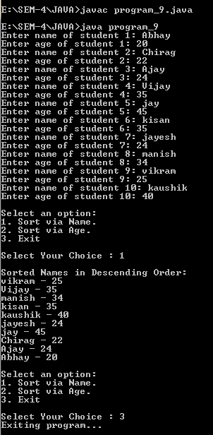

**10. Design a class MyString having a data member of type String and add member functions to achieve following task. (i) Reverse string (ii) String in Titlecase. (iii) Extract N-characters from rightend of the string Write a menu driven program to call these methods of MyString class. The program should not terminate abruptly.**

import java.util.Scanner;

public class program_10 {

private String str;

public program_10(String str) {

this.str = str;

}

public String reverse() {

StringBuilder sb = new StringBuilder(str);

return sb.reverse().toString();

}

public String titleCase() {

String[] words = str.split("\\s+");

StringBuilder sb = new StringBuilder();

for (String word : words) {

if (word.length() > 0) {

sb.append(Character.toUpperCase(word.charAt(0)));

sb.append(word.substring(1).toLowerCase());

sb.append(" ");

}

}

return sb.toString().trim();

}

public String extractFromRight(int n) {

if (n >= str.length()) {

return str;

}

return str.substring(str.length() - n);

}

public static void main(String[] args) {

Scanner scanner = new Scanner(System.in);

System.out.print("Enter a string: ");

String inputString = scanner.nextLine();

program_10 myString = new program_10(inputString);

while (true) {

System.out.println("\nSelect an option:");

System.out.println("1. Reverse the string");

System.out.println("2. Convert the string to title case");

System.out.println("3. Extract N characters from the right-end of thestring");

System.out.println("4. Exit");

System.out.print("\nSelect Your Choice : ");

int choice = scanner.nextInt();

scanner.nextLine();

switch (choice) {

case 1:

System.out.println("Reversed string: " + myString.reverse());

break;

case 2:

System.out.println("Title case string: " + myString.titleCase());

break;

case 3:

System.out.print("Enter the number of characters to extract: ");

int n = scanner.nextInt();

scanner.nextLine();

System.out.println("Extracted string: " +

myString.extractFromRight(n));

break;

case 4:

System.out.println("Exiting program...");

System.exit(0);

break;

default:

System.out.println("Invalid choice. Try again.");

}

}

}

}



