**1. Write a program to take command line input and check number is odd or even.**

**Code:**

**class evenodd {**

**public static void main(String[] args){**

**int a;**

**a=Integer.parseInt(args[0]);**

**if(a%2==0) {**

**System.out.println(a);**

**System.out.println(" is Even number");}**

**Else {**

**System.out.println(a);**

**System.out.println(" is Odd number");}**

**}**

**}**

**Output:**

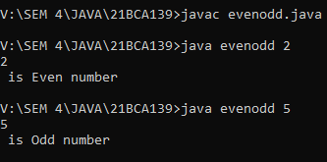

**2. Write a program to take command line input and sum of 2 number.**

**Code:**

**//write a java program to print sum of two numbers**

**class sum**

**{**

**public static void main(String[] args)**

**{**

**int a,b,c;**

**a=Integer.parseInt(args[0]);**

**b=Integer.parseInt(args[1]);**

**c=a+b;**

**System.out.println("sum is" +c);**

**}**

**}**

**Output:**

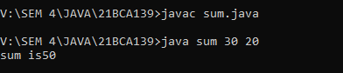

# 3. Write a program to take command line input and calculate a Simple Interest.

**Code:**

# class SimpleInterest {

# public static void main (String args[]){

# float p,r,t,si;

# p=Integer.parseInt(args[0]);

# r=Integer.parseInt(args[1]);

# t=Integer.parseInt(args[2]);

# si=(p*r*t)/100;

# System.out.println("The Simple Intrest is =\n"+si);

# }

# }

**Output:**

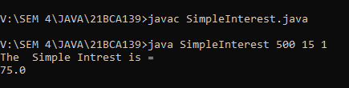

# 4. Write a Program to take command line input and Check Number is Positive or Negative.

**Code:**

# class negitiveorpositive

**{**

**public static void main(String[] args){**

**int n;**

**n=Integer.parseInt(args[0]);**

**//System.out.println("Enter Your Number:\n"+n);**

**if(n>0)**

**{**

**System.out.println("Number is positive");**

**}**

**else if(n<0)**

**{**

**System.out.println("Number is negative");**

**}**

**else**

**{**

**System.out.println("Number is neither negative or positive");**

**}**

**}**

**}**

**Output:**

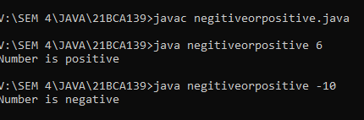

# 5. Write a Program to take command line input and Check Year is Leap Year or Not

**Code:**

**class leapyear**

**{**

**public static void main(String[] args)**

**{**

**int year;**

**year=Integer.parseInt(args[0]);**

**System.out.println("Enter The year:"+year);**

**if(year%400==0) {**

**System.out.println("This is leap year"+year);}**

**else if(year%100==0) {**

**System.out.println("This is not leap year"+year);}**

**else if(year%4==0) {**

**System.out.println("This is leap year"+year);}**

# else {

# System.out.println("This is not leap year"+year);}

# }}

**Output:**

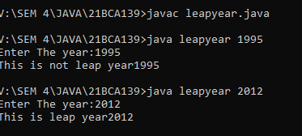

**6. Write a program to take command line input and find the Character Is Vowel or Not**

**Code:**

**class vowelornot{**

**public static void main (String [] args) {**

**String s= args[0];**

**char a=s.charAt(0);**

**if(a == 'a' || a == 'e' || a == 'i' || a == 'o' || a == 'u' || a == 'A' || a == 'E' || a == 'I' || a == 'O' || a == 'U' )**

**System.out.println(a +" is vowel");**

**else**

**System.out.println(a+ " is consonant");**

**}**

**}**

**Output:**

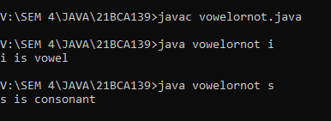

**7. Write a program to reverse a given number using while loop.**

**Code:**

**class reversenumberwhileloop {**

**public static void main(String[] args)**{

**int reminder=number%10;**

**reverse = reverse*10+reminder;**

**number=number/10;**

**int number=123456789,reverse=0;**

**while(number != 0){**

**System.out.println("The Reverse number is :"+reverse);**

**}**

**}**

**}**

**Output:**

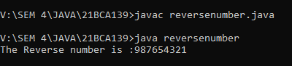

# 8. Write a program to reverse a given number using for loop.

**Code:**

**class reversenumberforloop{**

# public static void main(String[] args){

# int number=123456789,reverse=0;

# for(;number != 0;number=number/10){

# int reminder=number%10;

# reverse = reverse*10+reminder;}

# System.out.println("The Reverse number is :"+reverse);

# }

# }

**Output:**

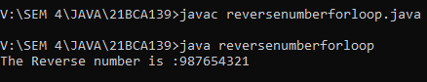

**9. Write a program to check number is Armstrong or Not**

**Code:**

**class Armstrongnumber{**

**public static void main(String[] args){**

**int num,temp,sum;**

**int i =1 , n =0;**

**num=Integer.parseInt(args[0]);**

**System.out.print("Enter the number : ");**

**sum = 0;**

**i = num;**

**while (num > 0){**

**n = num % 10;**

**num = num / 10;**

**sum = sum + (n * n * n);}**

**if (sum == i){**

**System.out.print(i+" is an ARMSTRONG Number.");}**

**else{**

**System.out.print(i+" is not an ARMSTRONG Number.");}**

**} }**

**Output:**

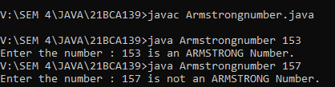

**10. Write a to check number is Prime number or not.**

**Code:**

class primeornot{

public static void main(String args[]){

int i,j=0,flag=0;

int n;

n=Integer.parseInt(args[0]);

j=n/2;

if(n==0||n==1){

System.out.println("This is not prime number\n"+n);} else{

for(i=2;i<=j;i++){

if(n%i==0){

System.out.println("This is not prime number\n"+n); flag=1;

break;}

}

# if(flag==0) {

# System.out.println("This is prime number\n"+n);}

# }

# }

# }

# Output:

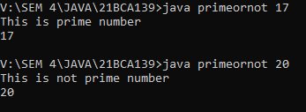

**11. Write a program to check given string is Palindrome or not**

**Code:**

**class palindrome{**

**public static void main(String[] args){**

**int p,add=0,t,n;**

**n=Integer.parseInt(args[0]);**

**System.out.println("The palindrome number is :"+n);**

**t=n;**

**while(n>0){**

**p=n%10;**

**add=(add*10)+p;**

**n=n/10;}**

**if(t==add){**

**System.out.println("Number is palindrome\n "+add);}**

**else{**

**System.out.println("Number is not is palindrome\n ")}**

**}**

**}**

**Output:**

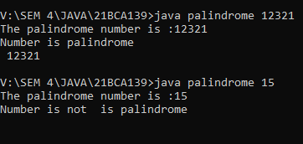

**12. Write a program in java to display the pattern like right angle triangle using an asterisk.**

# *

# **

# ***

# ****

# *****

**Code:**

# class pattern1{

# public static void main(String[] args){

# int i,j,n;

# n=Integer.parseInt(args[0]);

# System.out.println("Enter you number");

# for(i=0;i<n;i++){

# for(j=0;j<=i;j++){

# System.out.print(" *");}

# System.out.println("");}

# }

# }

**Output:**

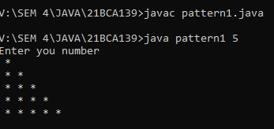

**13. Write a program in java to make such a pattern like a pyramid with numbers increased by 1. 1 2 3 4 5 6 7 8 9 1.**

**Code:**

**class pattern3{**

**public static void main(String[] args)**

**{**

**int n;**

**n=Integer.parseInt(args[0]);**

**System.out.println("Enter you number =");**

**int count =1;**

**for(int i=1;i<=n;i++)**

**{**

**for(int j=n;j>i;j--)**

**{**

**System.out.print(" ");**

**}**

**for(int k=1;k<=i;k++)**

**{**

**System.out.print(count + " ");**

**count++;**

**}**

**System.out.println();**

**}**

**}}**

**Output:**

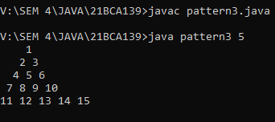

**14. Write a C Program to display the pattern using the alphabet.**

**A B C D E**

**A B C D**

**A B C**

**A B**

**A**

**Code:**

**class pattern2{**

**public static void main(String[] args) {**

**for(int i=4;i>=0;i--){**

**for(int j=0;j<=i;j++){**

**System.out.print((char)(j+65));}**

**System.out.println();}**

**}**

**}**

**Output:**

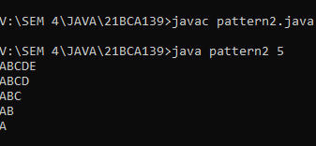

# 15. Write a program to take command line input and print factorial of given number.

**Code:**

class factorial{

public static void main(String args[]){

int i,f=1;

int n; //It is the factorial number

# n=Integer.parseInt(args[0]);

# for(i=1;i<=n;i++){

# f=f*i;}

# System.out.println("Factorial of "+n+" is: "+f);

# }

# }

# Output:

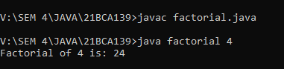

# 16. Write a program to display Fibonacci series .

**Code:**

# class fibonacci{

# public static void main(String args[]){

# int a=0,b=1,n,count=10,i;

# System.out.println(a+""+b);

# for(i=2;i<count;i++){

# n=a+b;

# System.out.println("" +n);

# a=b;

# b=n;

# }

}

}

**Output:**

