**JAVA JOURNAL 1**

# My project.png

1. **Write a program to take command line input and check number is odd or even.**

**class oddeven**

**{**

**public static void main(String[] args)**

**{**

**int num;**

**num=Integer.parseInt(args[0]);**

**if (num % 2 == 0) {**

**System.out.println(num+" The Number is Even");**

**}**

**else {**

**System.out.println(num+" The Number is Odd");**

**}**

**}**

**}**

**-: OUTPUT :-**

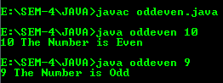

**2 . Write a program to take command line input and sum of 2 number.**

**public class sum_of_number**

**{**

**public static void main(String[]args)**

**{**

**int a,b,sum;**

**a=Integer.parseInt(args[0]);**

**b=Integer.parseInt(args[1]);**

**sum=a+b;**

**System.out.println("Sum Is Two Number : "+sum);**

**}**

**}**

**-: OUTPUT :-**



**3 . Write a program to take command line input and calculate a Simple Interest.**

**class Intrest**

**{**

**public static void main(String[]args)**

**{**

**float p,t,r,in;**

**p=Float.parseFloat(args[0]);**

**t=Float.parseFloat(args[1]);**

**r=Float.parseFloat(args[2]);**

**in=(p*t*r)/100;**

**System.out.println("Result Is: "+in);**

**}**

**}**

**-: OUTPUT :-**



**4 . Write a Program to take command line input and Check Number is Positive or Negative.**

**class posneg**

**{**

**public static void main(String[]args)**

**{**

**int num;**

**num=Integer.parseInt(args[0]);**

**if(num>0)**

**{**

**System.out.println("Number is positive");**

**}**

**else if(num<0)**

**{**

**System.out.println("Number is Negative");**

**}**

**else**

**{**

**System.out.println("Number is zero");**

**}**

**}**

**}**

**-: OUTPUT :-**

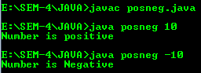

**5 . Write a Program to take command line input and Check Year is Leap Year or Not.**

**class LeapYear**

**{**

**public static void main(String[]args)**

**{**

**int y;**

**y=Integer.parseInt(args[0]);**

**if(y%400==0 && y%100==0 || y%100!=0 && y%4==0)**

**{**

**System.out.println(y+" Leap Year");**

**}**

**else**

**{**

**System.out.println(y+" Not a Leap Year");**

**}**

**}**

**}**

**-: OUTPUT :-**

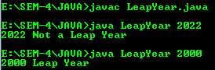

**6 . Write a program to take command line input and find the Character Is Vowel or Not.**

**class Vowels**

**{**

**public static void main(String[]args)**

**{**

**char ch=args[0].charAt(0);**

**if(ch=='a'||ch=='e'||ch=='i'||ch=='o'||ch=='u'||ch=='A'||ch=='E'||ch=='I'||ch=='O'||ch==U' )**

**{**

**System.out.println(ch+" Is a Vowels");**

**}**

**else**

**{**

**System.out.println(ch+" Is not a Vowels");**

**}**

**}**

**}**

**-: OUTPUT :-**

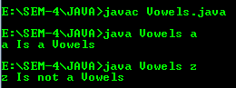

**7 . Write a program to reverse a given number using while loop.**

**class Revwhile**

**{**

**public static void main(String[]args)**

**{**

**int n,r;**

**n=Integer.parseInt(args[0]);**

**while(n>0)**

**{**

**r=n%10;**

**System.out.print(“Reverse Number Is : ”r);**

**n=n/10;**

**}**

**}**

**}**

**-: OUTPUT :-**



**8 . Write a program to reverse a given number using for loop.**

**class revfor**

**{**

**public static void main(String[]args)**

**{**

**int n,rev=0,re;**

**n=Integer.parseInt(args[0]);**

**for(;n!=0;n=n/10)**

**{**

**re=n%10;**

**rev=rev*10+re;**

**}**

**System.out.print("Reverse Number :"+rev);**

**}**

**}**

**-: OUTPUT :-**



**9 . Write a program to check number is Armstrong or Not.**

**class armstrong**

**{**

**public static void main(String[]args)**

**{**

**int i,n,arm=0,re,c;**

**n=Integer.parseInt(args[0]);**

**c=n;**

**while(n>0)**

**{**

**re=n%10;**

**arm=(re*re*re)+arm;**

**n=n/10;**

**}**

**if(c==arm)**

**System.out.print(" Is Armstrong Number ");**

**else**

**System.out.print(" Is Not Armstrong Number ");**

**}**

**}**

**-: OUTPUT :-**

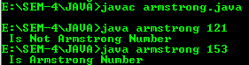

**10 . Write a to check number is Prime number or not.**

**class prime**

**{**

**public static void main(String[]args)**

**{**

**int i,n,count=0;**

**n=Integer.parseInt(args[0]);**

**for(i=1;i<=n;i++)**

**{**

**if(n%i==0);**

**{**

**count++;**

**}**

**}**

**if(count==2)**

**{**

**System.out.print(" Is Prime Number ");**

**}**

**else**

**{**

**System.out.print(" Is Not Prime Number ");**

**}**

**}**

**}**

**-: OUTPUT :-**

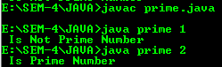

**11 . Write a program to check given string is Palindrome or not.**

**class Palindrome**

**{**

**public static void main(String[]args)**

**{**

**int n,s=0,r,c;**

**n=Integer.parseInt(args[0]);**

**c=n;**

**while(n>0)**

**{**

**r=n%10;**

**s=(s*10)+r;**

**n=n/10;**

**}**

**if(c==s)**

**System.out.print(" Is Palindrome Number ");**

**else**

**System.out.print(" Is Not Palindrome Number ");**

**}**

**}**

**-: OUTPUT :-**

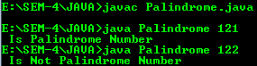

|  |
| --- |
| **12 . Write a program in java to display the pattern like right angle triangle using an asterisk.** |

**class RightTriangle**

**{**

**public static void main(String[] args)**

**{**

**int row = 5;**

**for (int i = 1; i <= row; i++)**

**{**

**for (int j = 1; j <= i; j++)**

**{**

**System.out.print("* ");**

**}**

**System.out.println();**

**}**

**}**

**}**

**-: OUTPUT :-**

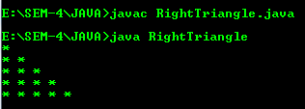

|  |
| --- |
| **13 . Write a program in java to make such a pattern like a pyramid with numbers increased by 1.** |

**class Pyramid**

**{**

**public static void main(String[]args)**

**{**

**int row = 5;**

**int num = 1;**

**for (int i = 1; i <= row; i++)**

**{**

**for (int j = 1; j <= row - i; j++)**

**{**

**System.out.print(" ");**

**}**

**for (int k = 1; k <= i; k++)**

**{**

**System.out.print(num++ + " ");**

**}**

**System.out.println();**

**}**

**}**

**}**

**-: OUTPUT :-**

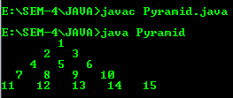

**14 . Write a C Program to display the pattern using the alphabet.**

**import java.util.Scanner;**

**class alphabet**

**{**

**public static void main(String [] args)**

**{**

**int i,a,b=0;**

**char c;**

**Scanner sc=new Scanner(System.in);**

**System.out.print("Enter No:- ");**

**a = sc.nextInt();**

**for(b=a;b>=1;b--)**

**{**

**c='A';**

**for(i=1;i<=b;i++)**

**{**

**System.out.print(c+" ");**

**c++;**

**}**

**System.out.println("\n");**

**}**

**}**

**}**

**-: OUTPUT :-**

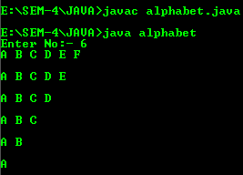

|  |
| --- |
| **15 . Write a program to take command line input and print factorial of given number.** |

**import java.util.Scanner;**

**class cmd_factorial**

**{**

**public static void main(String args[])**

**{**

**int n, c, f = 1;**

**System.out.print("Enter an integer to calculate its factorial : ");**

**Scanner in = new Scanner(System.in);**

**n = in.nextInt();**

**if (n < 0)**

**{**

**System.out.println("Number should be no-negative");**

**}**

**else**

**{**

**for (c = 1; c <= n; c++)**

**f = f*c;**

**System.out.println("Factorial of "+n+" is = "+f);**

**}**

**}**

**}**

**-: OUTPUT :-**

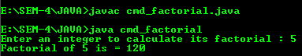

|  |
| --- |
| **16 . Write a program to display Fibonacci series.** |

**import java.util.Scanner;**

**class Fibonacci**

**{**

**public static void main(String[]args)**

**{**

**int n, a = 0, b = 0, c = 1;**

**Scanner s = new Scanner(System.in);**

**System.out.print("Enter value :- ");**

**n = s.nextInt();**

**System.out.print("Fibonacci Series :- ");**

**for(int i = 1; i <= n; i++)**

**{**

**a = b;**

**b = c;**

**c = a + b;**

**System.out.print(a+",");**

**}**

**System.out.print("\b");**

**}**

**}**

**-: OUTPUT :-**



