**JAVA JOURNAL 3**

# My project.png

1. **Write a program which accepts starting character and ending character. Display one by one character from starting character till the ending character at the interval of one second using thread.**

import java.util.Scanner;

public class j1 implements Runnable{

private char startChar;

private char endChar;

public j1(char startChar, char endChar) {

this.startChar = startChar;

this.endChar = endChar;

}

public void run(){

try{

for (char c = startChar; c <= endChar; c++) {

System.out.print(c + " ");

Thread.sleep(1000);

}

}

catch (InterruptedException e){

e.printStackTrace();

}

}

public static void main(String[] args){

Scanner scanner = new Scanner(System.in);

System.out.print("Enter starting character: ");

char startChar = scanner.next().charAt(0);

System.out.print("Enter ending character: ");

char endChar = scanner.next().charAt(0);

j1 cd = new j1(startChar, endChar);

Thread thread = new Thread(cd);

thread.start();

}

}

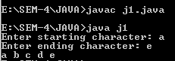

1. **Write a program that stores details of 5 employees and display this information after every 10 second.**

import java.util.Scanner;

public class program_2 {

public static void main(String[] args) {

String[] name=new String[5];

int[] age=new int[5];

String[] department=new String[5];;

double[] salary=new double[5];

Scanner sc = new Scanner(System.in);

for(int i=0;i<5;i++)

{

System.out.print("Enter Emp "+ (i+1) +" Name : ");

name[i] = sc.nextLine();

System.out.print("Enter Emp "+ (i+1) +" Age : ");

age[i] = sc.nextInt();

sc.nextLine();

System.out.print("Enter Emp "+ (i+1) +" Department : ");

department[i] = sc.nextLine();

System.out.print("Enter Emp "+ (i+1) +" Salary : ");

salary[i] = sc.nextDouble();

sc.nextLine();

System.out.println();

}

for(int i=0;i<5;i++)

{

try {

System.out.print("\nName: " + name[i] + ", Age: " + age[i] + ",Department: " + department[i] + ", Salary: " + salary[i]);Thread.sleep(10000);

}

catch (InterruptedException e)

{

e.printStackTrace();

}

}

}

}

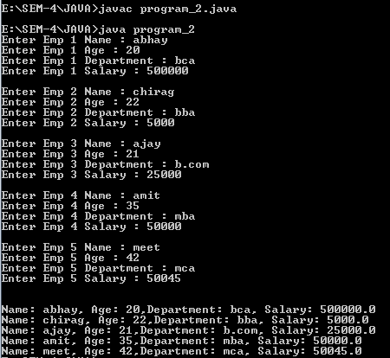

1. **Write a java application which accepts 10 names of student and their age. Sort names and age in descending order at an interval of 1 second using thread.**

import java.util.Arrays;

import java.util.Scanner;

public class program_3 {

public static void main(String[] args) {

Scanner scanner = new Scanner(System.in);

String[] names = new String[10];

int[] ages = new int[10];

for (int i = 0; i < 10; i++) {

System.out.print("Enter name of student " + (i + 1) + ": ");

names[i] = scanner.nextLine();

System.out.print("Enter age of student " + (i + 1) + ": ");

ages[i] = scanner.nextInt();

scanner.nextLine();

}

while (true) {

System.out.println("\nSelect an option:");

System.out.println("1. Sort via Name.");

System.out.println("2. Sort via Age.");

System.out.println("3. Exit");

System.out.print("\nSelect Your Choice : ");

int choice = scanner.nextInt();

scanner.nextLine();

switch (choice) {

case 1:

for (int i = 0; i < 10; i++) {

for (int j = i + 1; j < 10; j++) {

if (names[i].compareToIgnoreCase(names[j]) < 0) {

String tempName = names[i];

names[i] = names[j];

names[j] = tempName;

int tempAge = ages[i];

ages[i] = ages[j];

ages[j] = tempAge;

}

}

}

System.out.println("\nSorted Names in Descending Order:");

for (int i = 0; i < 10; i++) {

try {

System.out.println(names[i] + " - " + ages[i]);

Thread.sleep(1000);

}

catch (InterruptedException e) {

e.printStackTrace();

}

}

break;

case 2:

for (int i = 0; i < 10; i++) {

for (int j = i + 1; j < 10; j++) {

if (ages[i] < (ages[j])) {

int tempage = ages[i];

ages[i] = ages[j];

ages[j] = tempage;

String tempname = names[i];

names[i] = names[j];

names[j] = tempname;

}

}

}

System.out.println("\nSorted Ages in Descending Order:");

for (int i = 0; i < 10; i++) {

try {

System.out.println(ages[i] + " - " + names[i]);

Thread.sleep(1000);

}

catch (InterruptedException e) {

e.printStackTrace();

}

}

break;

case 3:

System.out.println("Exiting program...");

System.exit(0);

break;

default:

System.out.println("Invalid choice. Try again.");

}

}

}

}

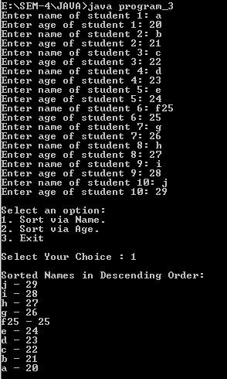

1. **Create package stores. Under it create a class called stock with member variable (item_no, item_name, stock_availible, and cost). Under the default package create a class called sales with field name (qty_sold) and it is the child class of stores class. Write a program to print the current stock of each item and perform addition.**

package stores;

public class stock {

private int item_no;

private String item_name;

private int stock_available;

private double cost;

public stock(int item_no, String item_name, int stock_available, double cost) {

this.item_no = item_no;

this.item_name = item_name;

this.stock_available = stock_available;

this.cost = cost;

}

public int getItem_no() {

return item_no;

}

public String getItem_name() {

return item_name;

}

public int getStock_available() {

return stock_available;

}

public double getCost() {

return cost;

}

public void setStock_available(int stock_available) {

this.stock_available = stock_available;

}

public void setCost(double cost) {

this.cost = cost;

}

public String toString() {

return "Item No.: " + item_no + ", Item Name: " + item_name + ", StockAvailable: " + stock_available + ", Cost: " + cost;

}

}

import stores.stock;

import java.util.ArrayList;

import java.util.Scanner;

public class PROG_4

{

public static void main(String[] args) {

ArrayList<stock> items = new ArrayList<stock>();

items.add(new stock(1, "Apple", 10, 20.0));

items.add(new stock(2, "Banana", 20, 30.0));

items.add(new stock(3, "Ball", 30, 40.0));

Scanner scanner = new Scanner(System.in);

while (true) {

System.out.println("\nCurrent Stock:");

for (stock item : items) {

System.out.println(item);

}

System.out.print("\nEnter the item no. to add stock, or 0 to exit:");

int item_no = scanner.nextInt();

if (item_no == 0) {

break;

}

stock item = items.stream().filter(i -> i.getItem_no() ==

item_no).findFirst().orElse(null);

if (item == null) {

System.out.println("Invalid item no.");

}

else {

System.out.print("\nEnter the quantity to add:");

int qty = scanner.nextInt();

item.setStock_available(item.getStock_available() + qty);

System.out.println("Stock added successfully.");

}

}

}

}

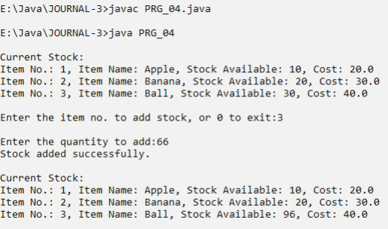

1. **Create a class namely Vehicle to maintain vehicle data like chassisNo, nameOfVehicle, colour, owner using singly circular linked list. Perform following operations on student list: a. Add vehicle details at the end of the list . b. Remove last vehicle detail in the list . c. Display all vehicle details in the list.**

import java.util.Scanner;

class Vehicle {

private int chassisNo;

private String nameOfVehicle;

private String colour;

private String owner;

private Vehicle next;

public Vehicle(int chassisNo, String nameOfVehicle, String colour, String

owner) {

this.chassisNo = chassisNo;

this.nameOfVehicle = nameOfVehicle;

this.colour = colour;

this.owner = owner;

this.next = null;

System.out.println("\nData Inserted Successfully.");

}

public int getChassisNo() {

return chassisNo;

}

public void setChassisNo(int chassisNo) {

this.chassisNo = chassisNo;

}

public String getNameOfVehicle() {

return nameOfVehicle;

}

public void setNameOfVehicle(String nameOfVehicle) {

this.nameOfVehicle = nameOfVehicle;

}

public String getColour() {

return colour;

}

public void setColour(String colour) {

this.colour = colour;

}

public String getOwner() {

return owner;

}

public void setOwner(String owner) {

this.owner = owner;

}

public Vehicle getNext() {

return next;

}

public void setNext(Vehicle next) {

this.next = next;

}

}

class VehicleList {

private Vehicle tail;

public VehicleList() {

tail = null;

}

public void addVehicle(int chassisNo, String nameOfVehicle, String colour,String owner) {

Vehicle newVehicle = new Vehicle(chassisNo, nameOfVehicle, colour,owner);

if (tail == null) {

tail = newVehicle;

tail.setNext(tail);

}

else {

newVehicle.setNext(tail.getNext());

tail.setNext(newVehicle);

tail = newVehicle;

}

}

public void removeLastVehicle() {

if (tail == null) {

System.out.println("List is empty");

return;

}

if (tail.getNext() == tail) {

tail = null;

return;

}

Vehicle current = tail.getNext();

while (current.getNext() != tail) {

current = current.getNext();

}

current.setNext(tail.getNext());

tail = current;

}

public void displayVehicles() {

if (tail == null) {

System.out.println("List is empty");

return;

}

Vehicle current = tail.getNext();

do {

System.out.println("-----------------------------------------------");

System.out.println("Chassis No: " + current.getChassisNo() +" \nName of Vehicle: " + current.getNameOfVehicle() +" \nColour: " + current.getColour() +" \nOwner: " + current.getOwner());

System.out.println("-----------------------------------------------");

current = current.getNext();

} while (current != tail.getNext());

}

}

public class program_5 {

public static void main(String[] args)

{

Scanner scan = new Scanner(System.in);

VehicleList vehicleList = new VehicleList();

while (true) {

System.out.println("\n-----------------------------------------------");

System.out.println("\nCircular Singly Linked List Operations\n");

System.out.println("-----------------------------------------------");

System.out.println("1. Insert at End.");

System.out.println("2. Delete from End.");

System.out.println("3. Get Item detail's.");

System.out.println("4. Exit.");

System.out.println("-----------------------------------------------");

System.out.print("Enter your Choice : ");

int choice = scan.nextInt();

switch (choice)

{

case 1 :

int ch_no;

String nameOfVeh, colour, owner;

System.out.print("Enter Chassis_No : ");

ch_no=scan.nextInt();

scan.nextLine();

System.out.print("Enter Name of vehicle : ");

nameOfVeh=scan.nextLine();

System.out.print("Enter Color of vehicle : ");

colour=scan.nextLine();

System.out.print("Enter Owner Name : ");

owner=scan.nextLine();

vehicleList.addVehicle(ch_no,nameOfVeh,colour,owner);

break;

case 2 :

vehicleList.removeLastVehicle();

System.out.println("\nData Deleted Successfully.");

break;

case 3 :

System.out.println("Vehicle details:");

vehicleList.displayVehicles();

break;

case 4 :

System.out.println("Program Exited...");

System.exit(0);

break;

default:

System.out.println("Invalid choice. Try again.");

}

}

}

}

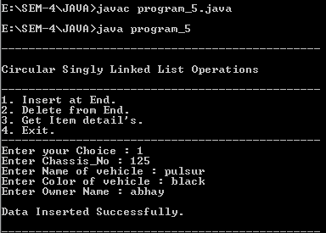

**6. Create a class namely Book to maintain Book details like id, name, quantity and author using singly linked list. Perform following operations on book list: a. Add book details in the begging of the list . b. Add book details at the end of the list . c. Add book detail at particular position . d. Remove first book detail from the list . e. Remove last book detail from the list . f. Display all book details in the list .**

import java.util.Scanner;

class Book {

private int id;

private String name;

private int quantity;

private String author;

private Book next;

public Book(int id, String name, int quantity, String author) {

this.id = id;

this.name = name;

this.quantity = quantity;

this.author = author;

this.next = null;

System.out.println("\nData Inserted Successfully.");

}

public int getId() {

return id;

}

public void setId(int id) {

this.id = id;

}

public String getName() {

return name;

}

public void setName(String name) {

this.name = name;

}

public int getQuantity() {

return quantity;

}

public void setQuantity(int quantity) {

this.quantity = quantity;

}

public String getAuthor() {

return author;

}

public void setAuthor(String author) {

this.author = author;

}

public Book getNext() {

return next;

}

public void setNext(Book next) {

this.next = next;

}

}

class BookList {

private Book head;

public BookList() {

head = null;

}

public void addBookAtBeginning(int id, String name, int quantity, String

author) {

Book newBook = new Book(id, name, quantity, author);

newBook.setNext(head);

head = newBook;

}

public void addBookAtEnd(int id, String name, int quantity, String author) {

Book newBook = new Book(id, name, quantity, author);

if (head == null) {

head = newBook;

} else {

Book current = head;

while (current.getNext() != null) {

current = current.getNext();

}

current.setNext(newBook);

}

}

public void addBookAtPosition(int id, String name, int quantity, String author,

int position) {

if (position == 1) {

addBookAtBeginning(id, name, quantity, author);

} else {

Book newBook = new Book(id, name, quantity, author);

Book current = head;

int currentPosition = 1;

while (currentPosition < position - 1 && current != null) {

current = current.getNext();

currentPosition++;

}

if (current != null) {

newBook.setNext(current.getNext());

current.setNext(newBook);

} else {

System.out.println("Invalid position");

}

}

}

public void removeFirstBook() {

if (head == null) {

System.out.println("List is empty");

} else {

head = head.getNext();

}

}

public void removeLastBook() {

if (head == null) {

System.out.println("List is empty");

}

else if (head.getNext() == null) {

head = null;

}

else {

Book current =head;

while (current.getNext().getNext() != null) {

current = current.getNext();

}

current.setNext(null);

}

}

public void displayBooks() {

if (head == null) {

System.out.println("List is empty");

} else {

Book current = head;

System.out.println("-----------------------------------------------");

while (current != null) {

System.out.println("ID: " + current.getId() + ", Name: " +

current.getName() + ", Quantity: " + current.getQuantity() + ", Author: " +

current.getAuthor());

current = current.getNext();

}

System.out.println("-----------------------------------------------");

}

}

}

public class program_6

{

public static void main(String[] args)

{

int id;

String name;

int quantity;

String author;

Scanner scan = new Scanner(System.in);

BookList bookList = new BookList();

while (true) {

System.out.println("\n-----------------------------------------------");

System.out.println("\nSingly Linked List Operations\n");

System.out.println("-----------------------------------------------");

System.out.println("1. Insert at Begining.");

System.out.println("2. Insert at End.");

System.out.println("3. Insert at Position.");

System.out.println("4. Delete from Head.");

System.out.println("5. Delete from Tail.");

System.out.println("6. Display Data.");

System.out.println("7. Exit.");

System.out.println("-----------------------------------------------");

System.out.print("Enter your Choice : ");

int choice = scan.nextInt();

switch (choice)

{

case 1 :

System.out.print("Enter Your ID : ");

id=scan.nextInt();

scan.nextLine();

System.out.print("Enter Your Name : ");

name=scan.nextLine();

System.out.print("Enter Quantity of Books : ");

quantity=scan.nextInt();

scan.nextLine();

System.out.print("Enter Author Name : ");

author=scan.nextLine();

bookList.addBookAtBeginning(id,name,quantity,author);

break;

case 2 :

System.out.print("Enter Your ID : ");

id=scan.nextInt();

scan.nextLine();

System.out.print("Enter Your Name : ");

name=scan.nextLine();

System.out.print("Enter Quantity of Books : ");

quantity=scan.nextInt();

scan.nextLine();

System.out.print("Enter Author Name : ");

author=scan.nextLine();

bookList.addBookAtEnd(id,name,quantity,author);

break;

case 3 :

int position;

System.out.print("Enter Position you want to Insert Record : ");

position=scan.nextInt();

System.out.print("Enter Your ID : ");

id=scan.nextInt();

scan.nextLine();

System.out.print("Enter Your Name : ");

name=scan.nextLine();

System.out.print("Enter Quantity of Books : ");

quantity=scan.nextInt();

scan.nextLine();

System.out.print("Enter Author Name : ");

author=scan.nextLine();

bookList.addBookAtPosition(id,name,quantity,author,position);

break;

case 4 :

bookList.removeFirstBook();

System.out.println("\nData Deleted Successfully.");

break;

case 5 :

bookList.removeLastBook();

System.out.println("\nData Deleted Successfully.");

break;

case 6 :

bookList.displayBooks();

break;

case 7 :

System.out.println("Program Exited...");

System.exit(0);

break;

default :

System.out.println("Invalid choice. Try again.");

break;

}

}

}

}

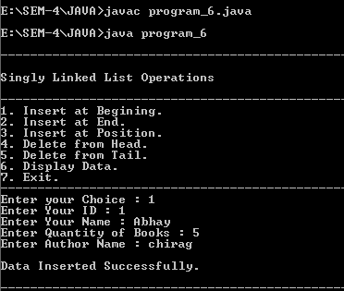

1. **Write a programme to draw smiley with colour using applet.**

import java.awt.*;

import java.applet.*;

/*<applet code="PRG_07.class" height="800" width="1860"> </applet>*/

public class program_7 extends Applet {

public void paint(Graphics g) {

g.setColor(Color.yellow);

g.fillOval(50,50,200,200);

g.setColor(Color.black);

g.drawOval(50,50,200,200);

g.setColor(Color.black);

g.fillOval(100,100,25,25);

g.fillOval(175,100,25,25);

g.setColor(Color.black);

g.drawArc(100,125,100,75,0,-180);

}

}





1. **Create an applet which displays a solid square having red colour. Display name of your college within the square with font style =’Times New Roman’, font size=50 and font colour=’Yellow’.**

import java.awt.*;

import java.applet.*;

//<applet code="PRG_08.class" height="800" width="1860"> </applet>

public class program_8 extends Applet {

public void paint(Graphics g) {

g.setColor(Color.red);

g.fillRect(200,200,400,400);

g.setColor(Color.yellow);

Font font = new Font("Times New Roman", Font.PLAIN, 50);

g.setFont(font);

FontMetrics metrics = g.getFontMetrics(font);

int x = (200 - metrics.stringWidth("My College")) / 2;

int y = ((200 - metrics.getHeight()) / 2) + metrics.getAscent();

g.drawString("VTCBCSR", 300+x, 300+y);

}

}



1. **Write a program to draw circle inside a square in applet with different colours.**

import java.awt.*;

import java.applet.*;

//<applet code="program_9.class" height="800" width="1860"> </applet>

public class program_9 extends Applet {

public void paint(Graphics g) {

g.setColor(Color.cyan);

g.fillRect(200,200,400,400);

g.setColor(Color.yellow);

g.fillOval(250,250,300,300);

}

}



1. **Write an applet program which accepts number of ovals user wants to display using parameter tag and draws ovals in different positions.**

import java.awt.*;

import java.applet.*;

/*<applet code="program_10.class" height="800" width="1860">

<param name="numOvals" value="10">

</applet>*/

public class program_10 extends Applet {

private int numOvals;

public void init() {

String numOvalsStr = getParameter("numOvals");

numOvals = Integer.parseInt(numOvalsStr);

}

public void paint(Graphics g) {

for (int i = 0; i < numOvals; i++) {

int x = (int)(Math.random() * 300);

int y = (int)(Math.random() * 300);

int w = (int)(Math.random() * 100);

int h = (int)(Math.random() * 100);

g.drawOval(x, y, w, h);

}

}

}



