**--: SET – 01 :--**

1. Print first five line of file "VTCBB.txt".

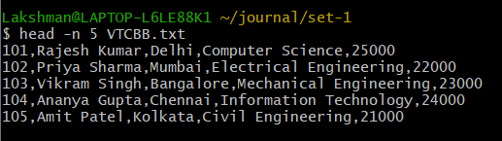

2. Print line 8 to 16 from file "VTCBB.TXT"

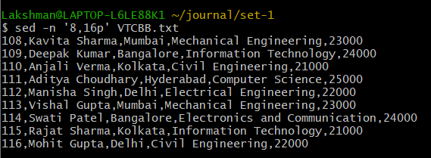

3. Print all directiory and file of current directory with hidden files and folder.

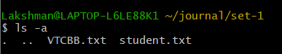

4. Print second charcter of each line of "VTCBB.txt"

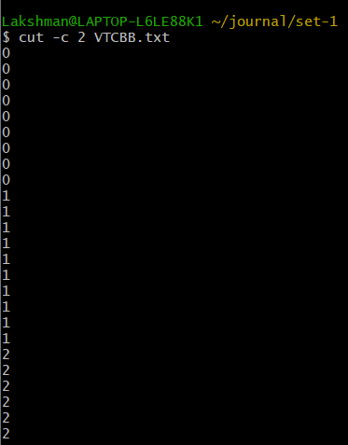

5. Display the character from 8 Bytes.

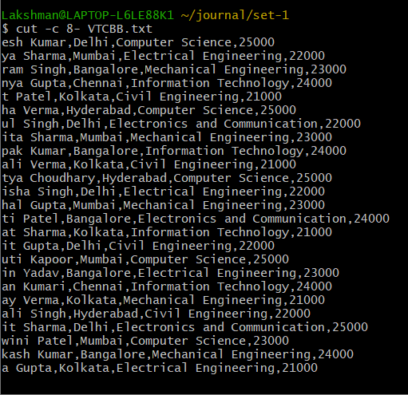

6. Skip first 5 character of each line and print it.

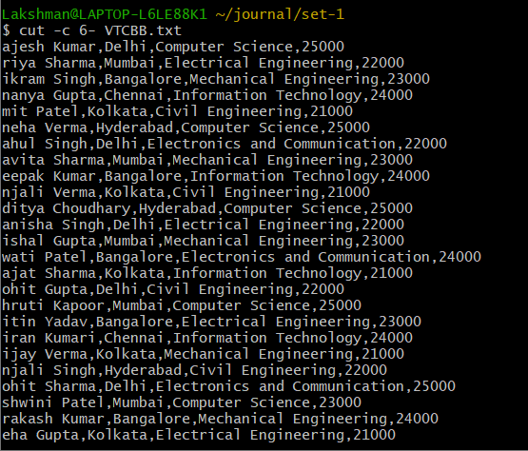

7. Print only unique record of file "student.txt"

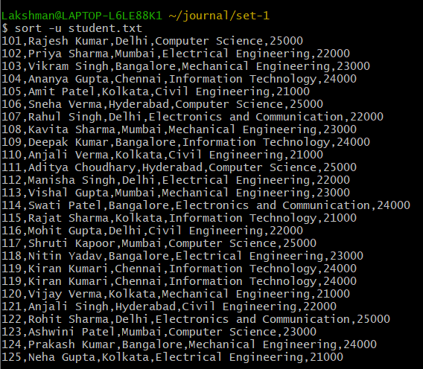

8. You have "stud.csv" file which contain sid,sname,city,dept. print only student name.

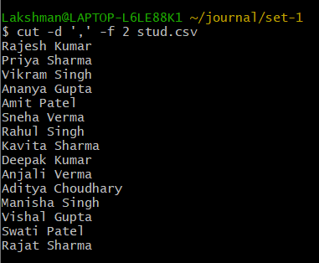

9. You have "stud.csv" file which contain sid,sname,city,dept. print only student name and dept.

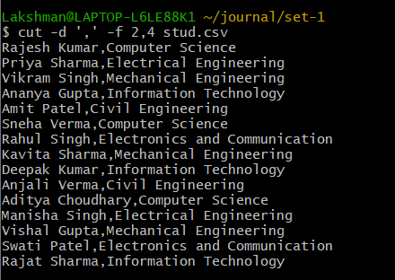

10. You have "stud.csv" file which contain sid,sname,city,dept,fee. print records in ascending order of student name.

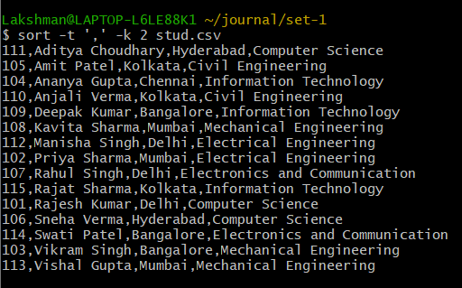

11. Display count of each line in "Stud.csv". Means how many time records repeat in file.

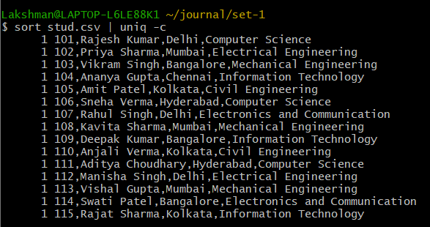

12. Convert "into.txt" file into uppercase.

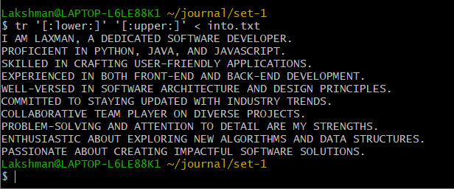

13. Print "VTCBB" as "VTBB".

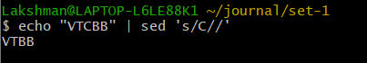

14. Print "VTCBB" as "VTCD".

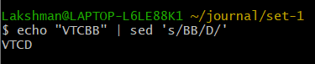

15. Display only duplicate line from file "stud.csv"

