1. Create table

stud(id,name) (use I'd as primary key)

stud_details(id,city,mobileno) (Use I'd as foreign key)

create table student(id int primary key,name text);

2. Insert minimum 10 records for each table.

insert into student values(1,'Yashvi');

insert into student values(2,'Prisha');

insert into student values(3,'Nisha');

insert into student values(4,'Misha');

insert into student values(5,'Seeya');

insert into student values(6,'Krina');

insert into student values(7,'Sanvi');

insert into student values(8,'Priti');

insert into student values(9,'Ayushi');

insert into student values(10,'Deviyani');

SELECT * FROM student;



CREATE TABLE student_details (id,city,mobile_no,FOREIGN KEY(id) REFERENCES student(id));

insert into student_details values(1,'madhi',9679456789);

insert into student_details values(2,'valod',9874564530);

insert into student_details values(3,'saputara',9872341290);

insert into student_details values(4,'bardoli',7890345678);

insert into student_details values(5,'vadodara',9089768934);

insert into student_details values(6,'surat',6789342390);

insert into student_details values(7,'ahmedabad',789067890);

insert into student_details values(8,'madhi',8907896789);

insert into student_details values(9,'valod',9089786756);

insert into student_details values(10,'bardoli',9089782345);

select*from student_details;

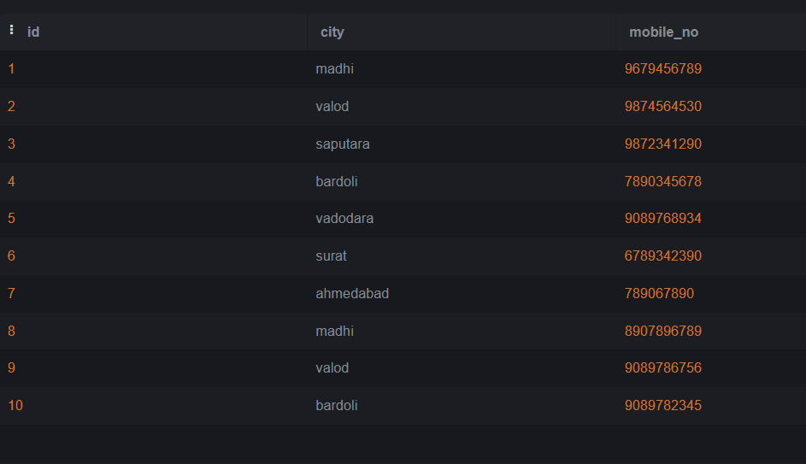

3. Display whose student come from the Surat City.

select*from student s, student_details sd

where s.id=sd.id and city='surat';



4. Display student details whose city name start with 'B'.

select s.id,s.name,sd.city,sd.mobile_no from student s, student_details sd

where s.id=sd.id and city like 'b%';



5. Update mobileno who are comming from 'Surat'

update student_details set mobile_no=9087689067

where city='surat';

select*from student_details;

