**Problem Set 3**

Assigned: 10/5/2018  
Due: 10/17/2018

Please add “LastName_” to the beginning of the file name prior to uploading to DB (Kong_ProblemSet3_HBEH762). We have a dataset, **aggpop.sas7bdat**, containing 216 children nested within 52 friendship groups. We are testing the hypotheses that aggressive behavior increases popularity. We also wish to test whether the effects of aggressive behavior on popularity vary by gender.

|  |  |  |
| --- | --- | --- |
| **Variable name** | **Name in SAS** | **Description** |
| ID | ID | Unique child-level identifier |
| Group | Group | Unique friendship group identifier |
| Aggressionij | Agg | Level 1 variable – rating of aggression for child *i* in friendship group *j*. (Note: we aren’t using this variable itself, but the centered version below.) |
| AggressionCWCij | Agg_CWC | Level 1 variable – Group mean centered rating of aggression for child *i* in friendship group *j*, centered around the mean for friendship group *j.* |
| AggressionGroupMeanj | Agg_GrpMean | Level 2 variable – Mean value of aggression ratings for all members of group *j*, centered around the grand mean. |
| Malej | Male | Level 2 variable – dummy variable which takes a value of 1 if group *j* is a male friendship group and 0 if group *j* is a female friendship group. |
| Popularityij | Pop | Dependent variable: Popularity rating of child *i* in group *j* |

We start with a random slopes model, to which we will sequentially add effects. Our initial model contains a Level 1 effect of group mean-centered aggression, as well as the Level 2 (group level) means of aggression, centered around the grand mean. The Level 1 effect of aggression is allowed to vary over schools -- i.e., we have random slopes. The model we have is written as follows:

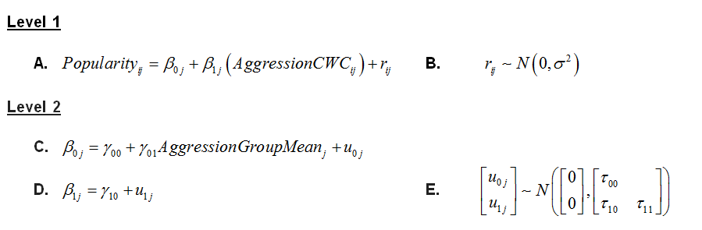

When asked how you would alter equations (Questions 3 and 8), you don't need to rewrite the equations, although you can if you want to. The equations are labeled with letters. For instance, if you were adding in a Level 1 effect of each student's social competence (a variable which we do not have, just an arbitrary example), you might write: "Add in an effect of social competence, with a coefficient labeled 'beta_2j', to Equation A."

The SAS code we use to fit this model is as follows:

**proc** **mixed** data=aggpop method=ml covtest ;

class group;

model pop= agg_cwc agg_grpmean /solution ddfm=bw ;

random intercept agg_cwc / subject=group vcorr;

**run**;

**In this assignment, please fit all models using ML (i.e., METHOD = ML) so that we can get likelihood values for model comparisons.**

This is the basic template we will be working from, so refer to the above equations, input, and output. Finally, assume that we have previously fit a null model, which found that the Level 1 (residual) variance was 6.31 and the Level 2 (intercept) variance was 3.56. We will call this null model, Model 0.

**Questions**

**Model 1. Random slope of aggression at Level 1.**

1. Fit the random slopes model shown above, the one for which the equations and SAS code are given, in SAS. We call this model **Model 1**. That is, just run the above code in SAS. Put the estimates of fixed and random effects here. (1 point)
2. Use the output from this model, as well as the variances from the null model listed above, to calculate the proportion of variance accounted for at Level 1 and Level 2 by this model. For the Level 2 variances, calculate the variance associated with the random intercept and the variance associated with the random slope – calculate these variances separately, rather than using the big formula for the joint variance accounted for at Level 2. (3 points)

**Model 2. Adding in the effects of male gender at Level 2.**

Now, we will add the Level 2 effect of gender group, *Malej*. Here we are just having the effect of gender group impact the overall predicted value of popularity, with no cross-level interactions -- that is, we are fitting an "intercepts-as-outcomes" model.

1. How would you alter the above equations to include the effect of gender at Level 2? (2 points)
2. Add the effect of gender group in at Level 2 in SAS. We call this model **Model 2**. Put the estimates of fixed and random effects here and show your input in the appendix. (1 point)
3. The -2*LL values and degrees of freedom for Model 0 and Model 1 are in the table below. Fill in the corresponding values for Model 2. (1 point)

|  |  |
| --- | --- |
| **Model** | **-2*LL** |
| Model 0 (Null model) | 1072.7 |
| Model 1 | 1039.8 |
| Model 2 |  |

1. Compare the fit of Model 1 to the fit of Model 2. What is the chi-square test statistic? Because Model 2 adds one parameter to Model 1, assume that the degrees of freedom for the chi-square test will be 1. The critical value for a chi-square test with 1 degree of freedom is 3.84. Does Model 2 fit significantly better than Model 1? (3 points)

6x. **Extra credit**: Why can’t we use the likelihood ratio test to compare the fit of Model 0 to Model 1? (1 points)

1. Write a few sentences interpreting all of the fixed effects in Model 2. Note their magnitude and significance level. To get a sense of the format for this, look at Question 2 in In-Class Assignment 5. (4 points)

**Model 3. Adding in a cross-level interaction between male gender and aggression.**

Now, we will add in a cross-level interaction between gender group and **person-level, group mean-centered aggression** (i.e., not the group mean of aggression!) to test the hypothesis that the within-group effects of aggression on popularity are different for male friendship groups and female friendship groups.

1. How would you alter the equations provided for Model 1 to include the effects of gender on both the intercept and slope? Hint: Note that the model we just fit, Model 2, added the effects of gender on the intercept -- so your answer here should also contain the changes made in Question 3. (2 points)
2. Fit this model (i.e. the slopes-as-outcomes model, or a model with a cross-level interaction) to the data in SAS. We call this model **Model 3**. Put the estimates of fixed and random effects here and show your input in the appendix. (1 point)
3. Does gender grouping moderate the effects of aggression on popularity? Provide a coefficient, t-statistic, and p-value to support your answer. (2 points)