Credit Card Default Prediction

***Wireframe Documentation***

Homepage

We have divided Credit Card Default Prediction System’s Homepage into Six Sections: -

1. First thing anyone will see a dashboard which shows the menu in the sidebar as well as below

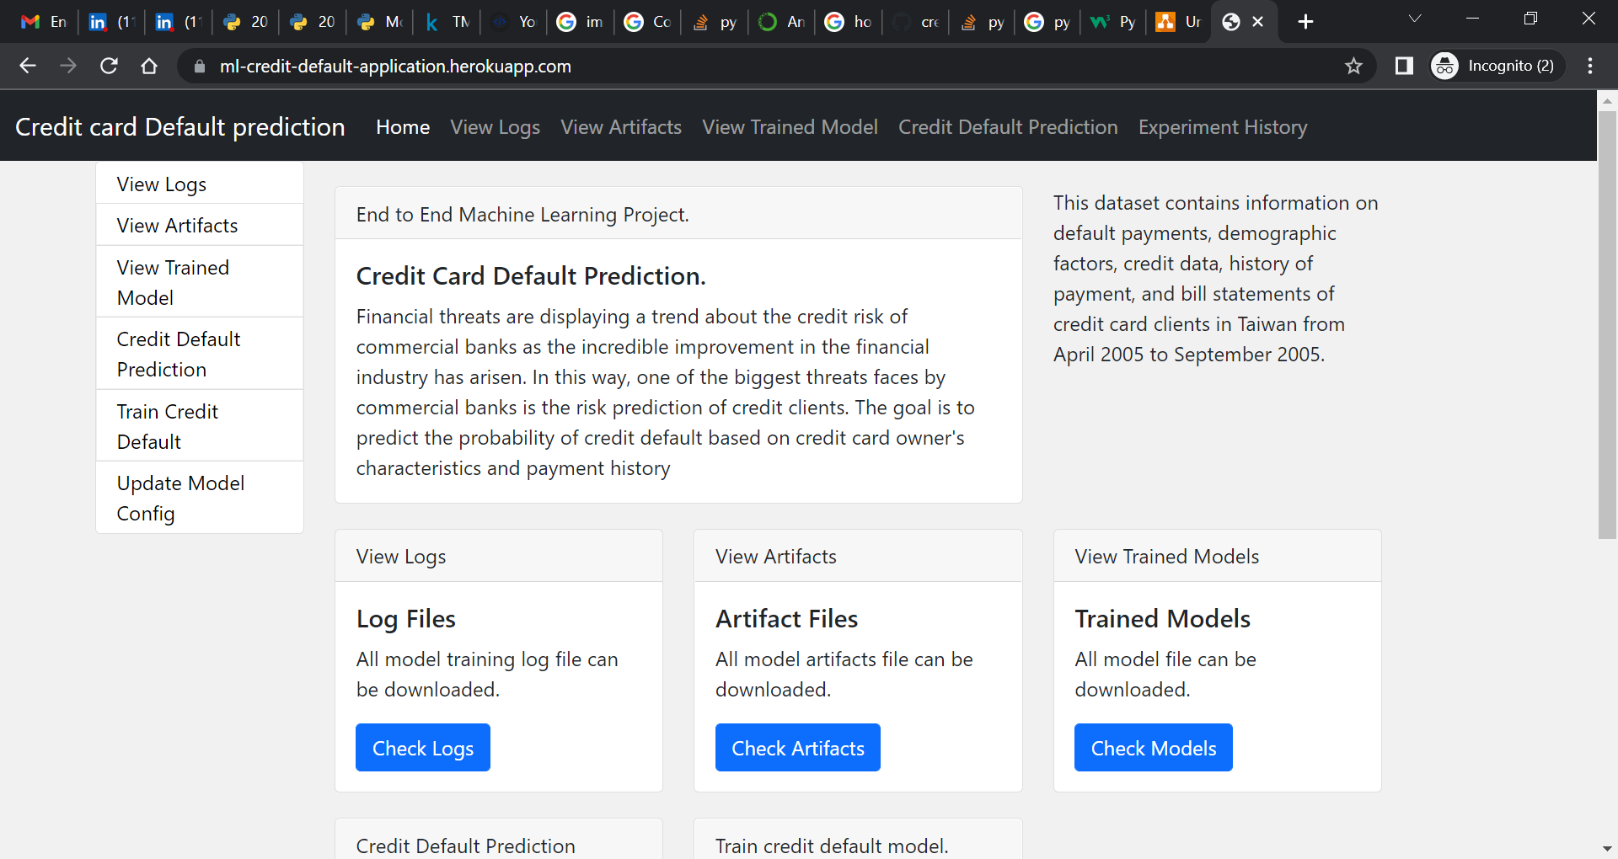

1. The User can train the credit default model once in the web before doing prediction.

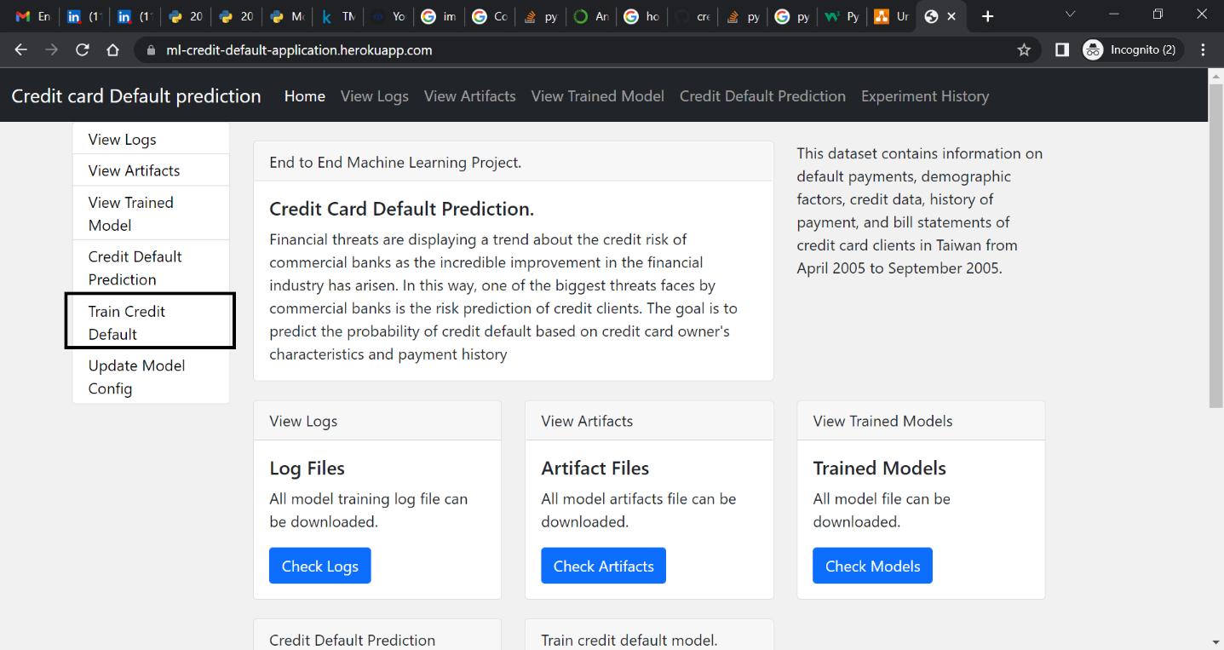

1. The User can view the logs in the “View Logs” screen.

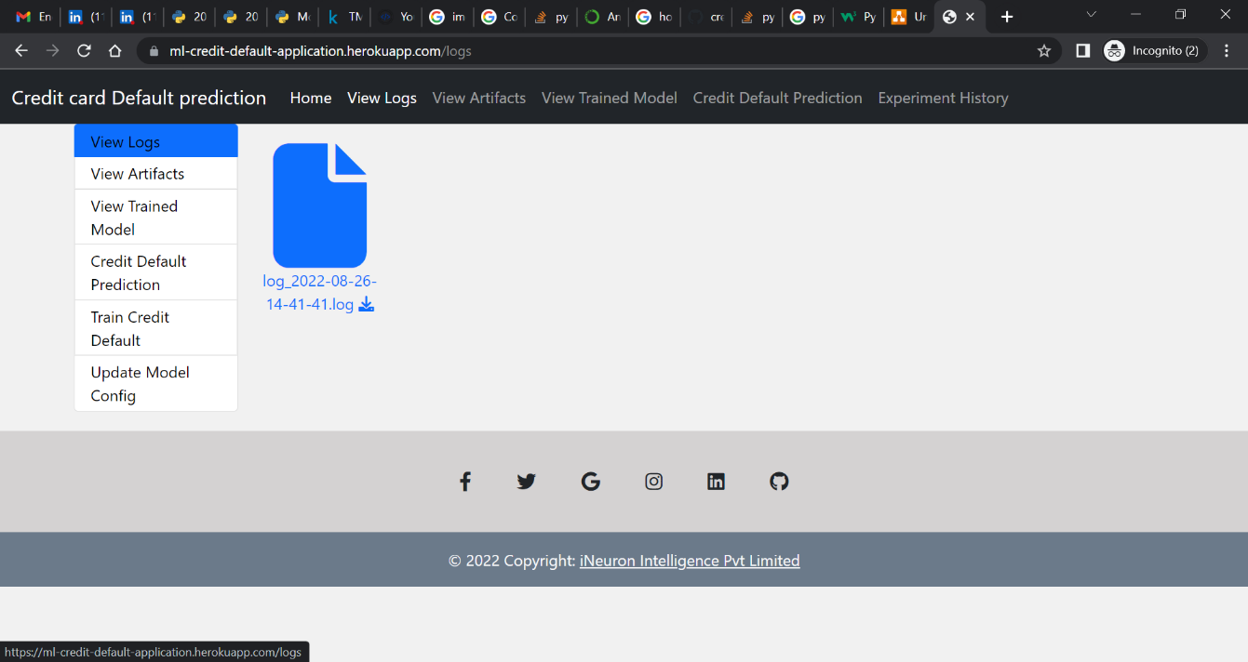

1. The User can view the Artifacts in the “View Artifacts” screen.

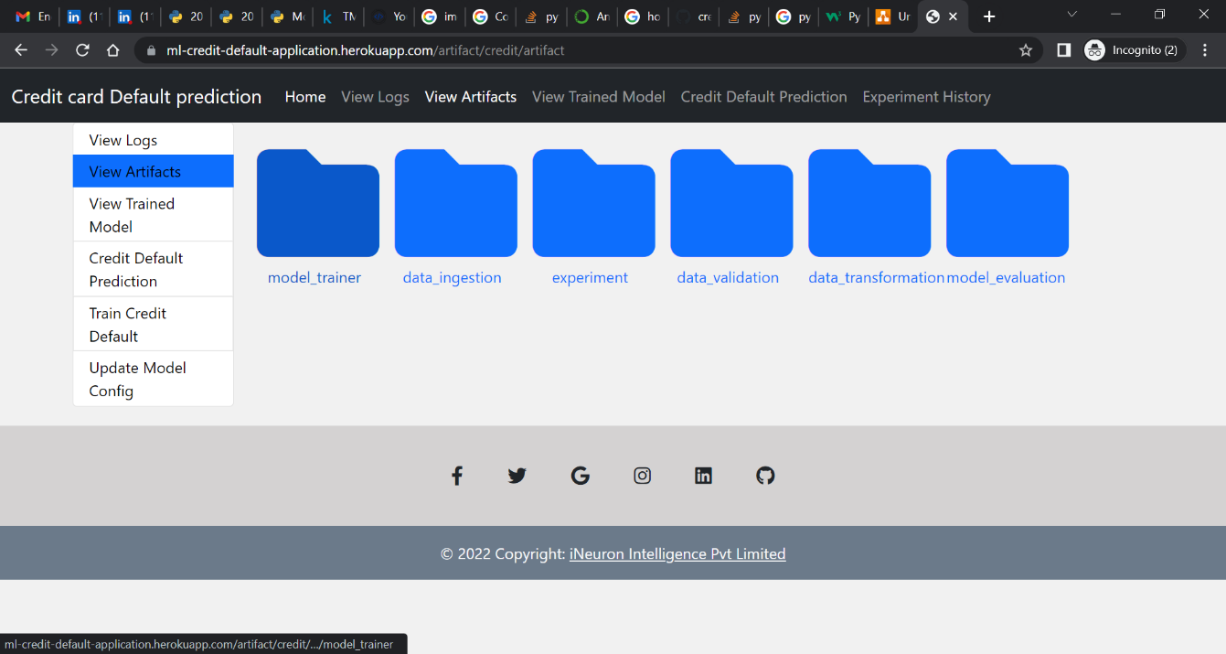

1. The User can view the model in the “View Trained Model” screen.

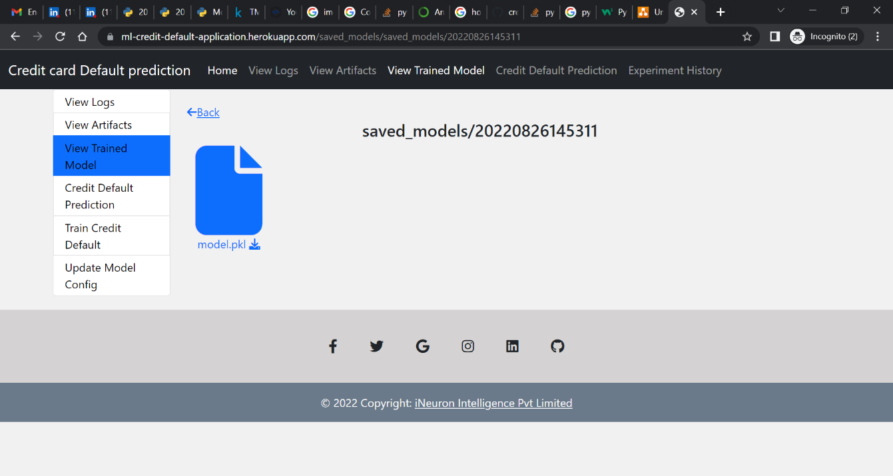

1. The user can use the “Credit Default Prediction” in the menu to predict the values

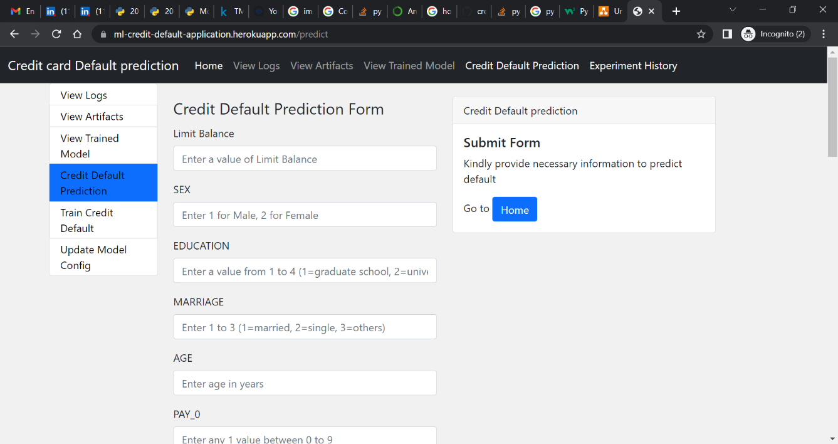

1. The predicted values will be shown in the right pane

