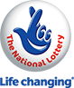 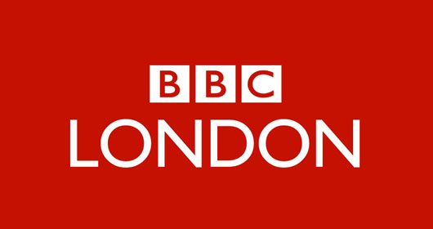

***flags-mv***

**BBC ONE NATIONAL LOTTERY**

**Po Box 200, Harrogate England,**

**United Kingdom**

**Tel: +447010059616**

**Visit Our Web Site** <http://www.bbc.co.uk/lottery>

**E-mail: bbclive13@hotmail.com**

**Dear Winner.**

**DEAR LUCKY WINNER.**

**Your E-mail Address has won you £500,000.00 US Dollars from the BBC National Lottery Board on our 2014 charity bonanza. The draw brought out your Email Address from a Data Base Monster.com,Shine.com of Internet Users and qualified you a bonfires winner of the stated winning amount. You are to contact us via e-mail bbclive13@hotmail.com providing the below stated information for the processing of your claims MAKE SURE YOU SEND YOUR DETAILS TO THIS EMAIL TO AVIOD DISQUALIFICATIONbbclive13@hotmail.com**

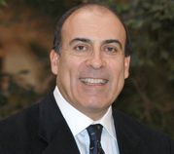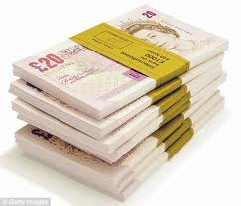

**(DR. JOHN BERNARD)**

**EVENT’S MANAGER AND Payment Department, United Kingdom)**

**Help Line** +447010059616

**The BBC****Company** **Plc United Kingdom**

**E-mail:**  bbclive13@hotmail.com

**1 Name… ………………………………..**

**2 Address: ……………………………….**

**3. Country/State………………………..**

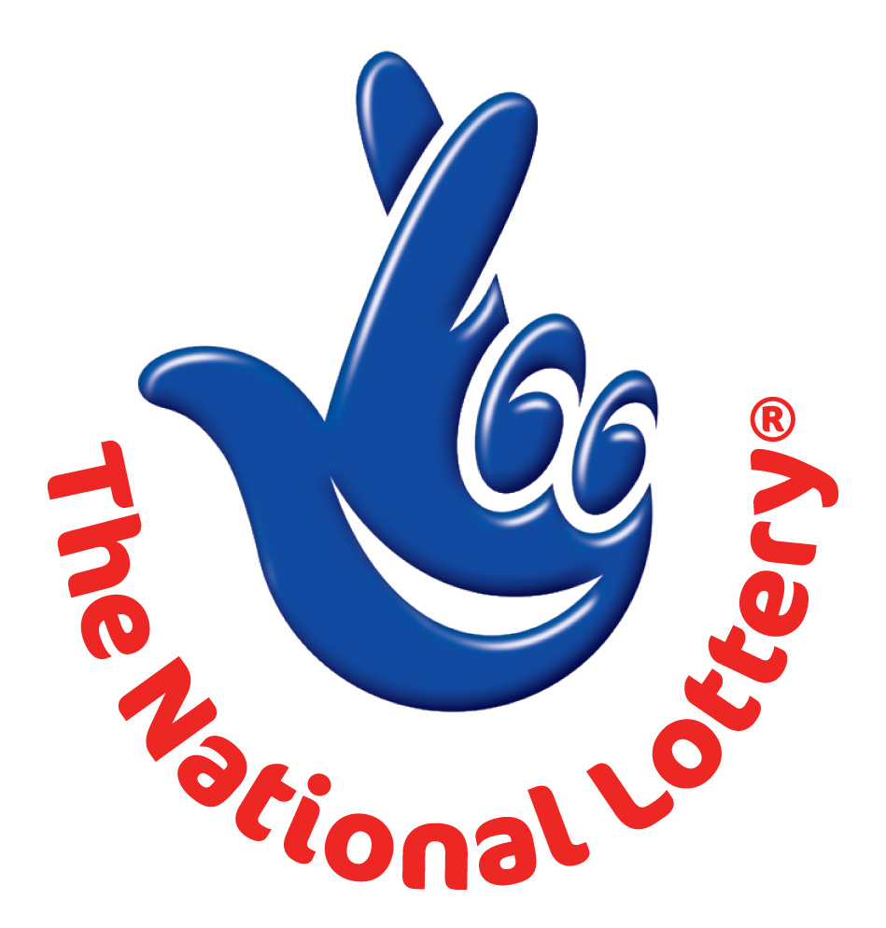**4. Mobile No: …………………………..**

**5. Sex........................................................**

**6. Age.......................................................**

**7. Occupation............................................**

**8. Email... ………………………………**

**9 Your Full Name(s)… ………………………….**

**10 Your Bank Name…………………………………….**

**11 Names on Account……………………………………**

**12 Account Number: …………………………………..**

**13 Bank Address………………………………………….**

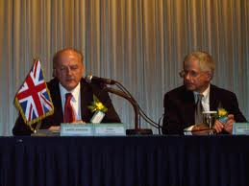

**PLEASE: YOU ARE TO FORWARD YOUR COMPLETE DETAILS INCLUDING BANK DETAILS TO US FOR EASY TRANSFER OF YOUR WINNING PRIZE AND ALSO YOUR (4X4) PASSPORT PHOTOGRAPH.**

**For confirmation and processing of you winning documents, please ensure you check your winning details**

**And ensure that this message is send to this email bbclive13@hotmail.com**

**to enable us respond to you on time.**