Vtekgroup-services

Vtekgroup-services are developed using **Laravel MVC framework** of php.

* First of all, you need to install **composer** for dependency management of php Laravel. [**https://getcomposer.org/**](https://getcomposer.org/)
* After installation go to xwhizz-services folder and run below command
  + composer install
  + php artisan key:generate
* To run php application you have to execute below command
  + php artisan serve
  + <http://localhost:8000>

**To integrate new changes from vtekgroup-ui project follow below list of steps**

* Go to vtekgroup-ui folder and run below command
  + ng build
* you will able to see **dist** folder which contains build
* copy files from dist folder and paste at below location
  + vtekgroup-services\public
* to check new change rerun below command
  + php artisan serve

**To run in local integrated environment like xampp server follow below list of command**

* copy vtekgroup-service folder and paste in below path
  + **xampp\htdocs**
* add below two entries in you host file
  + **127.0.0.1 localhost**
  + **127.0.0.1 vtekgroup-local.test**
* Goto below location
  + **C:\xampp\apache\conf\extra\httpd-vhosts.conf**
  + **Update above file with below content**
  + 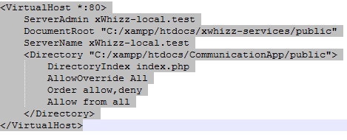
* Start xampp and goto vtekgroup-local.test whilch will open website in integrated environment.