Software Requirements Specification Template

Smart Inventory Web

Software Requirements Specification

Windows 7

11/30/2018

Satya Phani Shyam Appasani   
Pavithra Devdas   
Venkata Ajit Kumar Dokka   
Sri Ram Teja Komerisetti   
Prashanth Kumar Thallada   
Vyshnavi Srilaxmi Thannir

Submitted in partial fulfilment

Of the requirements of

CSIS 44-691 Graduate Directed Project 1

# Revision History

|  |  |  |  |
| --- | --- | --- | --- |
| **Date** | **Description** | **Author** | **Comments** |
| 11/18/2018 | Added Technical manual | Satya Phani Shyam Appasani  Pavithra Devdas  Venkata Ajit Kumar Dokka  Sri Ram Teja Komerisetti  Prashanth Kumar Thallada  Vyshnavi Srilaxmi Thannir | NA |
| 11/30/2018 | Added End User manual | Satya Phani Shyam Appasani  Pavithra Devdas  Venkata Ajit Kumar Dokka  Sri Ram Teja Komerisetti  Prashanth Kumar Thallada  Vyshnavi Srilaxmi Thannir | NA |
|  |  |  |  |
|  |  |  |  |

# Document Approval

The following Software Requirements Specification has been accepted and approved by the following:

|  |  |  |  |
| --- | --- | --- | --- |
| **Signature** | **Printed Name** | **Title** | **Date** |
| VT | Vyshnavi Srilaxmi Thannir | Manager | 11/30/2018 |
|  |  |  |  |
|  |  |  |  |

**Table of Contents**

**Table of Contents Page Number**

1. Introduction
   1. Purpose
   2. Scope
   3. Definitions, Acronyms, and Abbreviations
   4. References
   5. Overview
2. General Description
   1. Product Perspective
   2. Product Functions
   3. User Characteristics
   4. General Constraints
   5. Assumptions and Dependencies
3. Specific Requirements
   1. External Interface Requirements
      1. User Interfaces
      2. Hardware Interfaces
      3. Software Interfaces
      4. Communications Interface
   2. Functional Requirements
   3. Use Cases
   4. Class/Objects
   5. Technical Manual 25
   6. End user Manual 36
   7. Non-Functional Requirements

3.5.1. Performance

3.5.2. Reliability

* + 1. Availability
    2. Security
    3. Portability
  1. Inverse Requirements
  2. Design Constraints
  3. Logical Database Requirements
  4. Other Requirements
  5. Prototypes (for complete project)
  6. Use Case Diagrams

1. Design

4.1. ER diagram

4.2. GUI

**Table of Contents**

**Table of Contents Page Number**

1. Introduction
   1. Purpose:

The main Purpose of this is to create a website for a vendor and distributers where the vendors can bid for the required products so that a vendor can select the product at low cost as possible which will benefit his job.

* 1. Scope:

The scope of the project is that this website helps the Vendor to select the dealer of the choice and the price he wanted and number of products that he requires.

* 1. References
  2. Overview
  3. Functional Requirements(Revised)

Functional Requirements of the **Admin(Vendor)**:

1. Login credentials for the vendor to login and access his account.
2. Password recovery in case of forgotten password
3. Request to delete the account of the physical store owner.
4. Provision to change Password and password must be minimum of 8 characters and include special characters.
5. Should have access in case of Forget Password and create a new password.
6. Visibility of distributers request where the vendor can see the costs of the different products and select the matched one.
7. Able to accept and delete the requests of the distributors in the file.
8. Should have platform for payment for the distributors.
9. Track the product shipping details
10. Able to view user contact details
11. Get Bid information where he can view for which amount the product has be sold and to which customer
12. Able to send the shipment details if the user is selected.
13. Able to track the product shipment

**User Requirements**(Revised)**:**

1. A new user should register with name, email address, password and re-enter of password.

|  |  |  |  |
| --- | --- | --- | --- |
| Name | Email Address | Password | Re-Enter Password |

1. If the user already has an account, the use will login with email address and password.

|  |  |
| --- | --- |
| Email Address | Password |

1. Once the user as logged in, the user can request the no of items from the vendor and it will be displayed.
2. The user will have a request button or email to get the shipping label and request for payments from the vendor.
3. All the distributors will have the common plat form for viewing the requests based on the product.
4. Once the vendor looks at the request, vendor sends an email to the user a downloaded file with shipment details.
5. The user will have access to the downloaded shipment label.
6. User having the ability to select how many products he can deliver.
7. The user will add the shipping address and have a button to upload the shipping receipt which will be visible to the vendor.
8. The user details will be displayed both to user and vendor when they click on the details.

|  |  |  |  |  |
| --- | --- | --- | --- | --- |
| Name | Email Address | Items Recorded | Shipped Address to | Payment received |

ER-Diagram Smart-Inventory Web (Revised) :

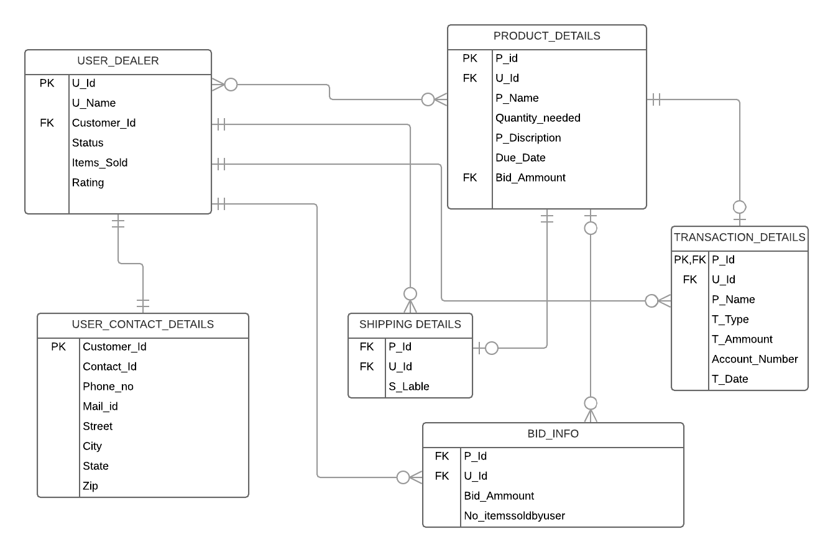

Mock up(proto-type) User:

User login page:

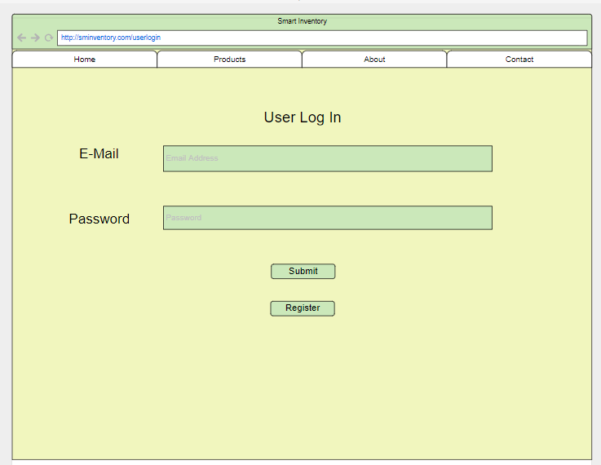

If new user he need to Register:

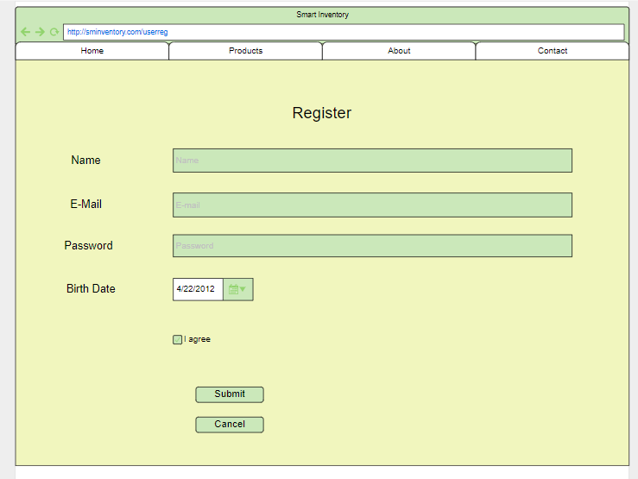

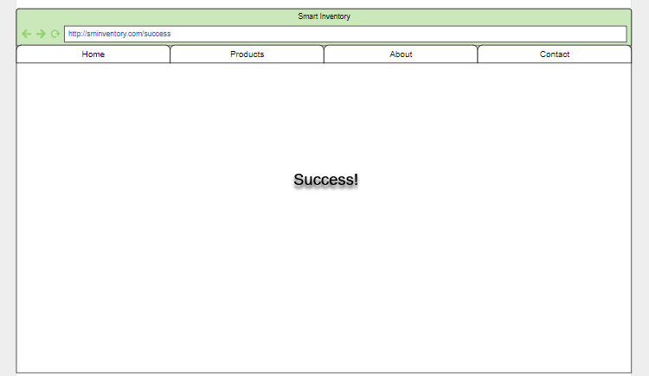

Products:

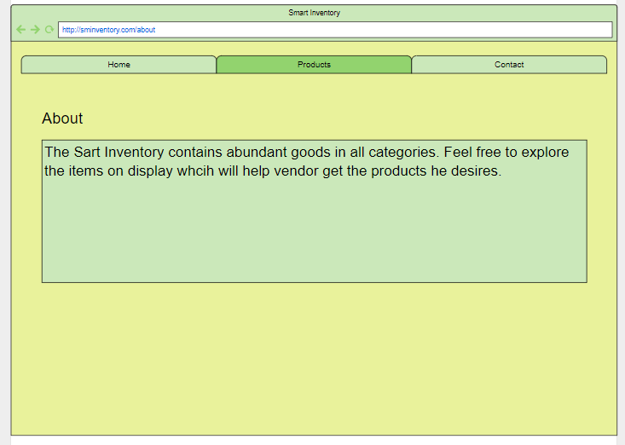

Details 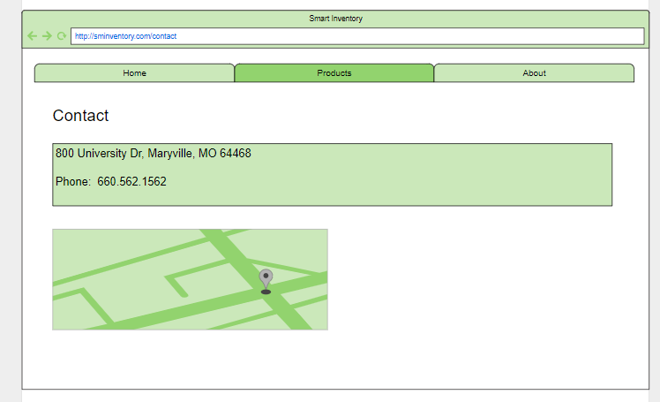

Items to select and its description

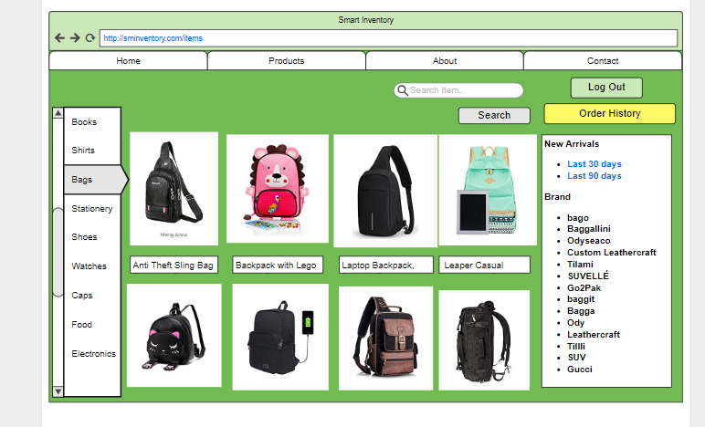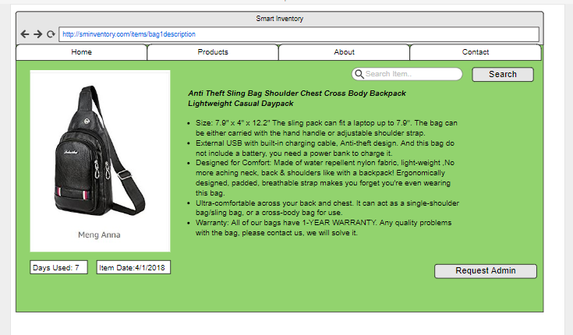

If Vendor(Admin) accepts the user request:

It admins accept the user

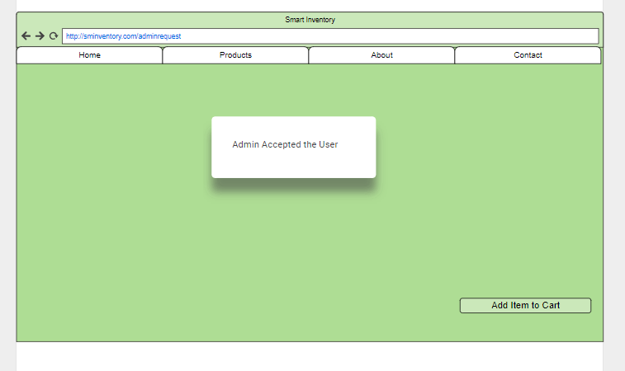

Then you get the purchase conformation and get shipping details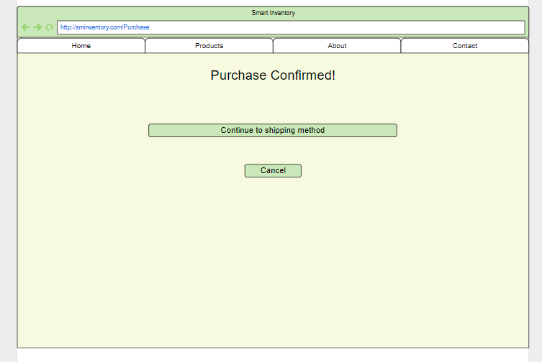

Then get information of admin accept or reject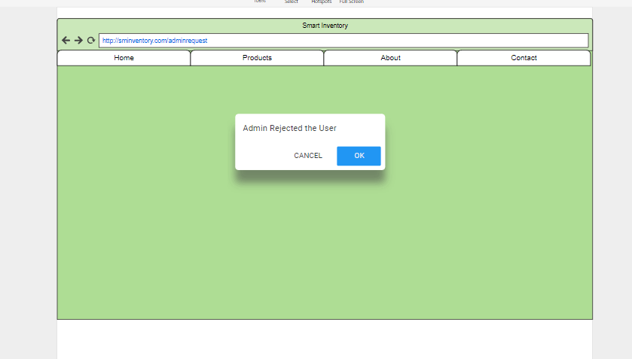

Shipment table to the user and payment confirmation

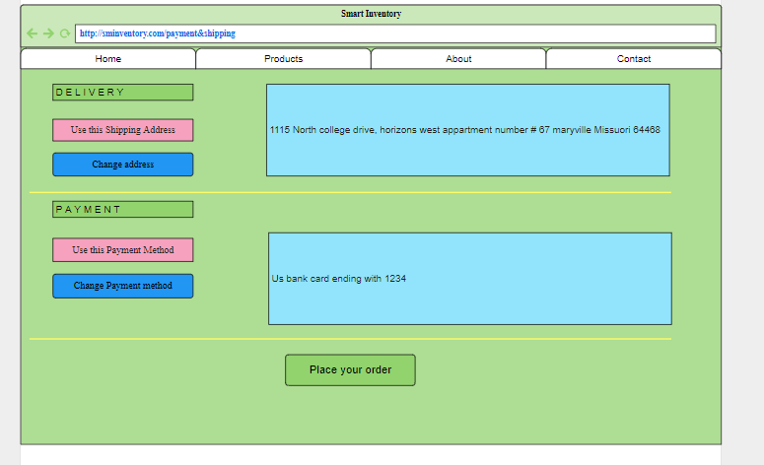

Vendor(Admin) login:

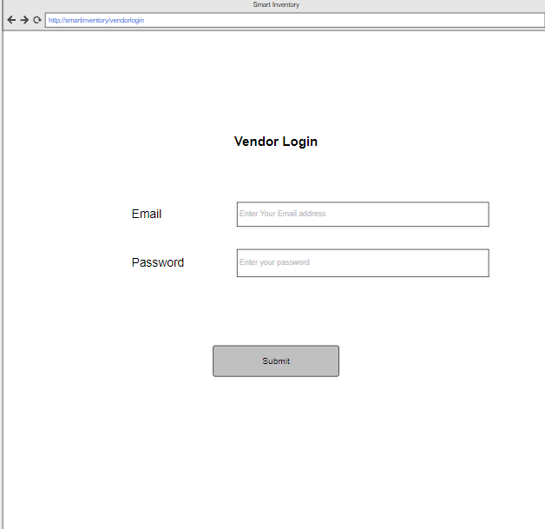

Vendor will select which item he required and quantity of the items and by which date he require them and post them so that the user can see.

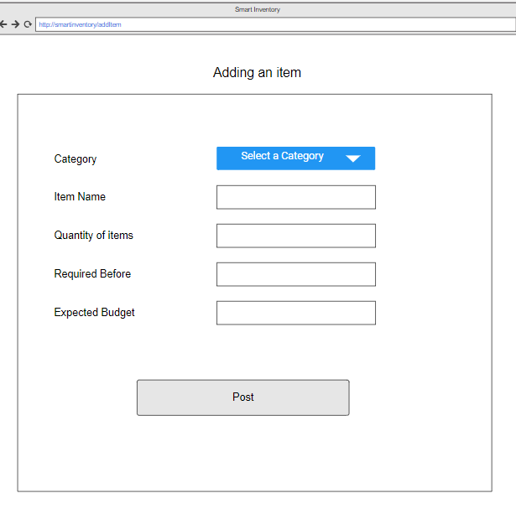

He will have the Visibility of users who bid for particular item where he can accept or deny the particular user.

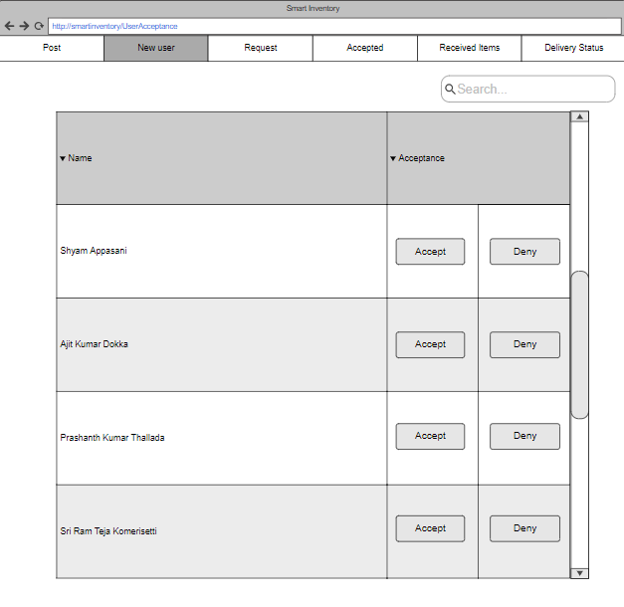

He will have an option to delete the item once he complete his requirement

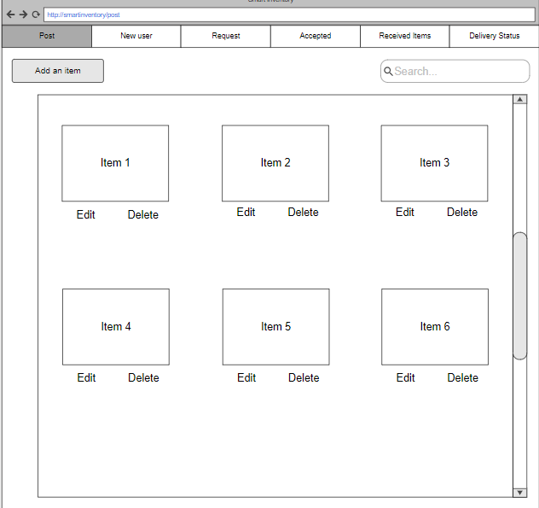

He can See name of product and how many a user will give them and to accept them.

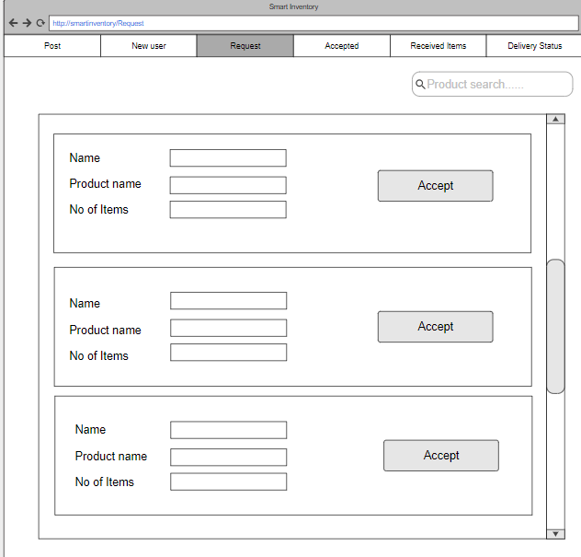

Once the user is selected he will have access to send shipment lable to the use:

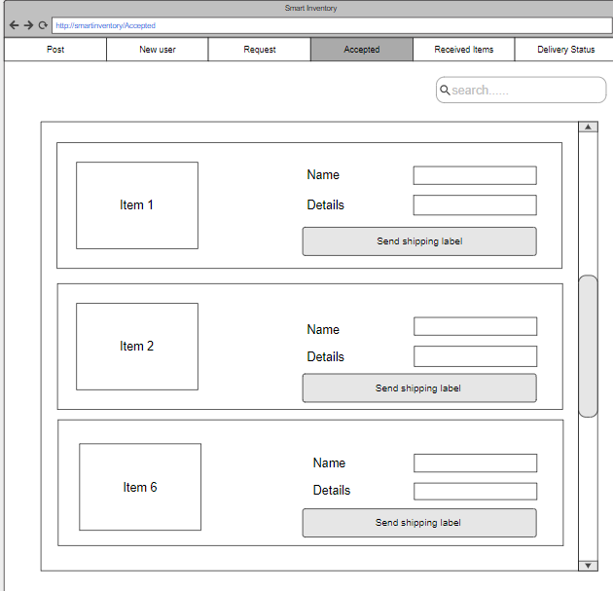

Once the items are finalized and delivered to the vendor he can make a payment :

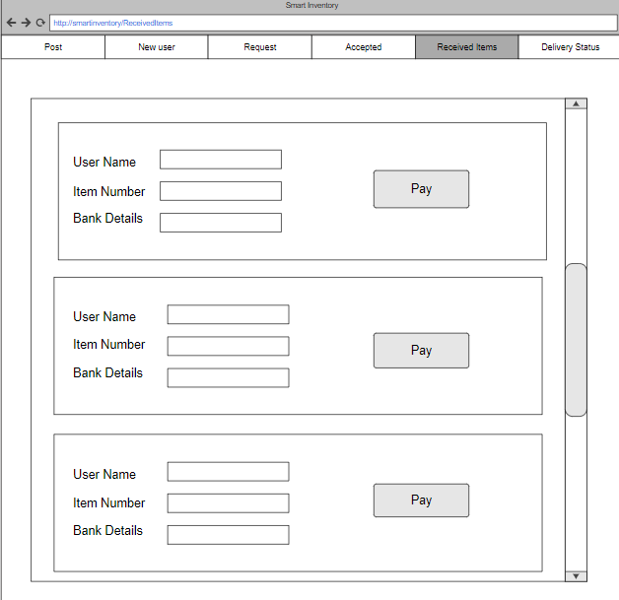

Once vendor selects payment he has to enter the account details:

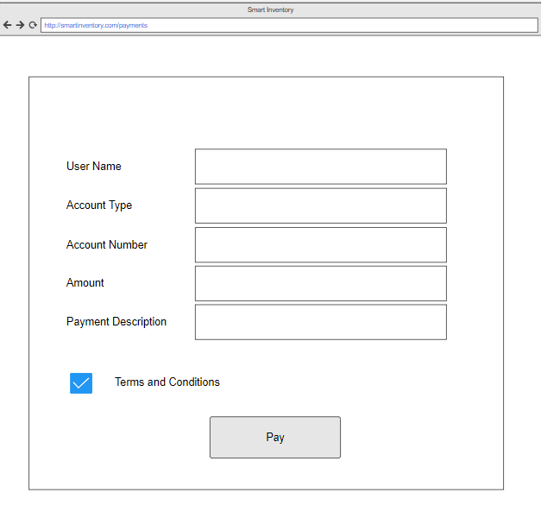

Vendor can know the status of the products that are delivered:

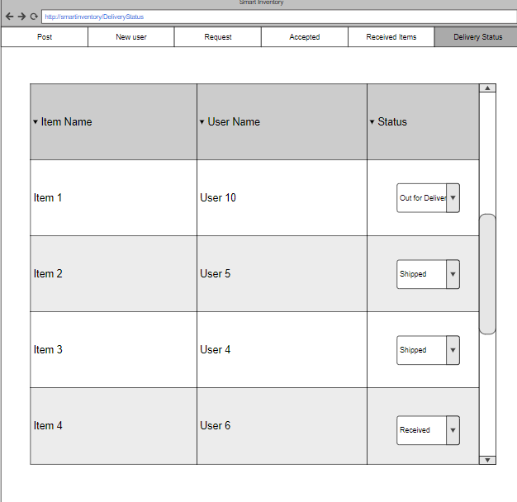

**3.5 Technical Manual**

**Admin Items Functionality:**

This module basically allows the admin to announce what product and how many products the admin requires. The admin also has the access to post the amount he/she would like to pay for each of the in the inventory system. Therefore in this functionality, the admin will the first login in the inventory system and records the number of items required to be posted along with the relevant required price.

**Technical functionality:**

**Technologies requirements:**

1. The website uses bootstrap in order to make the website responsive.
2. The technologies used to successfully run the project are:
   1. MongoDB
   2. Angular
   3. Node js
   4. Express

**Software requirements:**

1. Visual Studio - to add, run and modify out relevant code.
2. Currently using Command Line Interface to test the data is getting stored in the database by using MongoDB CURL commands.
3. Chrome/ Safari to view the running webpage.
4. Curl commands to test the contents of website in CLI.
5. Using MVC model to design the website.

**Scripting/ Programming Language requirements:**

1. HTML to implement the admin view to add items and post the items along with price.
2. CSS to implement the styling of the admin view would look and feel desired view.
3. Javascript and Typescript to add interactivity and event handling in the inventory website.

**Login Functionality**

Login functionality helps both the User and Admin to log in to the website and able to perform their respective duties  Therefore the functionalities in this cover for the design page and backend and database connectivity of log in

Login Page:

Helps the User and Admin to log in to the website and then display their respective pages Worked on creating and designing the login page using HTML and redirecting the HTML page through jade it is in the views folder

* This page has input for email and password and buttons for admin/user login
* Have included bootstrap functionality which helps in quick and auto adjustable interface
* And able to redirect to the registration for user page
* Could verify the correct ID and Password
* Link to the Forget password
* Working on redirecting to admin and user pages
* Worked on Css of the pages
* And connected login to the Mongodb on the system
* Java script for authentication of login

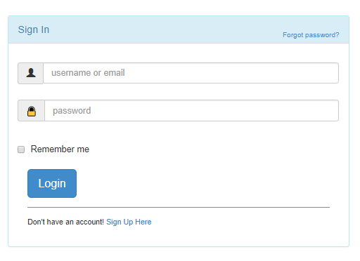

mongoDB connected

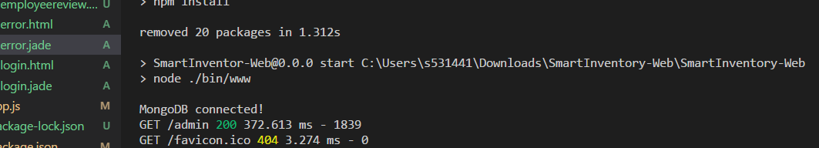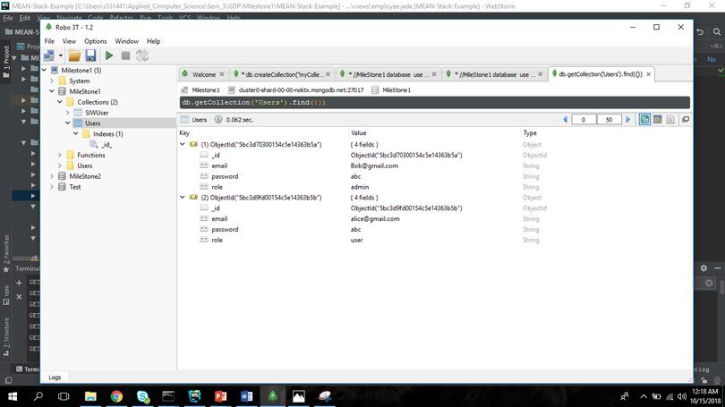

Html code:

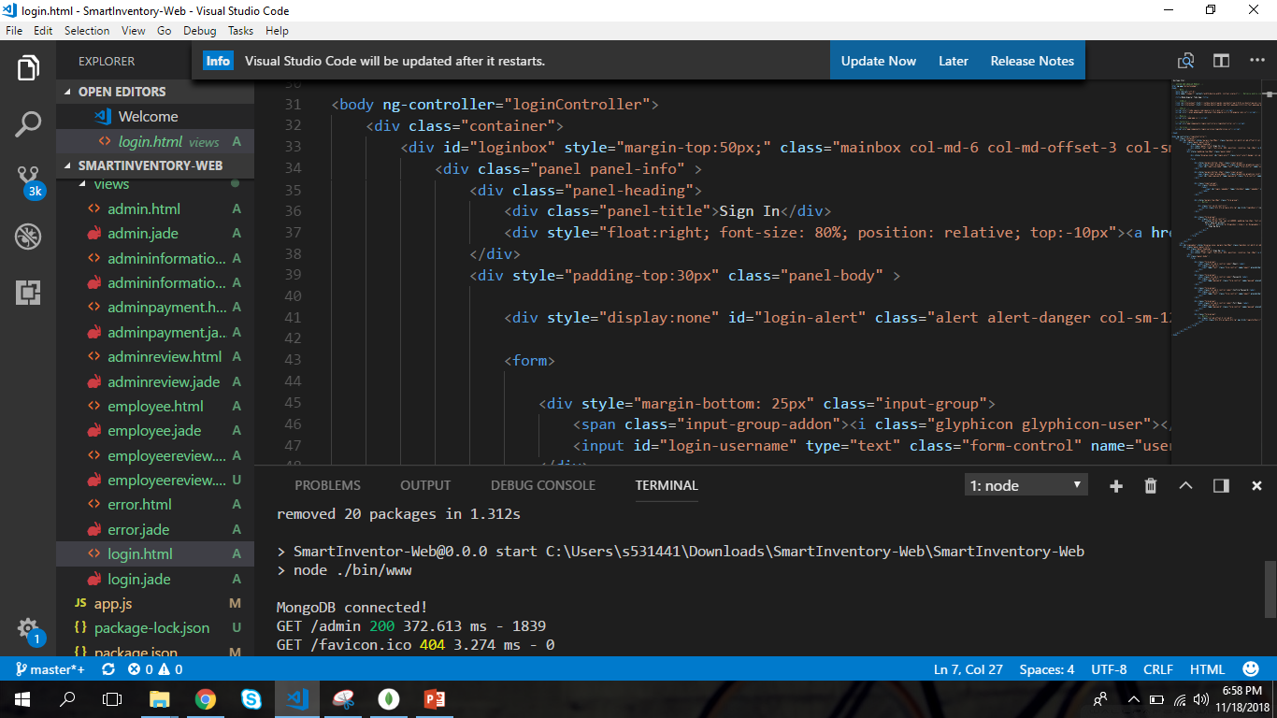

**Admin Review:**

In Admin Review Page the admin could able to review the orders on which the users are interested in making deal with admin. The overview is that when the admin add the required number of products to web page, all the users could able to view form the user page and send an accept message if they are interested in sending the products to admin. When the admin receive the acknowledgement from the users that he/she interested in sending the product, then admin will start reviewing the users details and product he/she interested in and will make a decision. For now I am presenting the webpage of how an admin could able to add the product into webpage and how the data regarding products is stored in local storage.

**Webpages and Functionalities of Admin Page:**

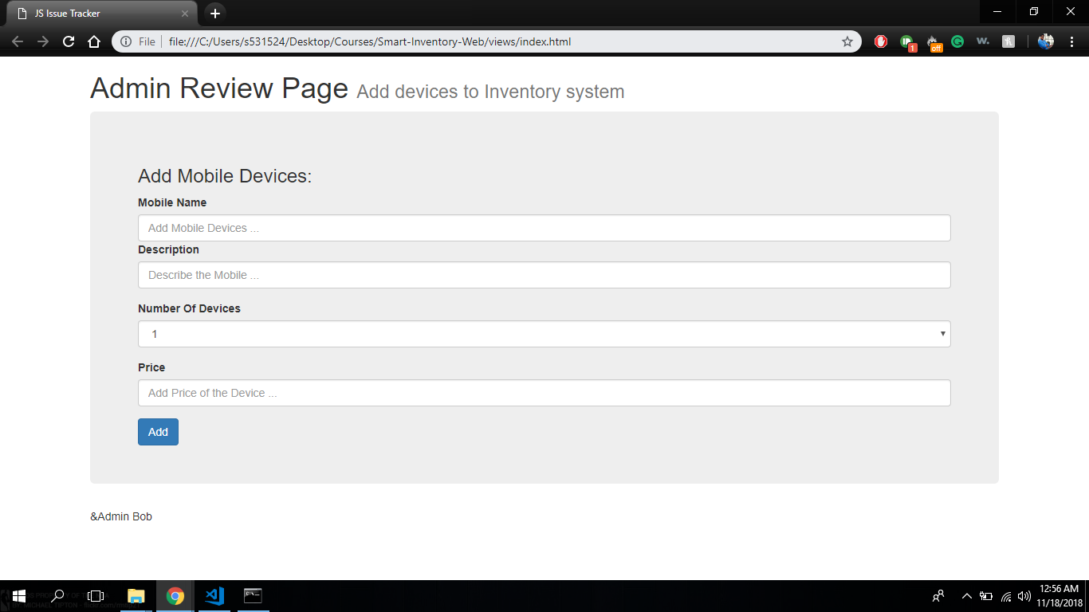

Figure 1: Admin Adding the products

In the above web page an admin can able add the products to website.

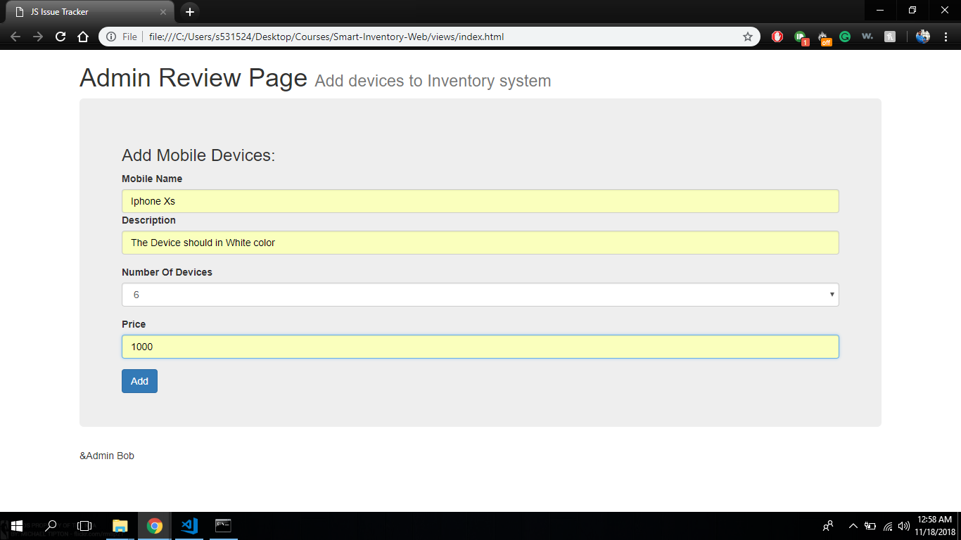

Figure 2: Adding Data

From the previous figure we can how the products details are added to the webpage.

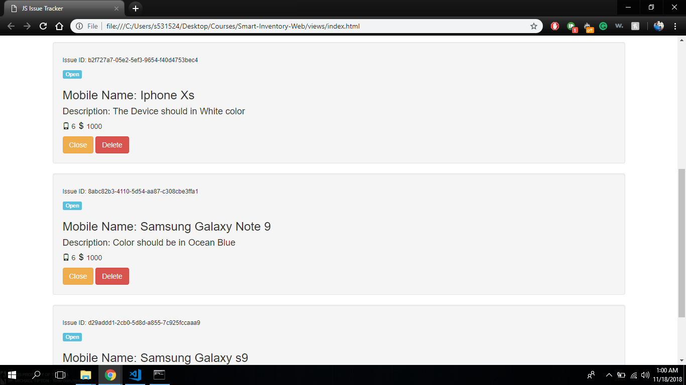

Figure 3: Displaying the data

The above web page shows all the data which we entered till now to admin page

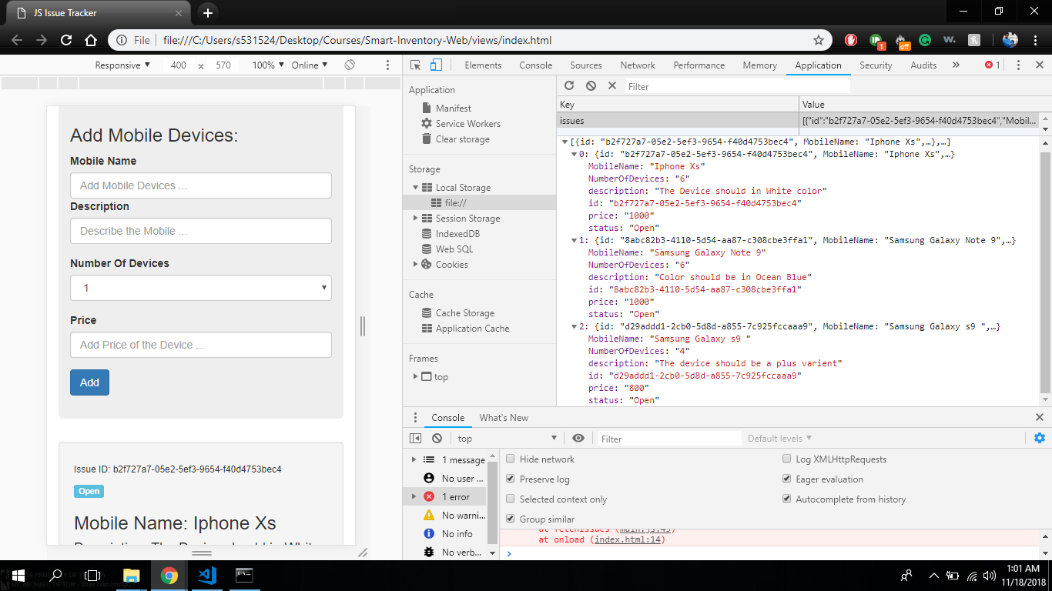

Figure 4: Raw Data in JSON Format

The above web page describes the raw data which entered in the admin page in a JSON format. These data will resides in an array until we manually erases the data.

The below screenshots are the HTML and JavaScript codes for the above web pages:

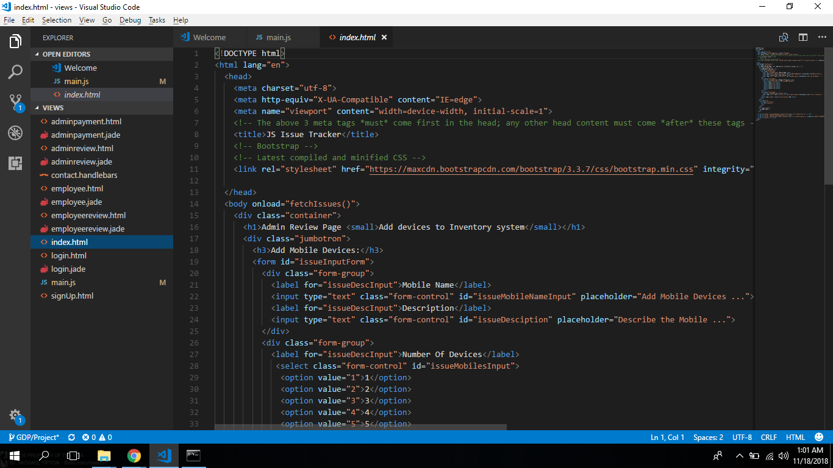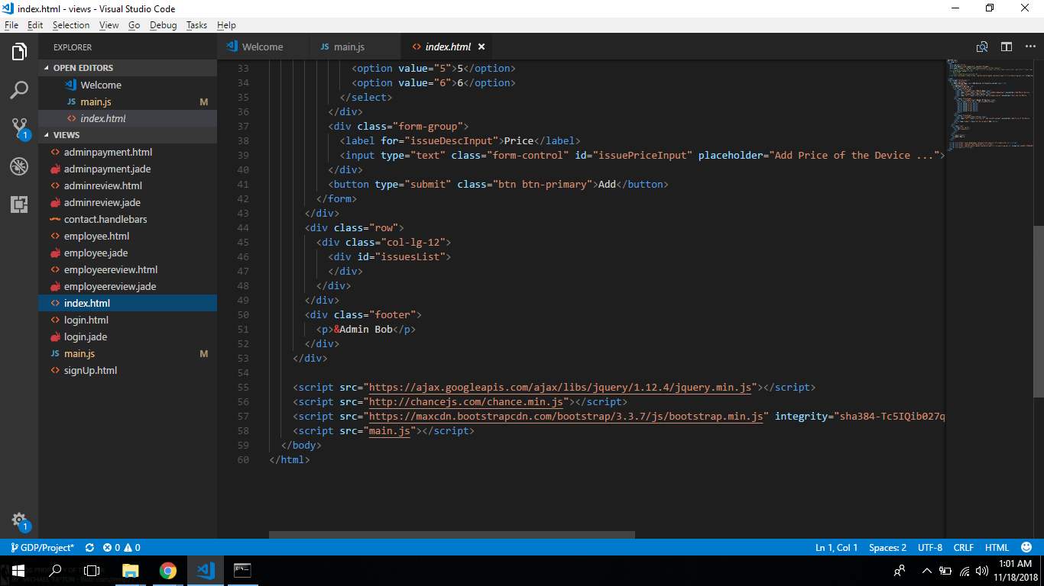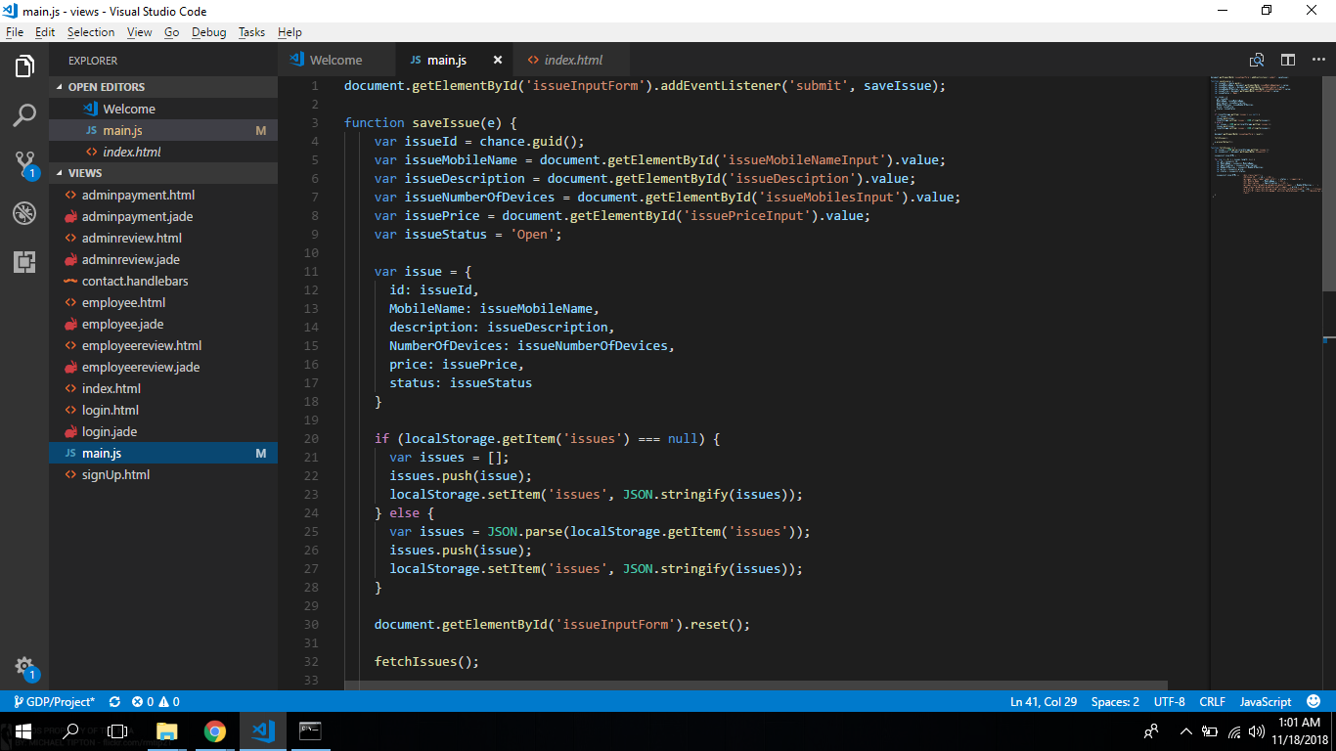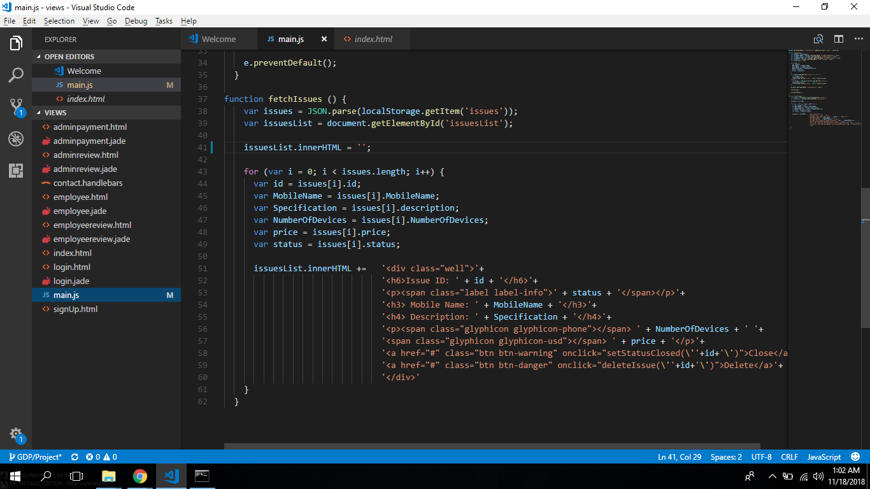

**User Review Page**

In user review page, the user is able to review the orders that are accepted by the admin(Amazon). The brief overview of this page is, when the admin add the an products and the number of product required, all the user are able to see the post and make request to the admin that they are interested to sell the products. Once the user makes the request, the admin gets the information that a user is ready to sell certain number of products. The admin reviews the requests made by all users, he accepts of decline the request made. These decisions (accepted/ declined) made by the admin are seen I the employee review page.

            In this User Review Page, the user will be able to see the status(accepted /  declined) of his request and if accepted, he is able to see the number of items he has to deliver and button that redirects to download shipping label page.

Functionalities of the page:

* Can redirect to the home page, user details page.
* The user can go the shipping label page.
* In shipping label page, User can download the shipping label sent from the admin and upload the return label.
* A logout button is also product, where the user can logout from the website.

Employee Review page:

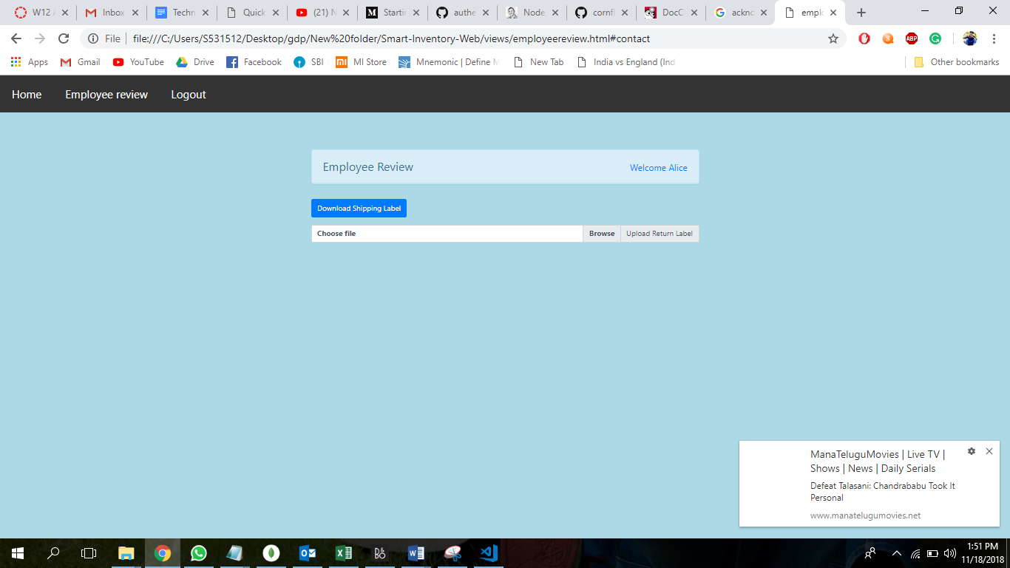

Raw Data in Json format :

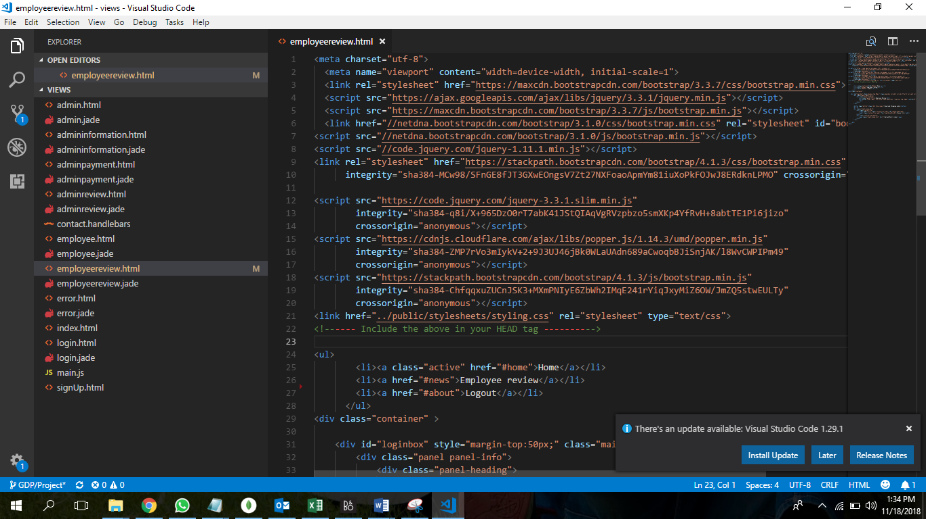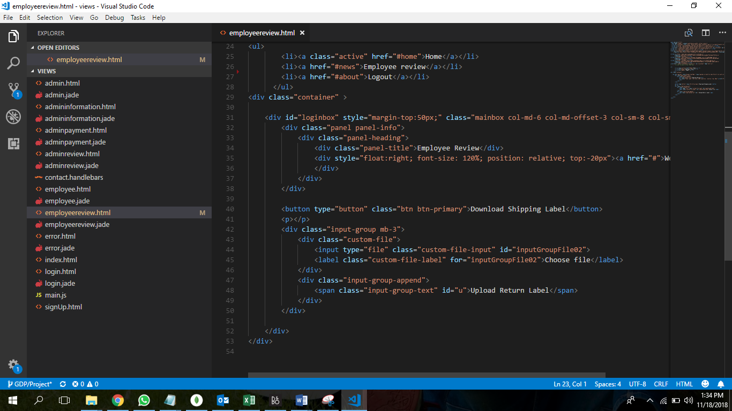

Database Connectivity

* Done with the connectivity to the database using mongo DB
* Currently working on giving data dynamically to the database.

**End user Manual**

**User Login Page:**

User will able to login from this page using his mail id and password and user will be redirected to the Page where he can view the product deals

User need to enter the email id

Then enter the password and login

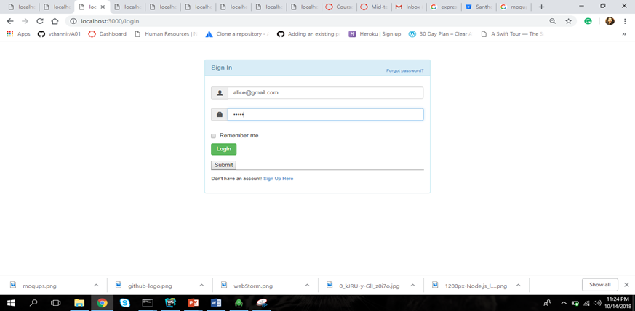

**Admin Review Page:**

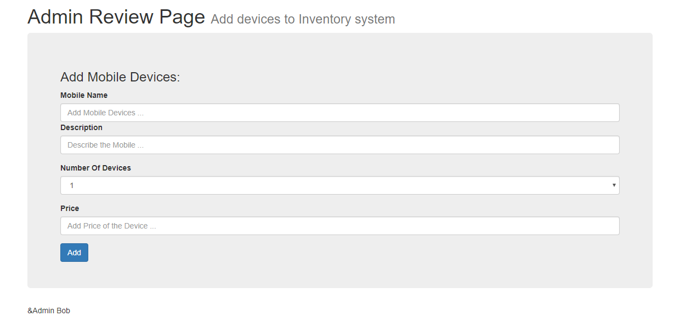

The above page is regarding how an admin can able to enter the products into website so that use can view from their web page

The admin should enter product details in Add Mobile Devices form:

1. Under Mobile Name section the admin needs to enter the name of the mobile devices.
2. Under Description Section the admin needs to enter the description like Device specifications, color, screen size etc.
3. Under Number of Devices section there is drop down which will show a Number of devices the admin should need.
4. Under the Price section the admin should enter the price of the device.
5. Once the admin filled all the details in the form then click on add button.

Once the Admin enter the details and click on the add button, the details of the device is going to be displayed under the form section which are fetched from the storage

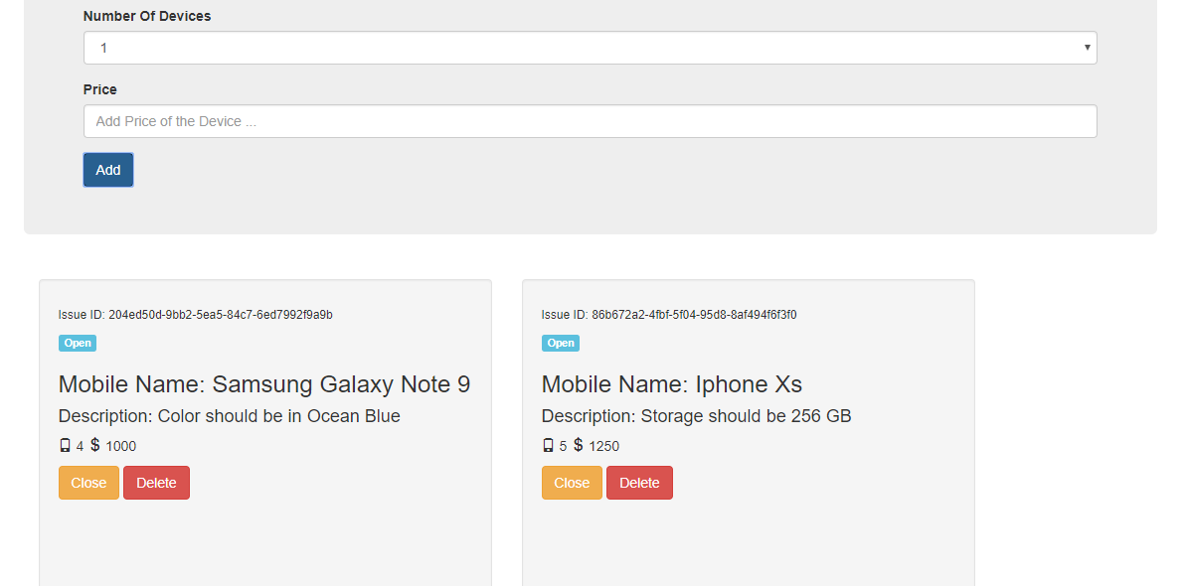

By clicking on delete button the admin can delete the entire details of the mobile device.

By clicking on the close button, the admin can state weather the device is available or not.

**User Review Page**

The above page is regarding how a user can review the status of the items that he want to sell.

The user will request the admin (Amazon) to sell his product by mentioning the number of products with the budget given by the admin. Once the admin is will to get the products from a certain vendor, he accepts the requests. Once the admins accepts the requests, the user can see whether the admin has accepted/ declined the requests of all the products.

Once the user see that the admin accepted the request, the user is provided with a button for downloading the shipping label for a certain item and also a button to upload the return label.



By clicking on the button Download shipping label helps you to download the shipping label sent by the admin

By clicking on the button Upload shipping label helps you to upload the return label which is helpful for the admin

**Shipment Details:**

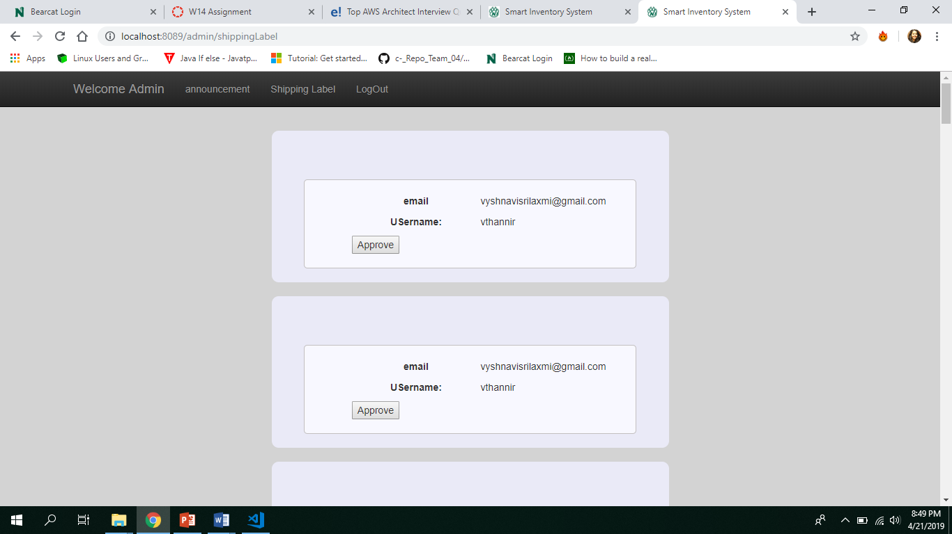

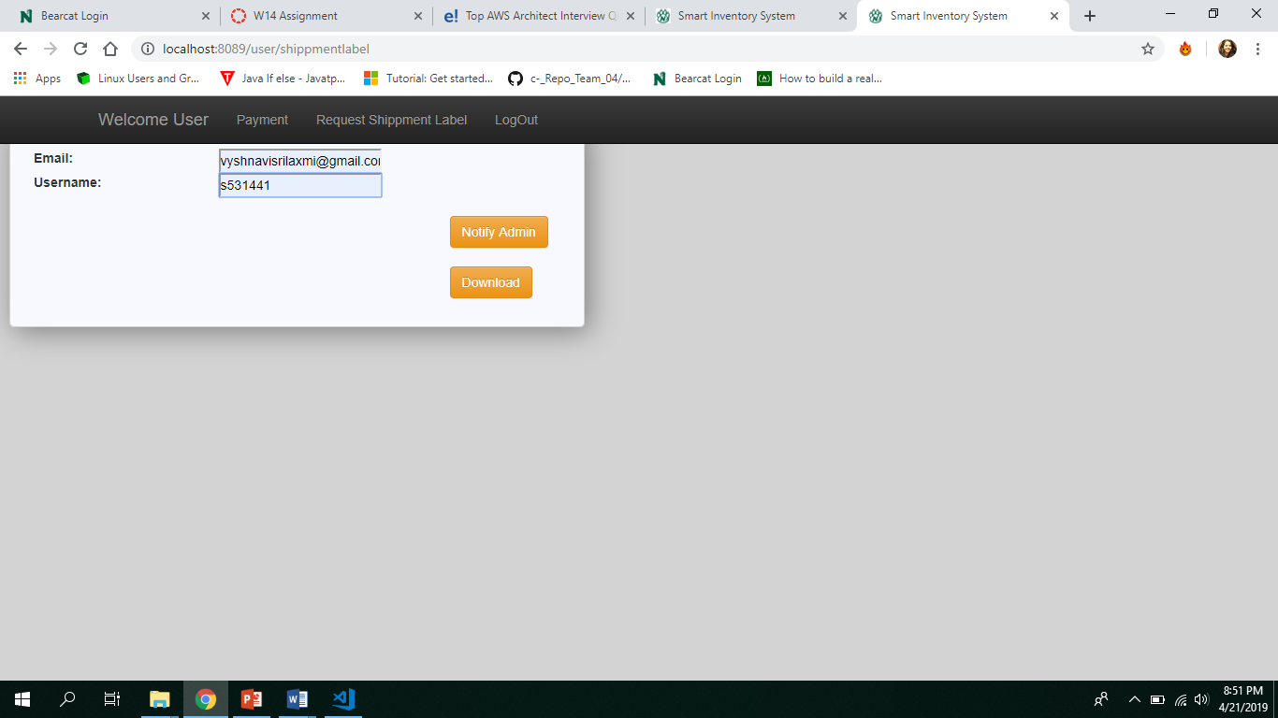

User request for payment and admin get notifications about it