PAPER

Fund Manager's Guide
Run your SEBI AIF end to end — from first close to distributions
A practical walkthrough for GPs and fund operators: forming the fund, raising from LPs, deploying capital, monitoring the portfolio, reporting to investors and staying SEBI-compliant — organised around the fund's lifecycle.
Paper — the OS for corporate legal

Contents

1. Welcome — Paper for fund managers
Paper gives a GP a single workspace to run a SEBI-registered AIF: your LPs and their capital accounts, your deal pipeline, your portfolio holdings and their performance, LP reporting, and your SEBI/MCA compliance — all in one place, with your LPs getting their own read-only portal.
This guide follows the natural lifecycle of a fund — form it, raise it, deploy it, manage and report on it, and harvest it — and shows exactly where each step lives in Paper. It's written for a first-time fund operator, but works just as well as a reference for an established firm.
Note: Fund workspaces open on a fund-first dashboard — commitments, NAV, TVPI and DPI up top — not the startup cap-table view. Everything below assumes you've created a workspace of type Fund.
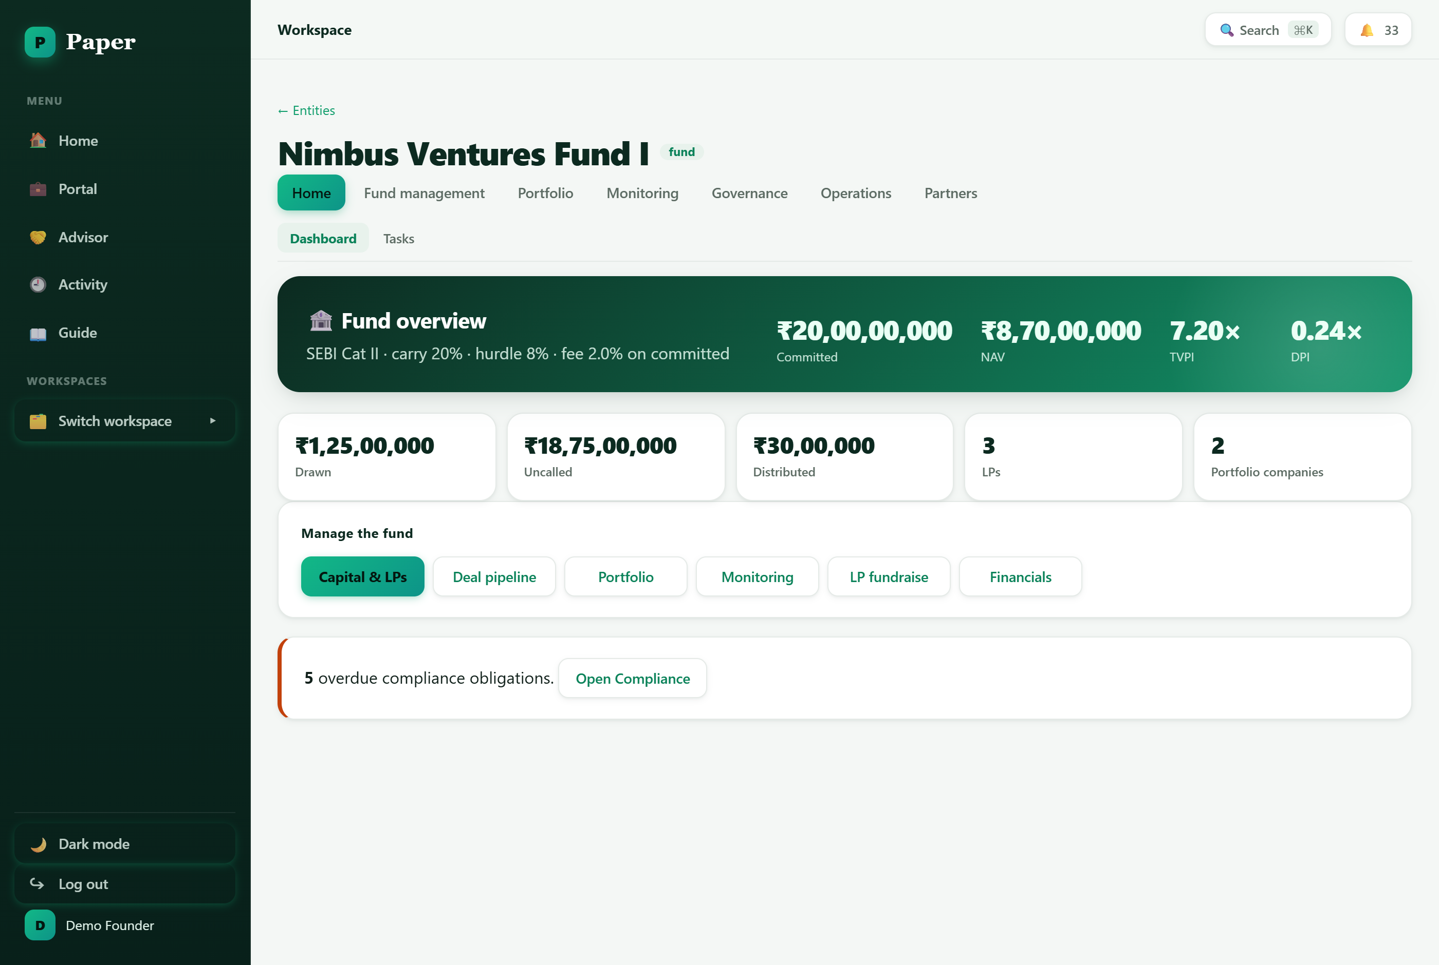
The fund dashboard — commitments, NAV, TVPI and DPI at a glance, with quick links into every part of the fund.

2. Set up your fund

Create the fund workspace
From the Home screen choose New workspace, name it (e.g. “Nimbus Ventures Fund I”) and pick the type Fund. Opening it takes you straight to the fund dashboard.

Set the fund profile
Record the fund's economics once and Paper uses them everywhere — in fee accruals, the distribution waterfall and the compliance calendar:
Fund setting | What it drives
SEBI AIF category | Category I / II / III — sets the compliance calendar and tax treatment.
Carry (carried interest) | The GP's profit share above the hurdle, used in the distribution waterfall.
Hurdle rate | The preferred return LPs earn before carry kicks in.
Management fee | Annual fee on committed (or drawn) capital — accrued and charged to capital accounts.

Find your way around
A fund workspace groups its tools along the top. The three fund-specific groups are the ones you'll live in:
- Fund management — the fund vehicle and LP relations — Capital & LPs, LP fundraise, Plan & forecast, Financials and LP updates.
- Portfolio — sourcing and holdings — Deal pipeline and Holdings.
- Monitoring — portfolio-company performance — KPIs, signals, tear sheets and benchmarking.
Governance, Operations and Partners round out board/compliance, documents and service providers. Press Ctrl/⌘ + K anywhere to jump straight to any of them.

3. Raise the fund
Fundraising in Paper is a CRM built for LPs. Work in Fund management → LP fundraise.
- Add prospective LPs and move them along a pipeline from first contact to a signed commitment.
- Log interactions and follow-ups, and track relationship strength so nothing goes cold.
- When an LP commits, record the commitment — it flows into the fund's committed capital and their capital account.
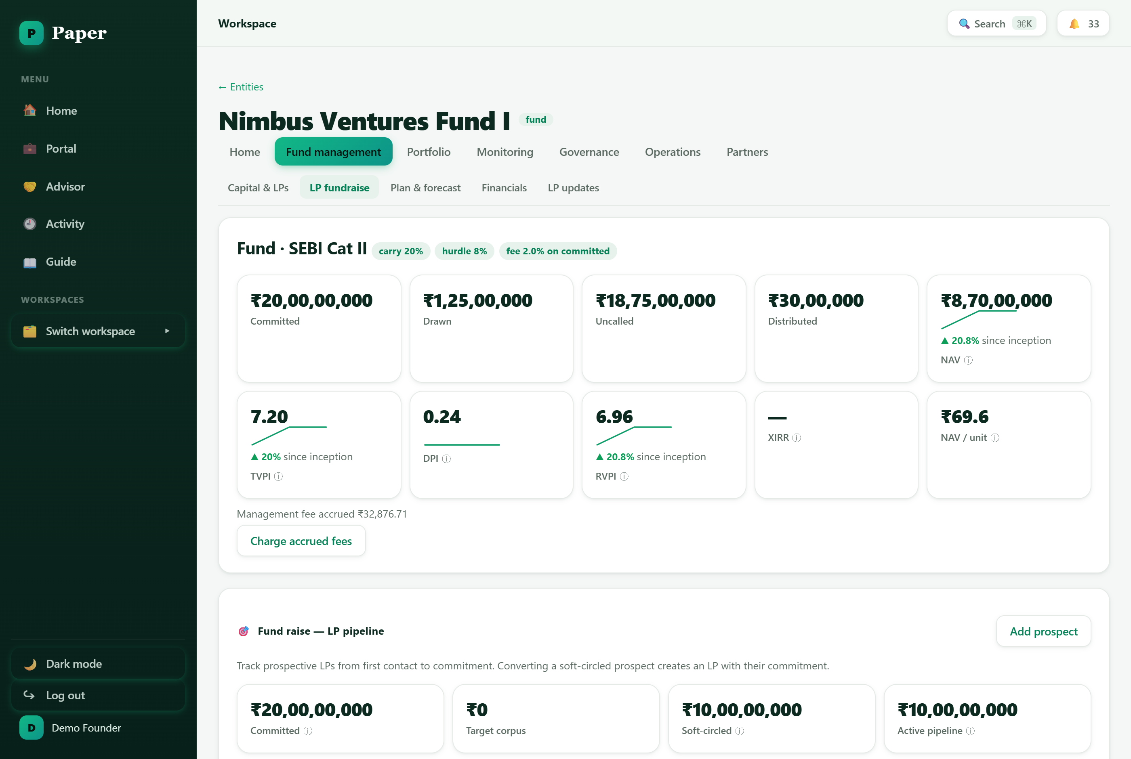
The LP fundraise pipeline — track prospective investors from first contact to a committed cheque.
Tip: Stale-deal and follow-up reminders keep your pipeline honest — the fund will surface LPs (and deals) that have gone quiet.

4. Onboard LPs and manage capital
Fund management → Capital & LPs is the heart of fund administration. It holds every LP, their capital account, and the fund's headline performance.
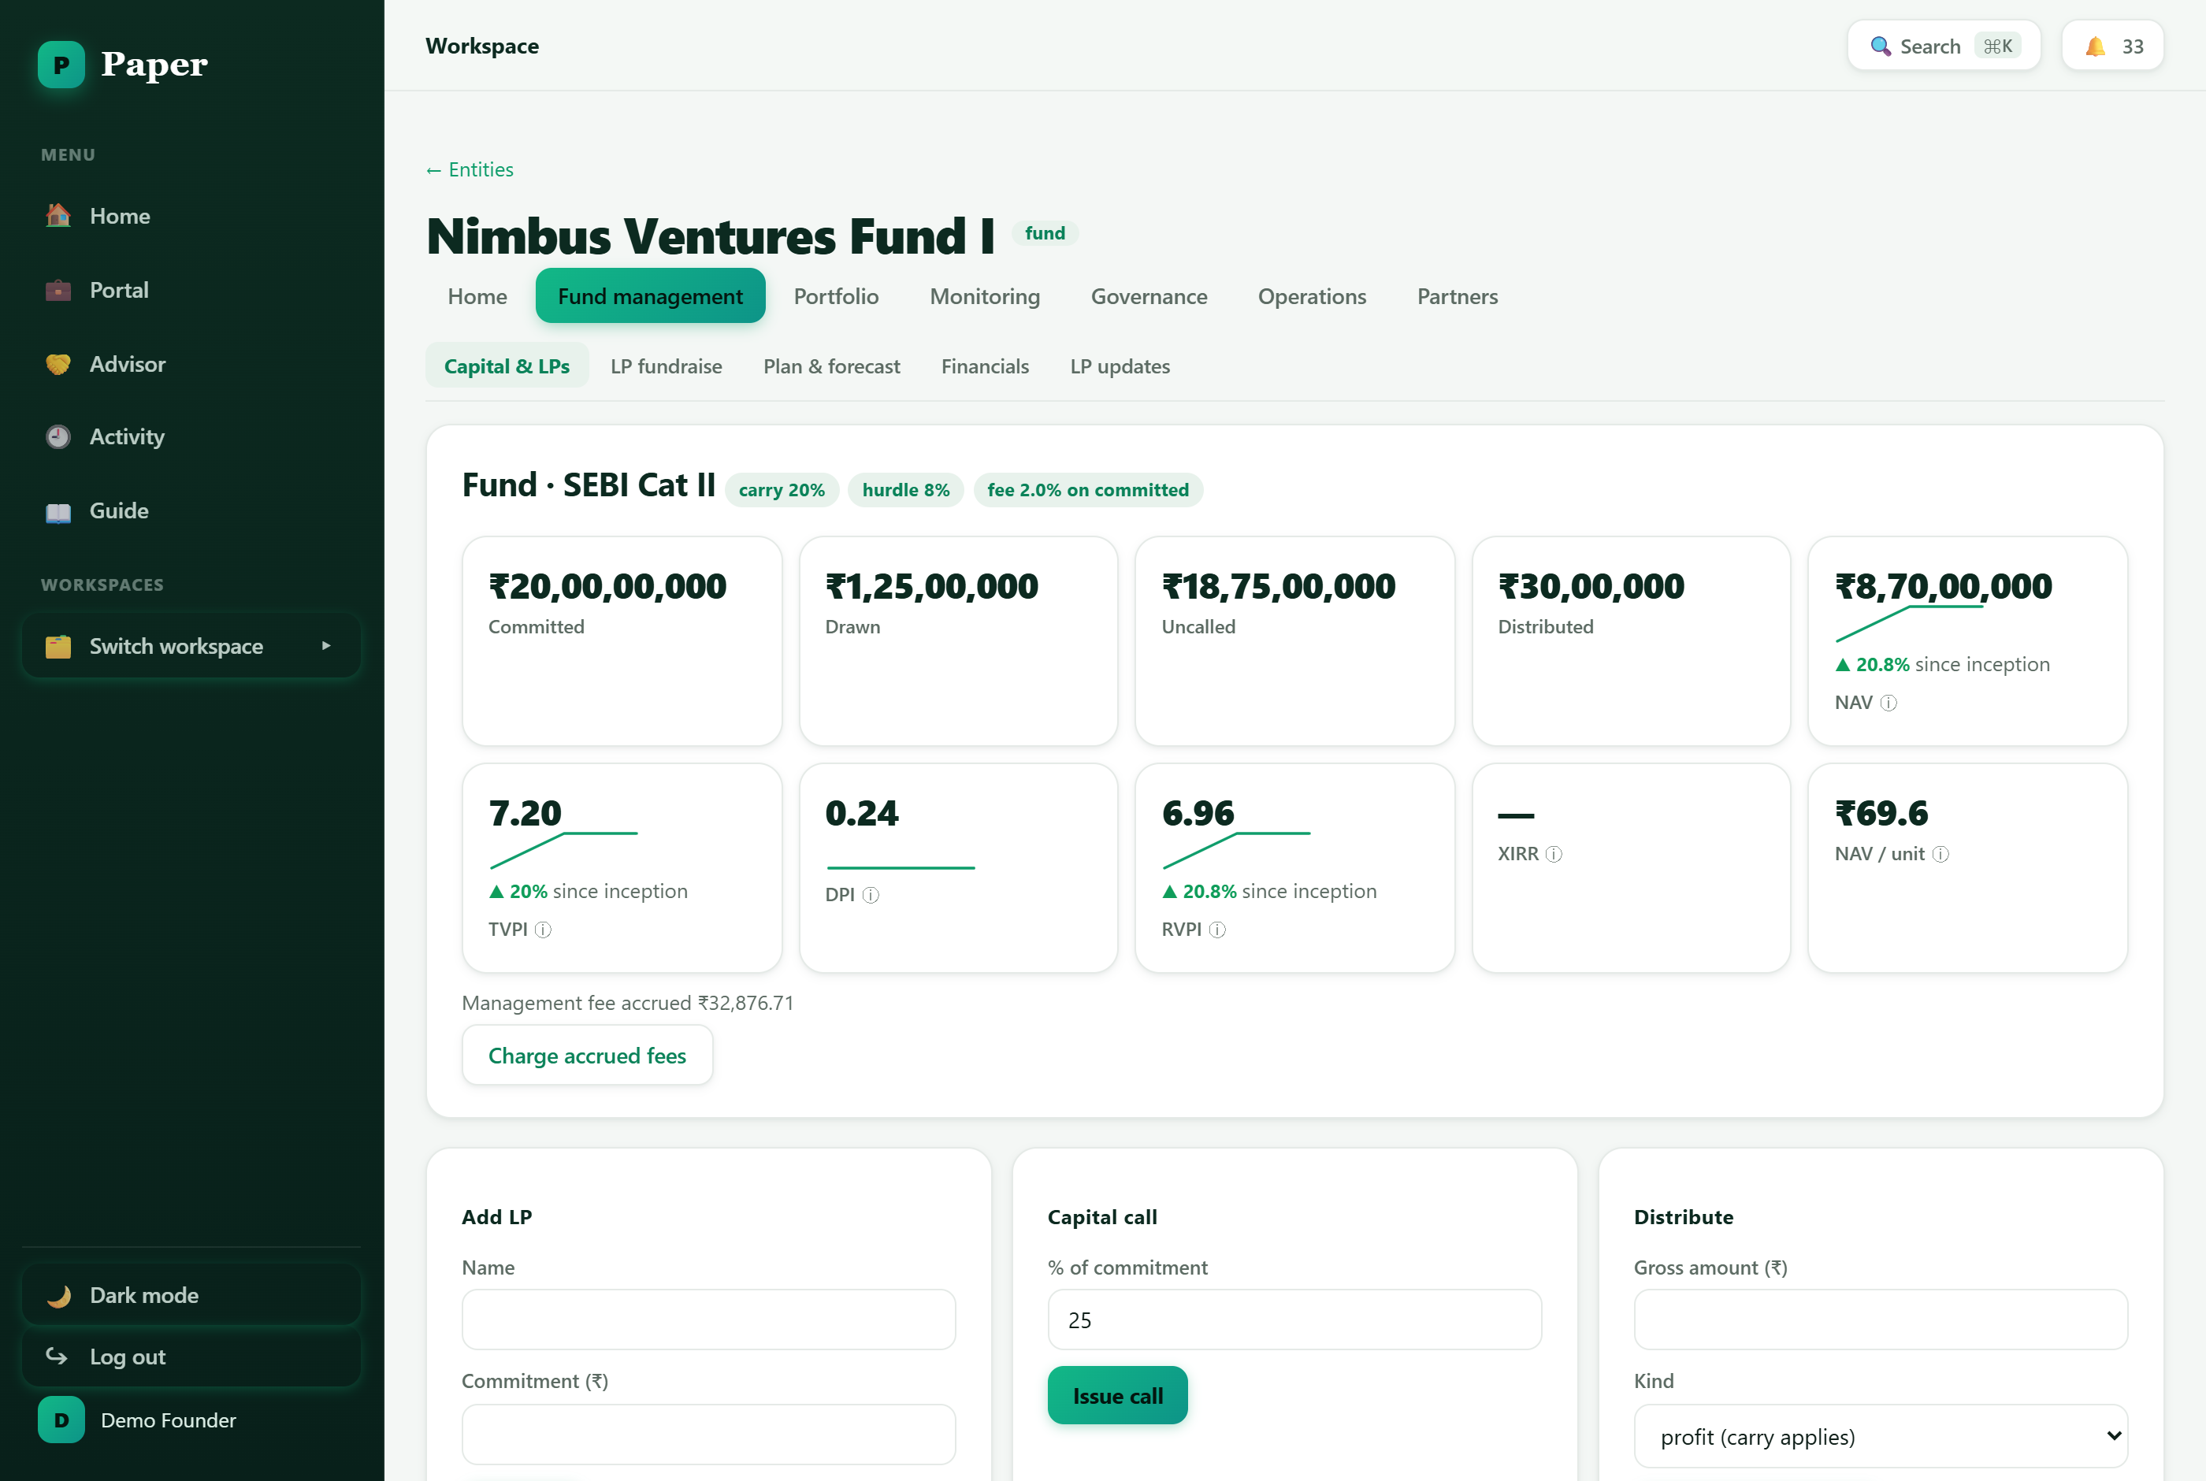
Capital & LPs — commitments, drawn and uncalled capital, unitised NAV and per-LP capital accounts.
- Capital calls — issue drawdown (capital-call) notices to LPs; each call updates their capital account and the fund's drawn/uncalled figures.
- Unitised NAV — the fund is unitised — LPs hold units and Paper tracks NAV per unit, so each LP's position is always current.
- Management fee — the management fee accrues automatically on committed capital; charge it into the capital accounts with one click.
- Distributions — record distributions and let Paper run the waterfall — return of capital, the LP preferred return (hurdle), GP catch-up and carry.

5. Source deals and invest
Portfolio → Deal pipeline is a deal CRM with a kanban board (sourced → screening → diligence → IC → term sheet). Add deals with the sector, cheque size and who referred them, track sources, and import an existing pipeline from CSV.
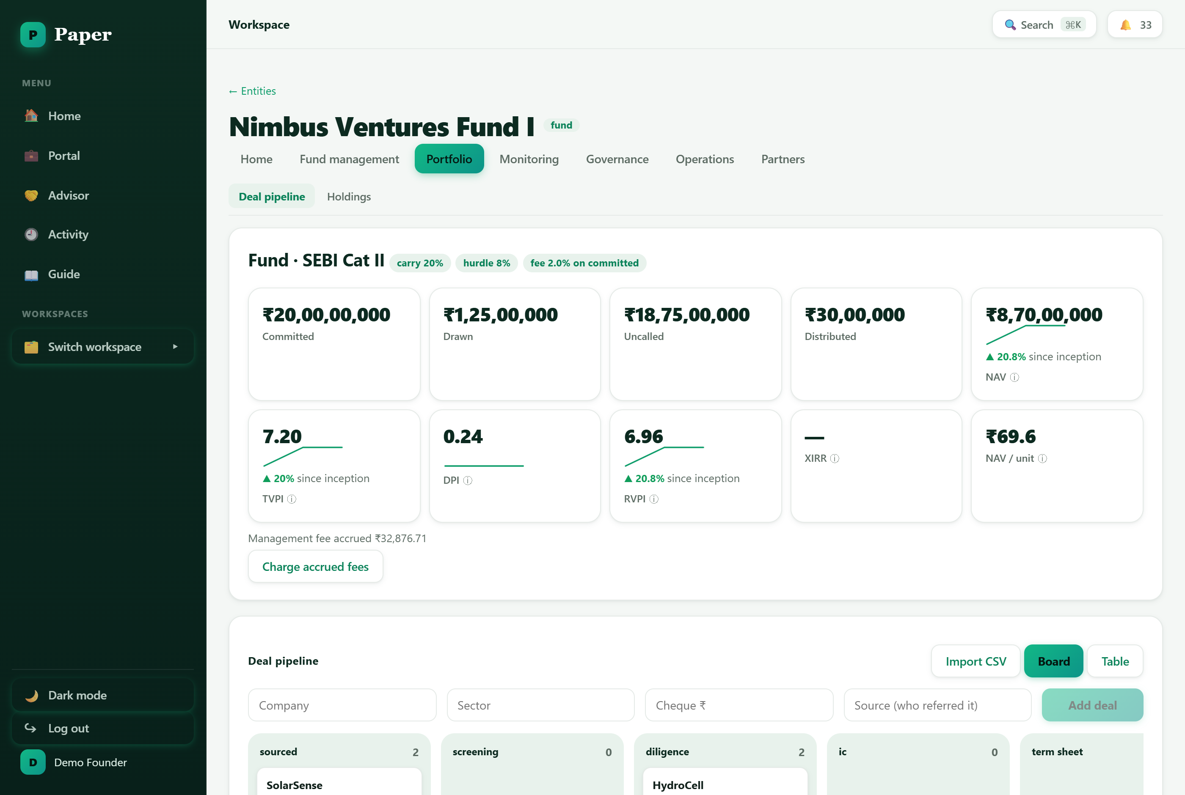
The deal pipeline — a kanban board from sourced to term sheet, above the fund's live performance metrics.

Record holdings and link to the company
When you invest, record the holding under Portfolio → Holdings. If the portfolio company also uses Paper, link the holding to its workspace — then you can pull its latest financials straight into your monitoring, with no re-keying.
Why the link matters: A linked holding turns founder-reported numbers into your monitoring data automatically — the seam between the startup and fund sides of Paper.

6. Monitor the portfolio
Monitoring tracks how your companies are actually doing. Each company's operating KPIs (revenue, cash, burn, runway) are collected over time; companies under six months of runway are flagged.
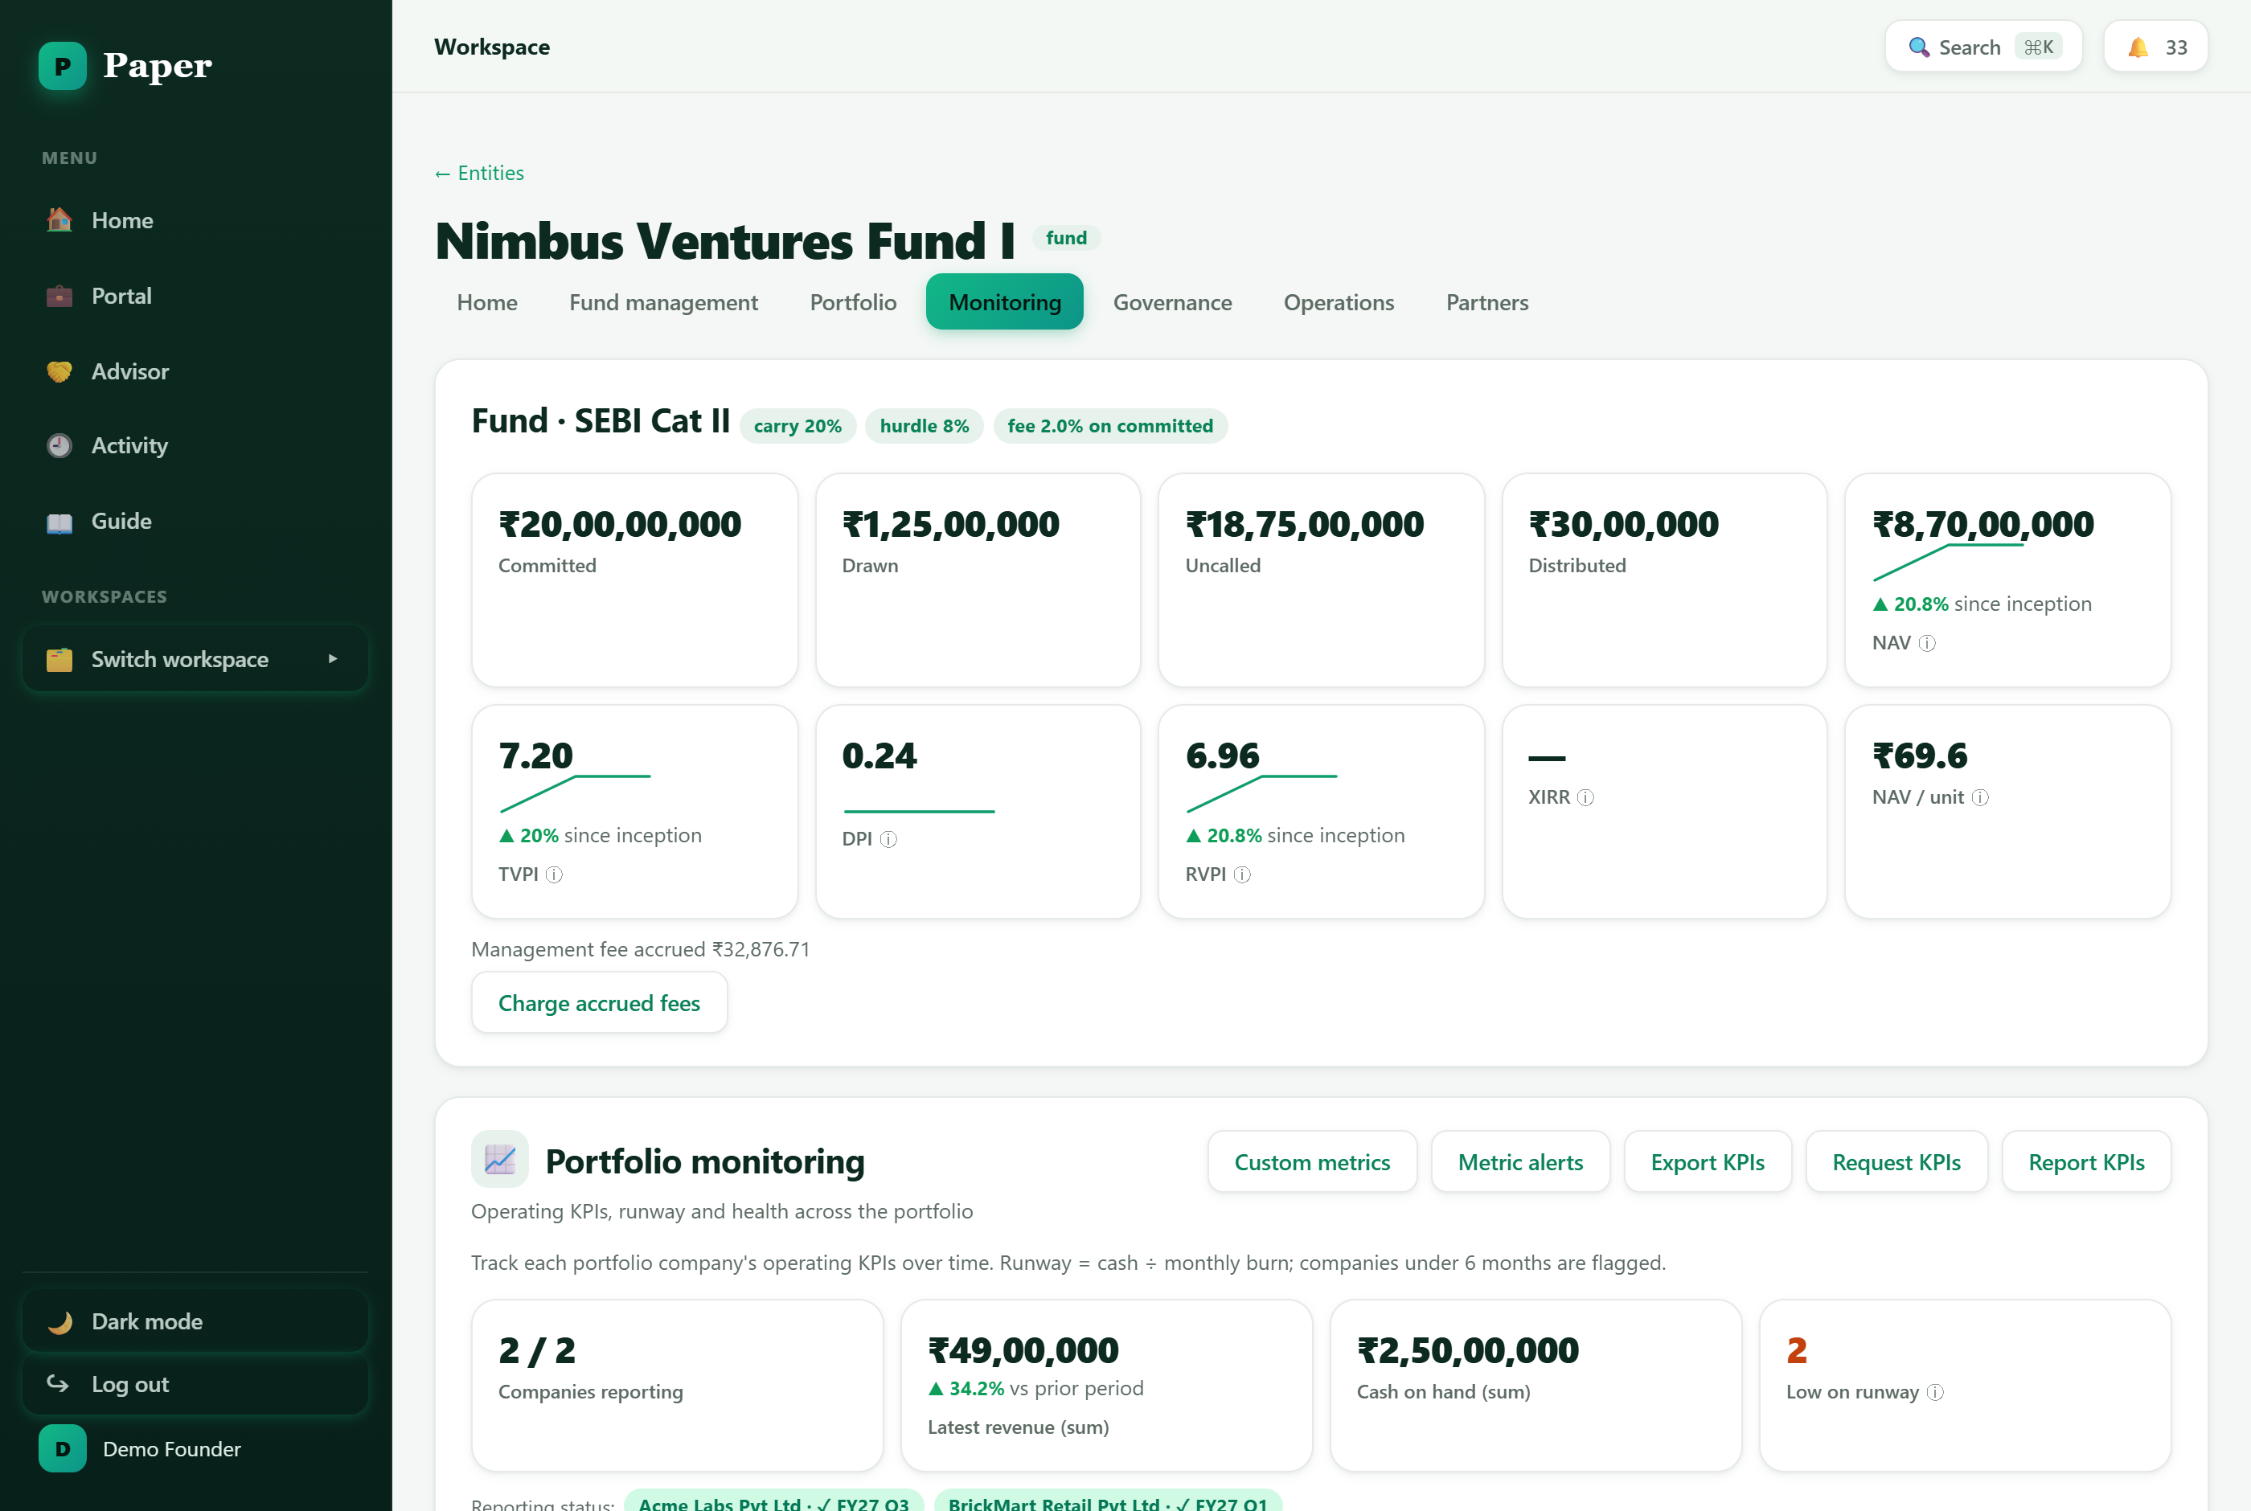
Portfolio monitoring — operating KPIs, runway and health across the portfolio, with reporting status per company.
- Request KPIs — send a reporting request to a portfolio company; the founder submits figures from their own portal (or a no-login link).
- Custom metrics & alerts — define your own metrics and ESG presets, and set alert thresholds that flag when a metric crosses a line.
- Signals — Paper surfaces early-warning risks and follow-on candidates from the numbers you're collecting.
- Tear sheets & benchmarks — generate a one-page company tear sheet, and benchmark companies against portfolio medians.

7. Report to your LPs
Great LP relations are a fundraising advantage. Paper gives your LPs a self-service portal and gives you a fast way to report.
- LP portal — every LP gets a read-only portal showing their commitment, capital account, units/NAV, documents and updates — and can view online capital-call notices.
- Updates & reports — publish recurring LP updates and generate a quarterly LP report pack; capital-account statements are produced as documents.
Good habit: A consistent quarterly pack — performance, capital account and portfolio highlights — is exactly what LPs expect and what makes your next fund easier to raise.

8. Fund finance, tax and SEBI compliance
Fund management → Financials holds the fund's financial statements. Governance → Compliance auto-populates your SEBI AIF obligations — including the quarterly activity report (AIF-QR) — with due dates and reminders, so filings never slip.
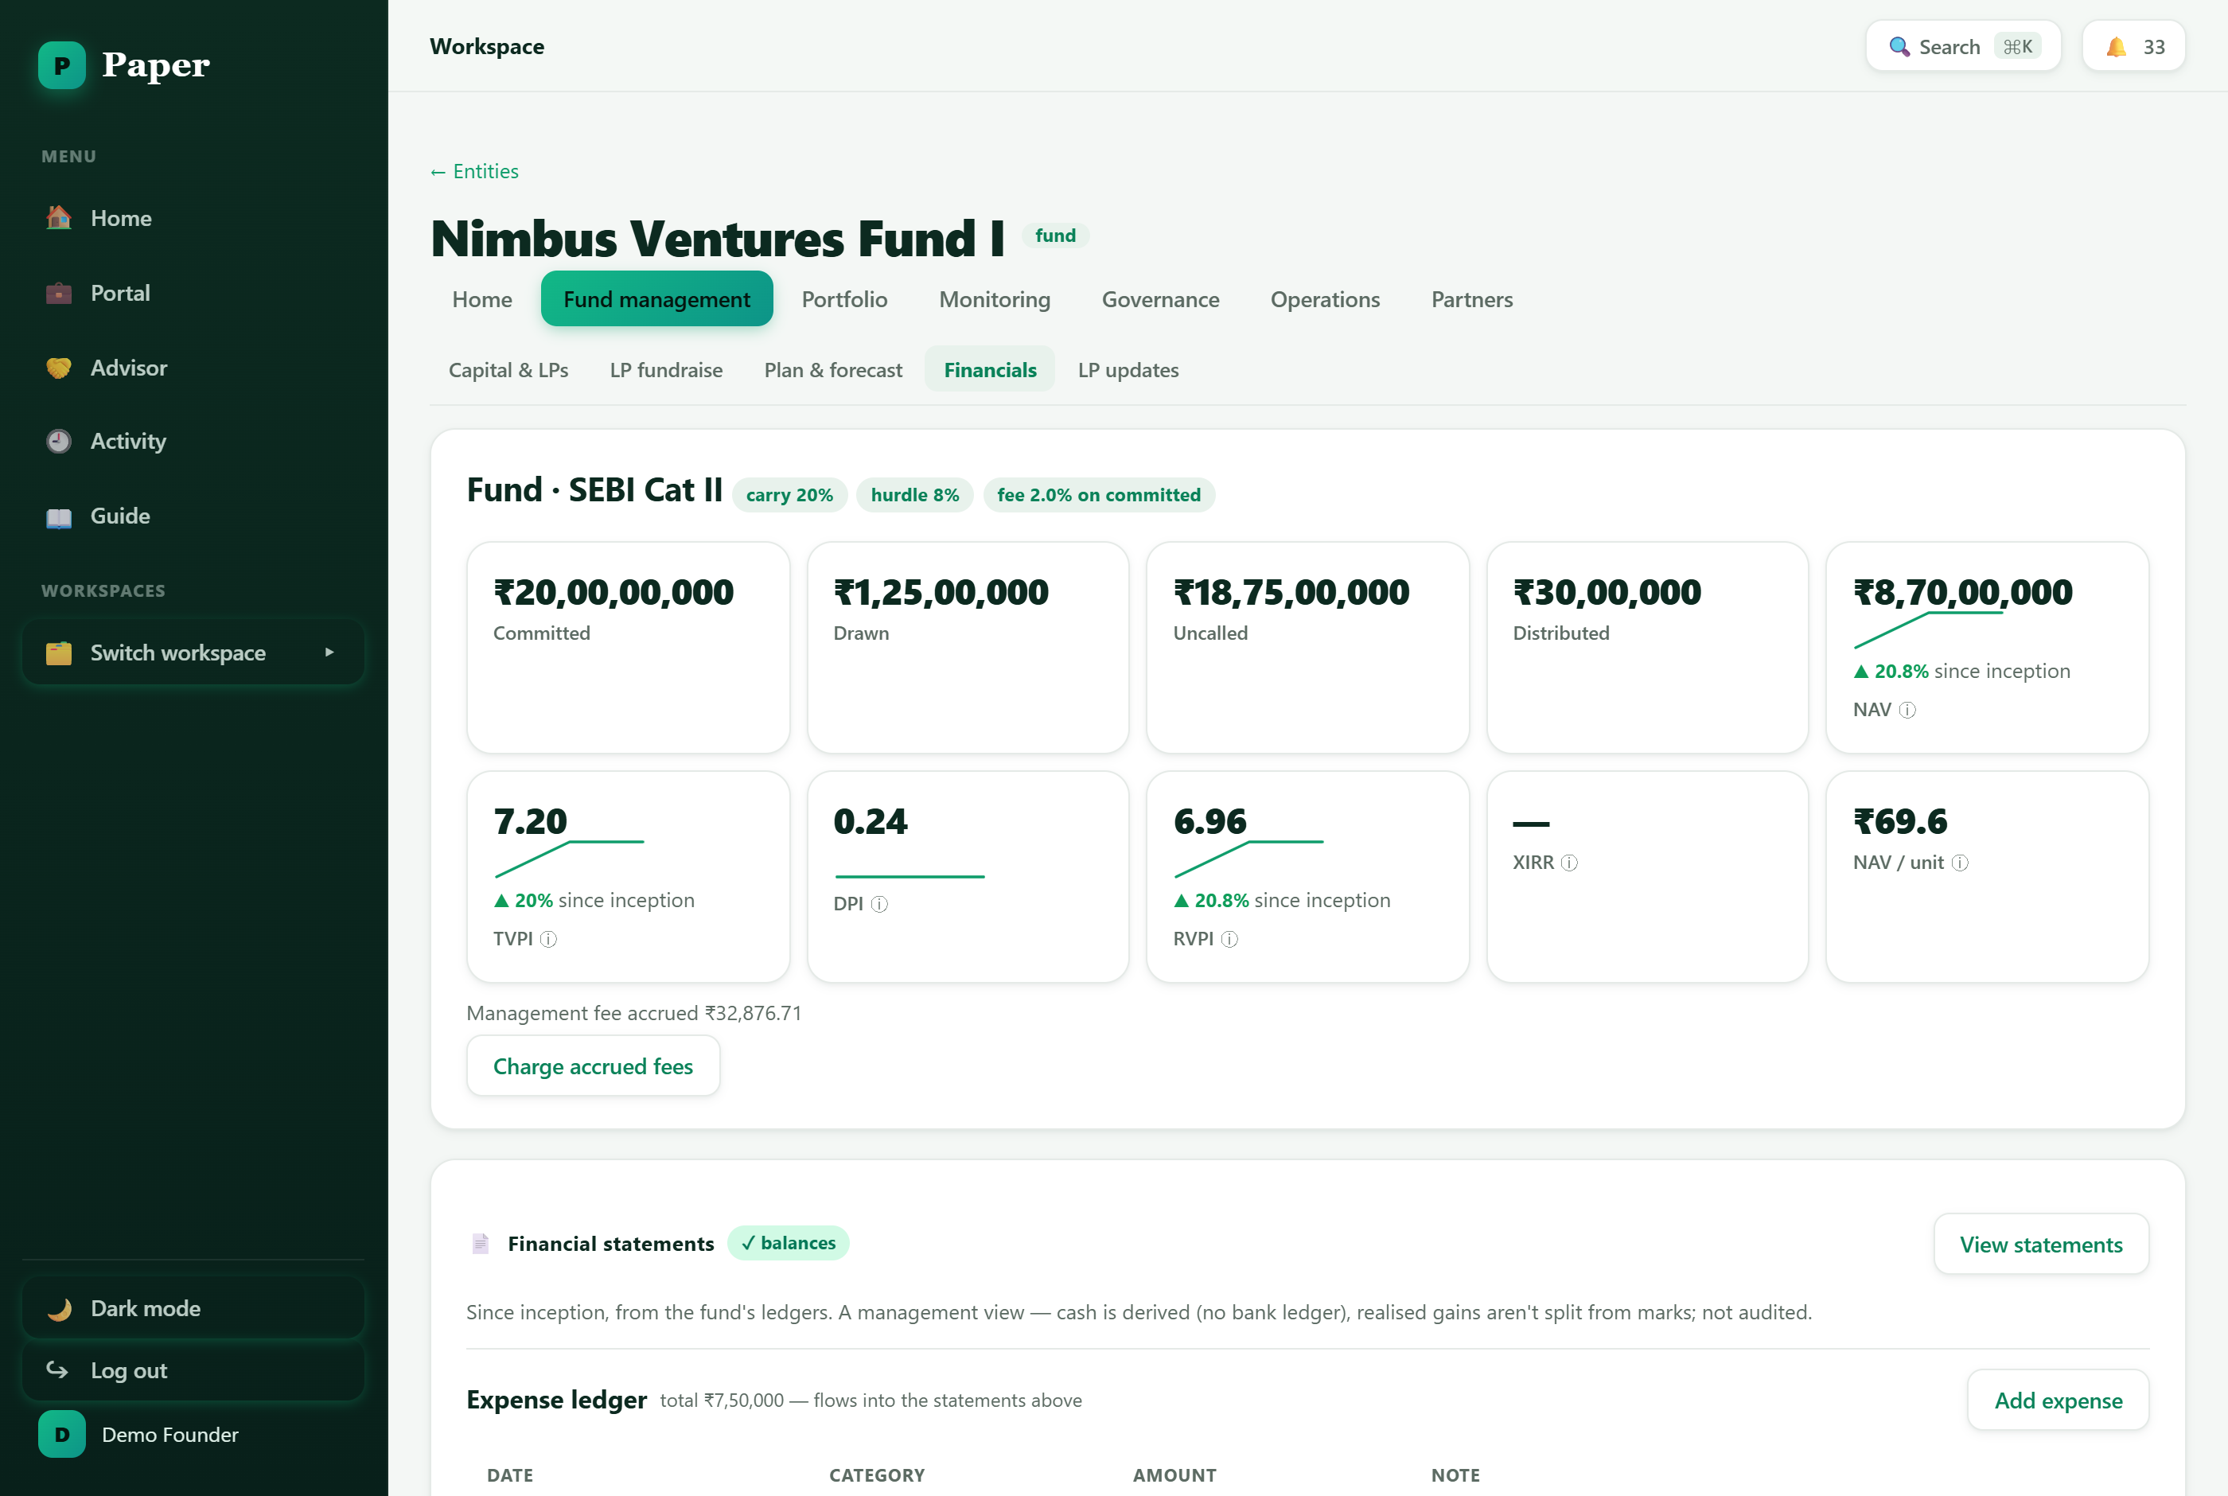
Fund financials — the fund's financial statements, alongside its live performance metrics.
- Financial statements — fund financial statements are maintained in Paper (general-ledger export is not included).
- Tax statements — generate the AIF tax statements (Form 64C / 64D) LPs need for their filings.
- Compliance calendar — the calendar tracks SEBI AIF filings (e.g. AIF-QR) plus the usual GST/TDS/MCA items, all flagged when due.

9. Plan and forecast
Fund management → Plan & forecast helps you construct and pace the fund: model the portfolio you intend to build, set aside follow-on reserves, pace deployment over the fund's life, and project returns.
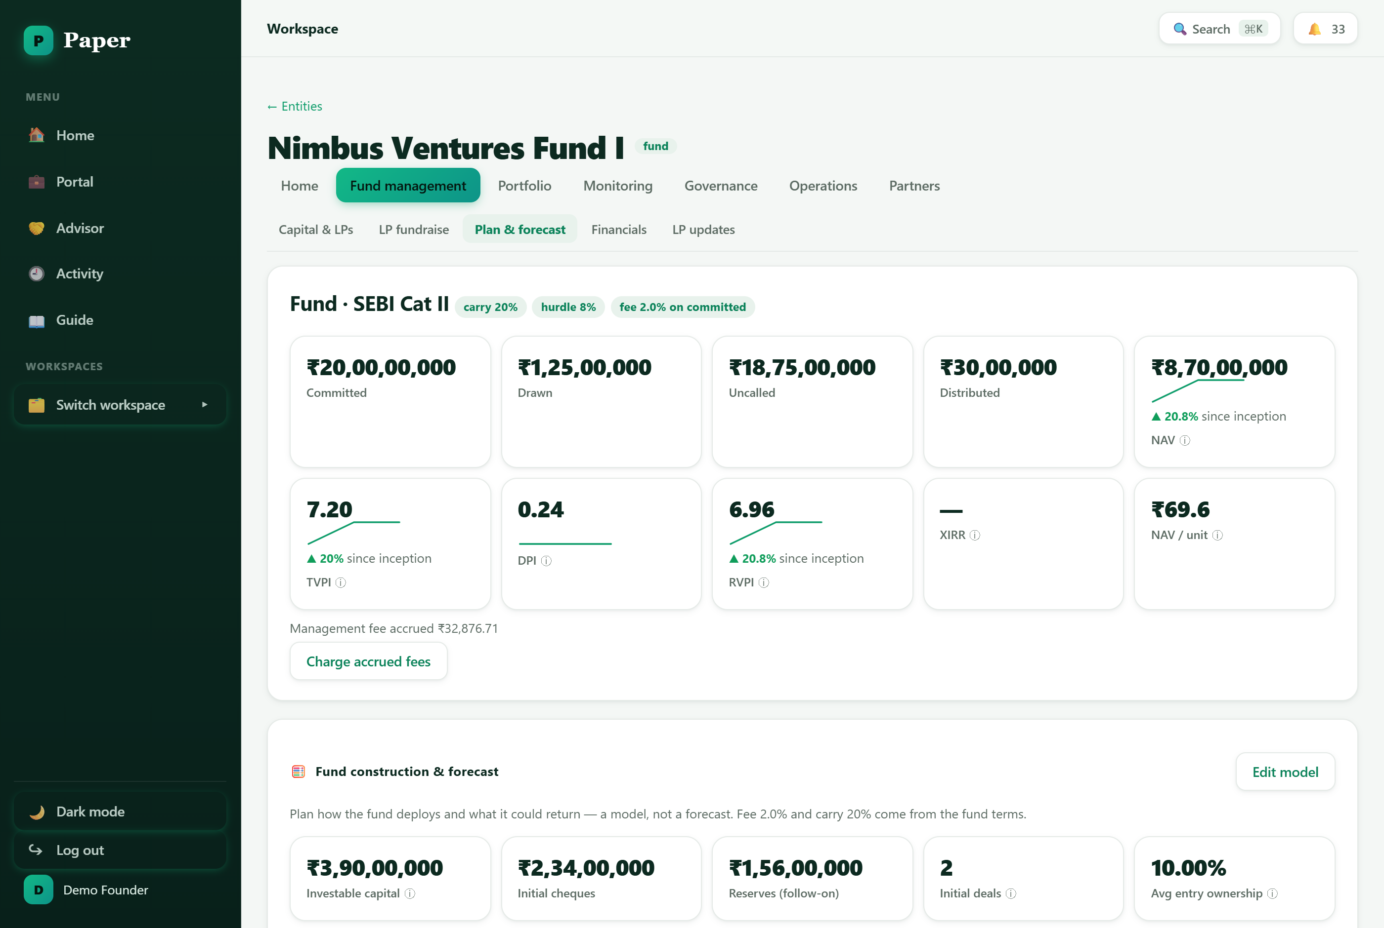
Plan & forecast — fund construction, reserves, deployment pacing and projected returns.

10. The fund lifecycle at a glance
A rough map of where you'll spend your time across the life of the fund:
Phase | What you're focused on | Where to work in Paper
Formation | Stand up the fund vehicle, SEBI category and economics | Create a Fund workspace + set the fund profile
Fundraising | Build an LP pipeline and secure commitments | Fund management → LP fundraise
Deploying | Source deals, invest, draw capital | Portfolio → Deal pipeline, Holdings · Fund management → Capital & LPs
Managing | Monitor the portfolio, call capital, report to LPs | Monitoring · Fund management → Capital & LPs, LP updates, Financials
Harvesting | Distributions, waterfall and final reporting | Fund management → Capital & LPs, Financials

And what lives where in a fund workspace:
Workspace area | What lives there
Home | Dashboard (the fund at a glance) and Tasks.
Fund management | Capital & LPs, LP fundraise, Plan & forecast, Financials, LP updates.
Portfolio | Deal pipeline and Holdings.
Monitoring | Portfolio-company KPIs, risk signals, tear sheets, benchmarking.
Governance | Board & Resolutions, Compliance (SEBI AIF calendar), Registers.
Operations | Documents and records.
Partners | Marketplace, Advisors, Managed Admin.

11. Getting help
- In-app Guide — the in-app Guide (in the sidebar) has walkthroughs for funds, startups and investors/LPs.
- Quick search — press Ctrl/⌘ + K to search and jump anywhere instantly.
- Next step — the fund dashboard's quick actions and compliance alerts point you at whatever needs attention next.

Paper — the OS for corporate legal. This guide describes the standard AIF/fund workflow; figures shown are illustrative sample data.

