PAPER

Investor & LP Guide
Your holdings, capital accounts and updates — all in one portal
A short walkthrough of the Paper investor portal for anyone who holds equity in a company or is a limited partner in a fund: how to read your portfolio, follow your LP capital account, respond to capital calls, and find your statements and updates.
Paper — the OS for corporate legal

Contents

1. Welcome to your investor portal
The Paper portal is your single, always-current window into everything you hold — across every company you've backed and every fund you're an LP in. There are no spreadsheets to reconcile and no “can you send me the latest?” emails: whatever the company or fund records in Paper, you see here, read-only.
Who it's for:
If you're a… | The portal shows you
Angel / individual investor | Your equity and SAFEs/notes in each company, marked at the latest valuation, with MOIC.
Fund LP | Your commitment, capital account, units and NAV, capital-call notices, statements and a look-through to the fund's companies.
Employee (option holder) | Your ESOP grants, vested vs. unvested, today's value vs. maximum potential, and exercise windows.
SPV / syndicate co-investor | Your position in each SPV deal, and any open invitations to commit.

Getting in: You don't set anything up. A company or fund adds you as an investor / LP in their Paper workspace, and you reach everything from the Portal link in the left sidebar. (SPV/syndicate invitations can also arrive as a no-login link — see §5.)

2. Your portfolio at a glance
Open Portal from the sidebar. The top of the page is your whole portfolio in one line — total value today, your MOIC (multiple on invested capital), and how much you've put in — over a marked-value trend you can view across 3M / 6M / 1Y / All.
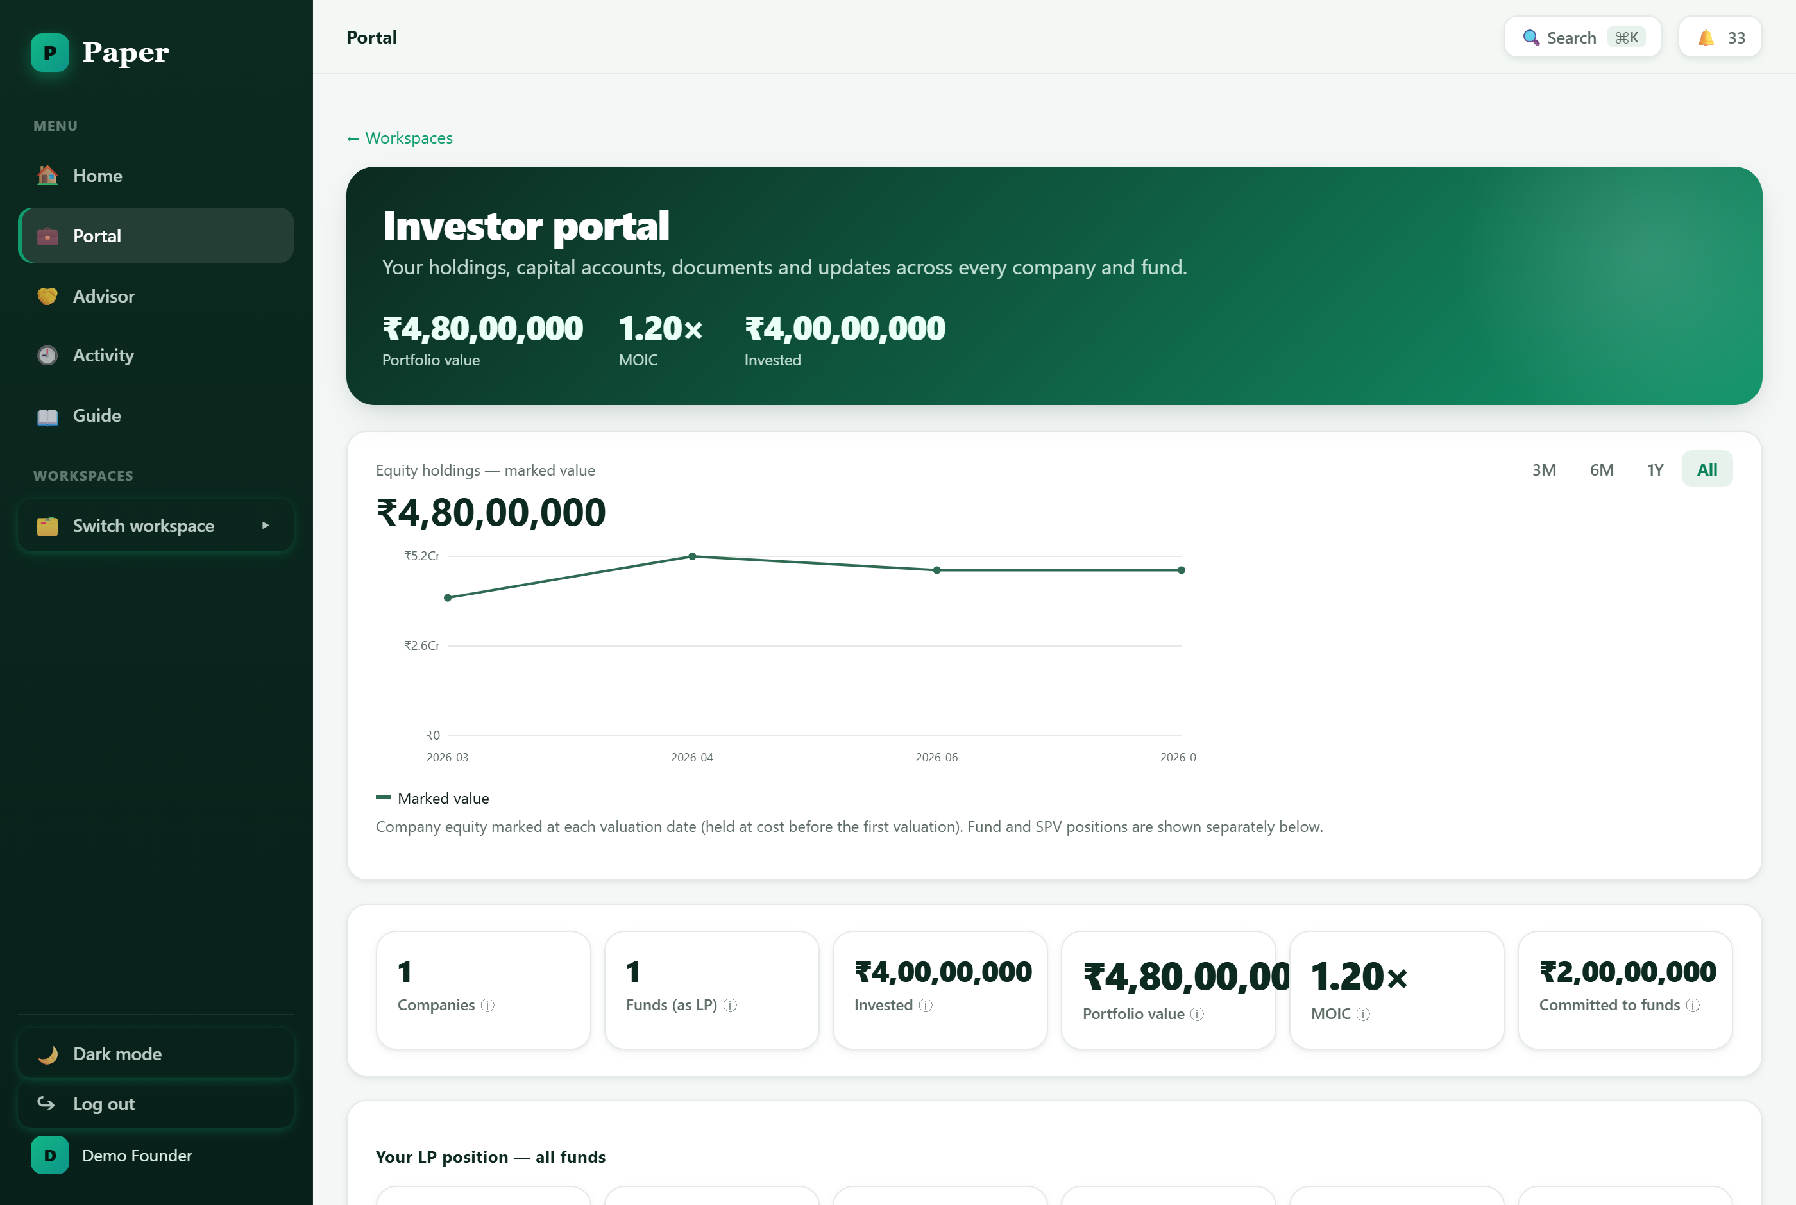
The investor portal — portfolio value, MOIC and invested up top, with a marked-value trend and a summary of companies and funds.
Below the hero, a summary strip breaks your position down: how many companies and funds you hold, total invested, current portfolio value, MOIC, and total committed to funds.

3. Your company holdings
For each company you've backed, the portal shows your equity and any SAFEs or convertible notes, marked at the company's latest fair market value (held at cost until the first valuation). You'll also see:
- Marked value — your position value and MOIC per company, updated as the company records new valuations.
- Instruments — your SAFEs and convertible notes and their terms, before they convert.
- Consents — any resolution where your consent is being requested — you can review and respond in place.

4. Your LP position (funds)
If you're an LP, the portal gives you the full picture of each fund you're in — the same numbers the GP sees, from your side.
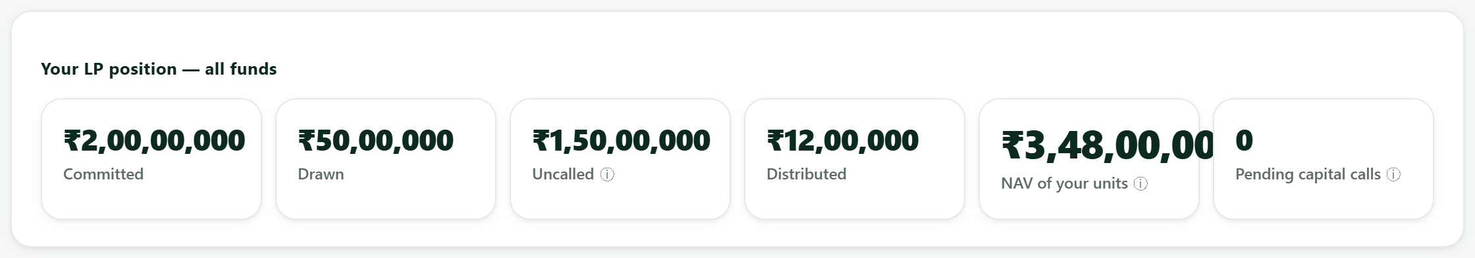
Your LP position across all funds — committed, drawn, uncalled, distributed, the NAV of your units, and any pending capital calls.
Drill into a fund and you get everything about your relationship with it in one card:
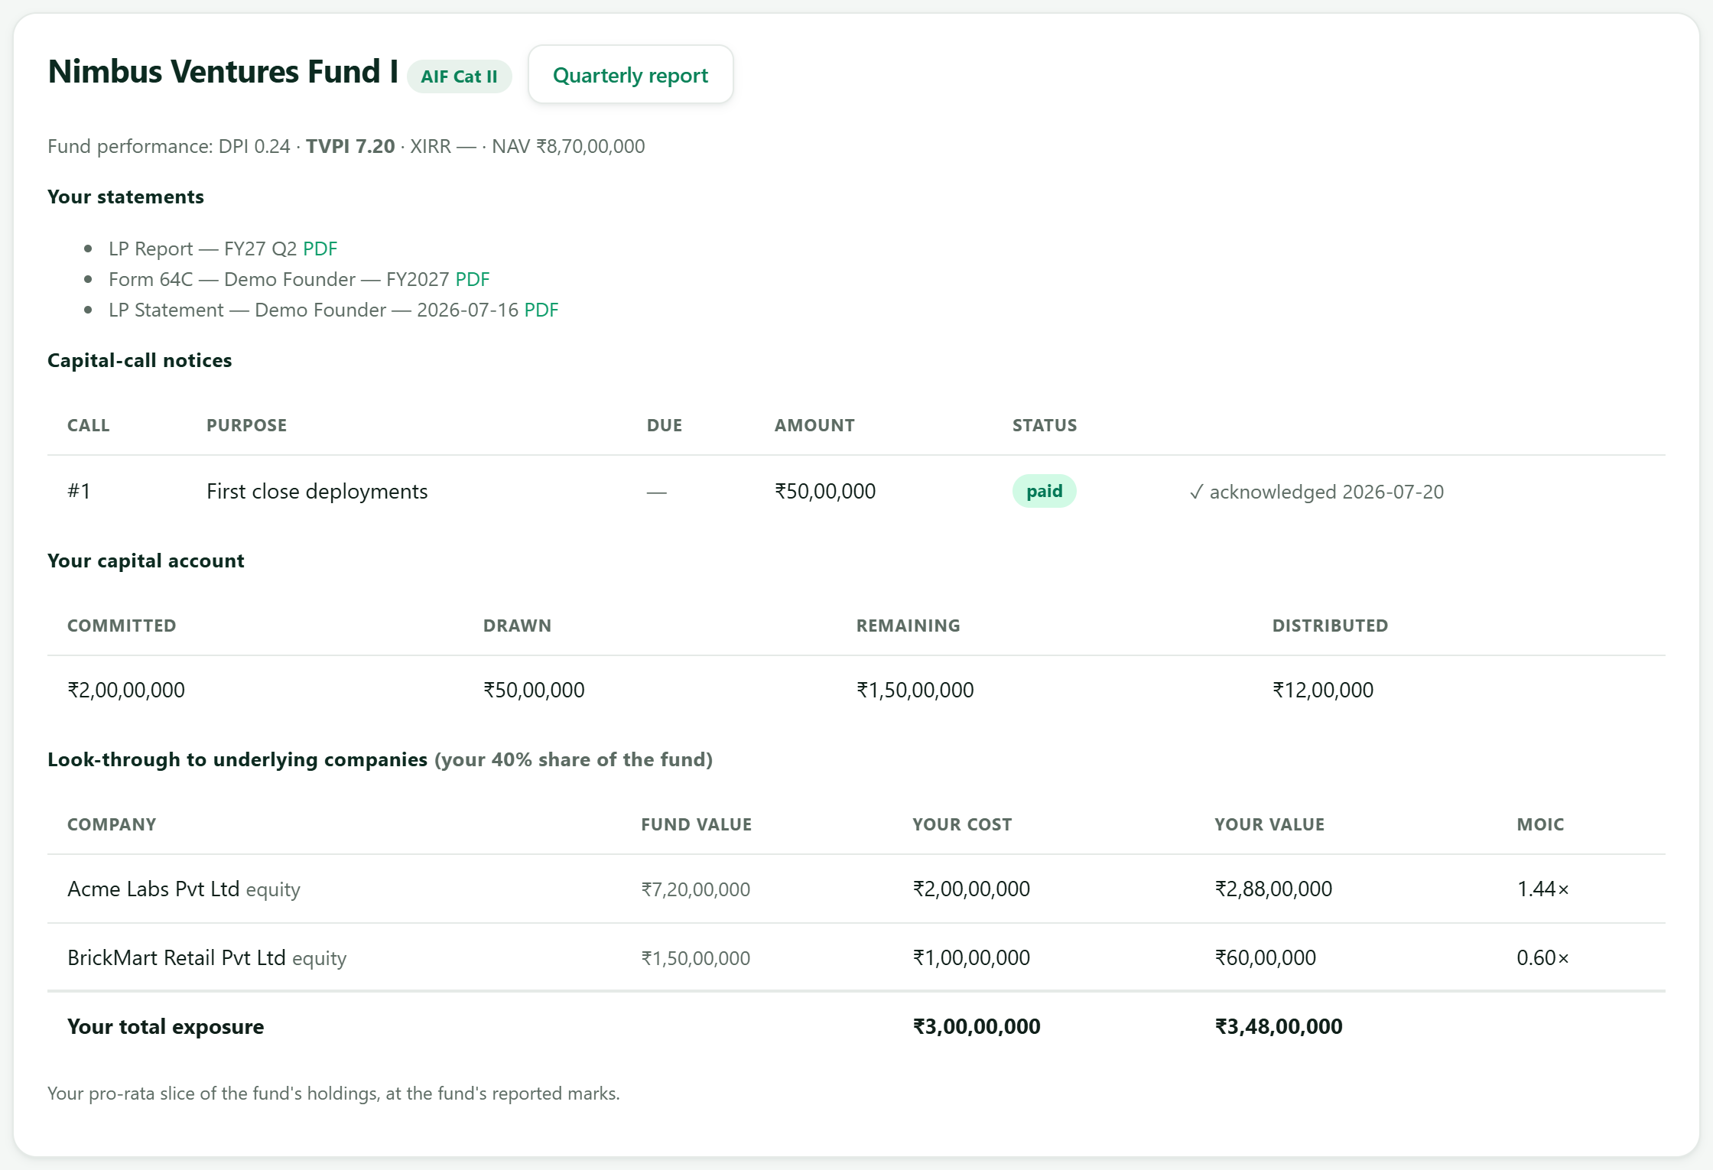
A fund from the LP's side — statements (LP report, Form 64C, capital-account statement), capital-call notices, your capital account, and a look-through to the fund's underlying companies.
- Capital account — committed, drawn, remaining (uncalled) and distributed capital — always current.
- Capital-call notices — review and acknowledge online drawdown notices; each shows the purpose, amount, due date and status.
- Statements — download your LP report, Form 64C/64D tax statement and capital-account statement as PDFs.
- Look-through — see your pro-rata slice of the fund's holdings — your cost, your value and MOIC per underlying company.

5. SPV & syndicate deals
If you co-invest through an SPV or syndicate, your position in each deal appears alongside your other holdings. When a new deal is opened to you, you may receive an invitation link:
- Open the invite link (it works without a login).
- Review the deal terms — the target company, minimum ticket and carry.
- Commit the amount you want; once funded, the position shows up in your portal with everyone else's.

6. Employee equity (ESOP)
If you hold employee options, the portal has a dedicated equity view: today's value of your vested options versus their maximum potential value, a vesting progress bar, upcoming vesting dates, and — where the company has opened a window — the ability to request an exercise. It's the clearest way to understand what your grant is worth and when.

7. Documents & updates
Everything shared with you lands in the portal: company and fund updates, quarterly reports, and your statements. You don't have to chase anyone — new updates simply appear, and the notifications bell (top-right) flags anything that needs your attention, like a capital call to acknowledge or a consent to give.
Tip: Check the portal at the start of each quarter — that's when fund reports, capital-account statements and company updates are usually published.

8. Getting help
- In-app Guide — the in-app Guide (in the sidebar) has walkthroughs for investors, startups and funds.
- Notifications — the 🔔 bell surfaces capital calls, consents and updates that need you.
- Read-only — everything in the portal is read-only reporting — to change a holding, contact the company or fund that manages it.

Paper — the OS for corporate legal. Figures shown are illustrative sample data.

