PAPER

Startup User Guide
Your workspace, from incorporation to funded — and beyond
A practical walkthrough of the flows a new company follows in Paper: setting up, staying compliant, raising capital and keeping investors in the loop — organised around your journey to success.
Paper — the OS for corporate legal

Contents

1. Welcome to Paper
Paper is a single workspace for everything a company has to keep legally in order — your cap table, employee equity, board and compliance filings, fundraising and investor relations. Instead of juggling spreadsheets, PDFs, a company secretary and a lawyer, you run it all from one place, and your investors get their own read-only view.
This guide is written for a founder starting from scratch. It follows the natural path a startup takes — incorporate, set up ownership, build a team, stay compliant, raise money, keep investors updated, and scale — and shows exactly where each step lives in Paper.
The big idea: Paper shows you what matters right now. As your company grows, it surfaces the next set of tools — you never have to hunt through features you don't need yet.
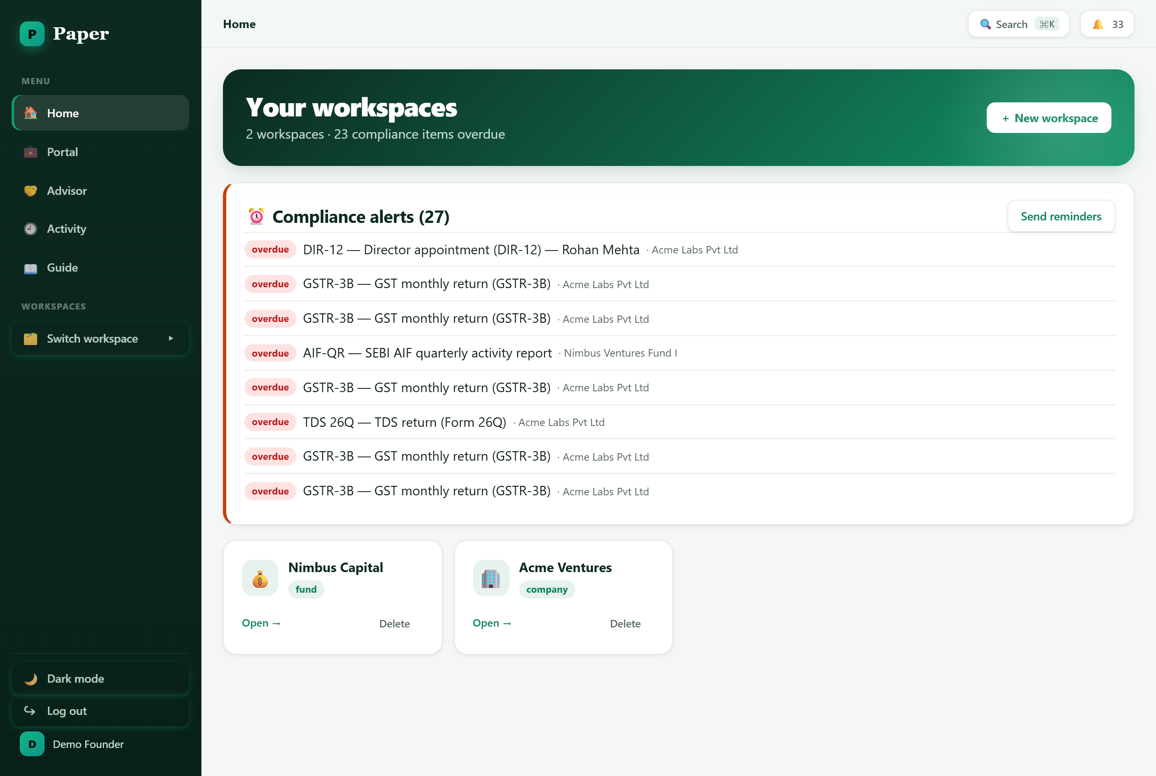
Your Home screen — every workspace in one place, with compliance alerts up top and one-click create.

2. Getting started (your first day)

Create your workspace
A workspace is your company. From the Home screen, choose New workspace, give it a name, and pick the type Company. You can run more than one workspace from the same login (useful for a holding company or a second venture), and switch between them from the sidebar.

Signing in to Paper.

Incorporate — or bring an existing company in
- Brand new: If you haven't incorporated yet, open the Incorporation wizard. It walks you through the intake for a new Private Limited company step by step.
- Already registered: If your company already exists, use Add an existing entity and enter its details (Pvt Ltd, LLP, and so on). Your cap table and registers pick up from there.

Choose a plan
Paper groups features into three plans so you only see what fits your stage. You can change plan at any time from the top of your workspace, and Paper will even suggest an upgrade when your data shows you've outgrown the current one.
Plan | Who it fits, and what it unlocks
Starter | Newly incorporated companies. The essentials: cap table, ESOP, documents, compliance calendar, board resolutions.
Growth | Companies actively raising. Adds fundraising rounds & SAFEs, diligence data rooms, investor CRM, valuations and scenario modelling.
Scale | Later-stage companies. Adds advanced cap-table actions (transfers, conversions, anti-dilution, exit waterfall), liquidity events and managed admin.

Set your stage and follow the checklist
Alongside the plan, you tell Paper your company stage (idea, pre-seed, seed, and so on). The stage drives a “what to do now” checklist on your dashboard — a short, ordered list of the next things worth doing, each linking straight to the right screen. Tick them off, and when you're ready, move to the next stage.
Tip: Not sure a feature exists? Press Show everything in your workspace to reveal every tab regardless of plan or stage — nothing is ever hidden permanently.

Finding your way around
- Sidebar — the left sidebar is your main menu — Home, the investor Portal, the Advisor view, an Activity log, and this in-app Guide.
- Workspace tabs — inside a workspace, tools are grouped along the top (Home, Ownership, Fundraise, Governance, Operations, Partners). Click a group to see its tabs.
- Quick search — press Ctrl/⌘ + K anywhere to jump to any screen or action instantly.
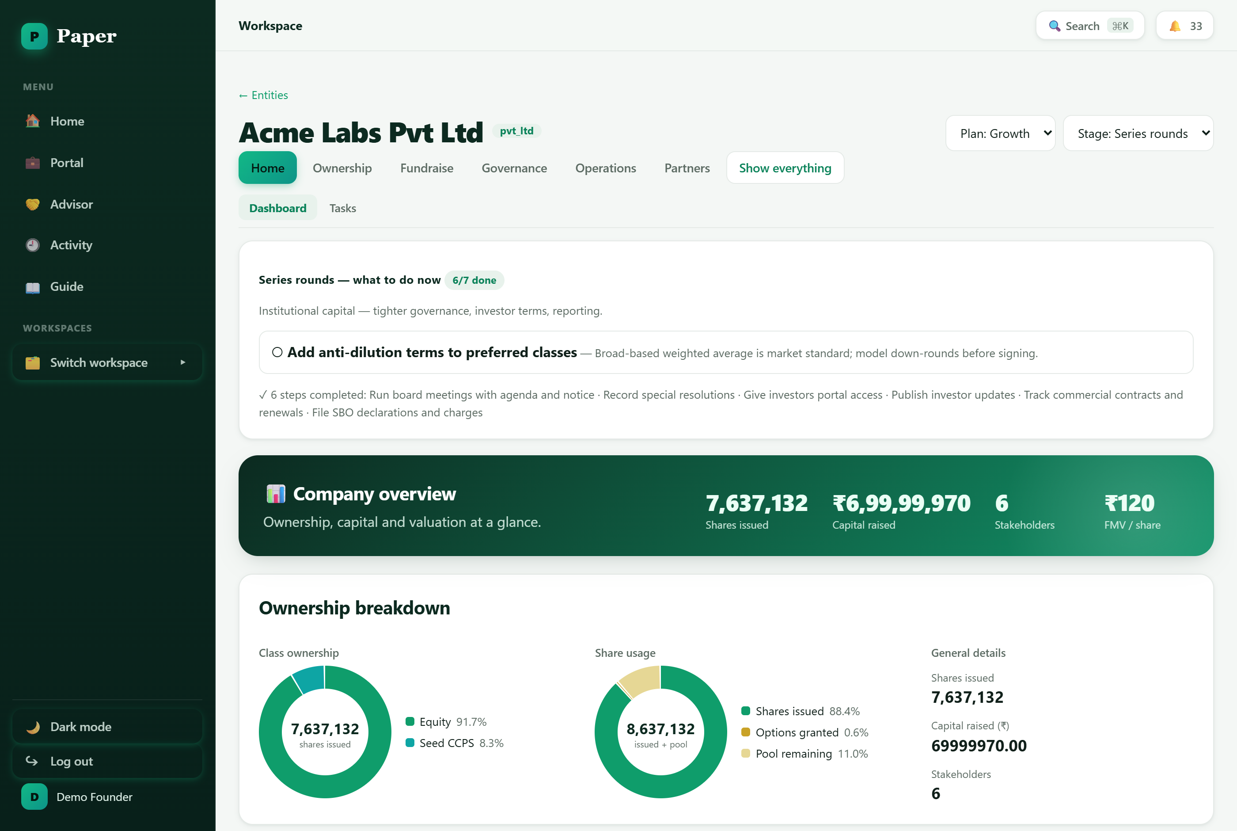
A company workspace: the plan/stage picker, the “what to do now” checklist, and a company-overview snapshot.

3. Set up your ownership
Your cap table is the source of truth for who owns what. Getting it right early saves painful clean-ups later. Work in Ownership → Cap Table.
- Create your share classes (e.g. Equity, and later CCPS for preference shares).
- Add your stakeholders — founders, angels, the ESOP pool, and later your investors.
- Record issuances — the founder shares, then each investment as it comes in. The cap table, ownership percentages and the 100%-ownership bar update automatically.
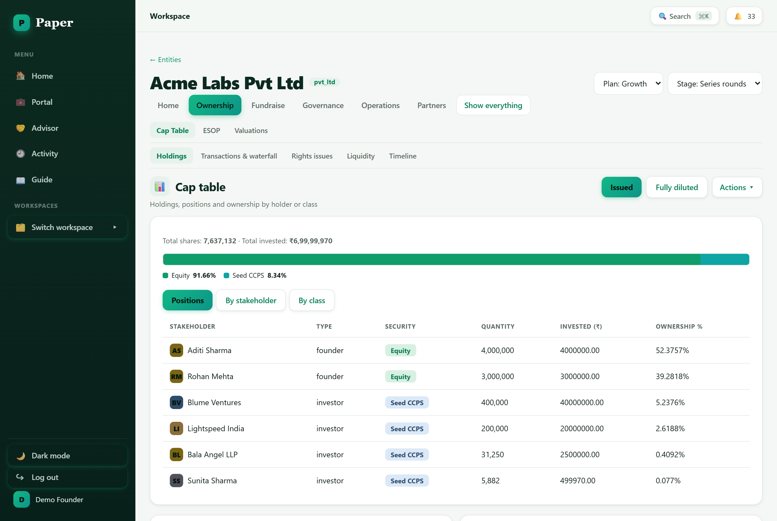
The cap table — a 100%-ownership bar, and pivots by position, stakeholder or share class.

Set up employee equity (ESOP)
In Ownership → ESOP, create an option pool and issue grants to employees with their own vesting schedules. Paper tracks vested vs. unvested options, and employees can see their own equity in the investor portal.

Record a valuation (FMV)
A fair market value per share underpins ESOP grants, option exercises and new rounds. In Ownership → Valuations, record your latest FMV (with the method and date). Paper flags when a valuation is missing or has expired so you're never pricing off stale numbers.
Why it matters: Investors and auditors expect a defensible valuation on file. Keeping it current here means your grants and round paperwork are always priced correctly.

4. Build your team and run operations

Hire and grant equity
In Operations → Team, use the Offer builder to put together a compensation package (salary plus options), then add the person to your team. New equity grants flow straight into your ESOP and cap table.

Contracts and finance
- Contracts — keep counterparties and agreements in one place under Operations → Contracts.
- Finance — track your monthly cash-and-burn to see your runway at a glance under Operations → Finance.

Documents
Operations → Documents is your document library. Generate board resolutions, agreements and letters from templates, fill in the blanks, preview them as a finished page, and send for e-signature. When you're raising, the same area holds your investor data room.

5. Stay compliant and well-governed
This is where Paper quietly saves you from missed deadlines and penalties. Work in the Governance group.

Board and resolutions
Record board and general meetings, draft and pass resolutions, and capture investor consents where they're required. Generated minutes and resolutions land in your Documents library.

The compliance calendar
Governance → Compliance auto-populates the statutory filings your company owes — MCA forms, GST returns, TDS, and more — with due dates. Overdue items are flagged on your home dashboard, and you can send yourself reminders so nothing slips.
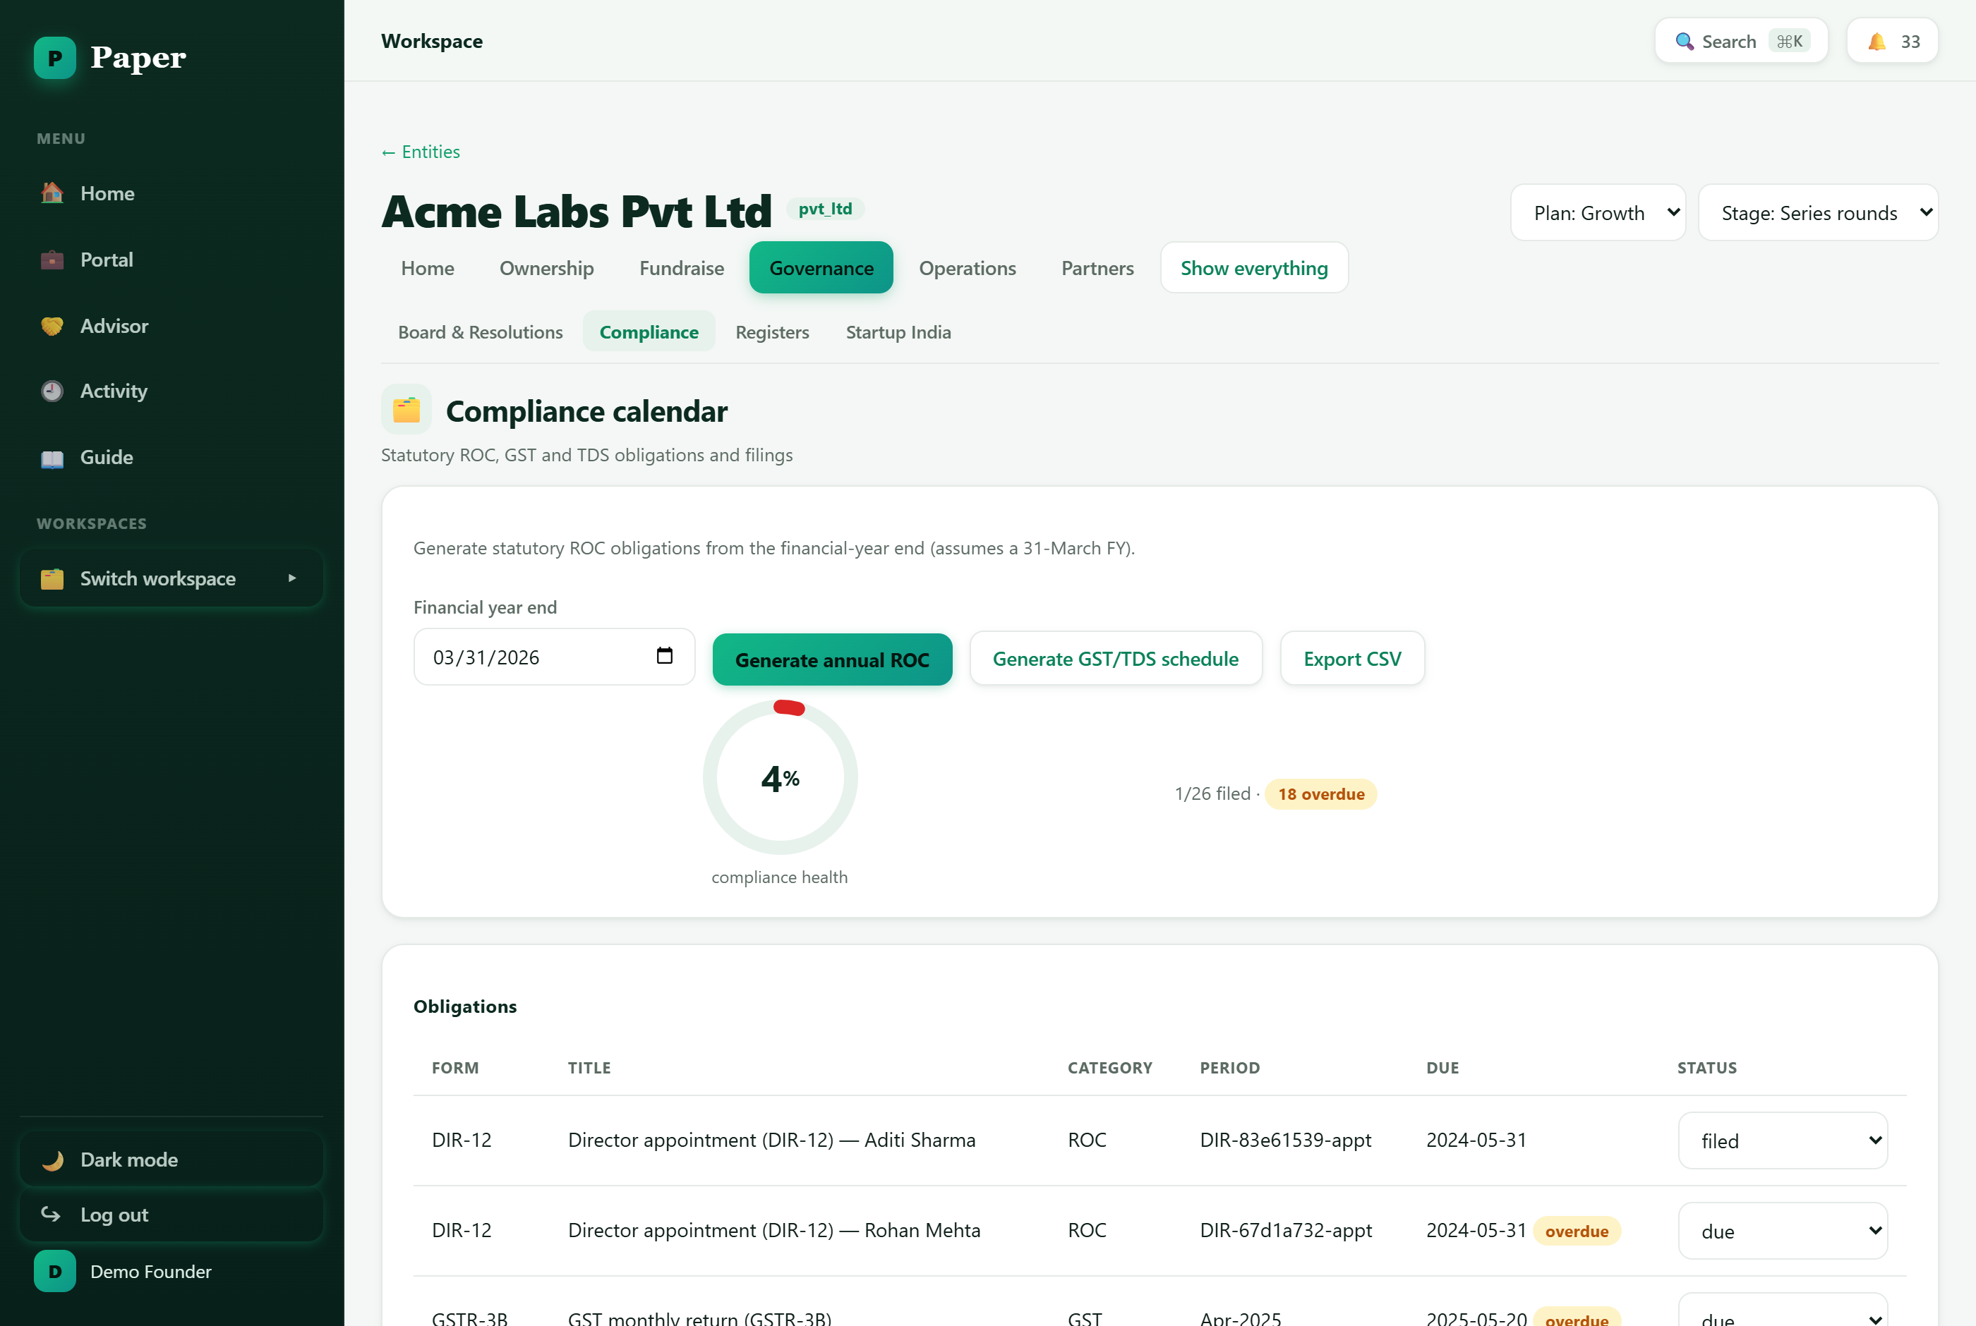
The compliance calendar tracks statutory filings and flags what's overdue.

Registers and Startup India
- Registers — your statutory registers (members, directors, charges) are maintained automatically as you record transactions.
- Startup India — check your eligibility and manage your DPIIT recognition from Governance → Startup India.
Tip: The compliance alerts on your Home screen and the 🔔 bell in the header are your early-warning system. Clear them weekly and you'll never be caught out by a filing.

6. Raise your round
When it's time to raise, Paper takes you from preparation to a closed round. Most of this lives in the Fundraise group (available on the Growth plan).

Prepare
- Make sure your valuation is current (Ownership → Valuations).
- Run the Diligence readiness check (Fundraise → Diligence) — it scores how investor-ready your records are and tells you what to fix.
- Assemble a data room in Operations → Documents to share with prospective investors.

Manage investors
Fundraise → Investors is your investor CRM — track prospects from first contact through to a committed cheque, log interactions, and share deal rooms.

Execute the round
In Fundraise → Rounds & SAFEs, create a priced round or a SAFE. Paper guides the SAFE flow from terms through board approval, agreement generation and e-signature, and folds the new money into your cap table on close.

Model the impact first
Before you commit to terms, use scenario modelling to see the pro-forma cap table after a hypothetical round — how ownership and dilution shift for everyone. Founders can see exactly what a term sheet means before signing.

7. Keep investors in the loop
Good investor relations are a growth engine. Paper gives your investors a self-service window and gives you an easy way to report.
- Investor Portal — every shareholder, option-holder and fund LP gets a read-only Portal showing their holdings, documents and updates — no more one-off cap-table emails.
- Updates & KPIs — send recurring updates to your investors, and respond to KPI requests when a fund that backed you asks for numbers.
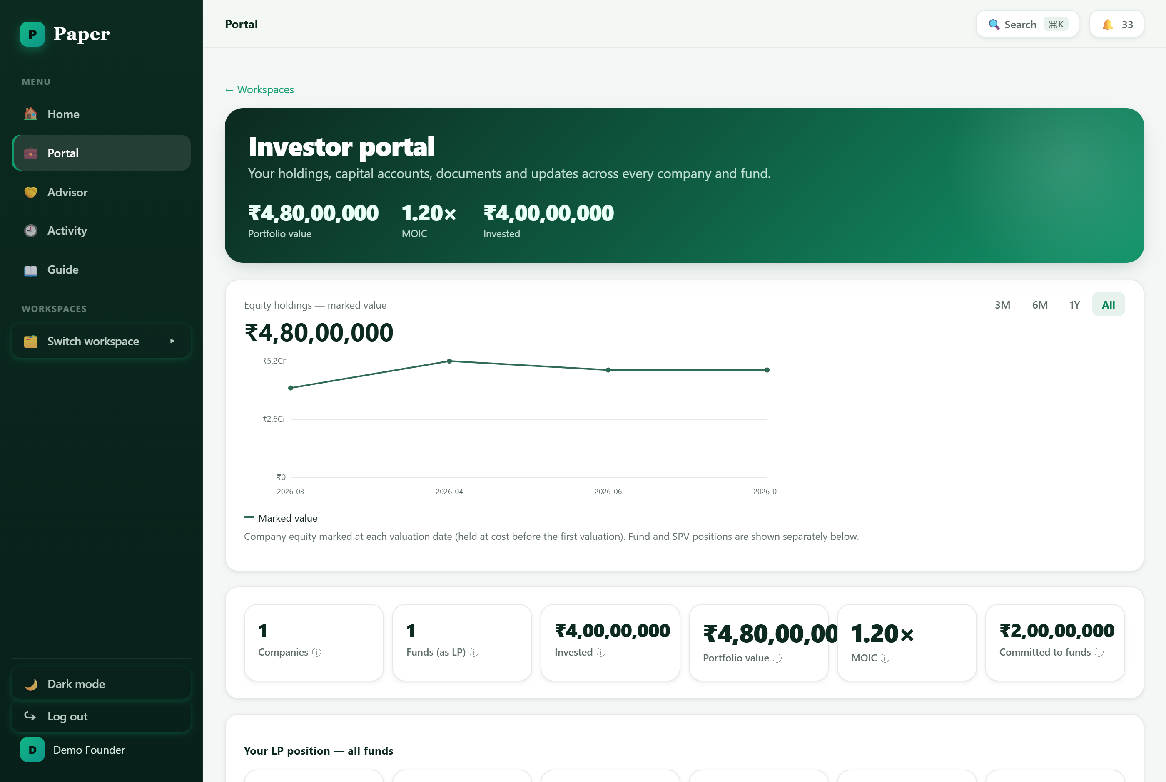
The read-only investor portal — what your shareholders and fund LPs see.
Good habit: A short monthly update in Paper keeps investors warm for your next round and cuts down on ad-hoc “can you send me the latest cap table?” requests.

8. Grow into Scale
As you mature, the Scale plan unlocks the heavier machinery — you'll grow into these rather than needing them on day one.
- Advanced cap table — transfers, conversions of SAFEs/notes, anti-dilution adjustments and an exit waterfall to see who gets what on a sale.
- Liquidity — run buyback and tender windows for your shareholders and employees.
- Partners — engage service providers (registered office, virtual CFO and more) from the Marketplace, bring in external Advisors with scoped access, or hand routine filings to Managed Admin.

9. The startup journey at a glance
A rough map of where you'll spend your time as you grow. Stages are guides, not gates — skip ahead or go back whenever it suits you.
Stage | What you're focused on | Where to work in Paper
Idea / Pre-seed | Incorporate, split founder equity, set up an ESOP pool | Incorporation wizard · Ownership → Cap Table, ESOP
Seed | Raise your first cheque (SAFE or priced round), stay compliant | Fundraise → Rounds & SAFEs · Governance → Compliance
Series A | Run diligence, model dilution, report to new investors | Fundraise → Diligence, Investors · Ownership → Valuations
Growth / Scale | Advanced cap table, liquidity, board governance at scale | Ownership (advanced) · Governance · Partners

And a reminder of what lives where in your workspace:
Workspace area | What lives there
Home | Dashboard (your company at a glance) and Tasks (everything due).
Ownership | Cap Table, ESOP, Valuations.
Fundraise | Rounds & SAFEs, Diligence, Investors.
Governance | Board & Resolutions, Compliance, Registers, Startup India.
Operations | Team, Contracts, Finance, Documents.
Partners | Marketplace, Advisors, Managed Admin.

10. Getting help
- In-app Guide — the in-app Guide (in the sidebar) has step-by-step walkthroughs for every audience — founders, funds and investors.
- Quick search — press Ctrl/⌘ + K to search and jump anywhere in seconds.
- Next step — your Home dashboard's “what to do now” checklist is the fastest way to know your next best step.

Paper — the OS for corporate legal. This guide describes the standard startup workflow; your available tools depend on your plan and stage.

