PHASE 2

Screenshot of SIEM integration:
Metasploitable3:
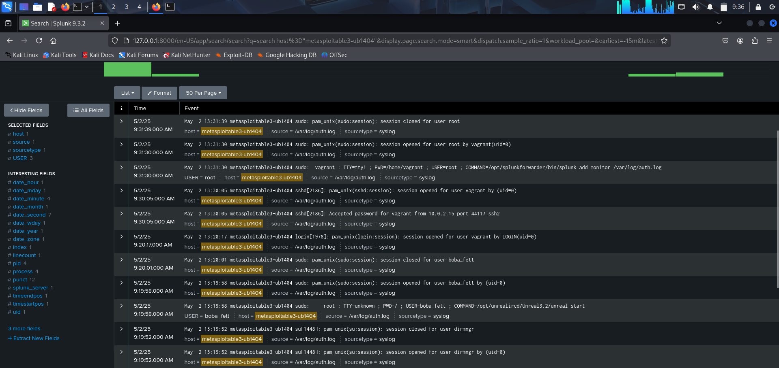

Attack visualization: successful and failed login:
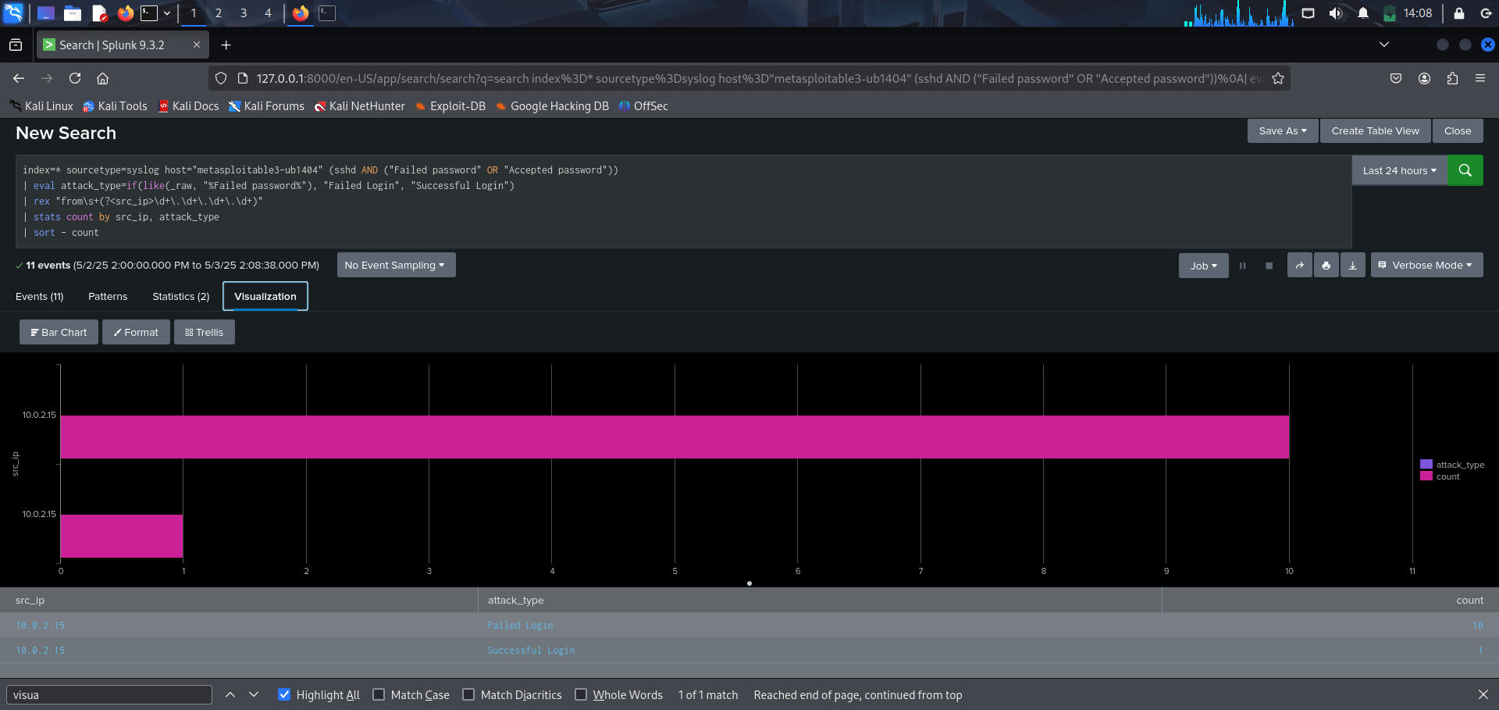
Because the machine goes over more false credentials, and it stops at success, it shows that there is only one successful login while we are having multiple failed login

