Test the connectivity to metasploitable3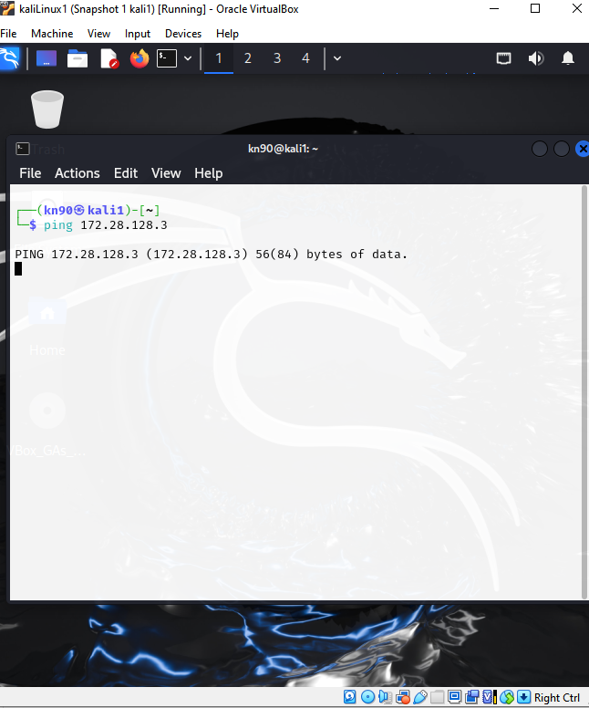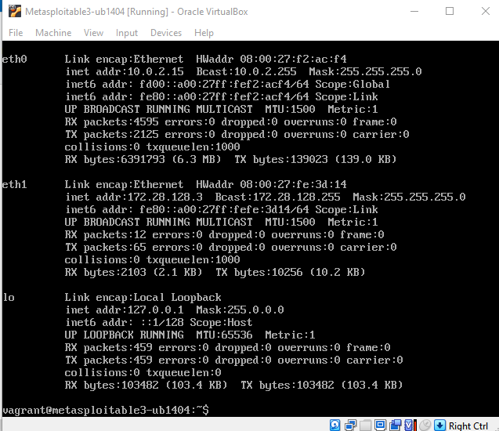
1. System & Service Patch
- Ran apt-get update and upgraded the SSH server package:
- sudo apt-get update
- sudo apt-get install --only-upgrade openssh-server

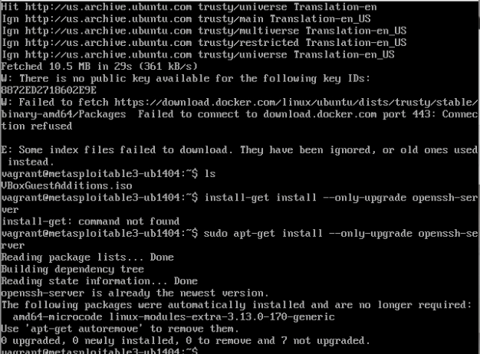
2. SSH Configuration Hardening
- Disabled password-based logins #no
- Disabled root logins #no
- Bound SSH to the host-only IP #ListenAddress 10.0.2.15
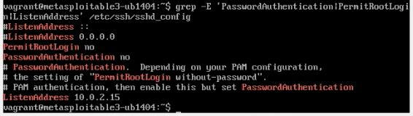
Restarted SSH

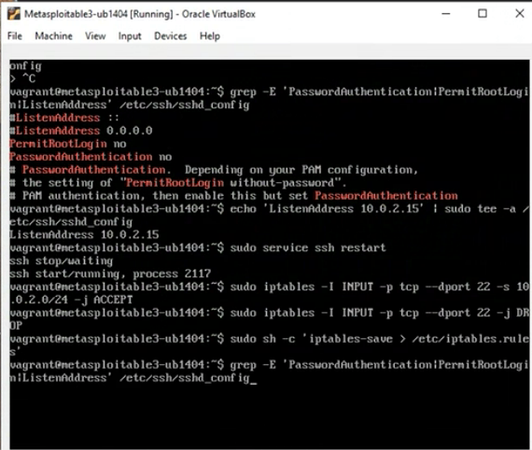
3. Network-Level Access Control
- iptables rules applied
  - Allow SSH only from the 10.0.2.0/24 subnet
  - Drop all other SSH connection attempts
- Persisted firewall rules

4. Verification on Metasploitable3
- SSH listening only on 10.0.2.15
- Configuration file check


