PHASE 2

Screenshot of SIEM integration:
Metasploitable3:
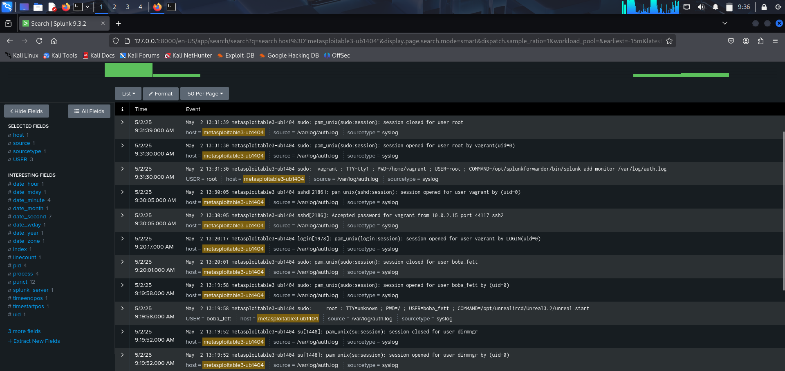

Attack visualization: successful login
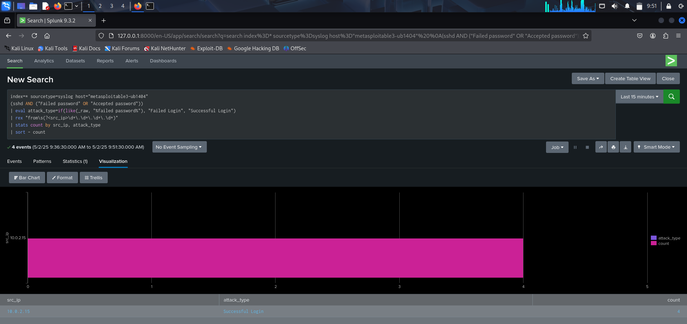

Attack visualization: failed login

