

**SWP391-Q5**

**Software Design Specification**

– Hanoi, February 2023 –

**Table of Contents**

I. Overview 4

1. Code Packages 4

2. Database Design 4

a. Database Schema 4

b. Table Description 4

II. Code Designs 5

1. <Feature/Function Name1> 5

a. Class Diagram 5

b. Class Specifications 5

c. Sequence Diagram(s) 5

d. Database queries 6

2. <Feature/Function Name2> 6

# I. Overview

## 1. Code Packages

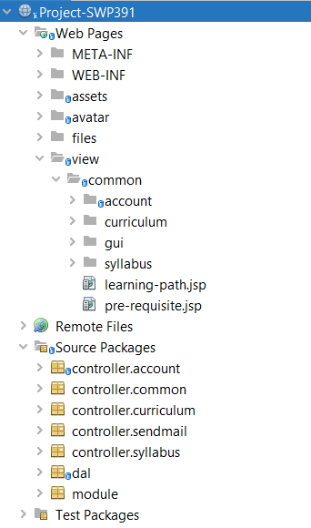

***Package descriptions***

|  |  |  |
| --- | --- | --- |
| **No** | **Package** | **Description** |
| *01* | *Controller.account* | *Gồm những servlet xử lí các request của người dùng về page account* |
| *02* | *Controller.common* | *Là những trang thông dụng như home, login, register* |
| *03* | *Controller.curriculum* | *Xử lí về curriculum, show list curriculum lấy từ dbs, search curriculum, get details* |
| *04* | *Controller.sendmail* | *Để xử lí phần tác vụ cần xác nhận bằng chuỗi random gửi về mail* |
| *05* | *Dal* | *Chứa những file làm việc với dbs mysql, file connect server, file get content từ data, insert, update, delete* |
| *06* | *Module* | *Chứa các class java là đối tượng của từng bảng có trong dbs, khi lấy được thông tin từ dbs ra thì sẽ lưu thông qua class object* |

## 2. Database Design

### a. Database Schema

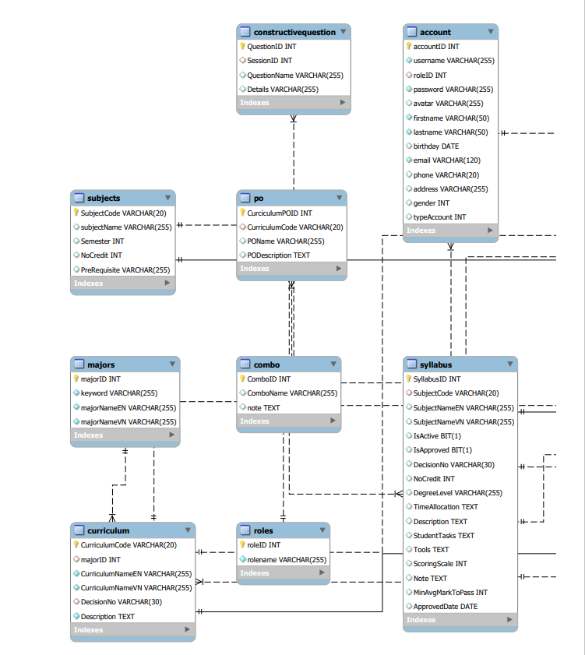

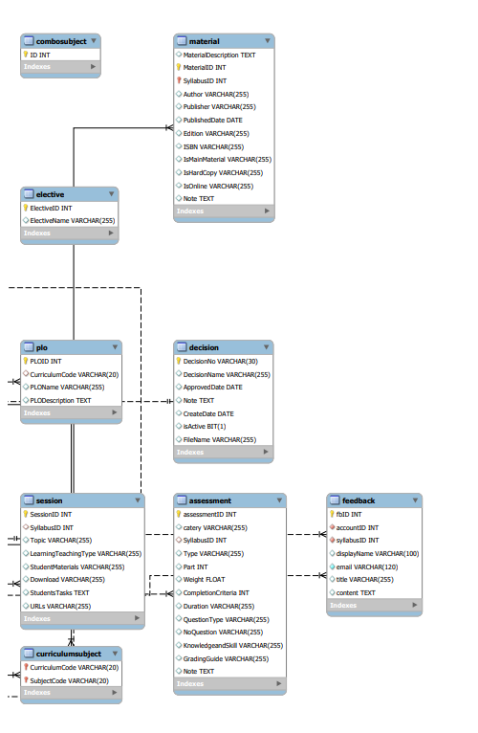

### b. Table Description

|  |  |  |
| --- | --- | --- |
| **No** | **Table** | **Description** |
| *01* | *<Table name>* | *<Description of the table>* |

# II. Code Designs

## 1. Search Syllabus List

### a. Class Diagram

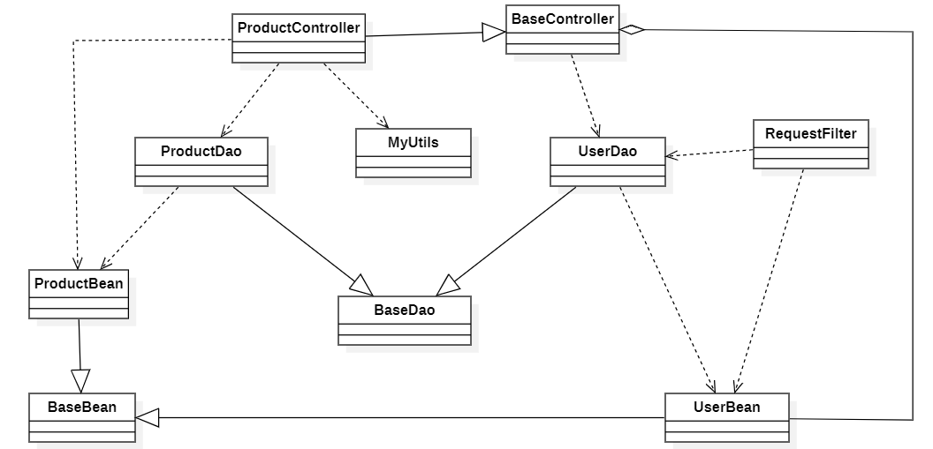

### b. Syllabus

#### Syllabus Class

|  |  |  |
| --- | --- | --- |
| **No** | **Method** | **Description** |
| *01* | *getSubjectCode()* | *return subject code* |
| *02* | *setSubjectCode()* | *update subject code* |
| *03* | *getSyllabusName()* | *return syllabus name* |
| *04* | *setSyllausName()* | *update syllabus name* |
|  | *getSyllabusID()* | *return syllabus id* |
|  | *setSyllabusID()* | *update syllabus id* |
|  | *getNoCredit()* | *return no credit* |
|  | *setNoCredit()* | *update no credit* |
|  | *getDegreeevel()* | *return no credit* |
|  | *setDegreeevel()* | *update no credit* |
|  | *getTimeAllocation()* | *return time allocation* |
|  | *setTimeAllocation()* | *update time allocation* |
|  | *getPreRequsite()* | *return prerequsite* |
|  | *setPreRequsite()* | *update prerequsite* |
|  | *getDescription()* | *return description* |
|  | *setDescription()* | *update description* |
|  | *getStudentTasks()* | *return student task* |
|  | *setStudentTasks()* | *update student task* |
|  | *getTool()* | *return tool* |
|  | *setTool()* | *update tool* |
|  | *getScoringScale()* | *return scoringScale* |
|  | *setScoringScale()* | *update scoringScale* |
|  | *getDecisionNo()* | *return decision No* |
|  | *setDecisionNo()* | *update decision No* |
|  | *isIsApproved()* | *return is Approved* |
|  | *setIsApproved()* | *update is approved* |
|  | *getNote()* | *return note* |
|  | *setNote()* | *update note* |
|  | *getMinAvgMarkToPass()* | *return min avg mark to pass* |
|  | *setMinAvgMarkToPass()* | *update min avg mark to pass* |
|  | *isIsActive()* | *return is active* |
|  | *setIsActive* | *return is active* |
|  | *getApprovedDate()* | *return approved date* |
|  | *setApprovedDate()* | *update approved date* |

#### Subject Class

***Subject***

|  |  |  |
| --- | --- | --- |
| **No** | **Method** | **Description** |
| *01* | *getNoCredit* | *Return noCredit* |
|  | *setNoCredit* | *Set noCredit* |
|  | *getPreRequisite* | *return preRequisite* |
|  | *setPreRequisite* | *Set preRequisite* |
|  | *getSemester* | *Return semester* |
|  | *setSemester* | *Set sesmester* |
|  | *getSubjectCode* | *Return subjectCode* |
|  | *getSubjectName* | *Return subjectName* |
|  | *setSubjectName* | *Set subjectName* |

### c. Sequence Diagram(s)

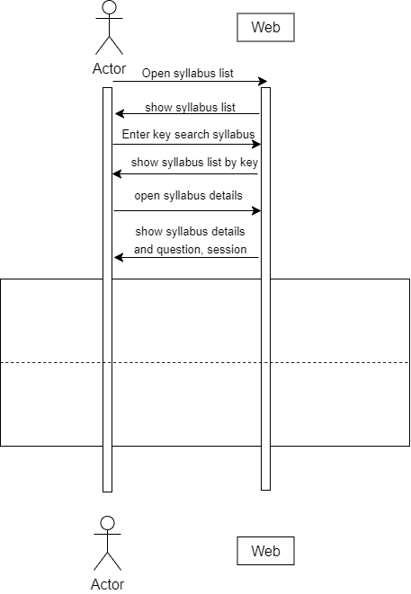

### d. Database Queries

|  |  |  |
| --- | --- | --- |
| **No** | **Method** | **Description** |
| *01* | *getListSyllabusByKey* | SELECT `syllabus`.`SyllabusID`,  `syllabus`.`SubjectCode`,  `syllabus`.`SubjectNameEN`,  `syllabus`.`SubjectNameVN`,  `syllabus`.`IsActive`,  `syllabus`.`IsApproved`,  `syllabus`.`DecisionNo`,  `syllabus`.`NoCredit`,  `syllabus`.`DegreeLevel`,  `syllabus`.`TimeAllocation`,  `syllabus`.`Description`,  `syllabus`.`StudentTasks`,  `syllabus`.`Tools`,  `syllabus`.`ScoringScale`,  `syllabus`.`Note`,  `syllabus`.`MinAvgMarkToPass`,  `syllabus`.`ApprovedDate`,  `subjects`.`subjectName`,  `subjects`.`Semester`,  `subjects`.`NoCredit`,  `subjects`.`PreRequisite`  FROM `syllabus` INNER JOIN `subjects`  ON `syllabus`.`SubjectCode` = `subjects`.`SubjectCode`"  WHERE `syllabus`.`SubjectCode` LIKE ? OR `syllabus`.`SubjectNameEN` LIKE ? OR `syllabus`.`SubjectNameVN` LIKE ? |
| *02* | *getSyllabus* | SELECT `syllabus`.`SyllabusID`,  `syllabus`.`SubjectCode`,  `syllabus`.`SubjectNameEN`,  `syllabus`.`SubjectNameVN`,  `syllabus`.`IsActive`,  `syllabus`.`IsApproved`,  `syllabus`.`DecisionNo`,  `syllabus`.`NoCredit`,  `syllabus`.`DegreeLevel`,  `syllabus`.`TimeAllocation`,  `syllabus`.`Description`,  `syllabus`.`StudentTasks`,  `syllabus`.`Tools`,  `syllabus`.`ScoringScale`,  `syllabus`.`Note`,  `syllabus`.`MinAvgMarkToPass`,  `syllabus`.`ApprovedDate`,  `subjects`.`subjectName`,  `subjects`.`Semester`,  `subjects`.`NoCredit`,  `subjects`.`PreRequisite`  FROM `syllabus` INNER JOIN `subjects`  ON `syllabus`.`SubjectCode` = `subjects`.`SubjectCode`  WHERE `syllabus`.`SubjectCode` = ?; |
| *03* | *getAllSyllabus* | SELECT `syllabus`.`SyllabusID`,  `syllabus`.`SubjectCode`,  `syllabus`.`SubjectNameEN`,  `syllabus`.`SubjectNameVN`,  `syllabus`.`IsActive`,  `syllabus`.`IsApproved`,  `syllabus`.`DecisionNo`,  `syllabus`.`NoCredit`,  `syllabus`.`DegreeLevel`,  `syllabus`.`TimeAllocation`,  `syllabus`.`Description`,  `syllabus`.`StudentTasks`,  `syllabus`.`Tools`,  `syllabus`.`ScoringScale`,  `syllabus`.`Note`,  `syllabus`.`MinAvgMarkToPass`,  `syllabus`.`ApprovedDate`,  `subjects`.`subjectName`,  `subjects`.`Semester`,  `subjects`.`NoCredit`,  `subjects`.`PreRequisite`  FROM `syllabus` INNER JOIN `subjects`  ON `syllabus`.`SubjectCode` = `subjects`.`SubjectCode`; |

## 2.

…