

**SWP391-Q5**

**Software Requirement Specification**

– Hanoi, February 2023 –

**Table of Contents**

I. Overview 4

1. Introduction 4

2. System Functions 5

3. Entity Relationship Diagram 6

II. Functional Requirements 7

1. <<Feature Name 1>> 7

a. <<Function Name 1>> 7

b. <<Function Name 2>> 7

2. <<Feature Name 2>> 7

# I. Overview

## 1. Introduction

Currently, the amount of knowledge is very wide, many students do not know where to focus their knowledge. Therefore, we will create a product that focuses on the materials and curriculum of the subjects taught in the school, focusing on the main knowledge to best grasp the basic knowledge of the subject.

## 2. System Functions

#### a. Screen Flow

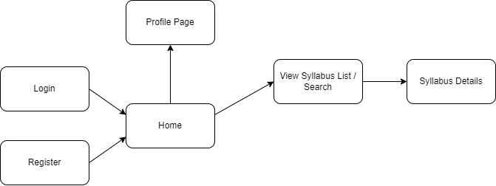

#### b. Screen Details

|  |  |  |  |
| --- | --- | --- | --- |
| **#** | **Feature** | **Screen** | **Description** |
| 1 | View List Syllabus | Syllabus | Xem thông tin của syllabus |
| 2 | Search Syllabus | Syllabus | Tìm kiếm syllabus theo subject code |
| 3 | View Syllabus Details | Syllabus-details | Xem thông tin chi tiết của syllabus |
| 4 | Feedback | Syllabus-details | Đánh giá của reviewer về syllabus |
| 5 | Download Materials | Syllabus-details | Tải material teacher/student của Syllabus |
| 6 | Login Google account | Login | Đăng nhập bằng tài khoản Google |

#### c. User Authorization

|  |  |  |  |  |  |  |  |
| --- | --- | --- | --- | --- | --- | --- | --- |
| **Screen** | **GUEST** | **STUDENT** | **TEACHER** | **REVIEWER** | **DESIGNER** | **CRDD** | **ADMIN** |
| Home | X | X | X | X | X | X | X |
| Syllabus List | X | X | X | X | X | X | X |
| Syllabus Details | X | X | X | X | X | X | X |
| Feedback |  |  |  | X |  |  |  |
| Reply Feedback |  |  |  | X |  | X |  |

## 3. Entity Relationship Diagram

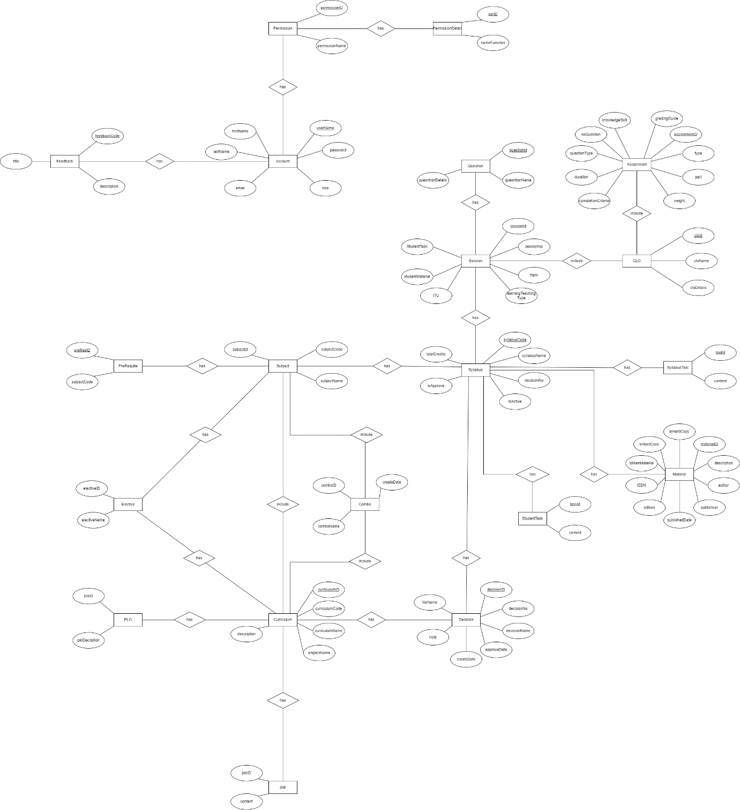

**Entities Description**

|  |  |  |
| --- | --- | --- |
| **#** | **Entity** | **Description** |
| 1 | User |  |
| 2 | Meal |  |
| 3 | Meal Subscription |  |
| 4 | … |  |

# II. Functional Requirements

## 1. Syllabus List Page

### a. Search syllabus

**- Search syllabus by subject code**

**

**- Xử lí load key search bằng ajax:**

let request;

function searchSyllabus() {

let key = document.getElementById("keyseach").value;

let page = document.getElementById("page");

let url = './syllabus?page='+ page +'&keysearch=' + key;

if (window.XMLHttpRequest) {

request = new XMLHttpRequest();

} else if (window.ActiveXObject) {

request = new ActiveXObject("Microsoft.XMLHTTP");

}

try {

request.onreadystatechange = getInfo;

request.open("POST", url, true);

request.send("POST");

} catch (e) {

alert("Unable to connect server")

}

}

function getInfo() {

if (request.readyState === 4) {

var val = request.responseText;

document.getElementById("list-items").innerHTML = val;

}

}

- **Xử lí với câu lệnh sql:**

SELECT `syllabus`.`SyllabusID`,

`syllabus`.`SubjectCode`,

`syllabus`.`SubjectNameEN`,

`syllabus`.`SubjectNameVN`,

`syllabus`.`IsActive`,

`syllabus`.`IsApproved`,

`syllabus`.`DecisionNo`,

`syllabus`.`NoCredit`,

`syllabus`.`DegreeLevel`,

`syllabus`.`TimeAllocation`,

`syllabus`.`Description`,

`syllabus`.`StudentTasks`,

`syllabus`.`Tools`,

`syllabus`.`ScoringScale`,

`syllabus`.`Note`,

`syllabus`.`MinAvgMarkToPass`,

`syllabus`.`ApprovedDate`,

`subjects`.`subjectName`,

`subjects`.`Semester`,

`subjects`.`NoCredit`,

`subjects`.`PreRequisite`

FROM `syllabus` INNER JOIN `subjects`

ON `syllabus`.`SubjectCode` = `subjects`.`SubjectCode`"

WHERE `syllabus`.`SubjectCode` LIKE ? OR `syllabus`.`SubjectNameEN` LIKE ? OR `syllabus`.`SubjectNameVN` LIKE ?

### b. Syllabus Details

**- Lấy ra thông tin chi tiết của một syllabus**

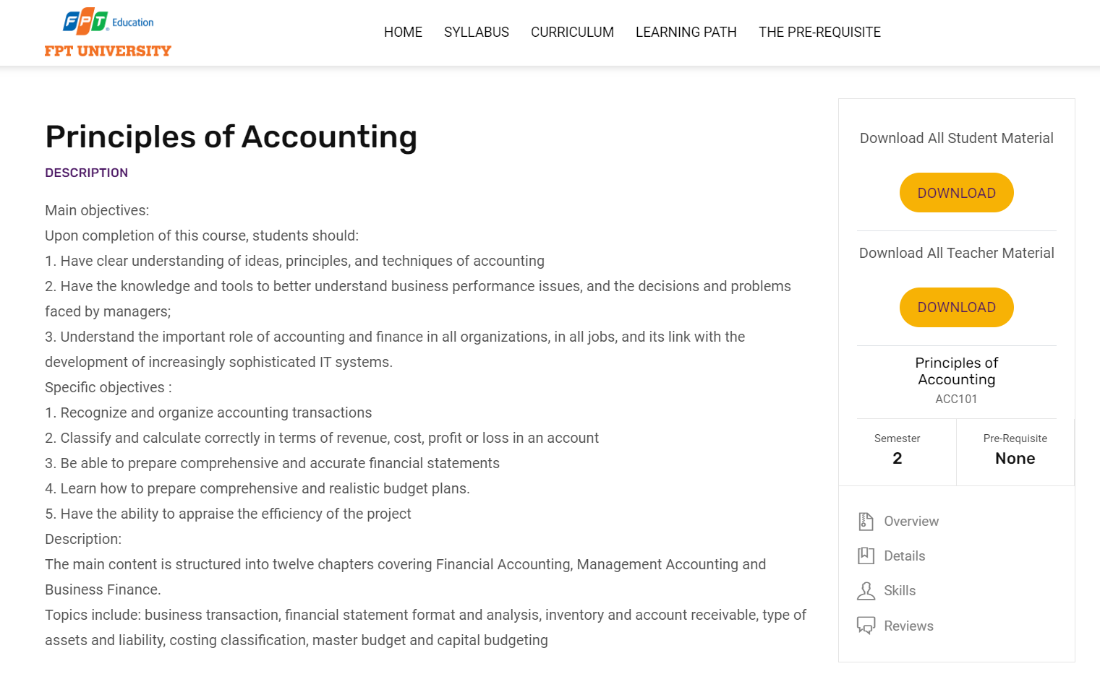

**- Download materials cho student và teacher**

**- Feedback và reply cho reviewer/CRDD**

**- Lấy thông tin của session, assessment, question.**

**- Code xử lí với sql:**

SELECT `syllabus`.`SyllabusID`,

`syllabus`.`SubjectCode`,

`syllabus`.`SubjectNameEN`,

`syllabus`.`SubjectNameVN`,

`syllabus`.`IsActive`,

`syllabus`.`IsApproved`,

`syllabus`.`DecisionNo`,

`syllabus`.`NoCredit`,

`syllabus`.`DegreeLevel`,

`syllabus`.`TimeAllocation`,

`syllabus`.`Description`,

`syllabus`.`StudentTasks`,

`syllabus`.`Tools`,

`syllabus`.`ScoringScale`,

`syllabus`.`Note`,

`syllabus`.`MinAvgMarkToPass`,

`syllabus`.`ApprovedDate`,

`subjects`.`subjectName`,

`subjects`.`Semester`,

`subjects`.`NoCredit`,

`subjects`.`PreRequisite`

FROM `syllabus` INNER JOIN `subjects`

ON `syllabus`.`SubjectCode` = `subjects`.`SubjectCode`

WHERE `syllabus`.`SubjectCode` = ?;

## 2. <<Feature Name 2>>

…