**Assignment 4:**

Module 4. Assignment 1: Creating Relations in 3NF from an Entity Relationship Diagram (ERD)

**Author:**

Valon Tika

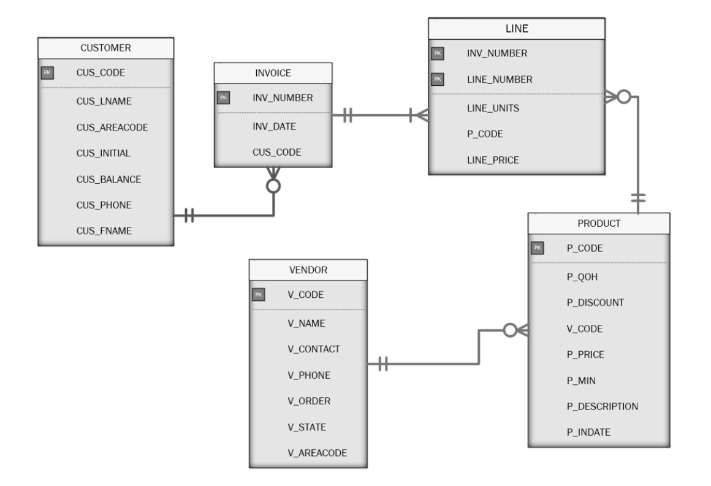

1. Identify all partial dependencies
   * LINE (LINE_UNIT, LINE_PRICE)
2. Identify all transitive dependencies.
   * CUSTOMER (CUS_AREACODE)
   * VENDOR (V_AREACODE)
   * PRODUCT (P_DISCOUNT)
3. List the relations from the 3NF Crow’s Foot ERD below.
   * **Customer** table relate to **Invoice** table as a foreign key (1:M) *1 mandatory to many optional*
   * **Invoice** table relates to **Line** table as both foreign and primary key *inv_number* of line table (1: M) 1 to Many - *1 mandatory to many mandatory*
   * **Product** table relate to **Line** table as foreign key *p_code* to that table (1:M) 1 to Many - *1 mandatory to many optional*
   * **Vendor** relate to the **product** table as foreign key *v_code* (1:M) 1 to Many - *1 mandatory to many optional*
4. List the primary keys and the foreign keys associated with the different  
   relations.
   * CUSTOMER
     1. CUS_CODE: PK
   * INVOICE
     1. INV_NUMBER: PK
     2. CUS_CODE: FK
   * LINE
     1. INV_NUMBER: PK
     2. LINE_NUMBER: PK
     3. P_CODE: FK
   * PRODUCT
     1. P_CODE: PK
     2. V_CODE: FK
   * VENDOR
     1. V_CODE: PK