**Assignment 2:**

Valon Tika

**Introduction:**

The purpose of this assignment is to determine 2 variables to use for initial regression modelling using the data from week 1. The regressions will be performed against the Sales Price of the training set of data to determine if we can see any predicting metrics to determine future sales prices of houses within the Ames, Iowa market. The same steps that were taken in Assignment 1 to subset and create the training set of data will be used in assignment 2.

File:ames_housing_data.csv

Code file: Assignment2.R

**Task:**

Section 1: Define eligible population for sample output and selection 2 predictors

We will continue with the eligible population set from week one where we used single family homes as our subset of data to perform our modelling efforts. The sample group will be defined only within the Ames, Iowa market. This is also considered as our drop conditions when filtering out the records that we don’t need for our analysis. We first concluded a set of conditions that labeled the records for what was considered as “drop conditions” for an appropriate housing subset.

|  |  |
| --- | --- |
| **Condition** | **Count** |
| Not SFR | 505 |
| Non-Normal Sale | 423 |
| Street Not Paved | 6 |
| Built Pre-1950 | 489 |
| No Basement | 28 |
| LT 800 SqFt | 9 |
| Eligible Sample | 1,470 |
| **Total** | **2,930** |

Here we can determine that we will start with 1,470 homes that are eligible for further analysis.

Section 2:Simple Linear Regression Modelling

The two variables that were selected were the total house square footage and total quality index

**Total house square footage:**

Simple linear regression of total house square footage against sales price.

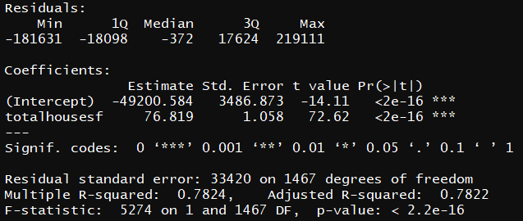

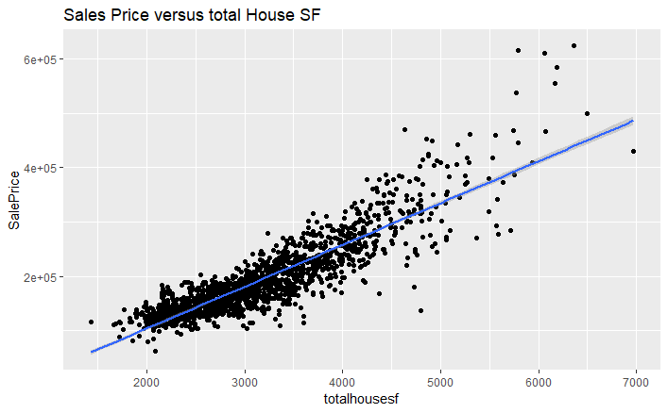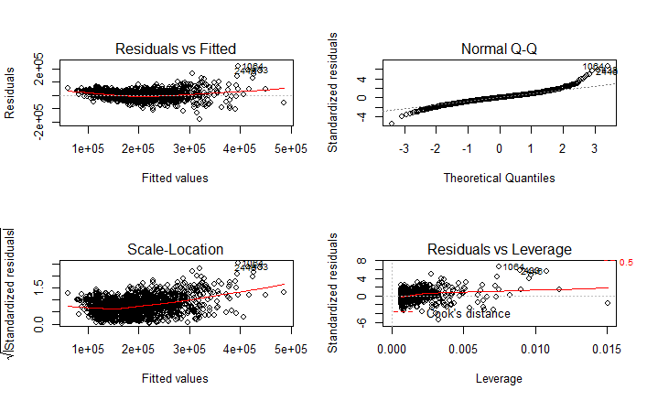

**Total Quality Index:**

Simple linear regression of total quality index against sales price.

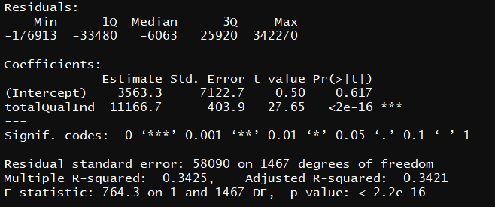

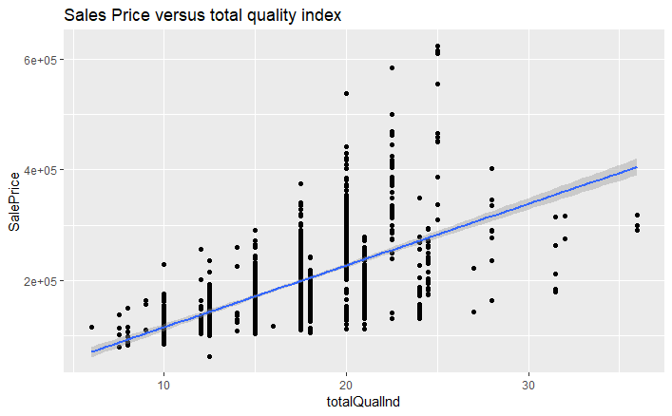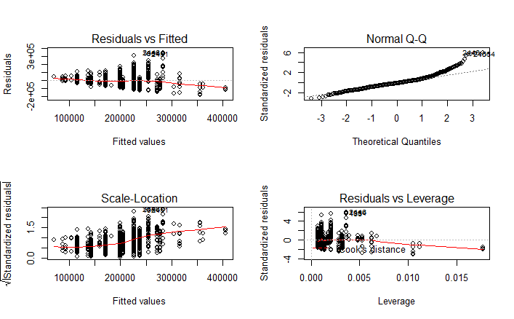

**Multiple Linear Regression Model:**

